

**KONYA FOOD AND AGRICULTURE UNIVERSITY**

**FACULTY OF ENGINEERING AND ARCHITECTURE**

**COMPUTER ENGINEERING DEPARTMENT**

**CENG 3800**

**SUMMER INTERNSHIP  
REPORT**

**ELİF NİDA ŞÖLEN**

**202010020036**

**PROCEEDIT THE BPAAS COMPANY**

**19/08/2024 – 15/09/2024**

**Table of Contents**

1. Introduction 4

2. Company Information 5

3. Work Done 6

3.1. Language App UI 7

3.2. Study About Backend 8

3.3.My Own Idea 16

4. Conclusion 16

References 17

Questionnaire 18

ABSTRACT

I completed the first month of my internship at Proceedit as a full stack developer. During this process, I learned how to use JIRA, a software development tool that engineers use to track and manage tasks, and I started using it. I also learned how to design a UI in Flutterflow. With this information, I designed a language learning application interface and added the necessary actions. For the backend side, I first worked on PostgreSQL and provided the necessary installations such as pgAdmin4. Then I started learning Flask, a microframework, and graphQL.

1.Introduction

I completed my summer internship at Proceeditthe BPaaS in the technology and engineering department. Proceedit is a company that helps businesses by simplifying their work, managing complexity, and facilitating collaboration with different stakeholders. I saw the full stack developer intern posting opened by Proceedit before and applied for it, and was accepted after certain tests and interviews. Since it was a 6-month internship, I chose my start date and started working with the team when the time came. For now, I only learned Flutterflow in the UI section, and I started with PostgreSQL in the backend. I continue with Flask and GraphQL**.**

2.Company Information

Proceedit is a company focused on simplifying complex business processes and automating operations. With its advanced Dynamic Process Application Server (dyPAS) technology, it provides fast and efficient automation of business processes, helping companies achieve up to 70% savings in operational costs. This innovative solution minimizes manual effort and boosts business efficiency. Adopting a No-Code approach, Burda Proceedit utilizes technology based on AI, RPA (Robotic Process Automation), and BPM (Business Process Management) engines, reducing the need for coding and enabling the rapid implementation of applications. As a result, businesses gain the advantages of cost-effectiveness, operational efficiency, and real-time adaptability to business demands.

3.Work Done

One of the things I started learning during the first month of my internship was flutterlow. With this information I learned, I designed the mobile language application interface. After learning how to use flutterflow on the front end and gaining some UI experience, I started working on the backend. For this, I realized that I needed to refresh my SQL knowledge because I had forgotten almost everything. Since I had not used PostgreSQL before, I worked on everything from scratch and I think that these studies will help me a lot on the backend side. After my PostgreSQL studies, I started working on Flask and GraphQL, which are frameworks. I am still working on them and I am fulfilling the tasks that my internship managers gave me.

3.1- Language App UI

I decided to design a language app with flutterflow. At first, I made a home page where you can choose the language you want to learn (figure 1). When you press the button of the language you want to learn, it redirects you to the page with reading, writing and listening options of that language. I provided this redirection with navigate to from the action features of flutterflow (figure 2). I also added conditions to the buttons and navbar because just navigating was not enough (figure 3). Then I created the sign in and sign up pages of the mobile app. (figure 4) Then I added navbar and appbar to my application. I added the necessary actions from the actions section of flutterflow and made it work as I wanted. When I came to the end of the pages I would make, I added a few animations that I wanted to add, so I could present a better appearance to the user (figure 5).

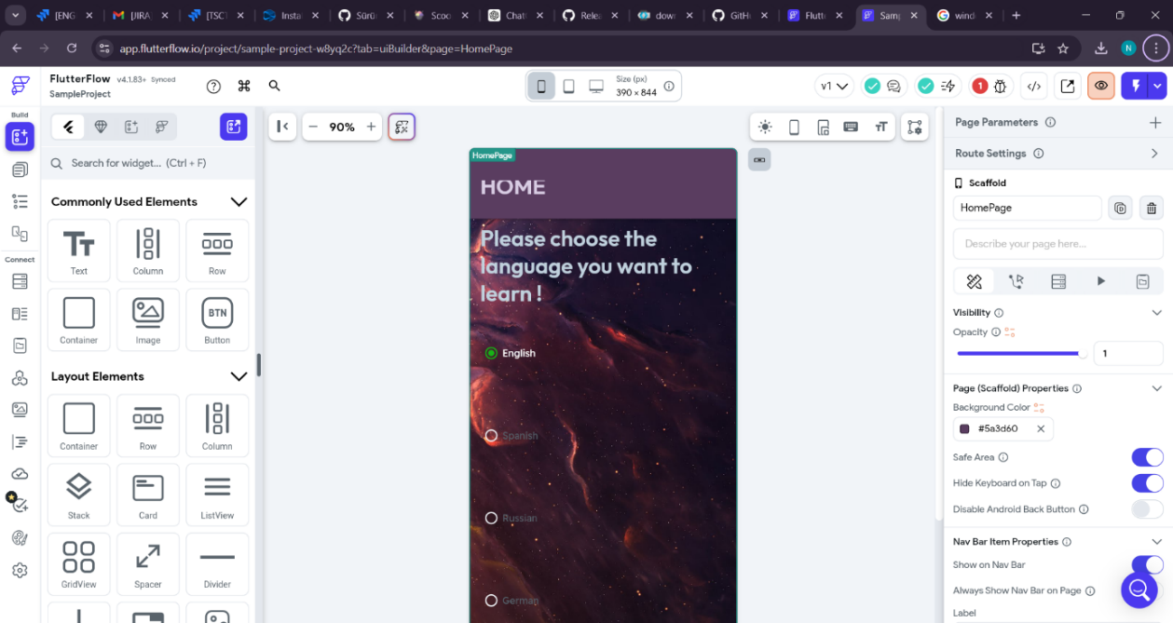

Figure 1

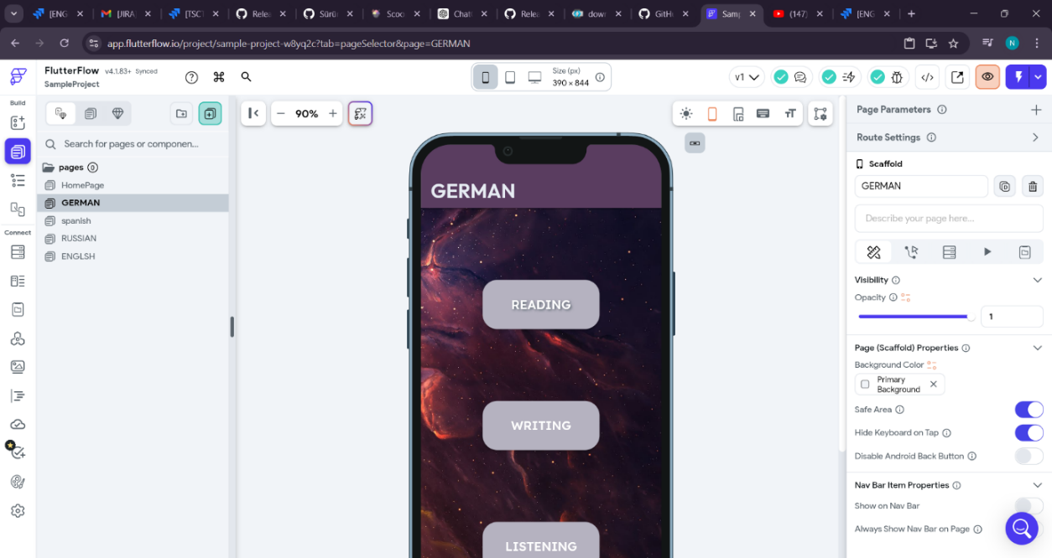

Figure 2

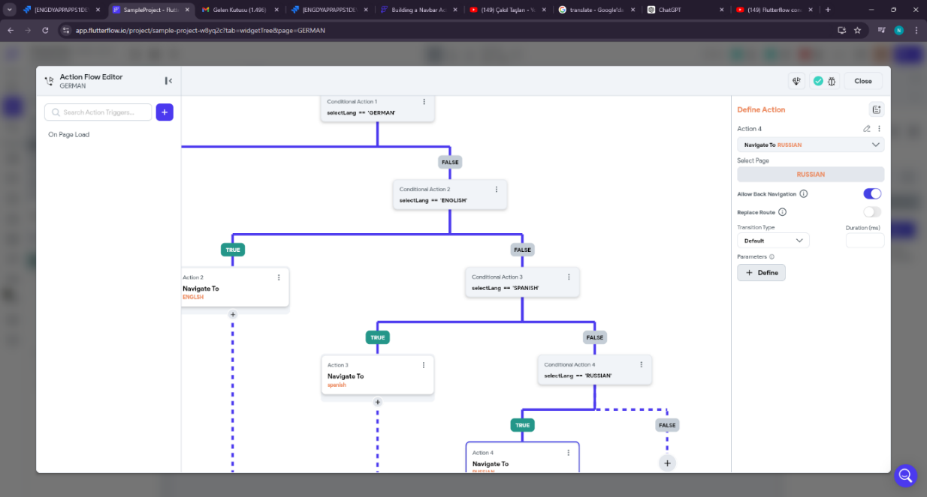Figure 3

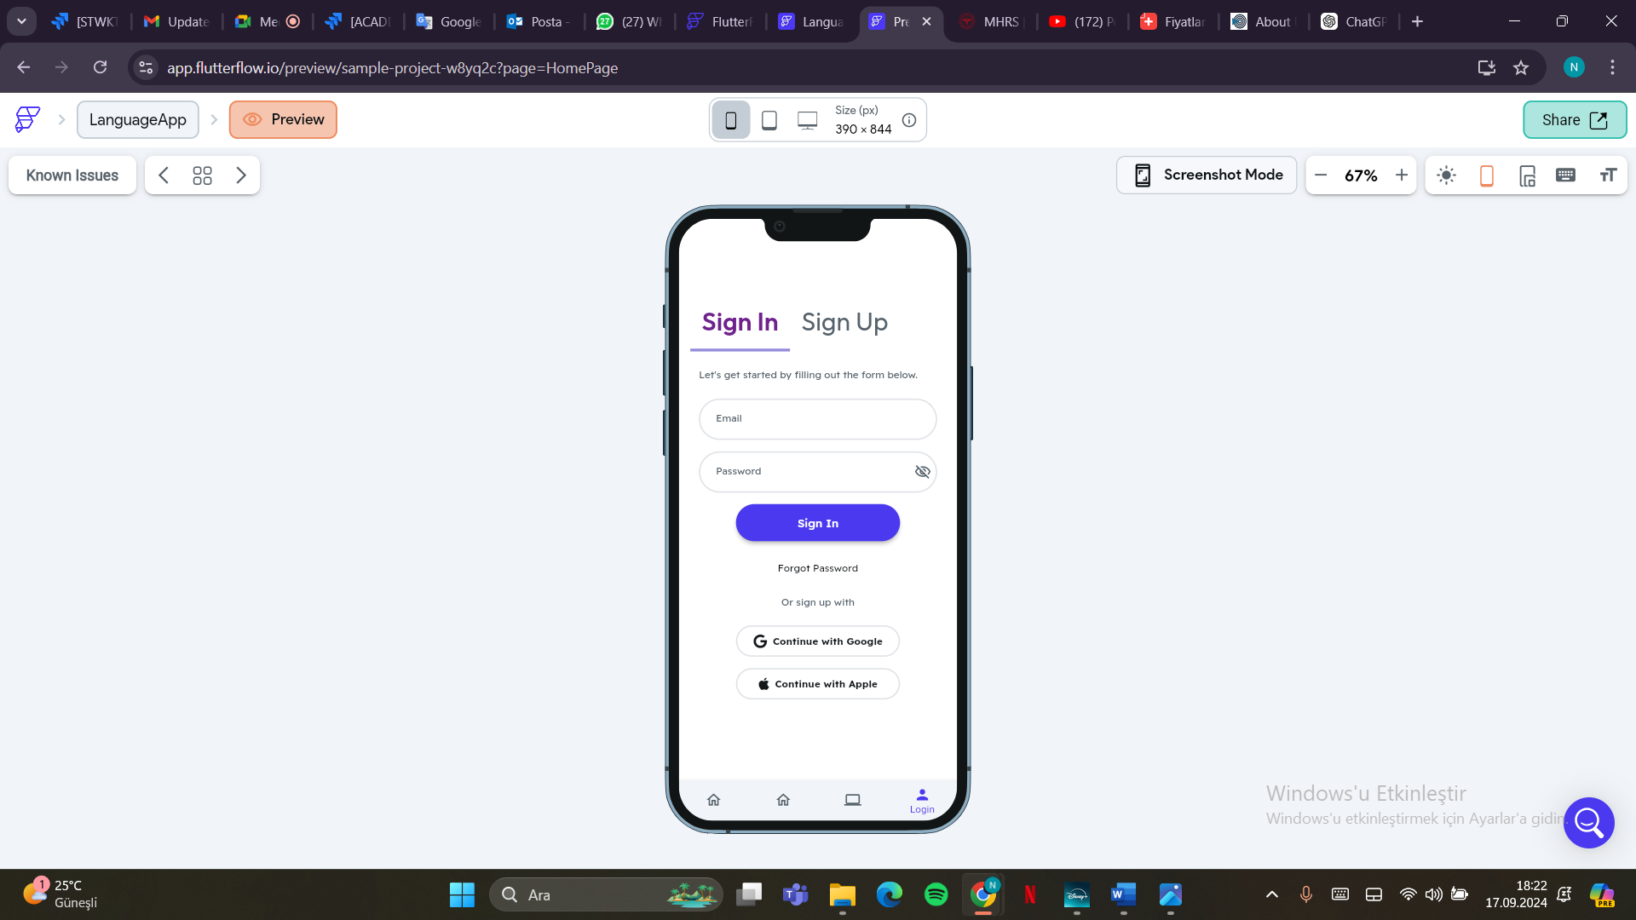

Figure 4

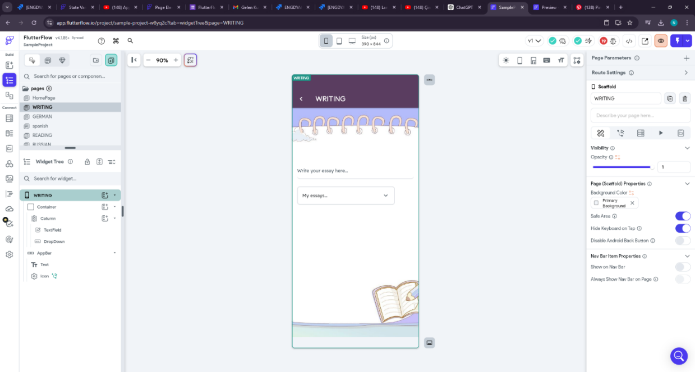

Figure 5

3.2 – Studies About Backend

Since I will use PostgreSQL for the backend, I first installed PostgreSQL and pgAdmin4 (Figure 6). Then, I listened to the lessons in the meeting records given in my jira account and started reading the documentation, then I decided to continue on a YouTube channel (Figure 7), I tried all the coding in this YouTube channel by applying it on pgadmin4 (Figure 8) and in this way I learned better. I can say that studying PostgreSQL took me a week or even more, but in the end I learned it really well. Then, I started my Flask and GraphQL studies assigned to me in Jira, for this I first read the Flask documentation (Figure 9) and again, feeling that it would not be enough, I found a nice YouTube channel, I still follow it. (Figure 10) At the same time, I am working on VS Code (Figure 11) and since I forgot the Python language, I am trying to remember this language.

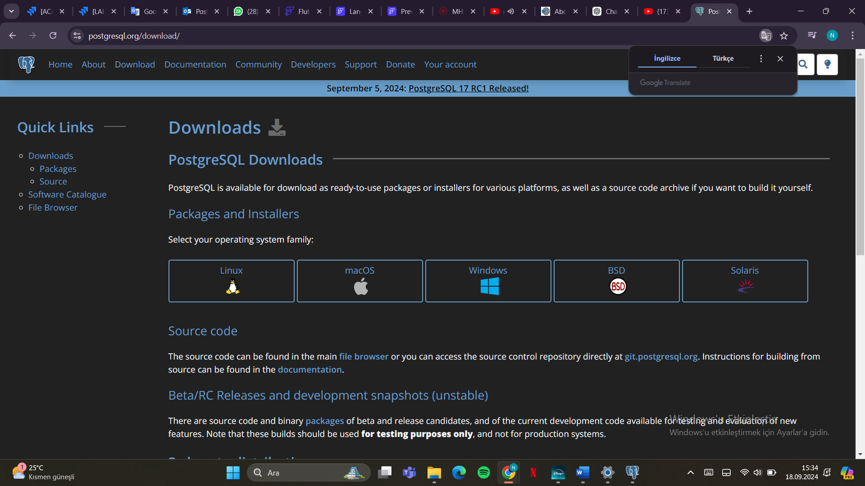

Figure 6

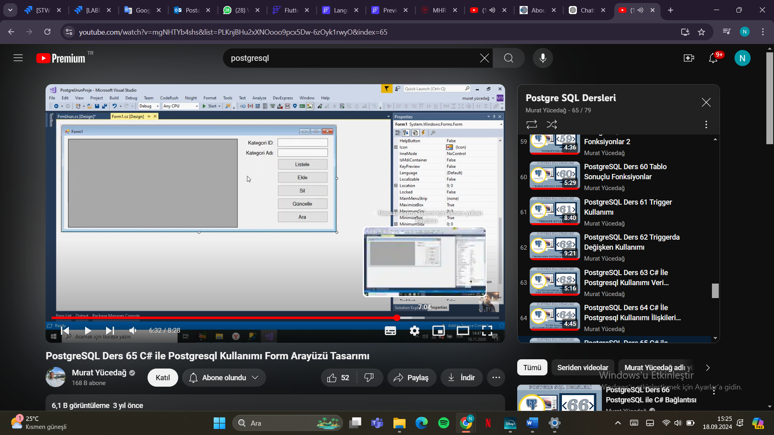

Figure 7

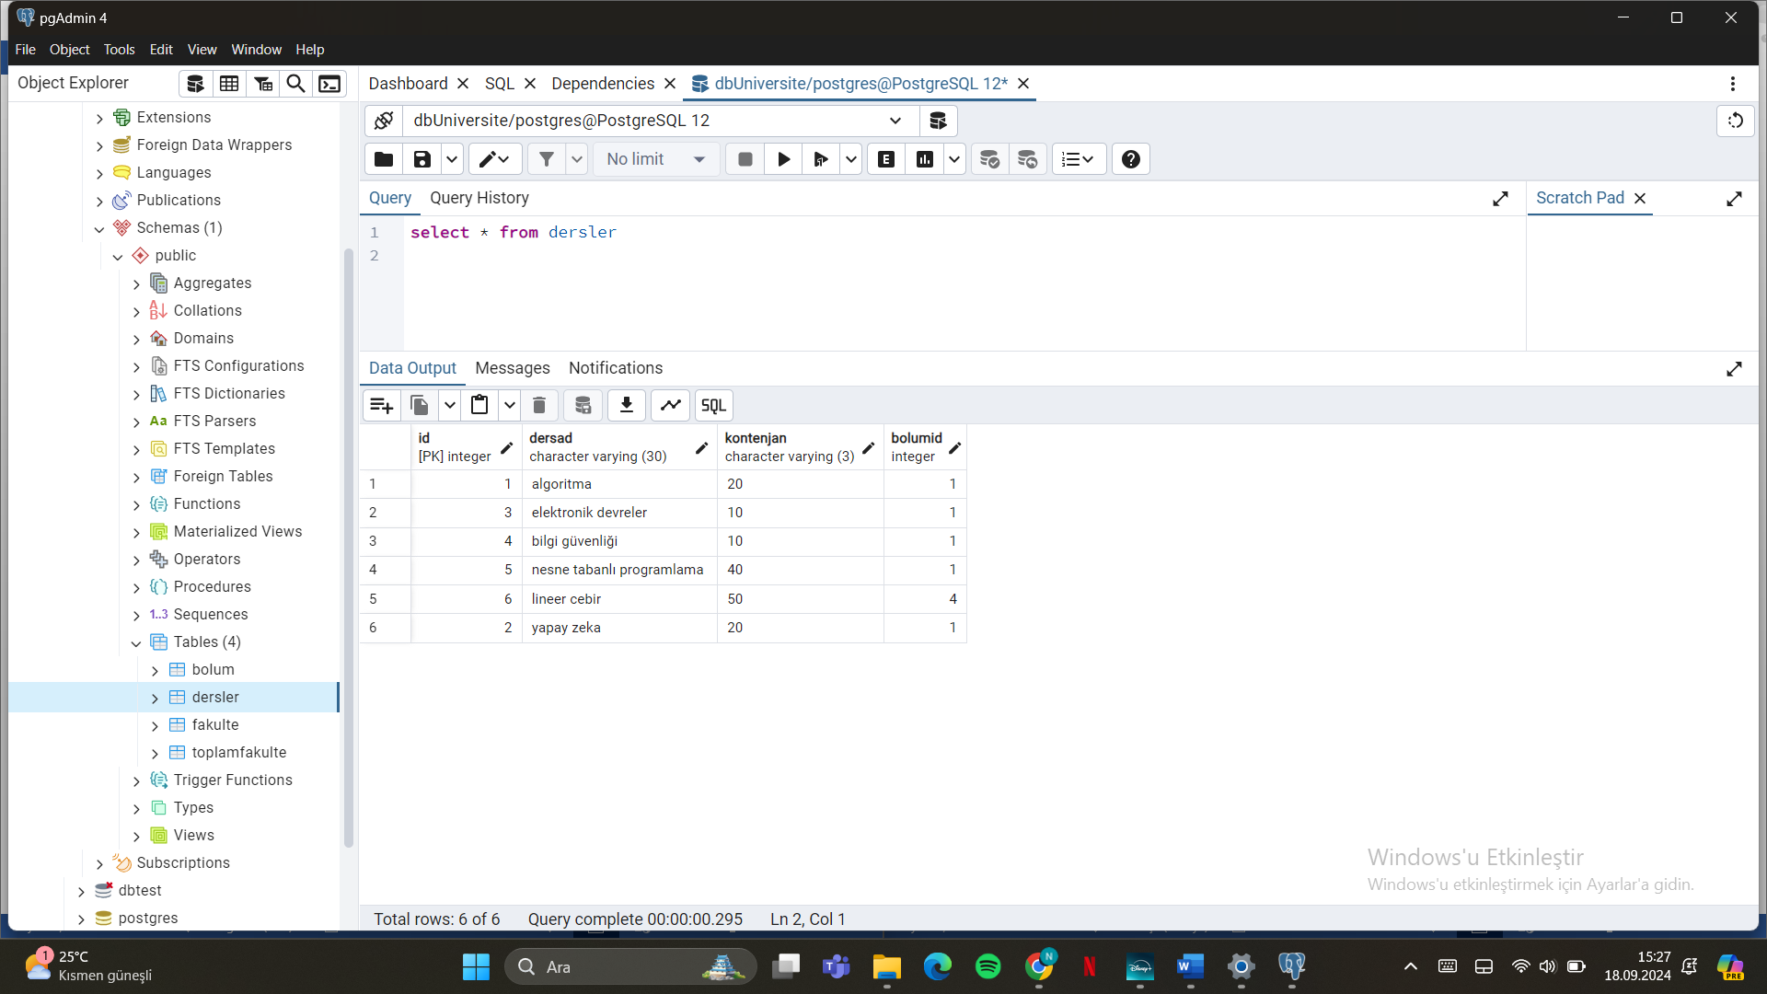

Figure 8

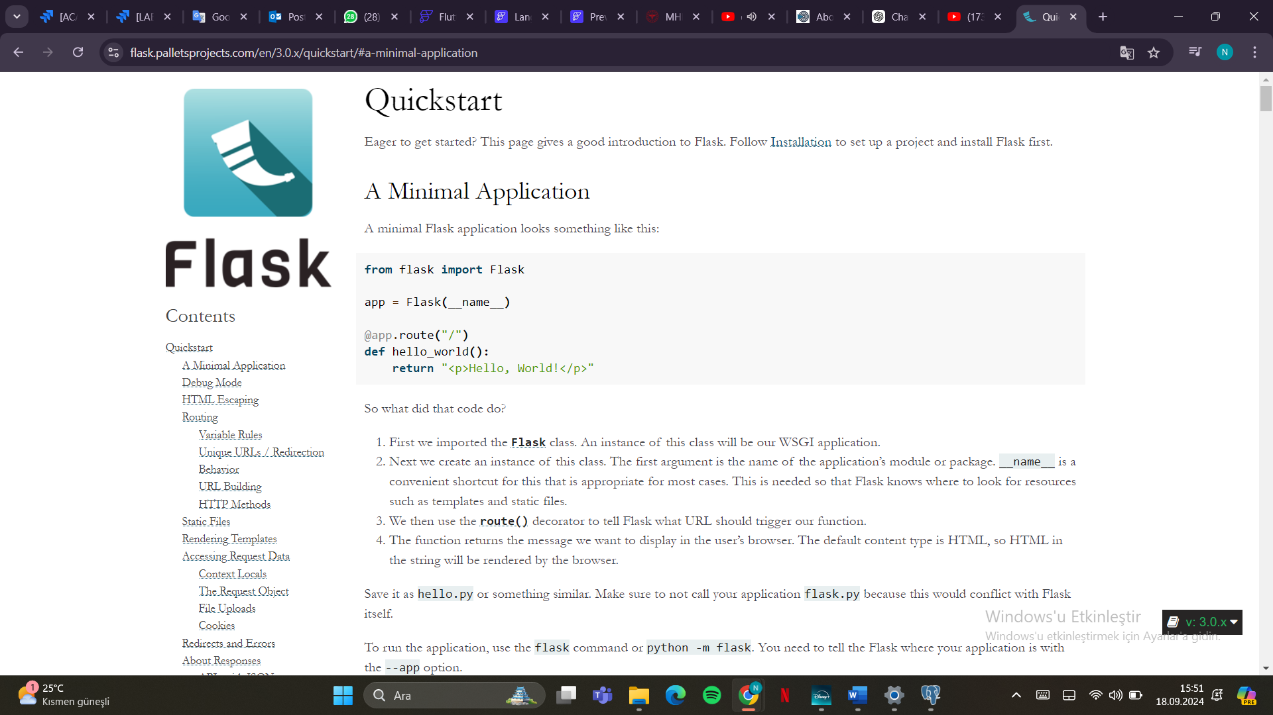

Figure 9

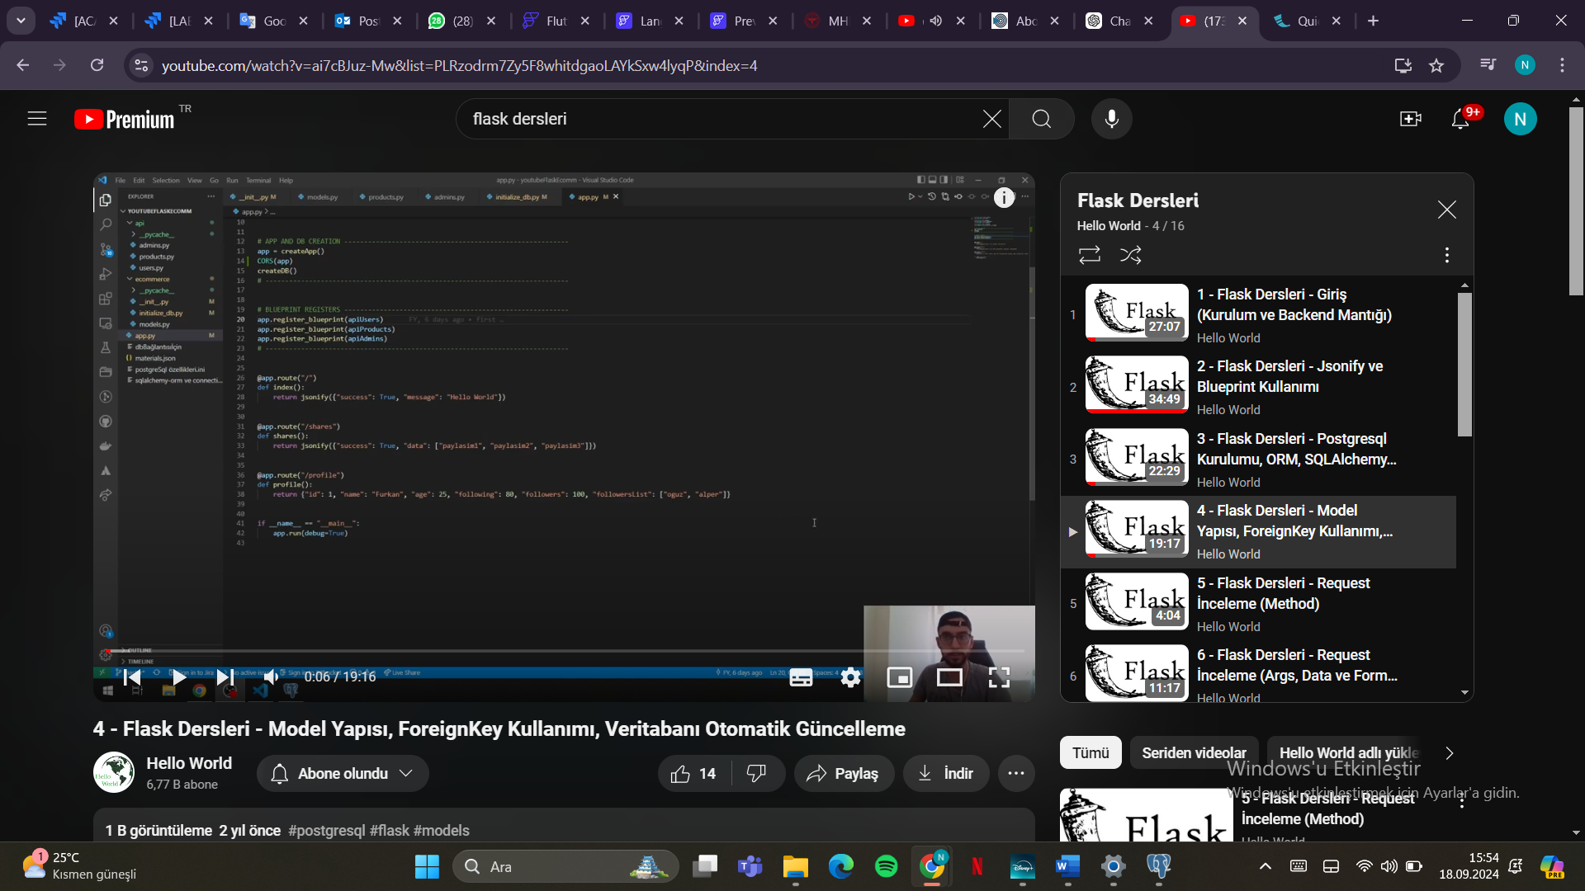

Figure 10

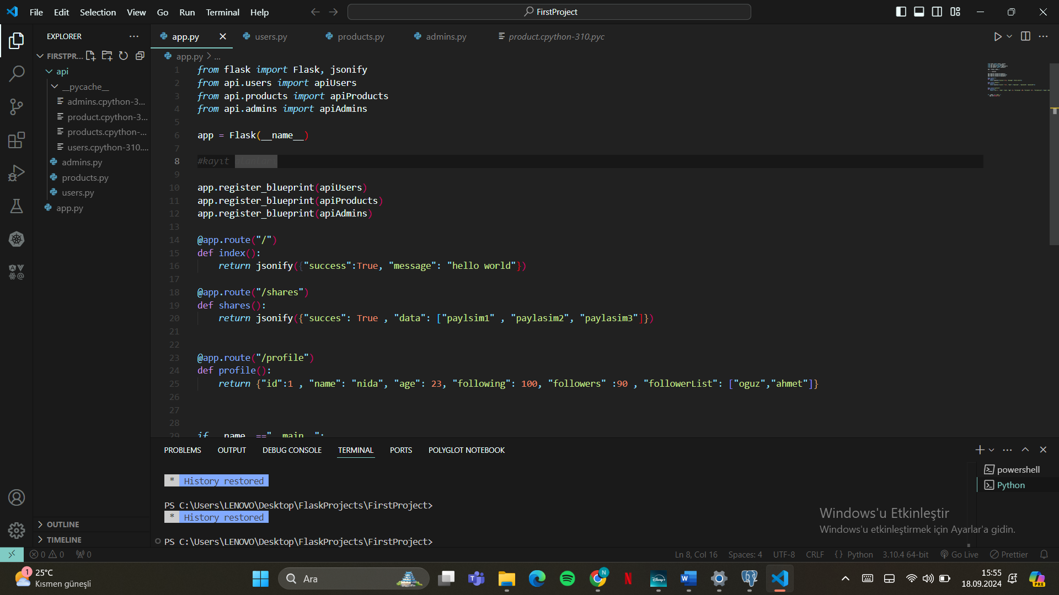

Figure 11

3.3-My Own Idea

While continuing these studies, I receive a lot of help from my internship managers, especially in the tasks assigned to me, I can find almost all the necessary documents. When I started my internship, I did not know anything about Flutterflow, postgreSQL, flask and graphQL. However, I started working intensively in a short time and learned many things including installation and software (front and back). I had the opportunity to observe that the engineers working here were a team and in communication with each other in every study.

4.Conclusion

Thanks to the studies I did during the first month of my internship, I learned a lot of new information. I had the opportunity to improve myself with this information I learned. I believe that I will make much better developments especially on the backend side. All these things I learned and will learn were very useful for my career.

**References**

Include any references that you used in the text such as:

1 - Konya Food and Agriculture University, “KONYA FOOD AND AGRICULTURE ÜNİVERSİTESİ ÖN LİSANS VE LİSANS EĞİTİM VE ÖĞRETİM YÖNETMELİĞİ,” 2018.

2- www.proceedit.com

**/**

**Questionnaire**

**Operating Systems Used**

Windows  Linux  Mac OS  Other:

**Programming Languages Used**

Python  C  C++  Java  C#  Matlab  R  JavaScript  Ruby  PHP  SQL  Swift  Kotlin   Other:

**Work focus**

Web application development  Game development

Desktop application development  Data science

Mobile application development  Software testing

Embedded development  Security and Network

Database oriented development  Other:

**Courses that are useful to your apprenticeship**

Introduction to Programming (with Python)  Programming Languages

C Programming  Software Engineering

Data Structures (with C++)  Computer Organization

Object Oriented Programming (with Java)  Design and Analysis of Algorithms

Database Management Systems  Other 1:

Computer Networks  Other 2:

**Target Industry**

Government  Defense  Medical  Entertainment  Telecom

E-commerce  Education  Finance  Agriculture  Other:

**Team Profile**

* Number of engineers:
* Number of scientists (i.e. Mathematician):
* Number of other workers:
* High school graduate count:
* University graduate count:
* MS graduate count:
* PhD graduate count:

Read the ‘The Joel Test: 12 Steps to Better Code’ and answer below questions:

* Do you use source control?
* Can you make a build in one step?
* Do you make daily builds?
* Do you have a bug database?
* Do you fix bugs before writing new code?
* Do you have an up-to-date schedule?
* Do you have a spec?
* Do programmers have quiet working conditions?
* Do you use the best tools money can buy?
* Do you have testers?
* Do new candidates write code during their interview?
* Do you do hallway usability testing?