Optimising Airbnb Pricing Strategies in New York City:
A REGRESSION AND CLUSTERING ANALYSIS OF LISTING CHARACTERISTICS AND MARKETSEGMENTATION


Sarka Pekarova
Ioanna Tziouvaka
Frederick Ogulensi
Kapinga Dimbu
Ruwan Perera

Contents

Executive Summary 2
Business Question 2
Dataset and Methodology 2
Regression Analysis 5
Clustering Analysis 5
Business Insights 5
Strategic Insight 6
Analytical Reflection 6
Conclusion 6
References 6

Optimising Airbnb Pricing Strategies in New York City
A Regression and Clustering Analysis of Listing Characteristics and Market Segmentation
Track 1: Classical Machine Learning (Regression and Clustering)

Executive Summary
This report analyses Airbnb listing data for New York City to understand the factors influencing pricing and to identify actionable market segments within the platform. Using the AB_NYC_2019 dataset containing 48,884 cleaned listings, the study combines exploratory data analysis, regression modelling and clustering techniques. Results show that pricing is primarily driven by location and room type, with Manhattan and entire-home listings forming the premium tier. A multivariate linear regression model explains approximately 53 percent of price variation on the log scale, confirming that pricing follows identifiable patterns while still reflecting local complexity. K-Means clustering identifies four practical listing segments including low activity listings, standard listings, investment listings and high demand value listings. These findings demonstrate that Airbnb pricing should be segment-aware and location-sensitive.

Business Question
How can Airbnb optimise pricing strategies across New York City based on location, property characteristics and availability patterns, and what actionable listing segments can be identified using clustering techniques?

Dataset and Methodology
The analysis used the AB_NYC_2019 dataset sourced from Kaggle containing New York City Airbnb listings. After removing zero-price errors and cleaning missing fields, the working dataset contained 48,884 listings. Missing values in reviews_per_month were filled with zero where listings had not yet received reviews. The last_review field was converted to a numerical variable representing days_since_review, and minimum_nights values were capped at 365 to avoid unrealistic outliers.
Exploratory data analysis revealed a heavily right-skewed price distribution, with a median price of $106 and mean of $153. Because regression models perform better with more normally distributed data, the price variable was log transformed before modelling. The modelling feature set included borough, neighbourhood, latitude, longitude, room type, minimum nights, number of reviews, review frequency, host portfolio size and availability indicators.
Two classical machine learning approaches were applied. K mean to model price prediction because it provides transparent and interpretable results. K-Means clustering was used to identify natural groups of listings within the marketplace. DBSCAN was also tested to evaluate density-based structure and identify potential outliers.
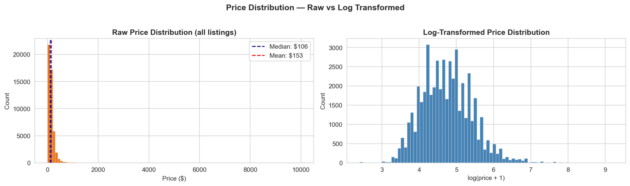
Figure 1. NYC Airbnb prices show strong right skew, supporting log transformation before modelling.
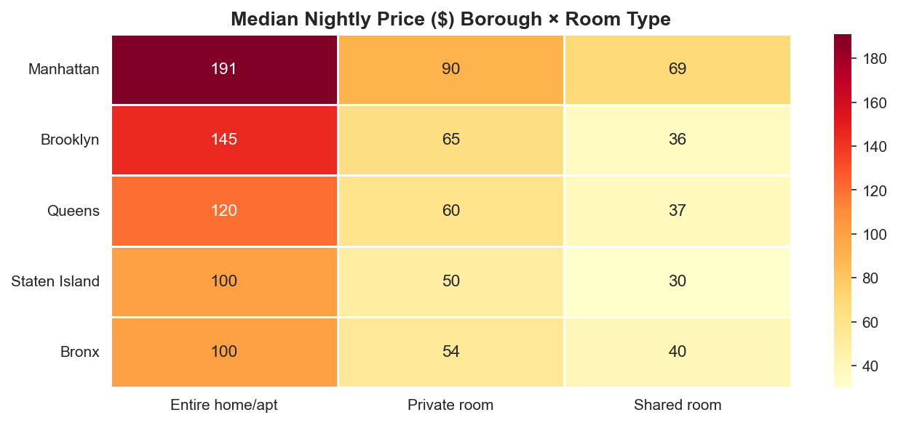
Figure 2. Median nightly prices vary by borough and room type, with Manhattan entire homes forming the premium tier.
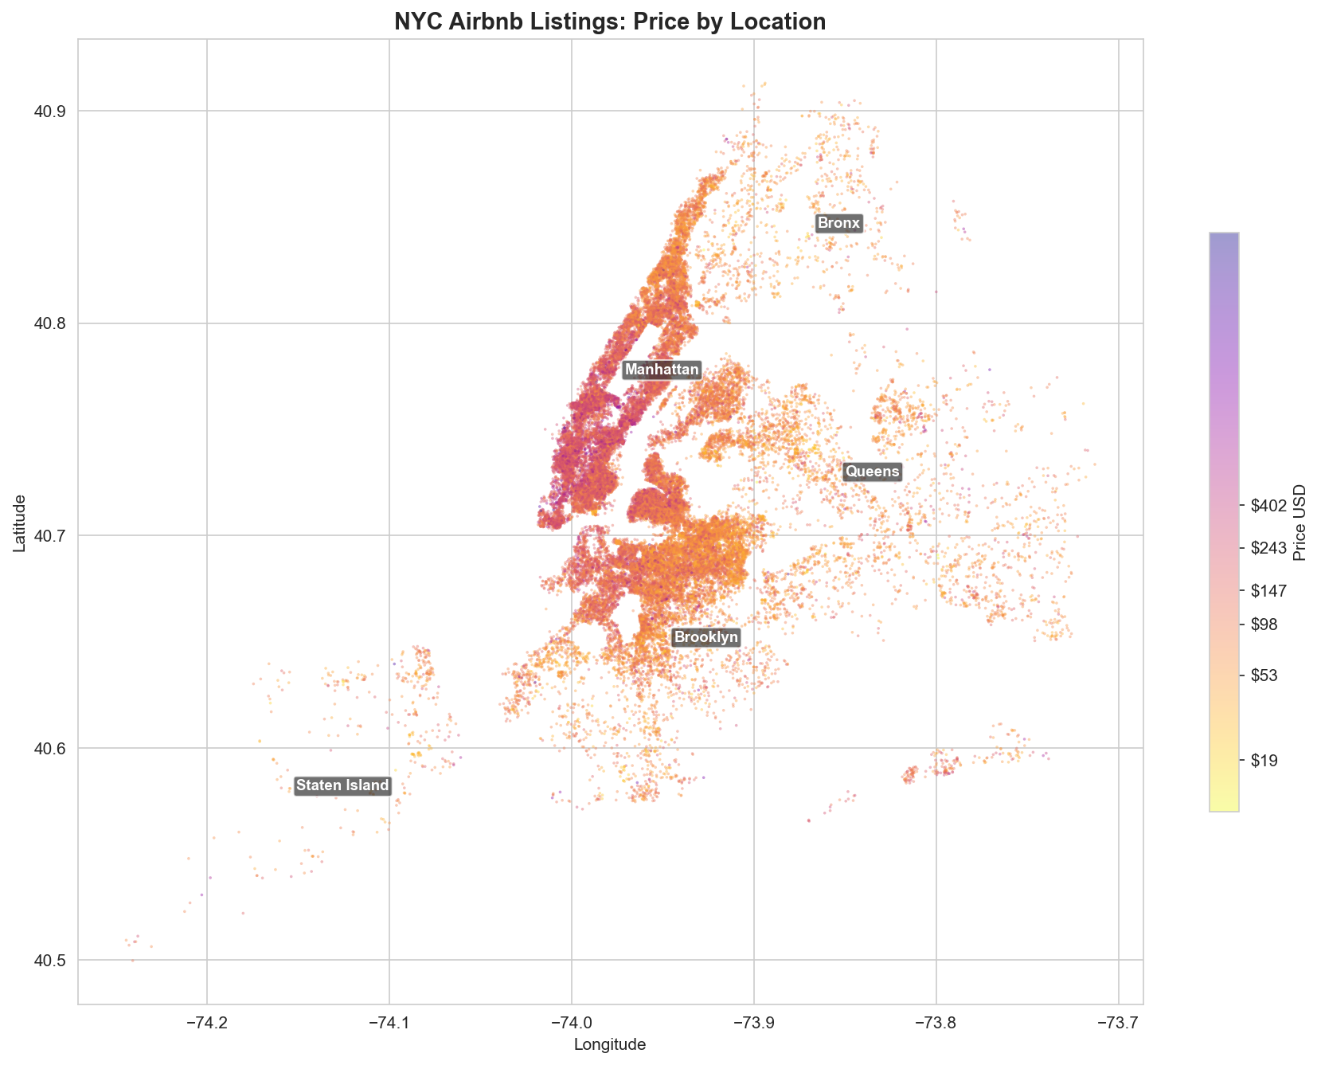
Figure 3. Geographic price hotspots concentrate in Manhattan and selected areas of Brooklyn.
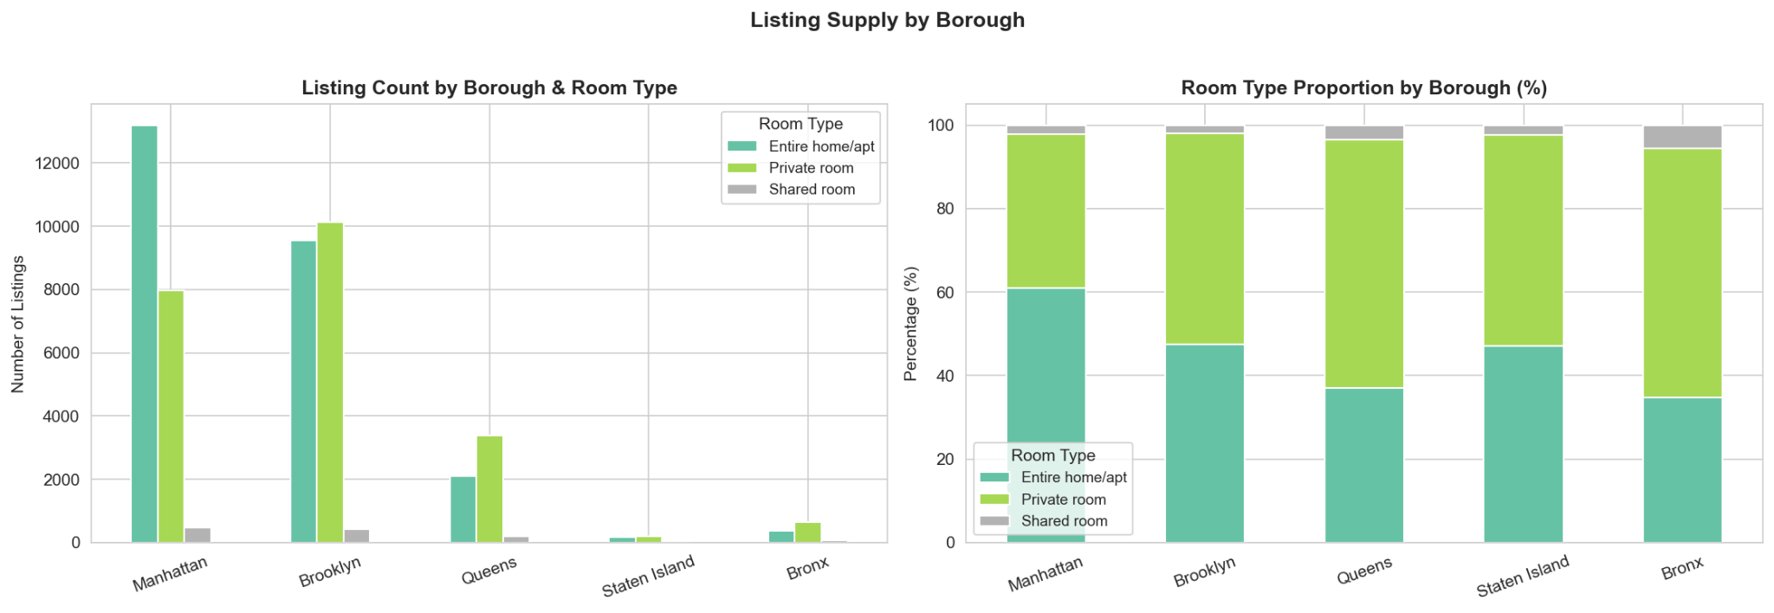
Figure 4. Supply distribution by borough and room type highlights structural market differences.

Regression Analysis
The multivariate linear regression model achieved an R² of approximately 0.53 with RMSE of around 0.475 on the log scale. This indicates moderate predictive performance and confirms that Airbnb pricing follows structured patterns while still being influenced by local variation. Borough and room type were the strongest predictors of price, with Manhattan consistently commanding the highest prices. Spatial coordinates captured micro-location effects, reinforcing the importance of neighbourhood context.
Review activity showed a slight negative relationship with price, suggesting that lower priced listings may compete on occupancy and booking volume. Hosts managing multiple listings tended to charge higher prices, which is consistent with more commercial pricing behaviour.

Clustering Analysis
K-Means clustering identified four practical market segments. Low Activity Listings show weak demand signals and high availability, indicating underperformance. Standard Listings represent the core of the market with moderate prices and balanced activity. Investment Listings are the most commercial segment with high prices and large host portfolios. High Demand Value Listings combine competitive prices with strong review activity, indicating high occupancy.
DBSCAN produced a low silhouette score of around 0.20, suggesting that the Airbnb market behaves more like a continuous economic spectrum than sharply separated natural clusters. K-Means therefore provided the most useful segmentation approach for management insights.

Business Insights
Airbnb should adopt a segment-aware pricing strategy rather than a single city-wide rule. Pricing guidance should prioritise borough, room type and micro-location because these variables carry the strongest pricing signal. High demand listings should focus on occupancy optimisation, while investment listings require yield and stay-length optimisation. Low activity listings should receive prompts encouraging improved listing quality and promotional pricing.

Strategic Insight
The analysis demonstrates that Airbnb pricing is primarily driven by structural market factors rather than simple numerical indicators. Location and accommodation type explain much of the price variation, while behavioural indicators such as review frequency reflect demand and listing popularity.

Analytical Reflection
While the regression model explains a substantial proportion of price variation, residual variance suggests that additional contextual factors influence pricing. Property quality, amenities, host reputation and neighbourhood micro-features such as proximity to attractions or transport infrastructure likely contribute to pricing differences. Future models could incorporate richer spatial variables or non-linear approaches such as gradient boosting to capture complex interactions between features.

Conclusion
Classical machine learning techniques provide both interpretable price prediction and practical market segmentation for Airbnb NYC. Location and room type are the dominant pricing drivers, while clustering reveals distinct business models across the marketplace. Pricing strategies should therefore be location-sensitive and segment-aware.

References
Cox, T. (2019) New York City Airbnb Open Data. Kaggle.
Hastie, T., Tibshirani, R. and Friedman, J. (2009) The Elements of Statistical Learning. Springer.
James, G., Witten, D., Hastie, T. and Tibshirani, R. (2021) An Introduction to Statistical Learning. Springer.

