Python & MongoDB

Assignment 4

COHDCBIS182F-005.

R J Abeysinghe.

**Setting up the path for mongod.exe**

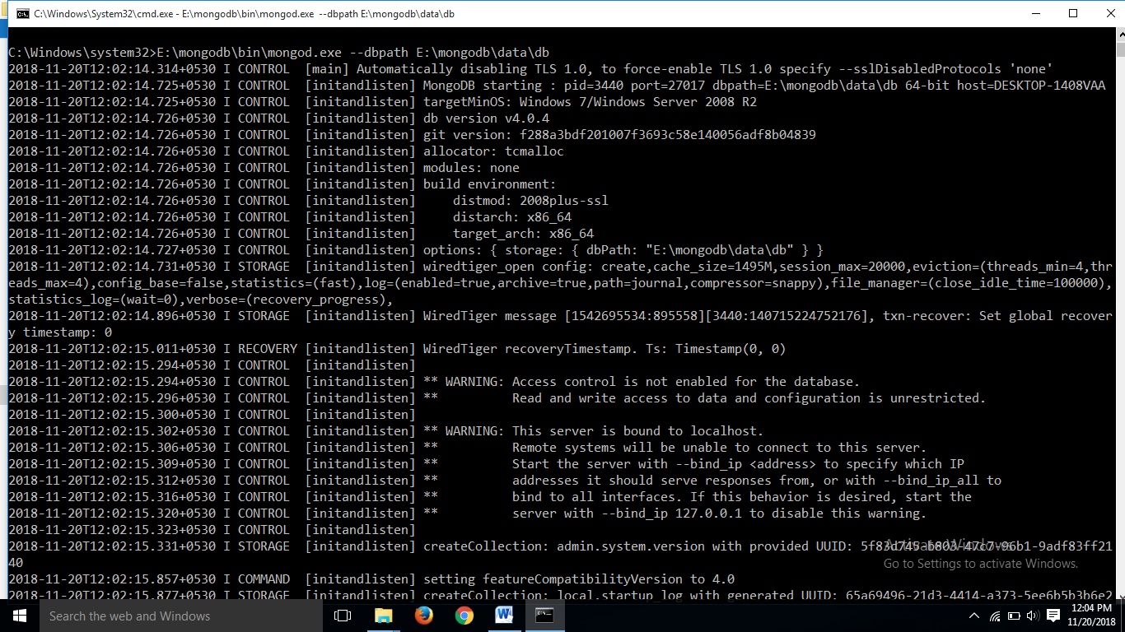

**Installing pymongo**

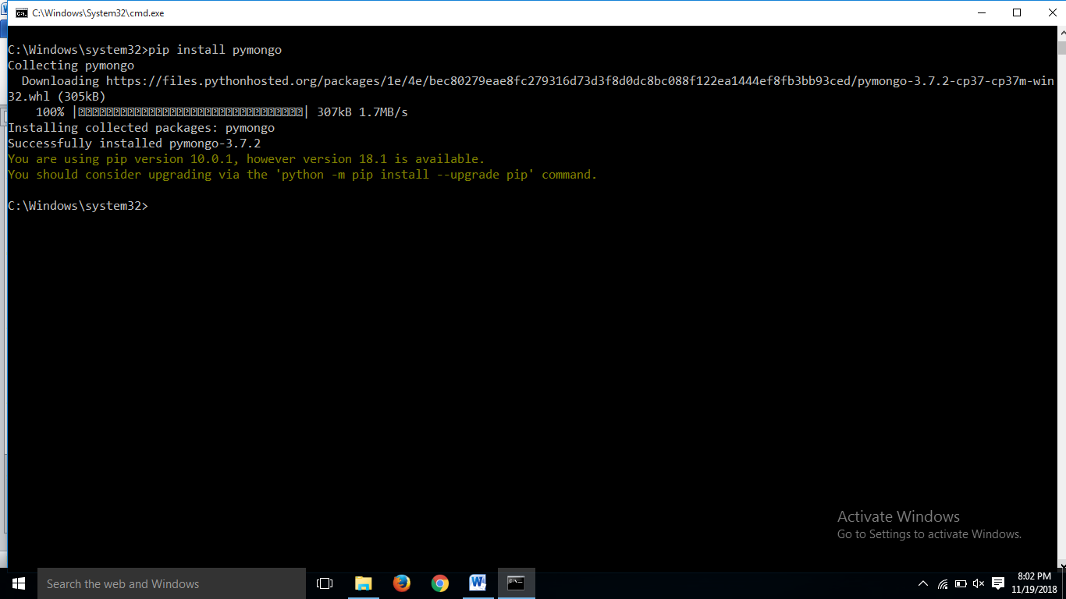

**Running the mongo.exe file**

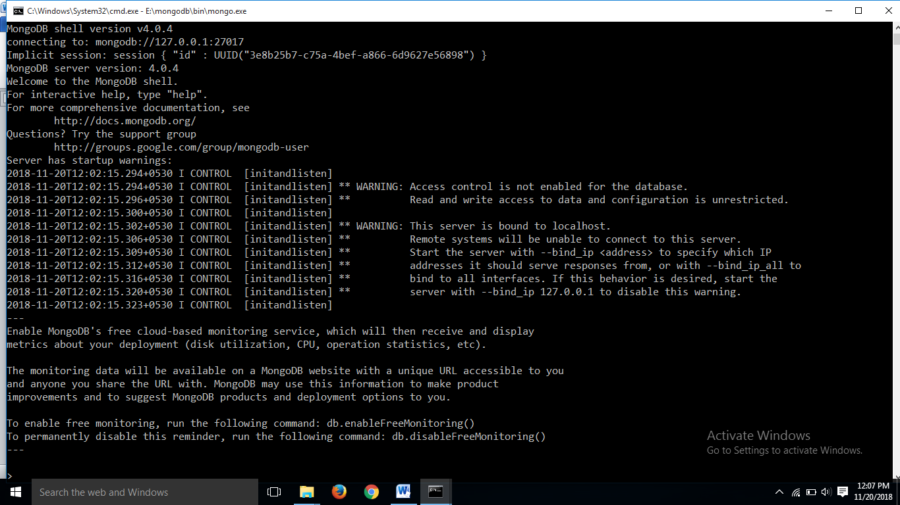

**Creating the Database, collection, inserting data**

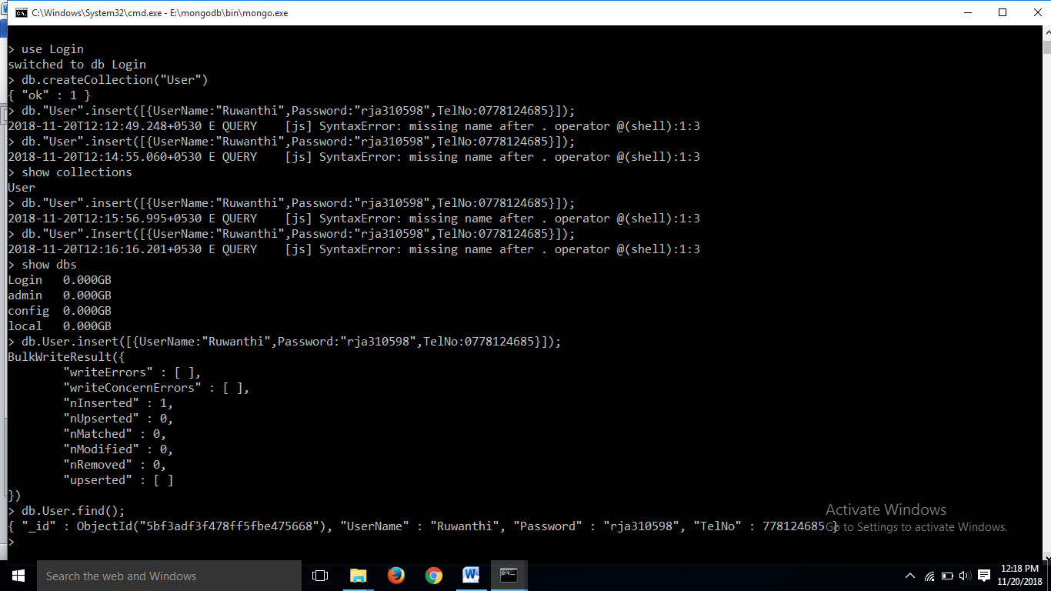

**Login form code (loginform.py)**

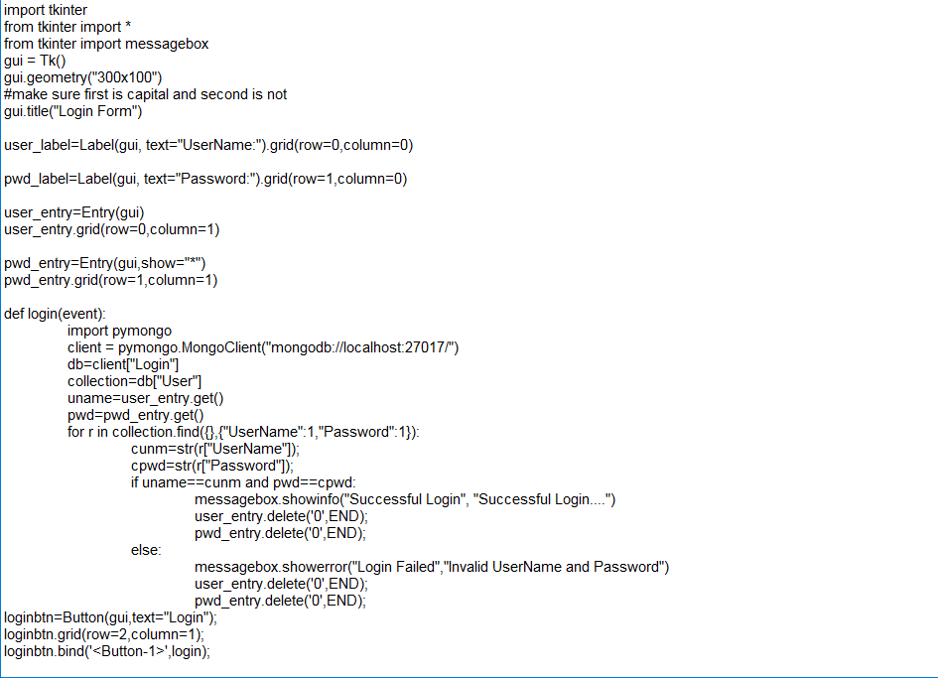

**The output**

