Scanner

The scanning is made using the StringTokenizer class, and therefore the lines from files are tokenized by also keeping the delimiters.

For the special operators, a check is made for each token, verifying the next token and adding them as one token if they are indeed compound tokens(e.g. <= >=).

Below are the results of the PIF and SymbolTable after scanning the following programs:

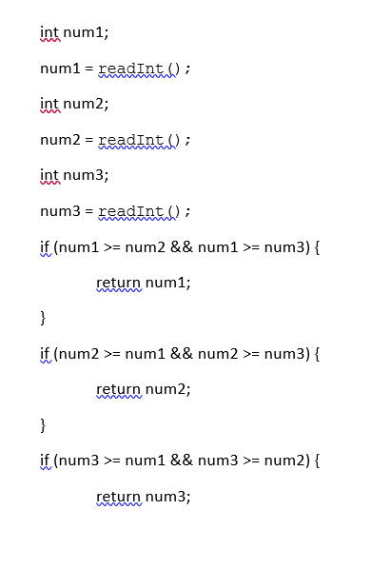

SymbolTable

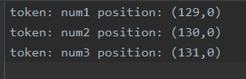

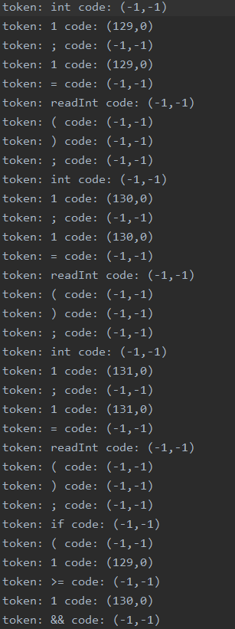 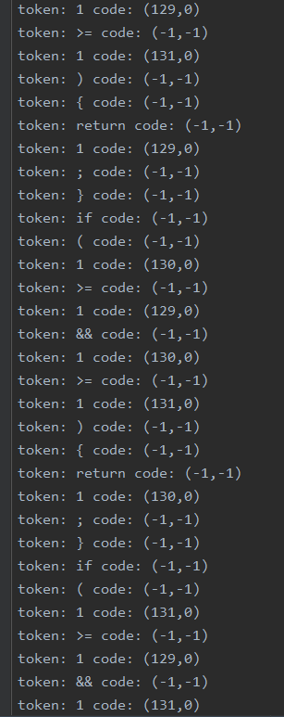

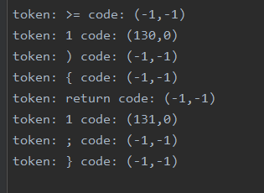

**Class Diagram**

