Laboratory 4 – FLCD

Finite automata

#### Class that contains 5 fields:

* States: list of states
* Final states: list of the final states
* Transitions: list of transitions
* Alphabet: list of the alphabet
* Initial state: initial state

Class diagram

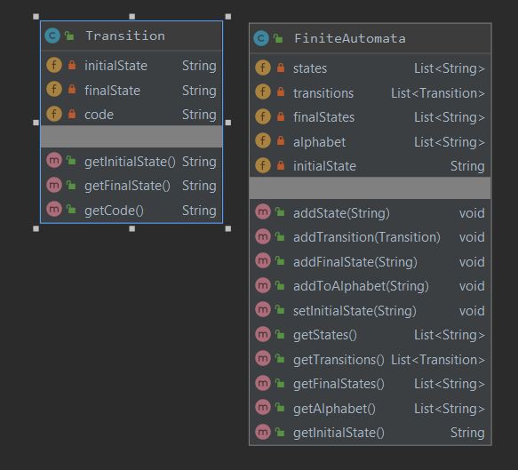

Examples:

1. fa.in

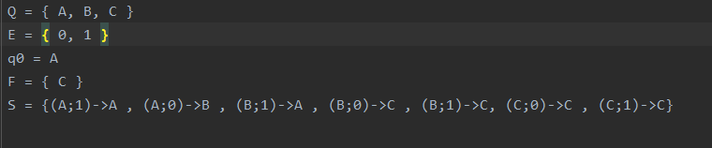

* States: A, B, C
* Alphabet: 0, 1
* Initial state: A
* Final state: C

Transitions: (A;1)->A , (A;0)->B , (B;1)->A , (B;0)->C , (B;1)->C, (C;0)->C , (C;1)->C

* DFA check:



1. fa.in

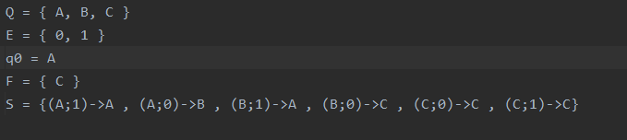

* States: A, B, C
* Alphabet: 0, 1
* Initial state: A
* Final state: C
* Transitions: 
* DFA check:

