Laboratory 5 – FLCD

Pop Ruxandra Paula : <https://github.com/ruxipaula/flcd>

Popa Mihai Adrian: <https://github.com/adrian-popa/flcd>

Grammar class

#### Class that contains 4 fields:

* nonTerminals : list of non-terminals
* terminals: list of the terminals
* startingSymbol: starting symbol
* productions: map (string -> list of list of strings)

LRItem class

#### Class that contains 3 fields:

* nonTerminal : string
* production: list of strings
* dotIndex: int – index that shows the position of the dot in the production

Parser class

#### Functions:

* **closure**: takes a list of LRItems as input and returns the closure of that list
* **goTo**: calls the closure function with the LRItems that match the corresponding state and symbol
* **canonicalCollection**: returns the canonical collection of the given grammar

productions

* We used a hashmap to represent the productions, keeping the non-terminals as the keys and the corresponding production as a list of lists that contain every symbol of the production.

Class diagram

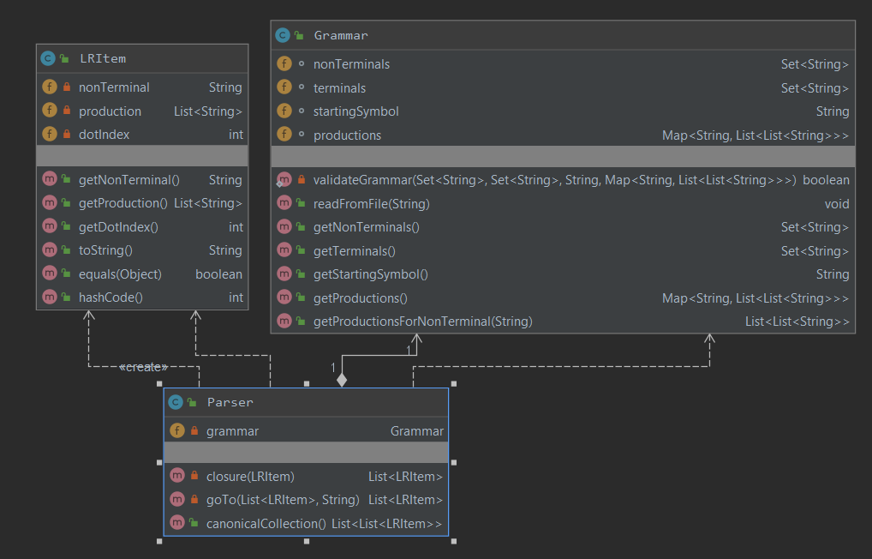

Examples:

1.

* grammar.txt:

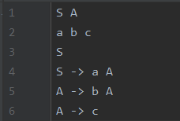

* Canonical Collection:

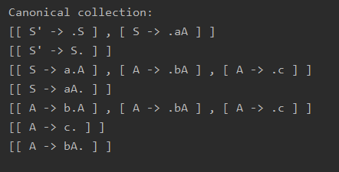

2.

* grammar.txt:

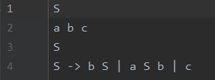

* Canonical Collection:

