**Appendices A. Results for subject 2**

The results of subjects 2 were consistent with those of subjects 1. Fig. A1, A2, and A3 correspond to the sections **3.1**, **3.1** and **3.2** in the main text.

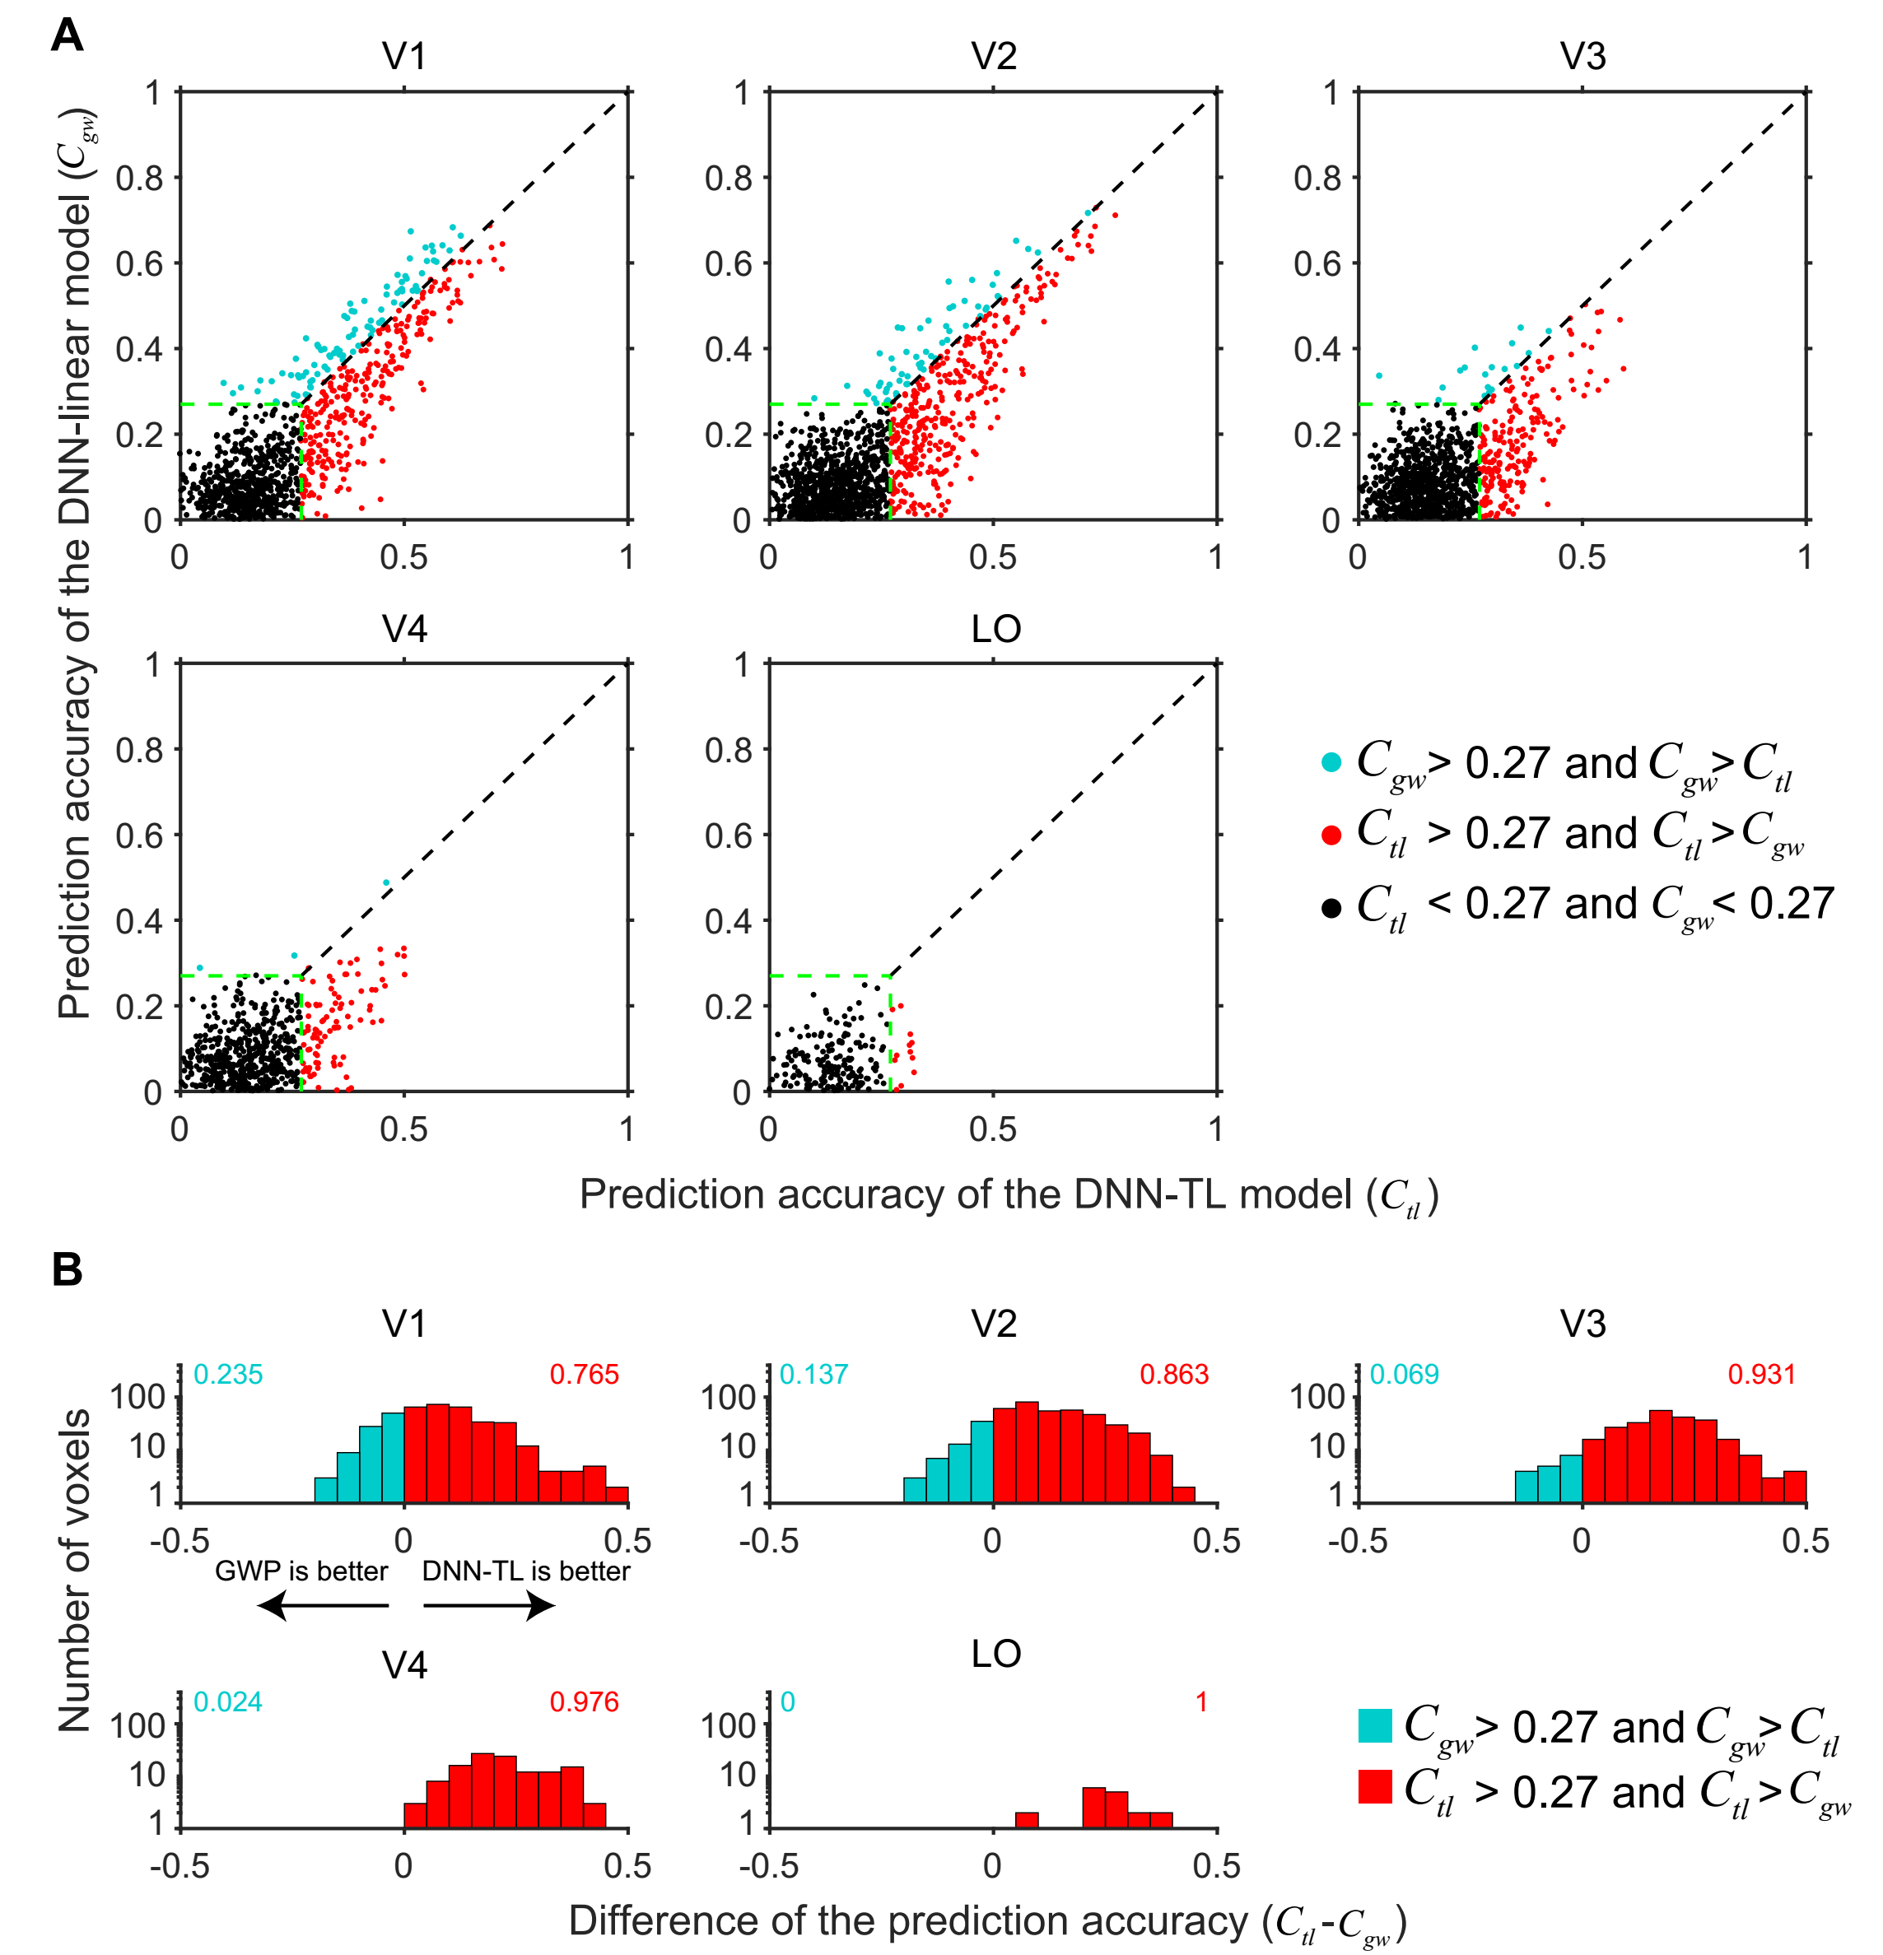

Figure A.1. Comparison of prediction accuracy between the DNN-TL () and GWP () models for subject 2. Refer to Figure 3 for a detailed description of the plot elements.

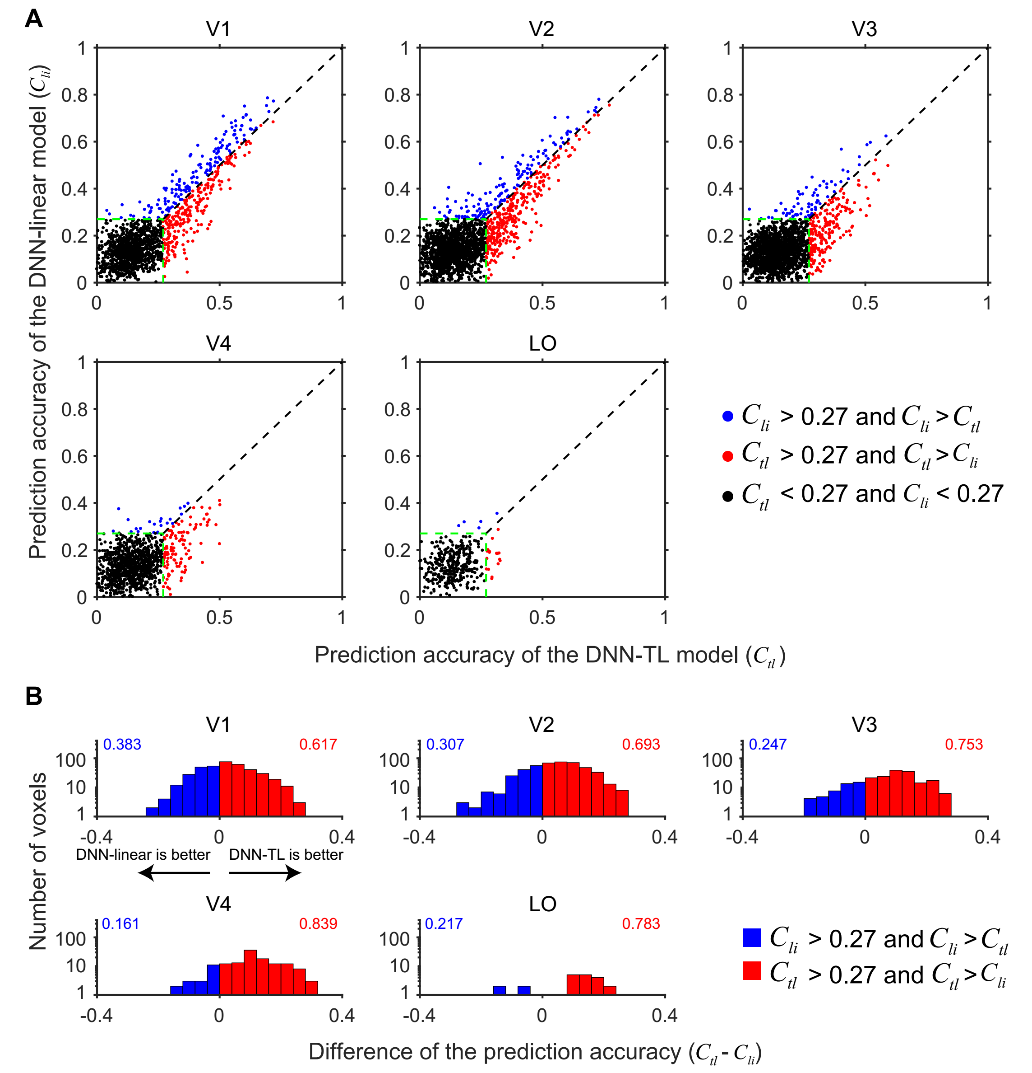

Figure A.2. Comparison of prediction accuracy between the DNN-TL () and the DNN-linear () models for subject 2. Refer to Figure 3 for a detailed description of the plot elements.

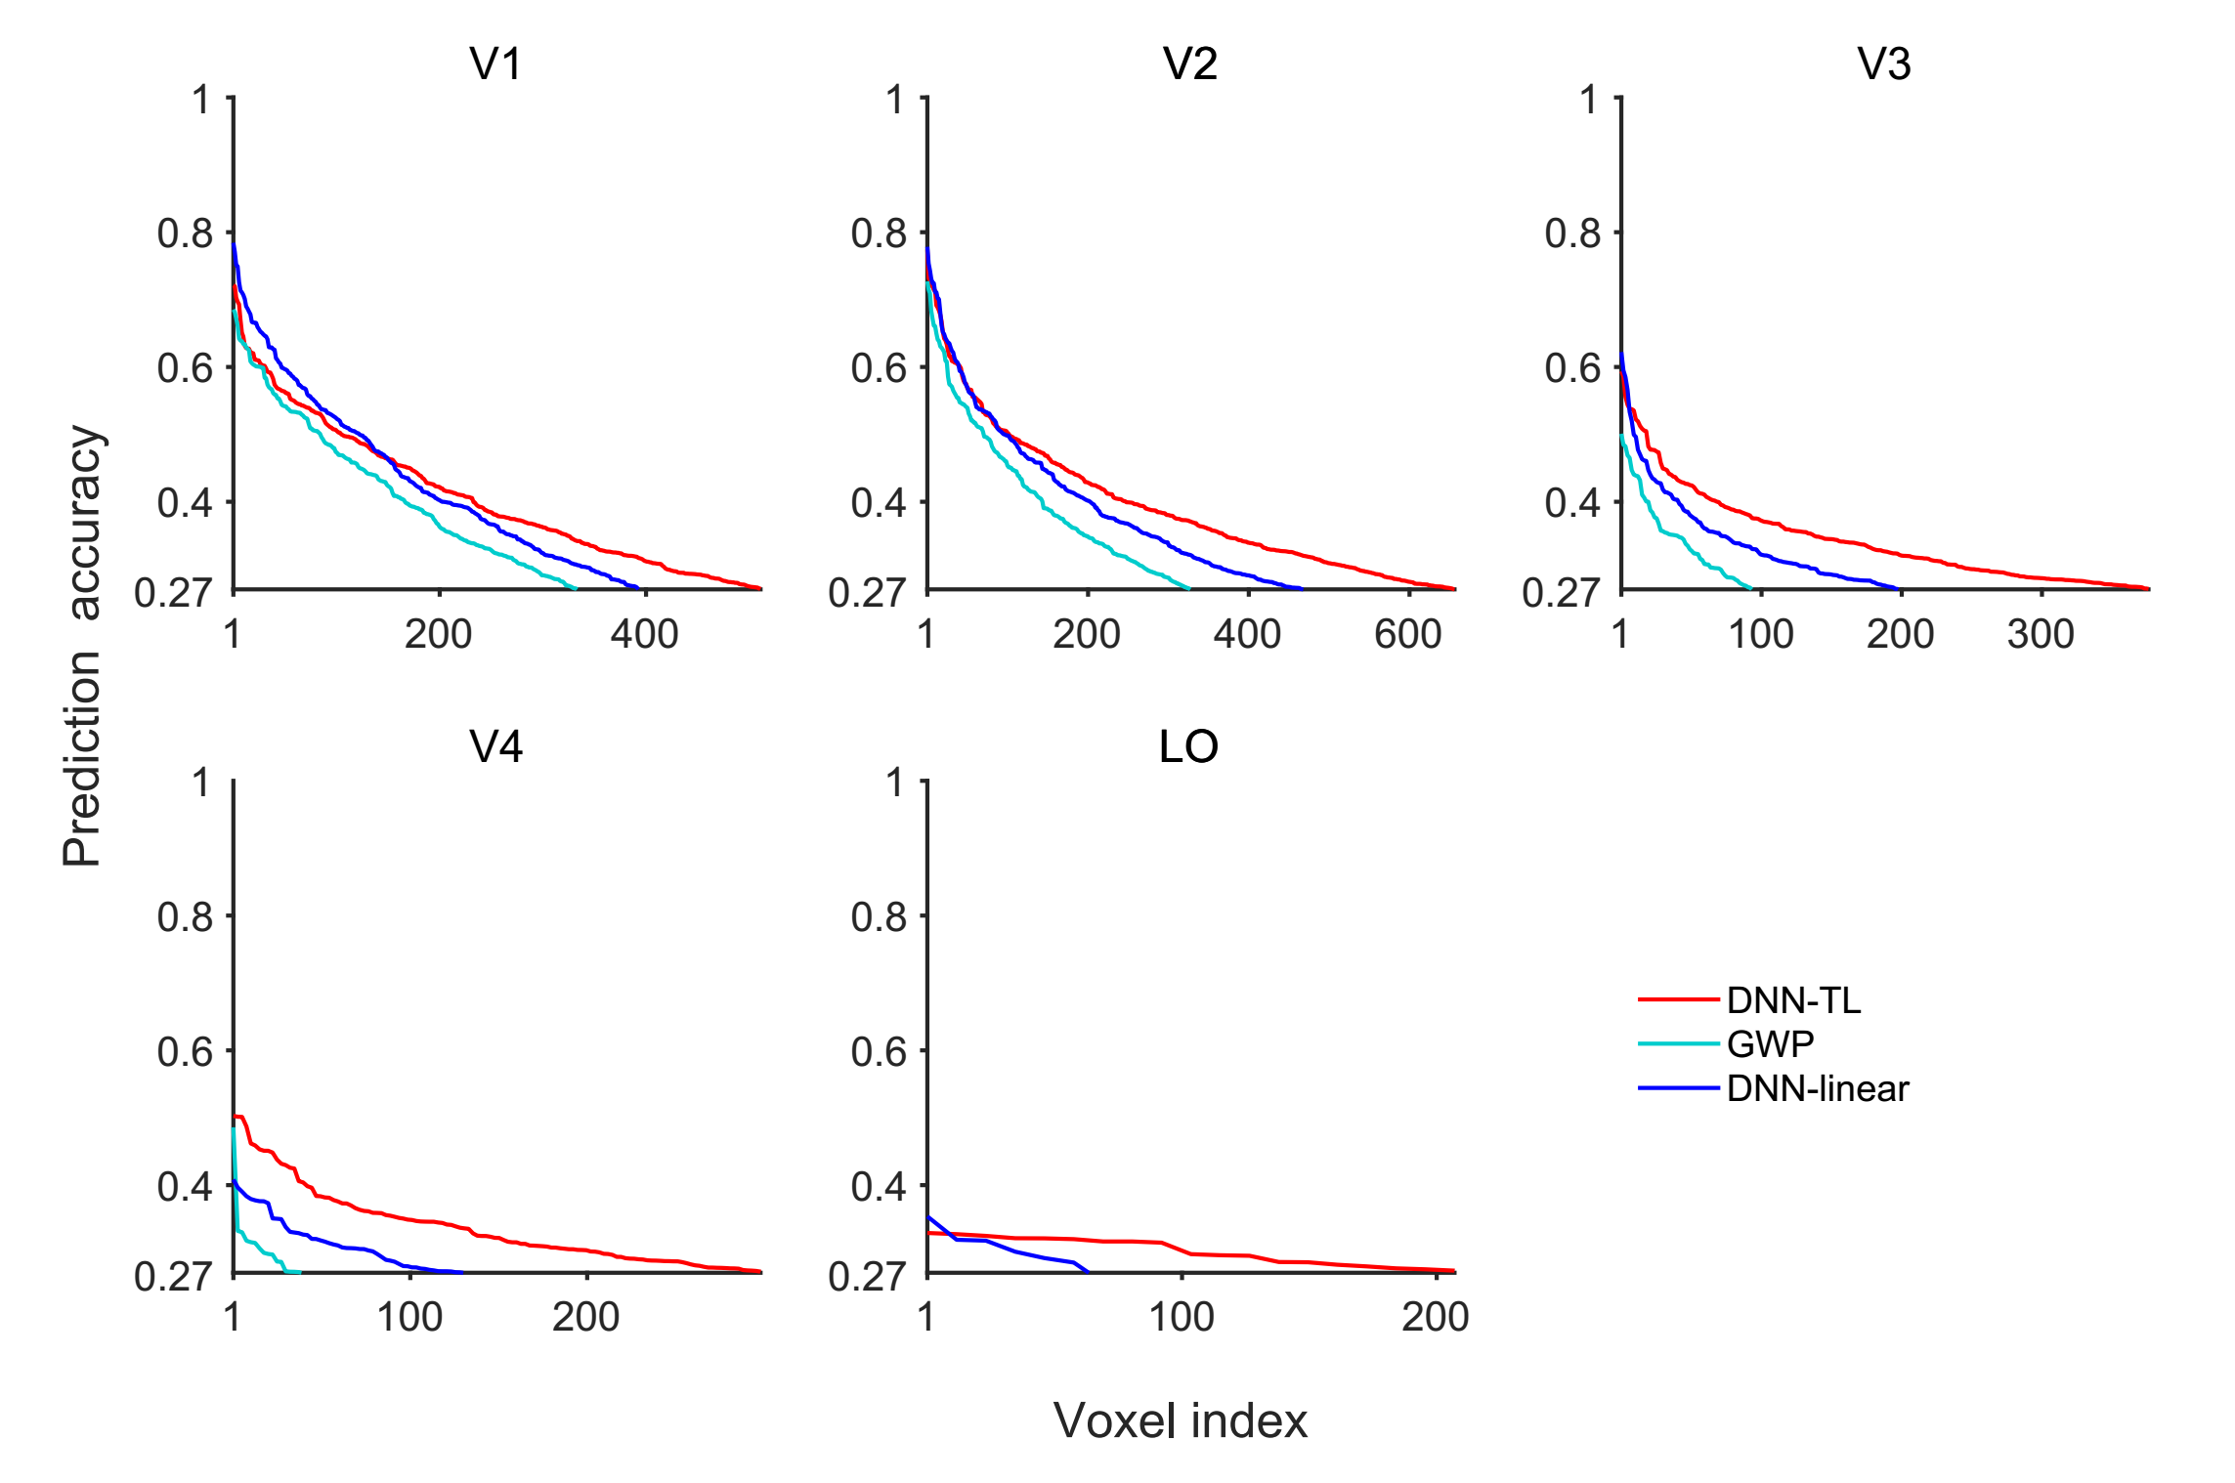

Figure A.3. Comparisons of the DNN-TL, GWP, and DNN-linear models by sorting voxels in the descending order of prediction accuracy for subject 2. Refer to Figure 5 for a detailed description of the plot elements.