**SUPPLEMENTARY INFORMATION**

**Title:** Disentangling locus of perceptual learning in the visual hierarchy of motion processing

Authors: Ruyuan Zhang and Duje Tadin

**Table of Contents**

Supplementary Figure 1: Learning curves of individual subjects

Supplementary Figure 2: Thresholds and percent of improvement of individual subjects

Macintosh HD:Users:ruyuan:Dropbox:Manuscript:PlaidLearn:PlaidLearnFigure:FigureS1_individual_raw.pdf

Figure S1. Individual learning curves for all subjects in the two training groups. Each line represents a learning curve of one subject. Other figure conventions are the same as in the Figure 4 in the main text.

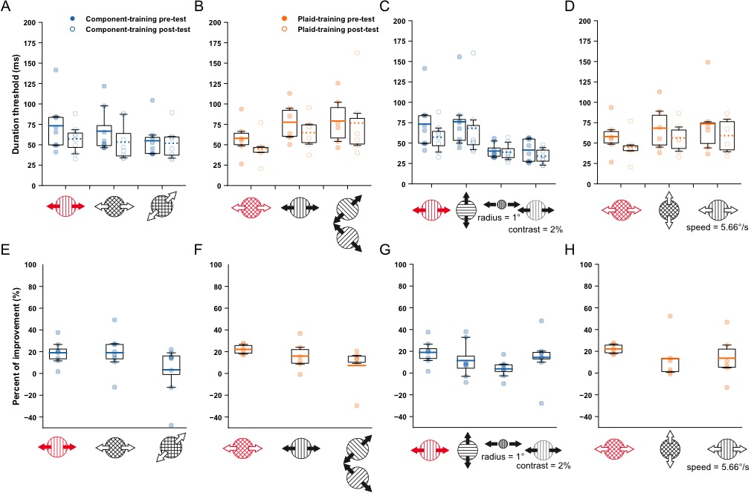

Figure S2. Duration thresholds and percent of improvement for all individual subjects, represented as scatter and box plots. Panels A-D depict duration thresholds at pre-test and post-test. Panels E-H depict percent of improvement for all training conditions (panels E-H correspond to panels A-D, respectively). Panels A, B, E and F correspond to the subplots E and F of Figure 5 in the main text. Panels C, D, G and H correspond to the subplots E and F of Figure 6 in the main text. In each panel, the shaded points represent the data for individual subjects. The lower and the upper boundaries of a box represent the 1st and the 3rd quartiles of the group data, respectively. The reach of whiskers denotes the 2.5th and the 97.5th percentiles of the group data. The horizontal lines in the box indicate the group averages, which correspond to the bar heights in the subplots E and F of Figures 5 and 6 in the main text. For panels A-D, the solid and the dashed lines represent averages for pre-test and post-test, respectively. Other figure conventions are the same as in Figures 5 and 6 in the main text.