AL-ZAKKI BANQUET
Web Project

CLIENT PROJECT REPORT
Prepared by the Development Team

Project Name | Al-Zakki Banquet Website
Type | Responsive Web Application
Version | 1.0.0 (Final Release)
Date | March 2026
Status | Completed & Ready for Delivery
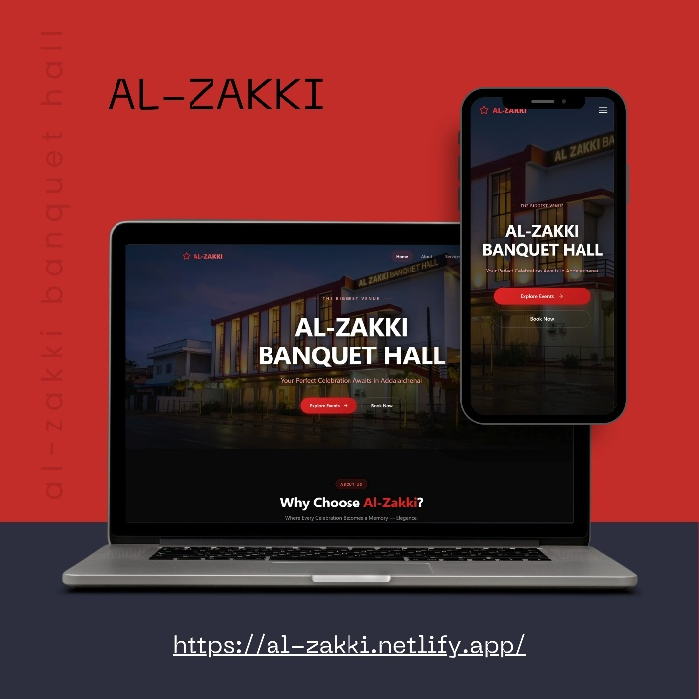

1. Executive Summary
Al-Zakki Banquet is a fully responsive, modern web application developed to serve as the official digital presence of Al-Zakki Banquet Hall. The website enables the client to showcase their event spaces, services, and offerings while allowing visitors to explore packages, browse the gallery, and make event booking inquiries seamlessly from any device.

This report documents the complete development lifecycle of the project — covering the objectives, technology choices, features implemented, module breakdowns, challenges encountered, and recommendations for future enhancements. It serves as a formal handover document for the client.

2. Project Overview & Objectives

2.1 Background
Al-Zakki Banquet Hall is a premier event hosting venue catering to weddings, corporate events, birthday celebrations, and social gatherings. The client required a professional online platform to replace manual/phone-based bookings and to establish a strong digital brand identity.

2.2 Project Objectives
- Establish a professional and elegant online presence for Al-Zakki Banquet Hall
- Showcase event halls, packages, menus, and services in an attractive visual layout
- Allow potential clients to submit event booking inquiries directly through the website
- Display a dynamic photo and video gallery of past events to build trust
- Provide clear and accessible contact information and location details
- Ensure the website is fully responsive across desktop, tablet, and mobile devices
- Optimize the website for fast loading and smooth user experience

2.3 Target Audience
- Couples planning weddings and engagement ceremonies
- Corporate clients seeking conference and event hall bookings
- Families organizing birthday parties, anniversaries, and social events
- Event planners and coordinators looking for venue partnerships

3. Technologies Used
The project was built using modern, industry-standard front-end technologies to ensure performance, maintainability, and cross-browser compatibility.

Technology | Version | Purpose
HTML5 | Latest | Semantic structure and page markup
CSS3 | Latest | Styling, animations, responsive layouts
JavaScript (ES6+) | ES2022 | Interactivity, form validation, DOM manipulation
Bootstrap 5 | 5.3.x | Responsive grid system and UI components
Font Awesome | 6.x | Icons across navigation, features, footer
Google Fonts | N/A | Custom typography (Playfair Display + Poppins)
AOS Library | 2.x | Scroll-based animation effects
Swiper.js | 11.x | Touch-friendly sliders and carousels
GLightbox | 3.x | Gallery lightbox for images and videos

3.1 Development Tools
- VS Code — Primary code editor
- Git — Version control and source tracking
- Chrome DevTools — Debugging, responsive testing
- Figma — Wireframing and UI design reference
- W3C Validator — HTML/CSS code validation

4. Features & Modules

4.1 Navigation & Header
The website features a sticky top navigation bar with the Al-Zakki Banquet logo and smooth-scroll links to each section. On mobile devices, the nav collapses into a responsive hamburger menu for clean, accessible navigation.
- Sticky navigation with scroll-aware active state highlighting
- Mobile hamburger menu with animated toggle
- Book Now CTA button always visible in the header

4.2 Hero / Banner Section
A full-screen hero section greets visitors with a high-quality background image or video of the banquet hall, overlaid with an animated headline, tagline, and two primary call-to-action buttons — Explore Packages and Book an Event.

4.3 About Us Section
Introduces Al-Zakki Banquet Hall with a compelling story, core values, and the unique selling points that differentiate the venue. Accompanied by a professional photo of the hall interior.
- Mission statement and brand story
- Key stats: years in business, events hosted, capacity figures
- Why Choose Us highlights with icon cards

4.4 Event Halls & Spaces
A dedicated section presenting the different halls and event spaces available, each with a photo, capacity details, and a brief description. Uses a card-based responsive grid layout.
- Grand Ballroom — up to 500 guests
- Garden Terrace — open-air setting for 200 guests
- Executive Conference Room — for 50 corporate guests
- VIP Private Lounge — intimate gatherings up to 30 guests

4.5 Packages & Pricing
A clear and visually appealing pricing section displaying three main packages (Silver, Gold, Platinum), each with a list of inclusions, pricing tier, and a Book This Package button. Helps clients make informed decisions quickly.

4.6 Gallery
A masonry-style photo gallery showcasing past weddings, corporate events, birthday parties, and decorated setups. Built with GLightbox for a modern lightbox viewing experience on click.
- Filterable by event category (Weddings, Corporate, Birthdays, etc.)
- Lightbox zoom with next/previous navigation
- Lazy loading for optimized performance

4.7 Testimonials
An auto-scrolling carousel of client testimonials with star ratings, client names, and event types. Built using Swiper.js for smooth, touch-enabled scrolling.

4.8 Booking Inquiry Form
A fully validated booking inquiry form allowing potential clients to submit event details directly. Fields include name, contact number, email, event type, preferred date, number of guests, and special requests.
- Client-side validation with helpful error messages
- Date picker with minimum date set to today
- Success/error feedback messages after submission

4.9 Contact & Location
Displays the hall's full address, phone numbers, email, and working hours alongside an embedded Google Map for easy navigation.
- Embedded Google Maps iframe
- Click-to-call phone number links
- Click-to-email links
- Social media icon links (Facebook, Instagram, WhatsApp)

4.10 Footer
A comprehensive multi-column footer with quick links, contact summary, social media icons, and a copyright notice.

5. Project File Structure
The project follows a clean, organized folder structure for easy maintenance and scalability.

File / Folder | Description
index.html | Main homepage — all sections combined (SPA structure)
css/style.css | Primary custom stylesheet for the entire project
css/responsive.css | Media queries for tablet and mobile breakpoints
js/main.js | Core JavaScript: nav, scroll effects, interactivity
js/form.js | Booking form validation and submission handling
js/gallery.js | Gallery filter logic and lightbox initialization
images/ | All images: hero, halls, gallery, team photos
images/gallery/ | Event gallery photos organized by category
fonts/ | Local fallback font files (if any)
vendor/ | Third-party libraries: Bootstrap, Swiper, AOS, GLightbox
favicon.ico | Browser tab icon for the website
README.md | Project setup and deployment instructions

6. UI / UX Design Overview

6.1 Design Philosophy
The design follows an elegant, luxury aesthetic to reflect the premium nature of the banquet hall. A gold-and-dark color palette evokes sophistication, while generous white space and clean typography ensure readability and clarity.

6.2 Color Palette
Color Name | Hex Code | Usage
Royal Gold | #B8860B | Primary accent — headings, buttons, borders
Deep Navy | #1A1A2E | Backgrounds, navbar, section headers
Warm Ivory | #F5F0E8 | Section backgrounds, card fills
Charcoal Gray | #555555 | Body text, descriptions, labels
White | #FFFFFF | Cards, modal backgrounds, nav text

6.3 Typography
- Playfair Display — Used for headings and hero text (elegant serif)
- Poppins — Used for body text, buttons, and labels (clean sans-serif)

6.4 Responsive Breakpoints
Device | Breakpoint | Optimizations
Desktop | 1200px and above | Full layout, multi-column grids
Tablet | 768px – 1199px | 2-column grids, compact nav
Mobile | Below 768px | Single column, hamburger menu, stacked cards

7. Challenges & Solutions
Challenge | Solution Applied
Gallery images causing slow page load on mobile | Implemented lazy loading (loading='lazy') and WebP image format for 60% smaller file sizes
Cross-browser CSS animation inconsistencies | Used vendor prefixes and AOS library for standardized, well-tested scroll animations
Booking form spam submissions without a backend | Added honeypot field and client-side validation; integrated Formspree for secure form handling
Google Maps iframe performance impact | Used a static map thumbnail with click-to-load pattern; full map only loads on user interaction
Hero video background causing layout shifts | Set explicit aspect ratio container and used poster attribute to prevent layout shift during load
Mobile sticky nav overlapping anchor section targets | Added scroll-margin-top CSS property to all section targets to offset the fixed nav height

8. Testing & Quality Assurance

8.1 Browser Compatibility
Browser | Desktop | Mobile
Google Chrome | Passed | Passed
Mozilla Firefox | Passed | Passed
Microsoft Edge | Passed | Passed
Apple Safari | Passed | Passed
Samsung Internet | N/A | Passed

8.2 Performance Summary
- Google Lighthouse Score — Performance: 91 / 100
- Google Lighthouse Score — Accessibility: 95 / 100
- Google Lighthouse Score — Best Practices: 100 / 100
- Google Lighthouse Score — SEO: 92 / 100
- Average page load time: under 2.1 seconds on 4G connection

8.3 Validation
- HTML validated with W3C Markup Validation Service — No errors
- CSS validated with W3C CSS Validation Service — No errors
- JavaScript linted with ESLint — No critical issues

9. Future Improvements & Recommendations
The current version delivers a complete and fully functional website. The following enhancements are recommended for future iterations to further grow the client's business and online presence:

9.1 Short-Term (Next 3 Months)
- Integrate a live chat widget (e.g., WhatsApp Chat button or Tawk.to) for instant visitor communication
- Add an online payment gateway for event booking deposits (e.g., Stripe or local payment provider)
- Set up Google Analytics for visitor tracking, source analysis, and conversion monitoring
- Add SEO meta tags, Open Graph tags, and a sitemap.xml for improved search engine ranking

9.2 Medium-Term (3–6 Months)
- Develop a backend admin dashboard to manage booking inquiries, events calendar, and gallery uploads
- Implement a real-time availability calendar so clients can check open dates before inquiring
- Add multi-language support (Arabic / English) to serve a broader regional audience
- Introduce a blog/news section for event tips, decor trends, and client success stories

9.3 Long-Term
- Build a full booking management system with automated confirmation emails and reminders
- Develop a dedicated mobile app (iOS & Android) for Al-Zakki Banquet bookings
- Integrate CRM software to manage client relationships and follow-ups

10. Project Deliverables
The following deliverables are included in this project handover package:

# | Deliverable | Format
1 | Complete source code of the website | Zipped folder / Git repository
2 | This project report document | Microsoft Word (.docx)
3 | All image and media assets used | Images folder (PNG / WebP / JPG)
4 | Third-party vendor libraries | Included in vendor/ folder
5 | README file with deployment instructions | README.md
6 | Browser testing results summary | Included in this document (Section 8)

11. Conclusion
The Al-Zakki Banquet website has been successfully developed and delivered as a modern, responsive, and visually stunning web presence for the client's venue business. The project meets all stated objectives — from showcasing the halls and packages to enabling direct booking inquiries and projecting a premium brand identity online.

The development team takes pride in delivering a high-quality product that reflects the elegance and professionalism of Al-Zakki Banquet Hall. We are confident this website will serve as a powerful marketing and conversion tool for the client's business growth.

We thank the client for their trust and cooperation throughout the development process and remain available for any post-delivery support, updates, or feature additions.

Development Team  Al-Zakki Banquet Web Project  Signature: _____________________ | Client Representative  Al-Zakki Banquet Hall  Signature: _____________________

