TourPlanner

Project Protocol — SWEN Semester Project
Repository:
Stack: Spring Boot 4.0 · Java 25 · Angular 21 · PostgreSQL · JPA/Hibernate · Log4j2
Time invested: ~80–100 hours
Contents: 1 Architecture · 2 Features & Unique Feature · 3 Design Pattern · 4 Use Case Diagram · 5 Wireframe · 6 Class Diagram · 7 Sequence Diagram (Full-Text Search) · 8 Unit Tests · 9 Libraries & Lessons Learned · 10 Time Tracking

1. Application Architecture
TourPlanner is a two-tier web application. The backend is implemented in Java 25 / Spring Boot 4.0 following a strict three-layer architecture (Presentation → Business → Data Access). The frontend is an Angular 21 single-page application that uses the MVVM pattern via signals and dedicated *.vm.ts view-model classes. All communication between the two tiers uses HTTP/JSON; every request carries a JWT Bearer token validated by a Spring Security filter before the request reaches any controller.
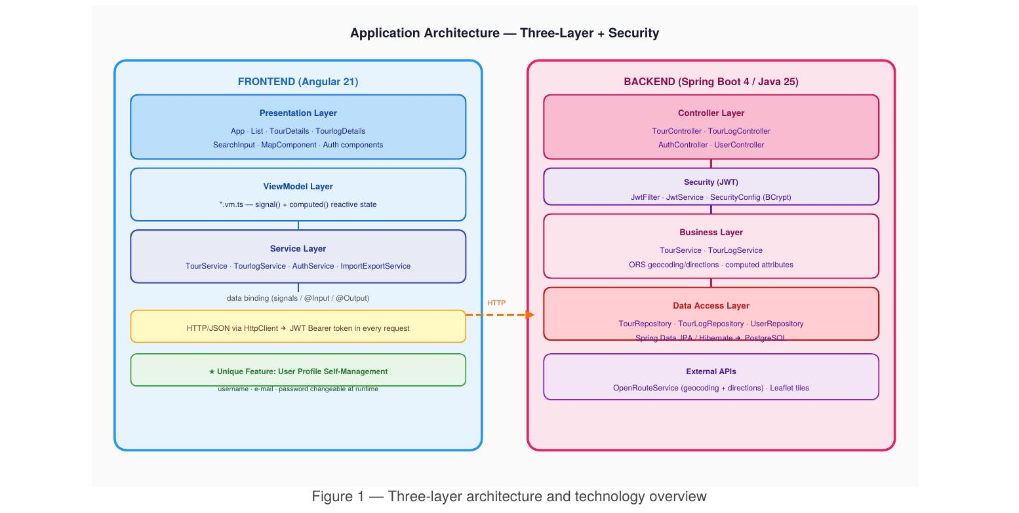
Figure 1 — Three-layer architecture and technology overview

Backend layers
- Controller Layer: REST endpoints (@RestController). Receives HTTP requests, extracts the userId injected by the JWT filter, delegates immediately to the Business Layer. Contains no business logic.
- Business Layer: TourService and TourLogService. All domain logic lives here: ORS geocoding, ORS Directions, computed-attribute calculation (popularity / child-friendliness), ownership validation, and the filtered full-text search.
- Data Access Layer: Spring Data JPA repositories. All queries are parameterised JPQL — no SQL concatenation, so SQL injection is structurally prevented. Hibernate maps entities to PostgreSQL tables.
- Security: JwtFilter (OncePerRequestFilter) validates the token on every request. BCryptPasswordEncoder hashes passwords. CORS is configured for localhost:4200.

Frontend layers
- Presentation Layer: Angular standalone components (App, List, TourDetails, TourlogDetails, SearchInput, MapComponent, auth components).
- ViewModel Layer: *.vm.ts injectable services providing signal() state and computed() derived values. Each component injects its own VM via the providers array.
- Service Layer: TourService, TourlogService, AuthService, ImportExportService — handle HTTP calls and expose async Promise-based APIs to the components.

2. Implemented Features

Core features
- Authentication: Self-registration and login using username + password. Passwords are BCrypt-hashed; sessions use stateless JWT tokens (24 h expiry).
- Tour CRUD: Create, read, update, delete tours. On create/update the backend geocodes the from/to locations via ORS and fetches distance and estimated time from ORS Directions.
- Tour Logs CRUD: Each tour can have multiple logs (date/time, comment, difficulty, distance, time, rating 1–5). Logs are linked to a tour and user; no cross-user sharing.
- Leaflet Map: The selected tour is rendered on a Leaflet map using CartoDB tiles. The route polyline is fetched live from ORS Directions with a per-render cancellation token to avoid displaying stale routes when the user switches tours quickly.
- Computed Attributes: Popularity (capped count of logs, 0–5) and child-friendliness (penalty-based score from difficulty, average distance and average time, 0–5) are calculated in TourService (Business Layer) using @Transient fields on Tour. They are serialised in JSON and displayed as star ratings in the UI.
- Full-Text Search: A single JPQL query searches tour name, description, from/to names, transport type and log comments/difficulty. Results are enriched and optionally filtered by minimum popularity and minimum child-friendliness (the two computed attributes), fulfilling the requirement that the search also considers computed values. The frontend debounces keystrokes by 300 ms.
- Import / Export: Tours and their logs are exported as a versioned JSON file (format: {exportedAt, version, tours[{…, logs:[…]}]}). On import, IDs are stripped and tours are re-created via the normal create path (ORS re-fetched, new UUIDs). Error handling reports per-tour failures without aborting the whole batch.
- Input Validation: Frontend: view-model isFormValid() checks before any HTTP call (required fields, email format, password ≥ 6 chars, rating 1–5). Backend: ownership checks in every mutating operation; try/catch on ORS calls.
- Logging: Log4j2 with a console and rolling-file appender (daily + 10 MB, kept 30 days). Every service method logs at INFO/DEBUG level; errors and unauthorised accesses at ERROR/WARN.

★ Unique Feature: User Profile Self-Management
After login the user can open a Profile panel and update their username, e-mail address and password without logging out. This is implemented end-to-end:
- Frontend: ProfileComponent + ProfileViewModel — a modal form with client-side validation (at least one field must be non-empty).
- Backend: PUT /api/users/me — reads the authenticated userId from the JWT, applies partial updates (only non-blank fields are changed), re-hashes the password with BCrypt if a new one is provided.
- After a successful username change, AuthService.updateUsername() refreshes localStorage and the reactive signal so the UI reflects the new name immediately.
This feature is meaningful in a multi-user application because it lets users correct mistakes made at registration time and rotate their password — something that most competing basic implementations skip entirely.

3. Design Pattern: Repository Pattern
The Repository Pattern is deliberately applied to the entire data access layer. Each aggregate root has its own repository interface that extends JpaRepository:
Repository | Aggregate | Key custom query
TourRepository | Tour | searchByUserId(userId, term) — JPQL full-text
TourLogRepository | TourLog | findByTourId(id), findByTourUserId(userId)
UserRepository | User | findByUsername(username)

Why this pattern was chosen:
- It isolates all database interaction behind an interface, so the Business Layer never constructs queries or touches EntityManager directly.
- Spring Data JPA auto-generates the implementation at startup — no boilerplate DAO classes needed.
- Custom queries use @Query with named parameters (:term, :userId), which are parameterised by the JPA runtime and structurally prevent SQL injection.
- Unit tests mock the repository interfaces with Mockito, letting TourServiceTest exercise all business logic without a running database.
The pattern is visible in the sequence diagram (Section 7): TourService calls tourRepository.searchByUserId() and tourLogRepository.findByTourUserId() as the only DB-touching steps; everything else (enrichment, filtering) happens in pure Java.

4. Use Case Diagram
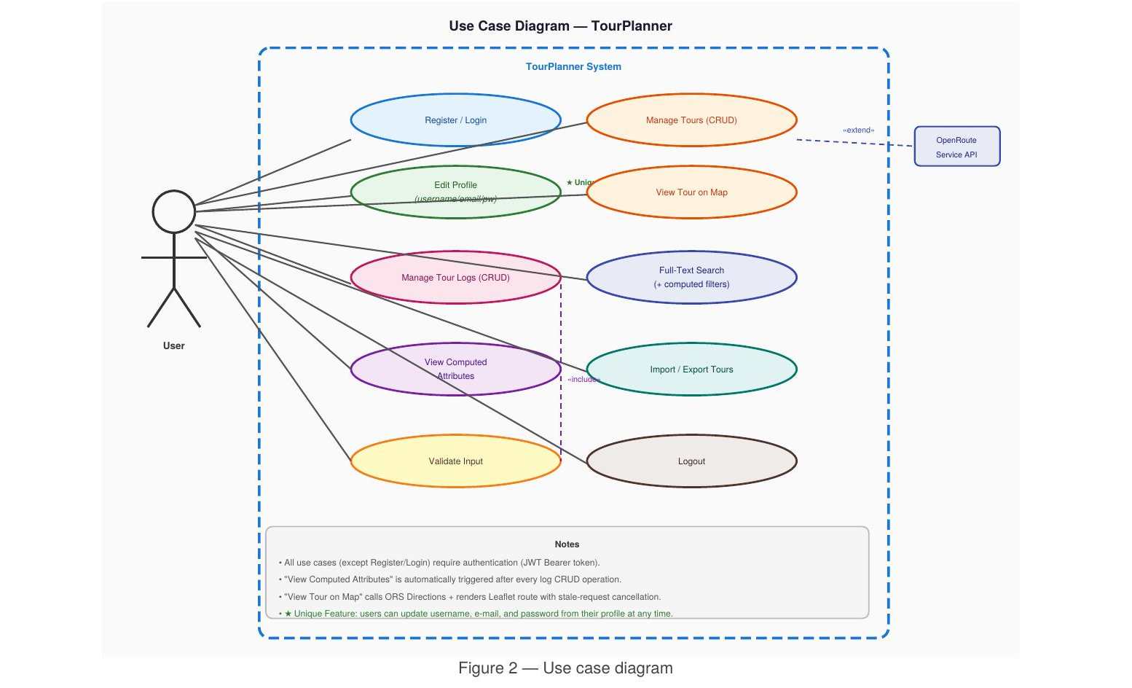
Figure 2 — Use case diagram
All use cases except Register / Login require a valid JWT token. The «include» relationship to Validate Input applies to every mutating use case. The «extend» to OpenRouteService API is triggered automatically whenever a tour is created, updated, or selected on the map.

5. UI Wireframe
Layout decisions:
- Fixed left sidebar (380 px) for the tour list; fluid right panel for the map. The map panel always occupies remaining viewport width.
- The selected tour expands inline below its card, showing a tabbed panel (Details / Tour Logs) without a page navigation. This keeps the map visible at all times.
- Search bar, min-popularity filter and min-child-friendliness filter sit together in the navbar — they are visually grouped to communicate that they all control the same tour list.
- The Profile modal (unique feature) is accessible from the navbar. It is a lightweight overlay, not a separate route.
Screen-by-screen wireframes
The wireframes below document every individual screen and modal state of the Angular single-page frontend. The set covers both authentication states, the authenticated main view, the full tour and tour-log CRUD dialogs, and the profile self-management modal (the unique feature). The selected tour always expands inline beneath its list card so the map stays visible, and the same tabbed panel switches between Details and Tour Logs.
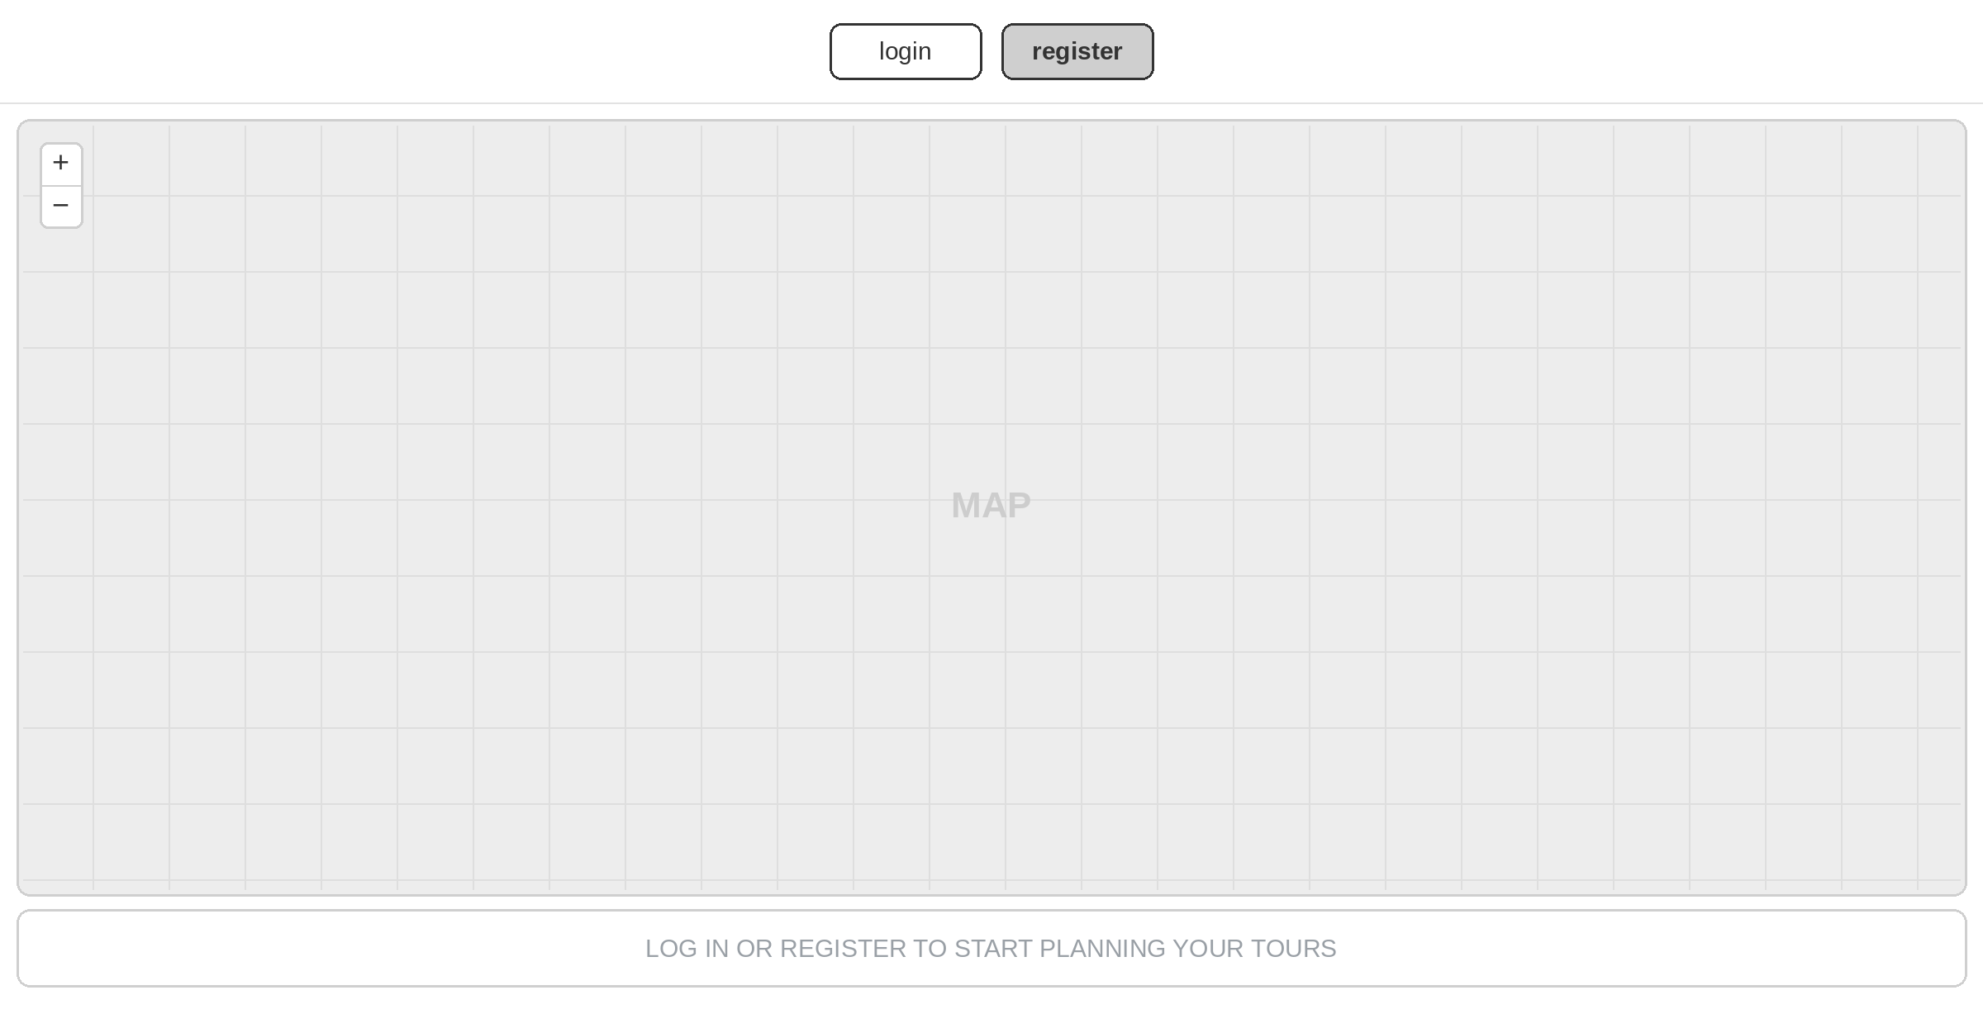
Figure 3 — Public landing view (logged-out): full-screen Leaflet map; tour data stays hidden until the user authenticates.
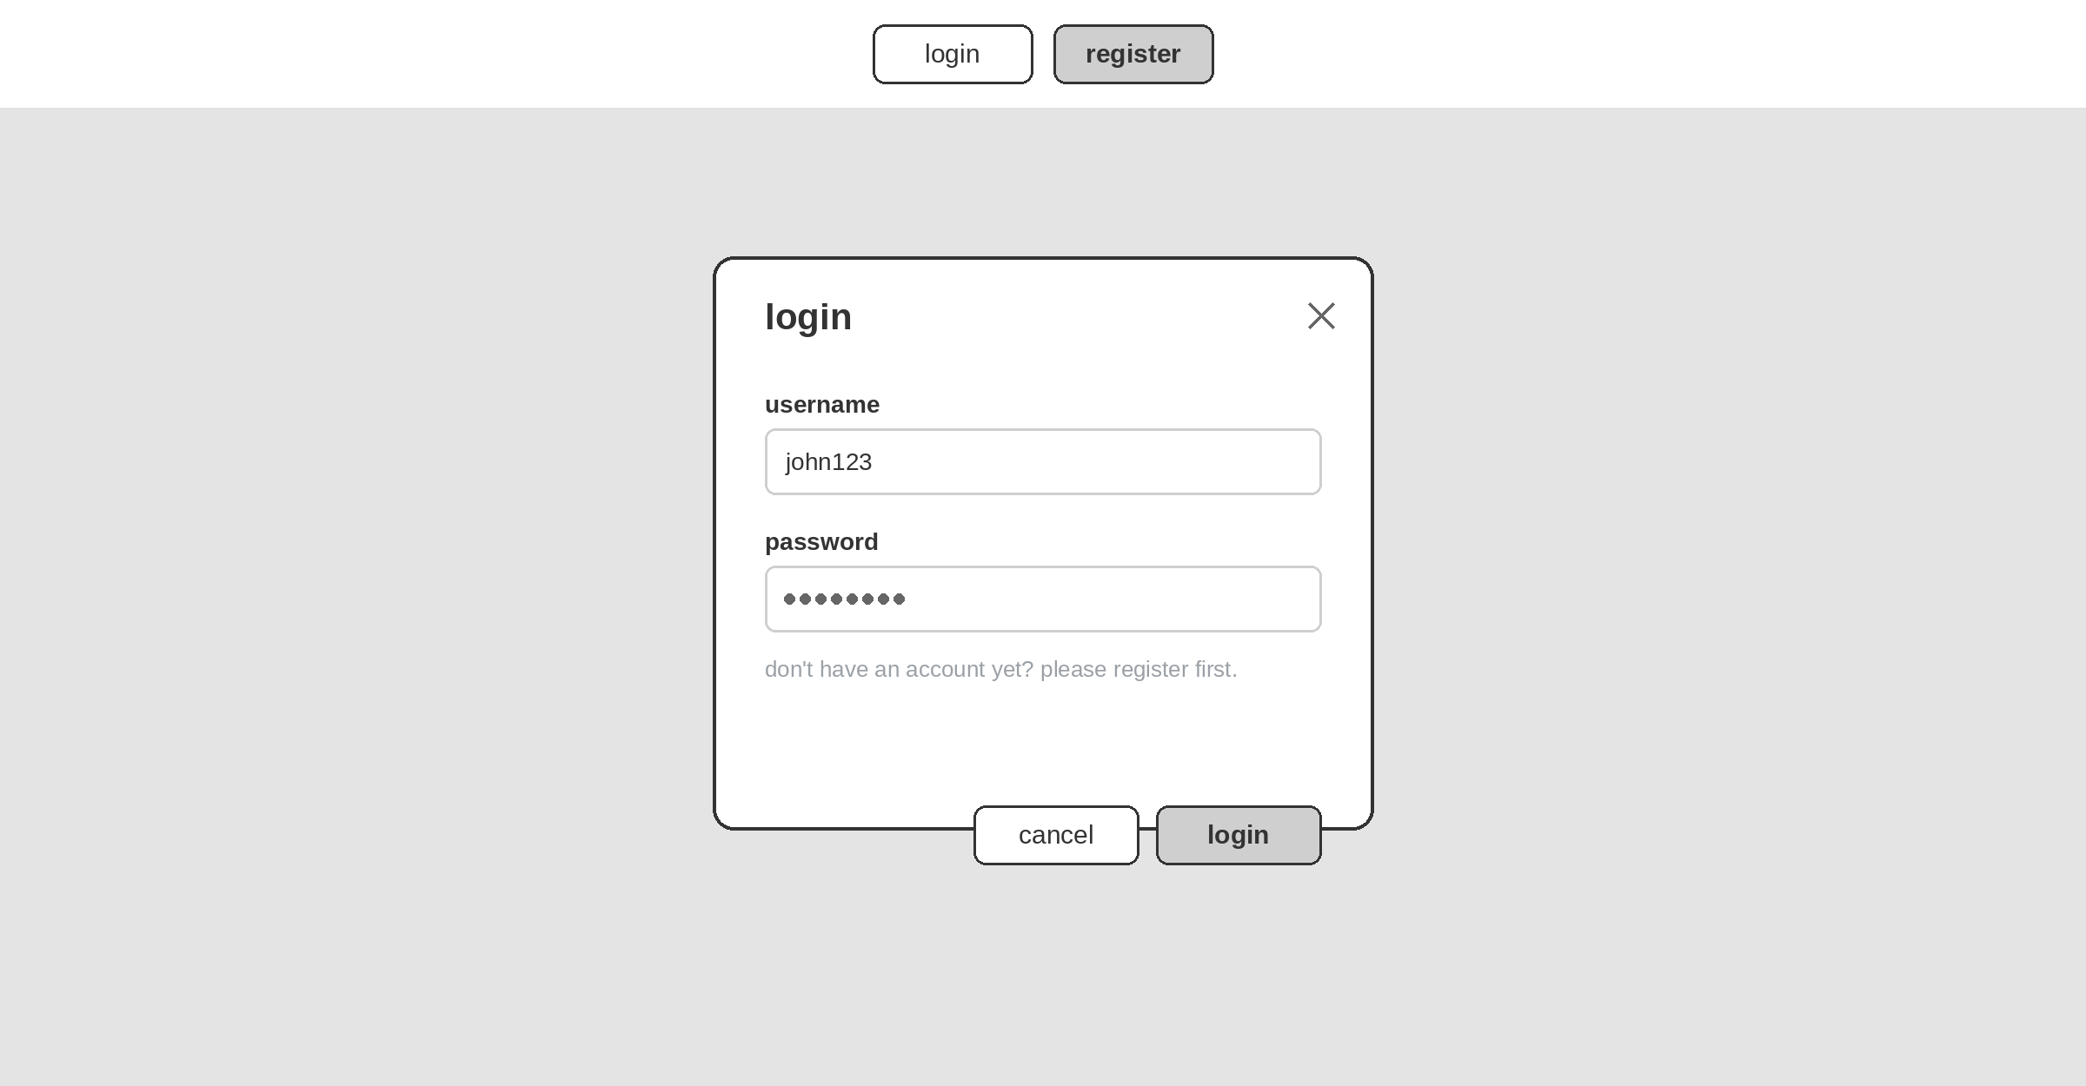
Figure 4 — Login modal: username / password, validated client-side before the JWT request.
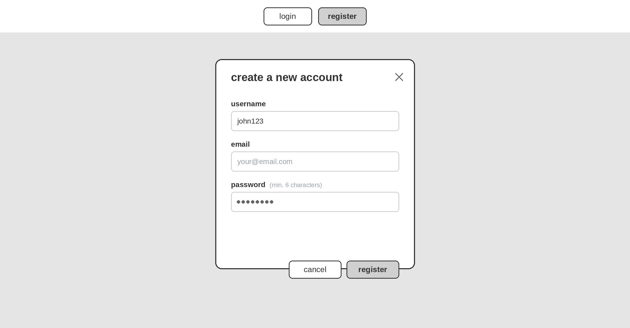
Figure 5 — Registration modal: self-service sign-up (username, e-mail, password ≥ 6 characters).
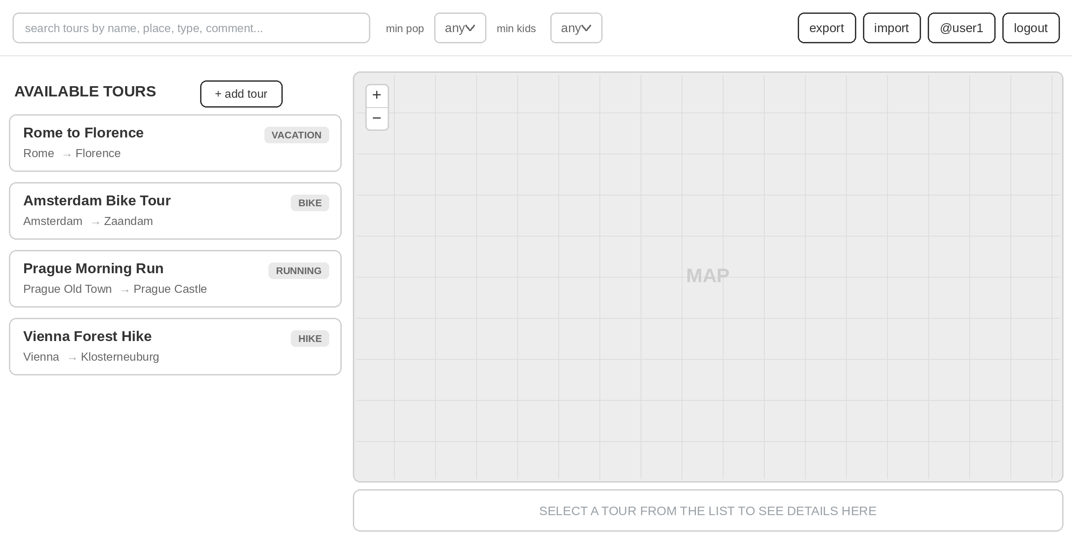
Figure 6 — Authenticated main layout: fixed tour-list sidebar, fluid map panel, navbar search and the two computed-attribute filters.
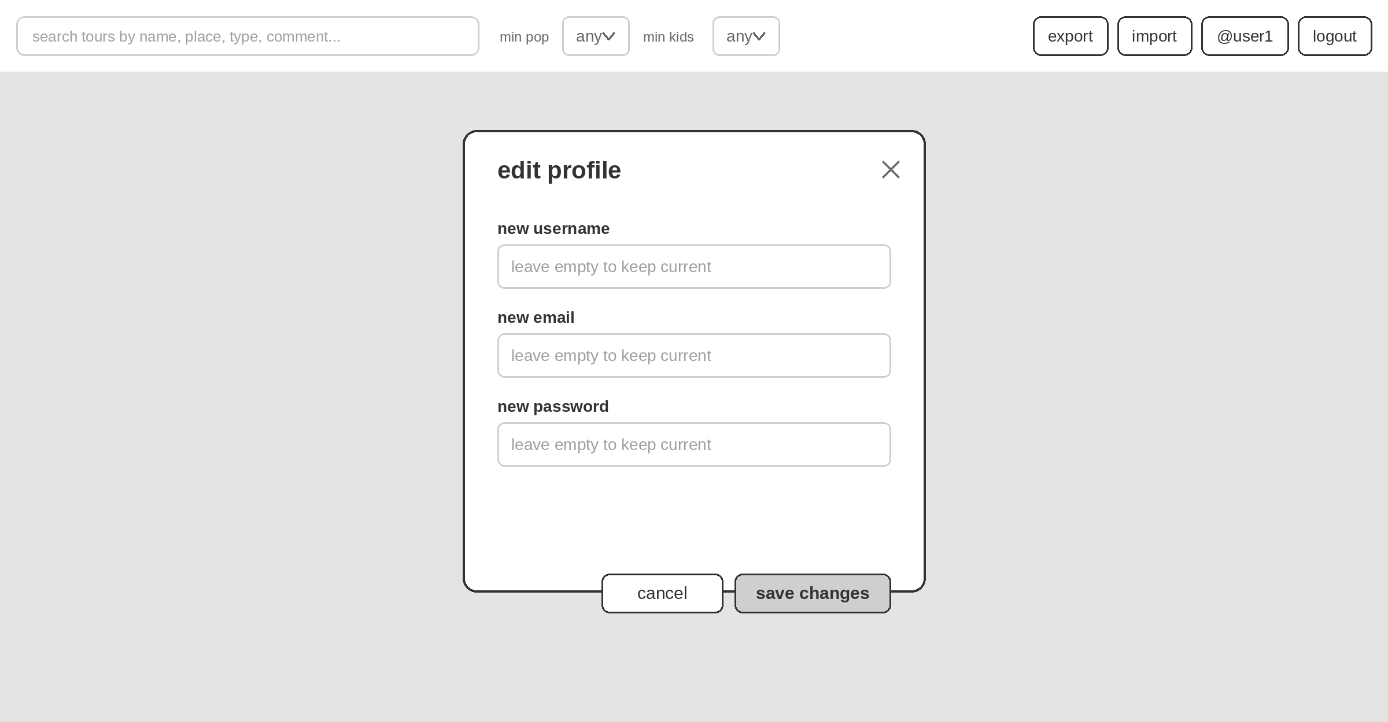
Figure 7 — Profile self-management modal (unique feature): partial update of username, e-mail and password.
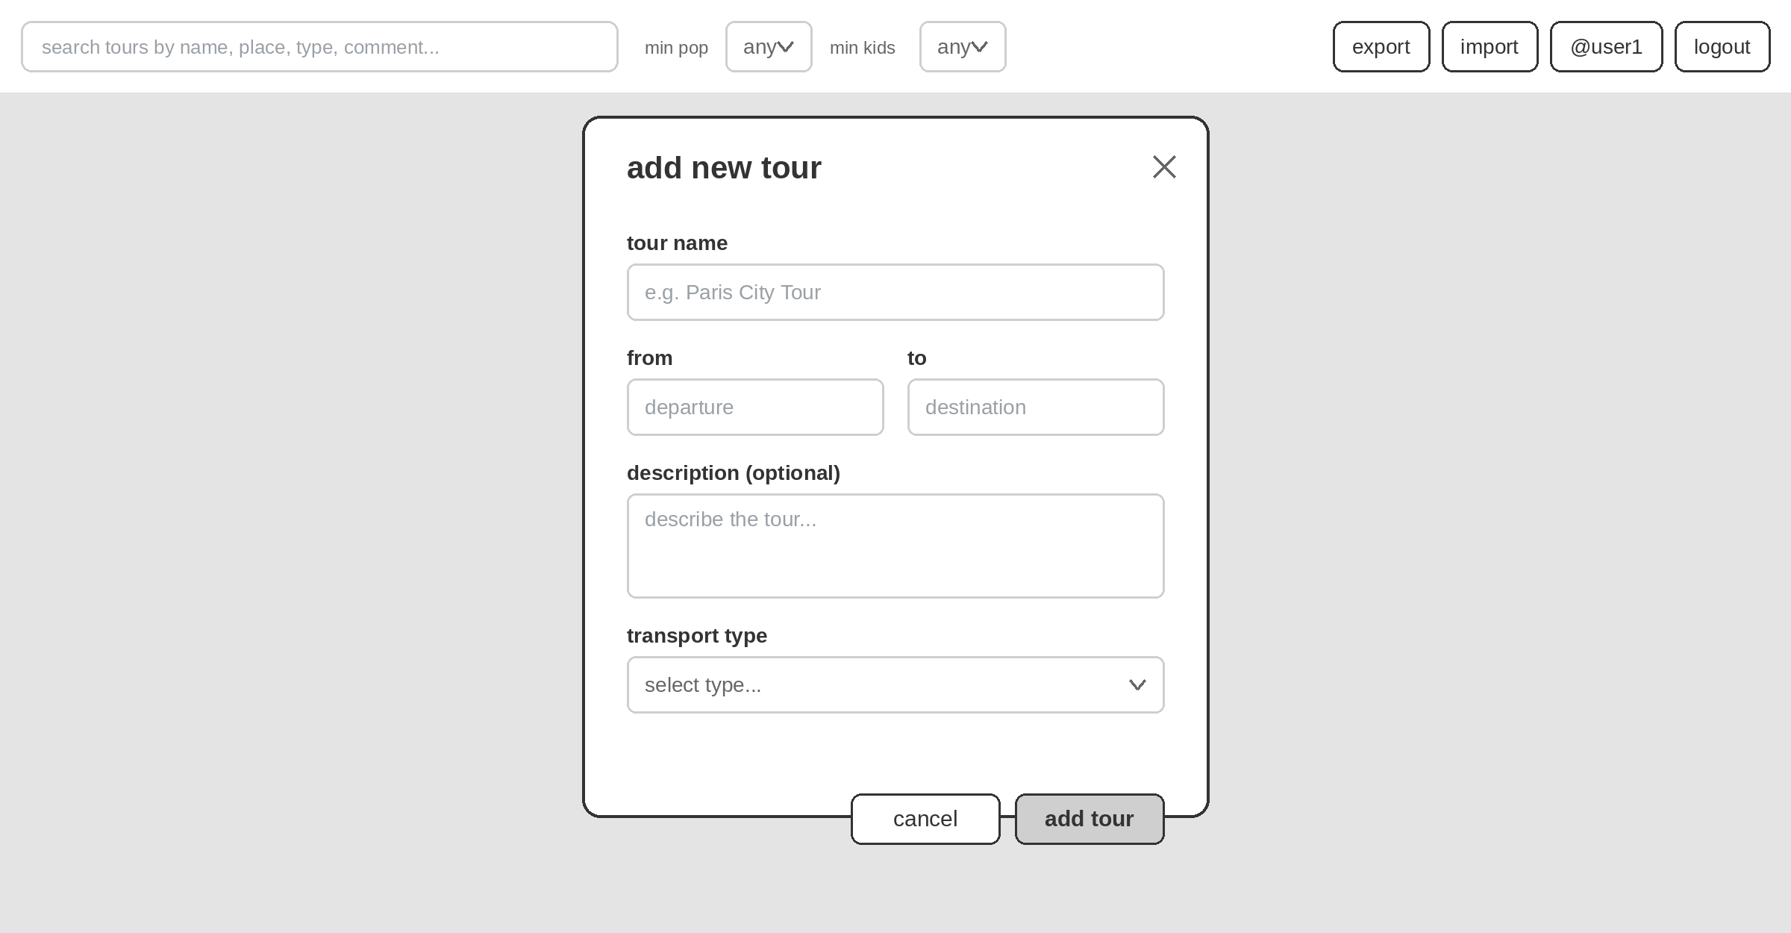
Figure 8 — Create-tour modal: name, from / to, description and transport type; from / to are geocoded via ORS on submit.
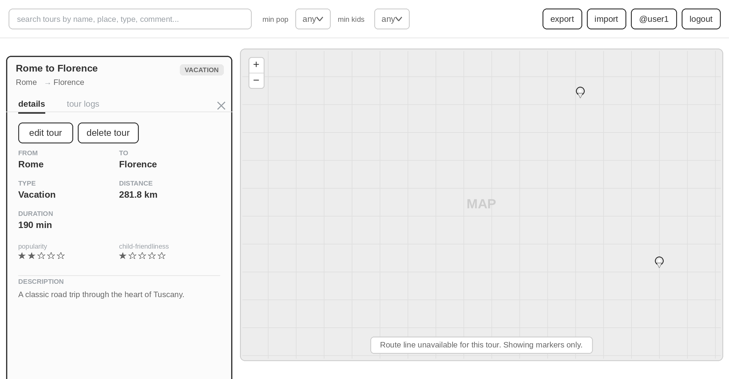
Figure 9 — Selected tour, Details tab: inline expanded panel with ORS distance / time and star-rated popularity & child-friendliness.
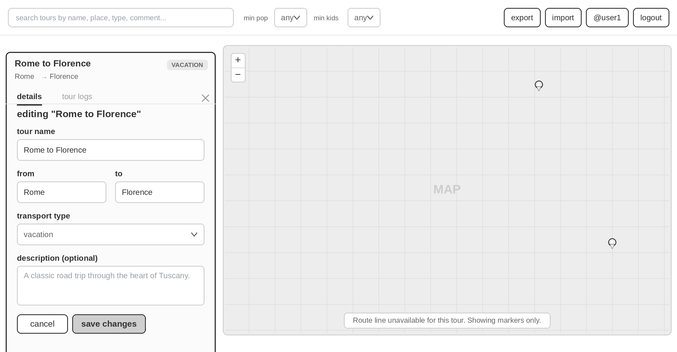
Figure 10 — Edit-tour form: same panel in edit mode; saving re-fetches ORS geocoding and directions.
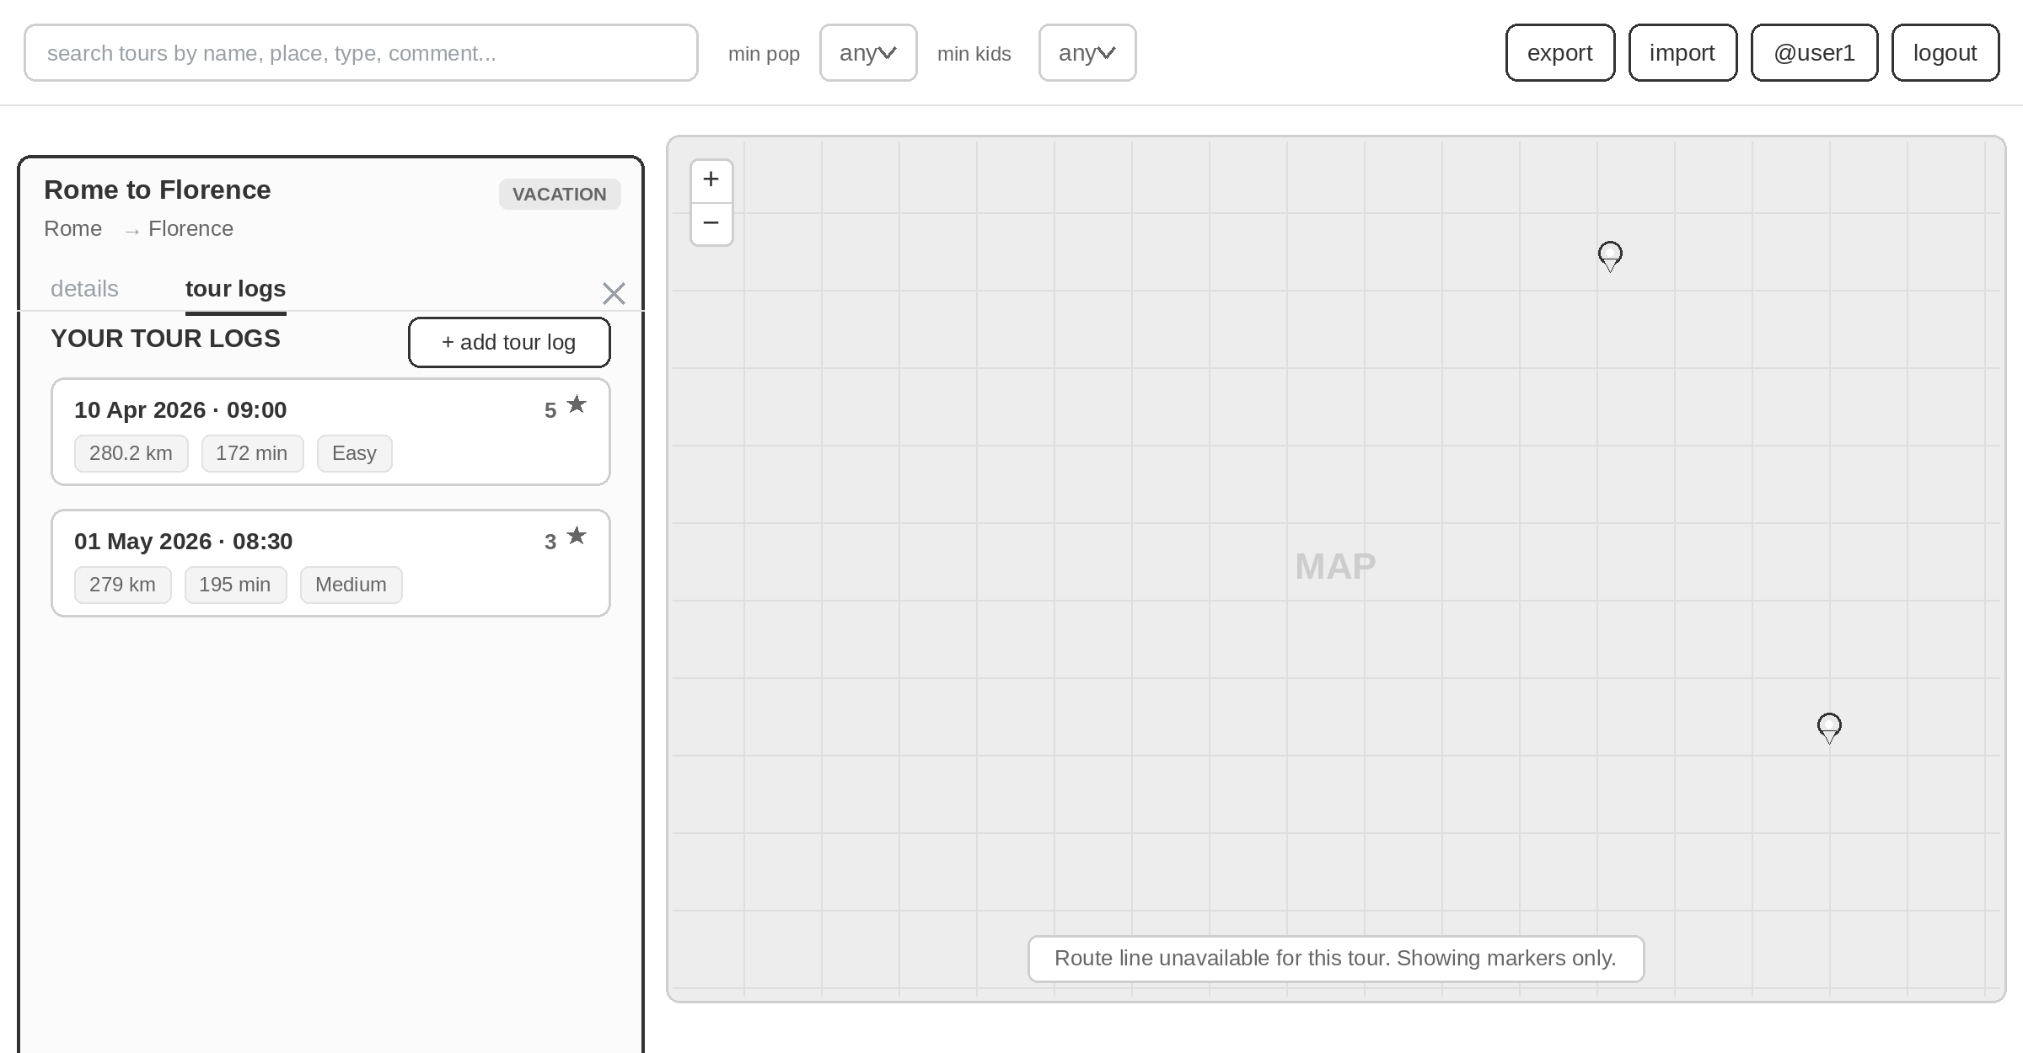
Figure 11 — Selected tour, Tour Logs tab: per-tour log list (date/time, distance, duration, difficulty, rating).
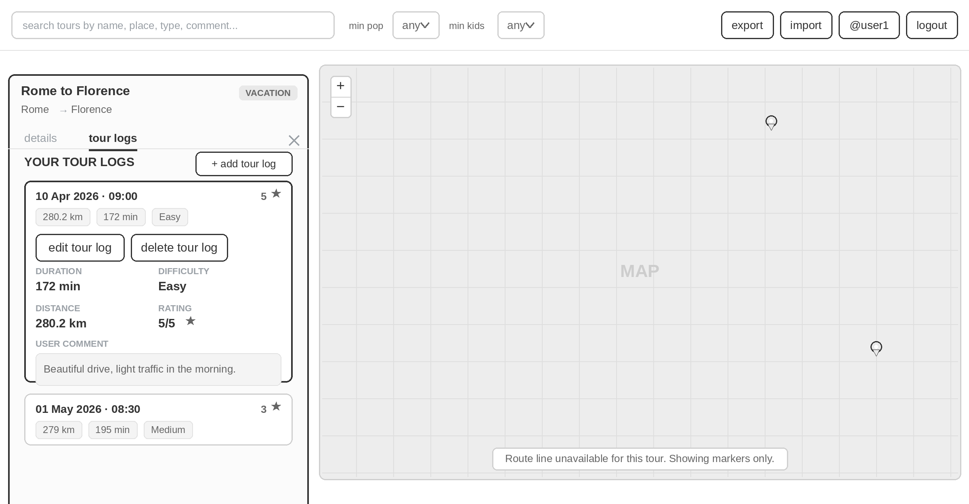
Figure 12 — Expanded tour-log entry: full detail with edit / delete actions and the user comment.
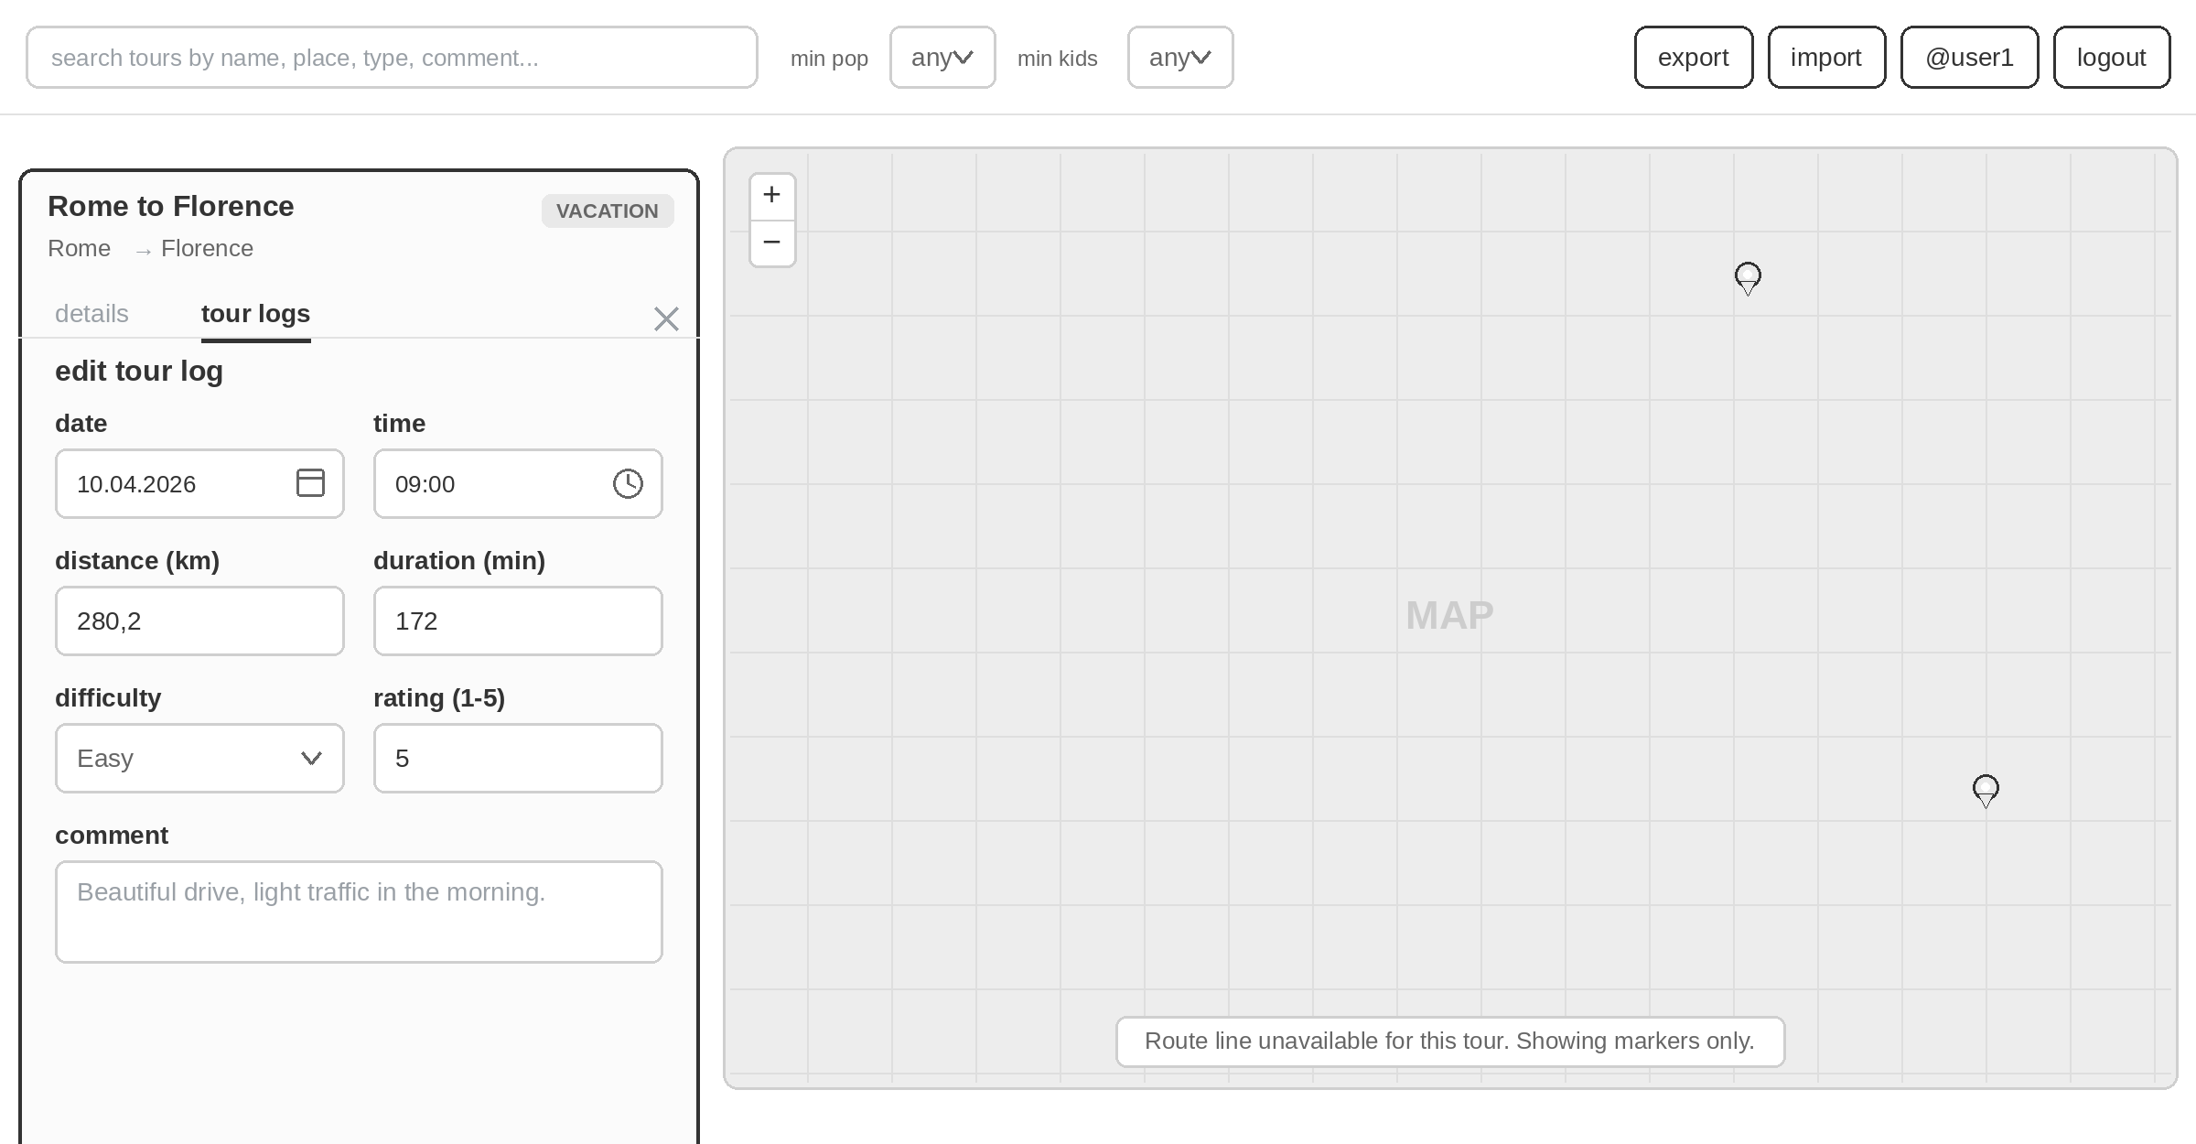
Figure 13 — Edit tour-log form: date, time, distance, duration, difficulty and rating (1–5) with a comment.

6. Class Diagram
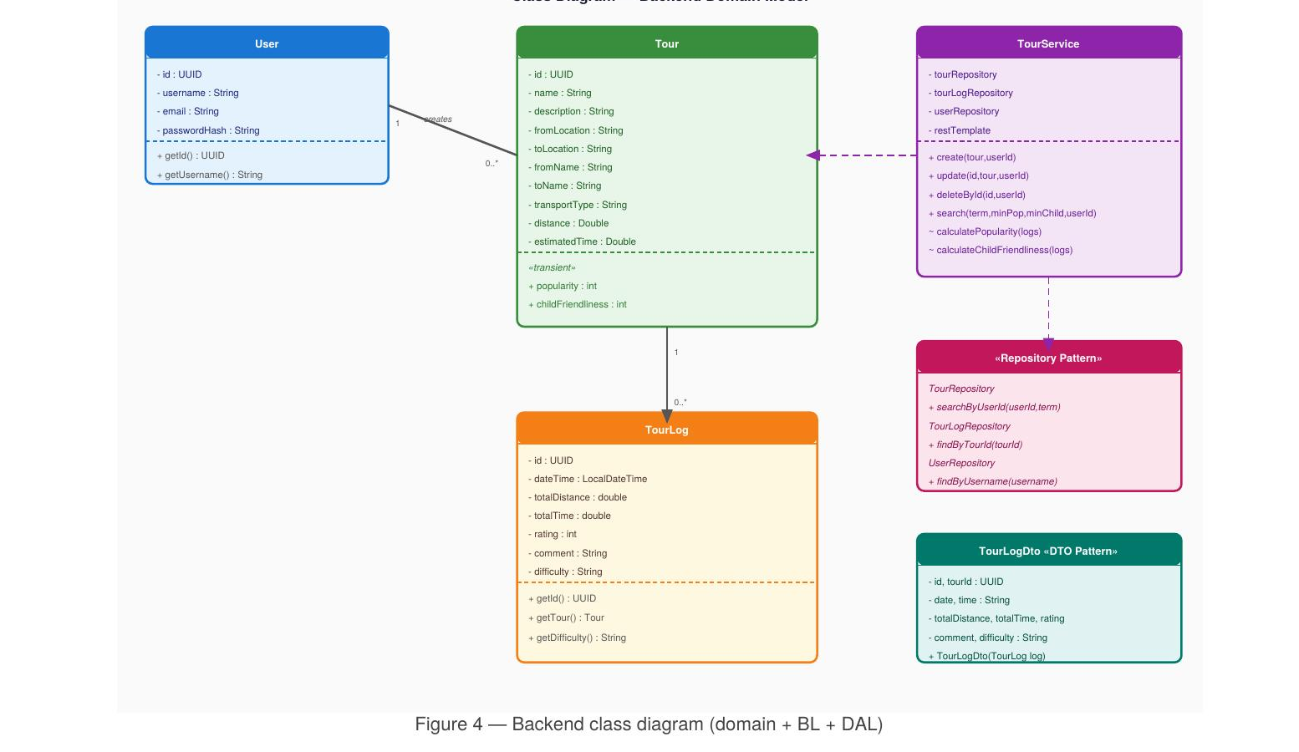
Figure 14 — Backend class diagram (domain + BL + DAL)
Key design decisions visible in the diagram:
- Tour.popularity and Tour.childFriendliness are @Transient — they are never persisted to PostgreSQL. TourService computes and sets them at runtime; Jackson serialises them in the JSON response so the frontend receives them ready to display.
- TourLog is @JsonIgnore on the Tour side and loaded separately. This prevents recursive serialisation and keeps the /api/tours payload lean.
- TourLogDto wraps TourLog for the API boundary — it converts LocalDateTime to separate date/time strings (matching Angular's date input format) and exposes tourId as a flat UUID instead of a nested Tour object.

7. Sequence Diagram — Full-Text Search
The sequence diagram below documents the end-to-end flow for the most complex feature: full-text search combined with computed-attribute filters.
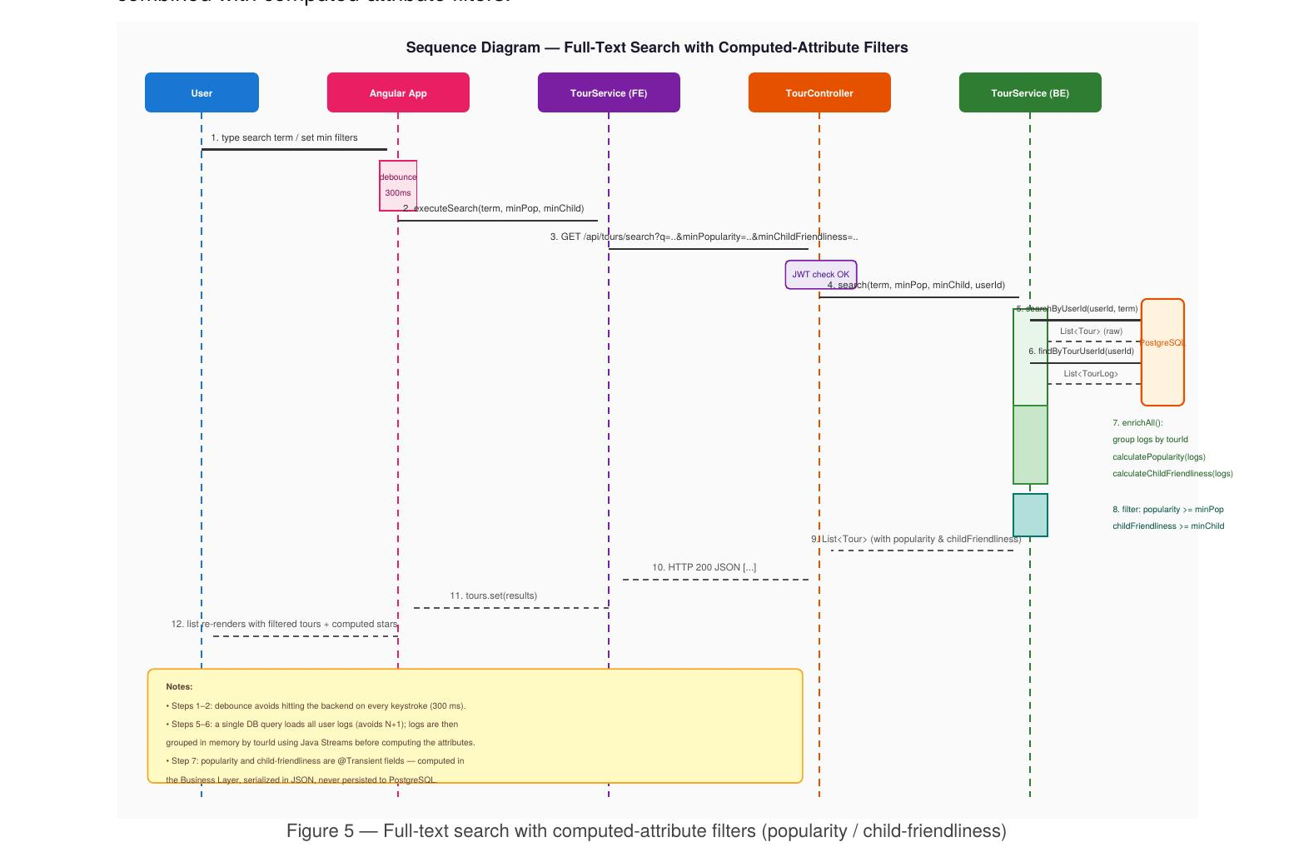
Figure 15 — Full-text search with computed-attribute filters (popularity / child-friendliness)
Critical design choices in this flow:
- Step 1–2: A 300 ms debounce in the Angular App prevents a backend call on every keystroke. The debounce is reset by both text changes and filter changes.
- Step 5: A single findByTourUserId() call loads all logs for the user in one query. This avoids the N+1 problem (one query per tour). Logs are then grouped in memory with Java Streams before computing per-tour attributes.
- Step 6 (enrichAll): calculatePopularity() and calculateChildFriendliness() are package-private methods on TourService — they are directly unit-tested in TourServiceTest without mocking.
- Step 7: The filter is applied in the Business Layer (Java stream filter), not in SQL. This keeps the JPQL query simple and reusable; the filtering logic for computed attributes (which are @Transient and unknown to the DB) correctly lives in Java.
- The response carries popularity and childFriendliness as plain int fields in the JSON — the frontend binds them directly in the template without any local computation.

8. Unit Tests
The project contains 42 backend unit tests (well above the required 20) across three test classes, all using JUnit 5 + Mockito + AssertJ.
Test class | # Tests | What is tested
TourServiceTest | 25 | Business logic: create/update/delete ownership, ORS fallback, transport-profile selection, geocoding, search delegation, computed-attribute calculation, min-score filter
TourControllerTest | 9 | HTTP layer: request routing, userId extraction from JWT attribute, correct delegation to TourService, 404 on missing tour
TourLogControllerTest | 8 | Log CRUD routing, 404/403 propagation from service, authorisation guard verification

Why these tests are critical:

calculatePopularity / calculateChildFriendliness
These are the core business rules for two required features. A regression here would produce silently wrong star ratings with no runtime error. Testing the edge cases (0 logs → 0, 7 logs → capped at 5, Expert + long distance → clamped to 1) ensures correctness across the full input range.

search with minPopularity / minChildFriendliness filter
Verifies that the search correctly excludes tours below the requested threshold. This is the mechanism by which the search 'considers computed values' — a checklist requirement worth 2 points.

Ownership guards (update / delete / log access)
Without these checks any authenticated user could delete another user's tours. The tests verify that the guard throws before any repository write, and that the repository delete methods are never called on an unauthorised request.

ORS fallback (create_orsCallFails_savesTourWithZeroDistanceAndTime)
ORS is an external service that can be temporarily unavailable. This test ensures the application saves the tour with distance=0 and logs a warning instead of crashing with an unhandled exception.

Transport-profile selection (bike/hike/null)
The ORS profile name in the URL determines which routing engine is used. An error here would silently route hikers on roads. The tests verify the exact URL substring for each transport type.

Controller delegation (no business logic in controller)
These tests mock TourService completely and verify that the controller forwards every parameter correctly. If business logic ever leaks into a controller the test would still pass — but the architecture tests (ownership, ORS, etc.) would not catch it because they test TourService directly. Both layers must be tested.

9. Libraries, Technologies & Lessons Learned
Library / Tool | Version | Why chosen
Spring Boot | 4.0.5 | Industry-standard Java backend framework; starter-webmvc in SB4 replaces -web
Spring Data JPA | 4.x | Repository pattern auto-generated from interfaces; prevents SQL injection by design
Hibernate | 7.x | ORM included with Spring Data JPA; @Transient allows computed fields
PostgreSQL | latest | Required by the project specification; robust and well-supported by Hibernate
JJWT (jjwt-api) | 0.12.3 | Compact, well-maintained JWT library for Java; fluent builder API
Log4j2 | 2.x | Required by spec; rolling-file appender with size + time triggers
JUnit 5 + Mockito | current | Required by spec; Mockito enables full isolation of BL from DB in unit tests
AssertJ | current | Fluent assertions make test failure messages more descriptive than JUnit assertEquals
Angular | 21.1 | Required by spec; standalone components + signals make MVVM clean and reactive
Leaflet | 1.9.4 | Lightweight map library; renders GeoJSON from ORS without heavy dependencies
OpenRouteService API | v2 | Free tier supports geocoding + directions; multiple transport profiles
Tailwind CSS | 4.x | Installed for utility-first styling; PostCSS integration with Angular build

Key lessons learned:

Computed attributes belong in the Business Layer, not the UI.
Initially popularity and child-friendliness were computed in the Angular App component. This meant the backend search could not filter on them (they were unknown server-side). Moving the logic to TourService (as @Transient fields) fixed both the architectural violation and the search requirement in one step.

Spring Boot 4 starter renames require attention during migration.
spring-boot-starter-web is now spring-boot-starter-webmvc in SB4. The old name still resolves (deprecated), so the error is silent — the project compiles but picks up deprecated infrastructure. Always consult the SB4 migration guide.

A single bulk-load + in-memory grouping beats N+1 queries.
The first version of enrichAll() called findByTourId() inside a loop — one DB round-trip per tour. Replacing it with a single findByTourUserId() and a Streams groupingBy reduced DB calls from O(n) to O(1) for the list endpoints.

JWT stateless auth simplifies horizontal scaling.
Using stateless JWT (no server-side session store) means the backend can be deployed as multiple instances without a shared session cache. The userId is extracted from the token in a filter and injected as a request attribute — no database lookup per request.

Data binding correctness requires a single source of truth.
The intermediate feedback noted that state was duplicated across multiple view-models (@Input copies). The correct MVVM approach in Angular is to hold shared state in a single injectable store/service (signals) that all components inject directly, eliminating copy-propagation via @Input chains.

10. Time Tracking
Area | Estimated hours
Project setup (Spring Boot 4, Angular 21, PostgreSQL, JWT, Log4j2) | 8
Backend: entity model, JPA repositories, migrations | 6
Backend: TourService (ORS geocoding + directions, auth guards) | 10
Backend: TourLogService + controllers | 6
Backend: security (JwtFilter, JwtService, SecurityConfig) | 5
Backend: unit tests (42 tests across 3 classes) | 8
Backend: computed attributes + filtered search (BL refactor) | 5
Frontend: Angular component structure + MVVM pattern | 8
Frontend: Leaflet map (routing, markers, stale-render cancellation) | 6
Frontend: Import / Export (JSON, versioning, error handling) | 4
Frontend: Profile self-management (unique feature, full stack) | 5
Frontend: Search bar + computed-attribute filter selects | 3
Testing, debugging, integration | 8
Protocol / documentation | 6
Total | ~88 hours

Git history is part of the documentation (commit messages, branching). The repository is available at: https://github.com/ruzickovamarketa123/SEL2

