REPORT

Mavzu: CentOS 8 versiyasidan Rocky linuxga migratsiya qilish
1.https://docs.rockylinux.org/guides/migrate2rocky/ migrate2rocky.sh
mana shu tool orqali migratsiya qilamiz .
2. CentOS 8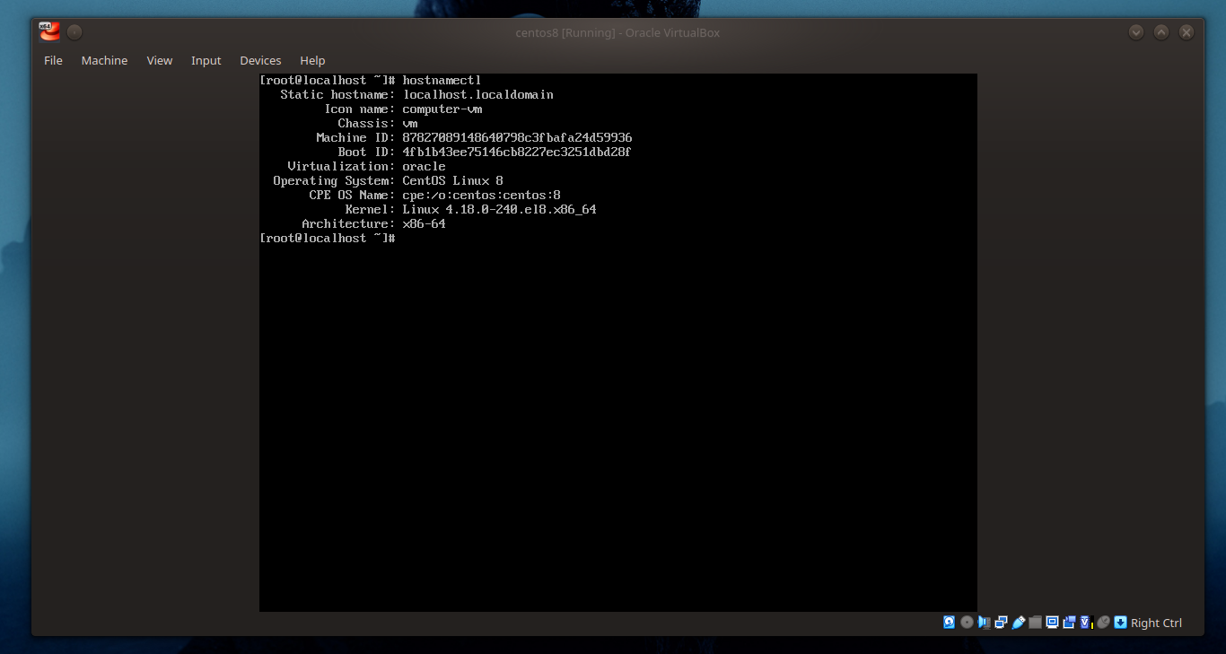

3.tool ni curl -O https://raw.githubusercontent.com/rocky-linux/rocky-tools/main/migrate2rocky/migrat
e2rocky.sh orqali yuklab olamiz
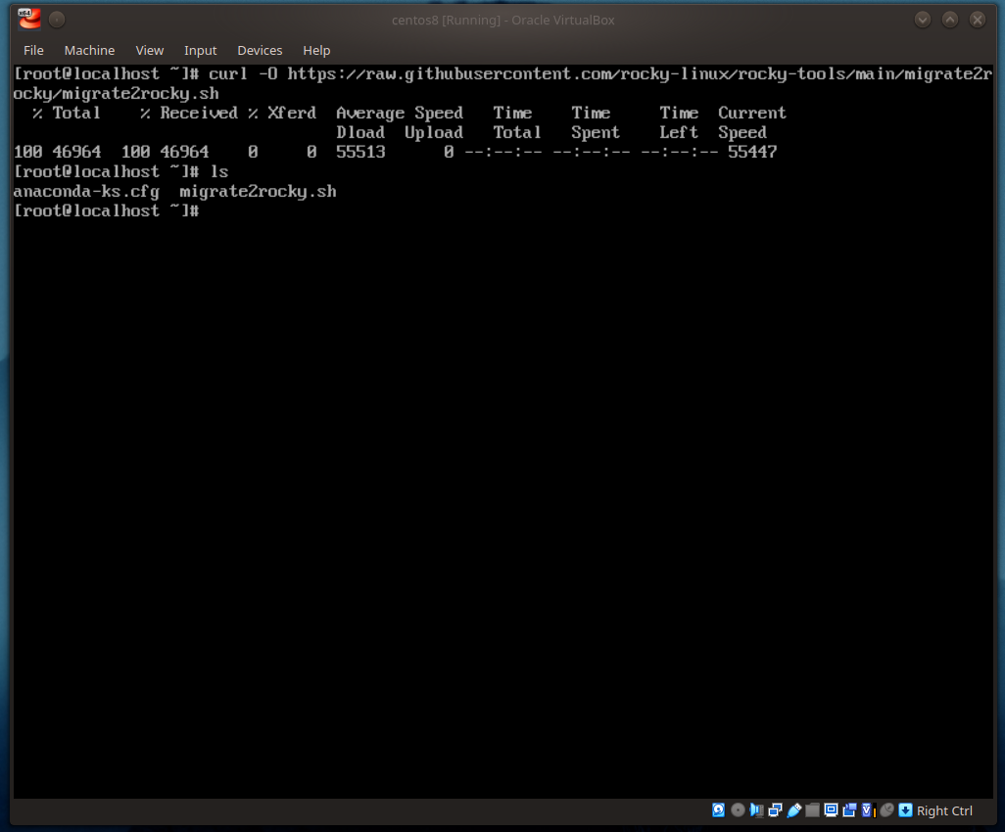

4. yuklagan filemizga +x huquqini beramiz

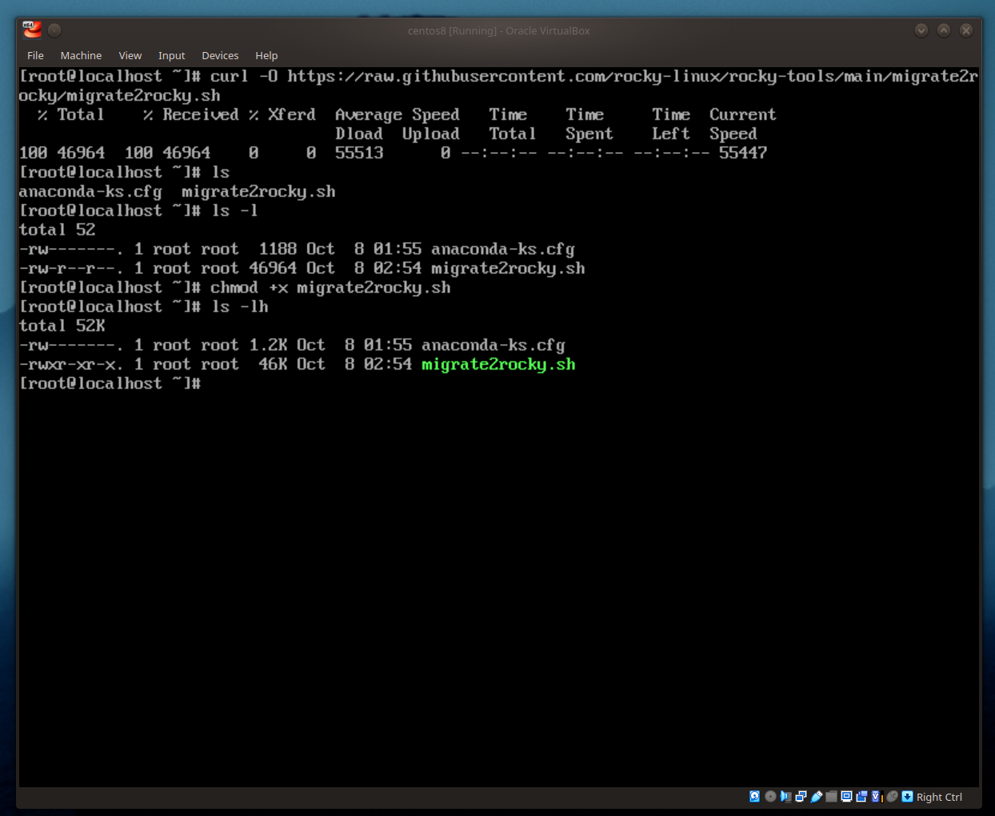

5. endi scriptni ishga tushiramiz

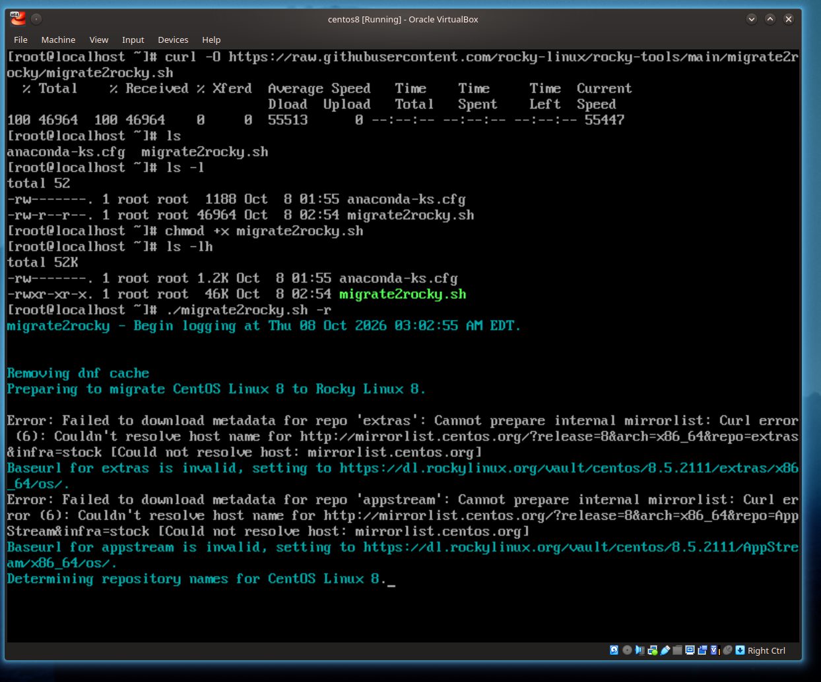

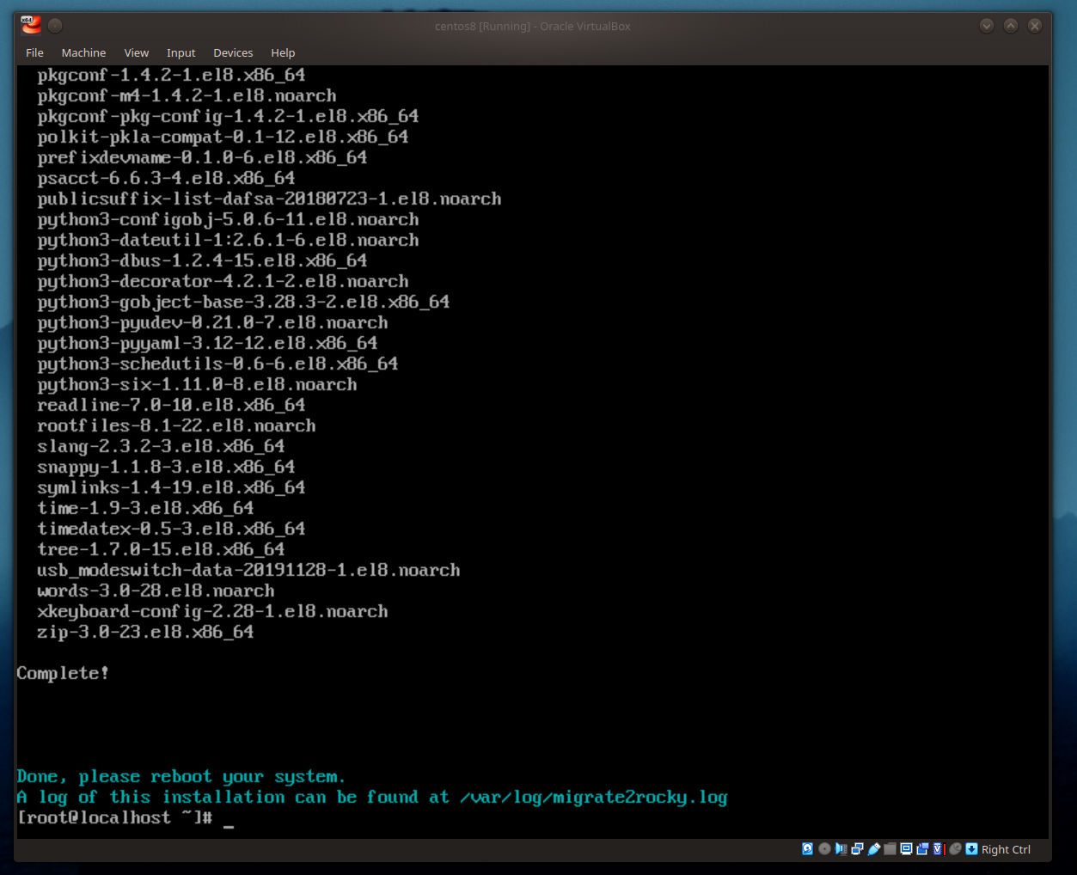

yakunlandi endi reboot beramiz.

