This waiver is provided for informational purposes. All members and participants are encouraged to read and understand the following terms before joining any club activity.
WAIVER AND LIABILITY TERMS
Participation in any activity organized by the Star Touring Motorcycle Club Philippines (the Club) is voluntary and may involve certain risks, including but not limited to accidents, personal injury, or property damage.
The participant acknowledges full responsibility for their own safety, actions, and equipment during rides and events.
The Club and its organizers shall not be held liable for any injuries, damages, or losses incurred during participation in official or unofficial club activities.
All riders are expected to follow traffic rules and safety protocols, including wearing proper safety gear and ensuring their motorcycles are in roadworthy condition.
This waiver remains in effect throughout the participant's involvement with the Club and applies to all current and future events, unless otherwise revoked in writing.
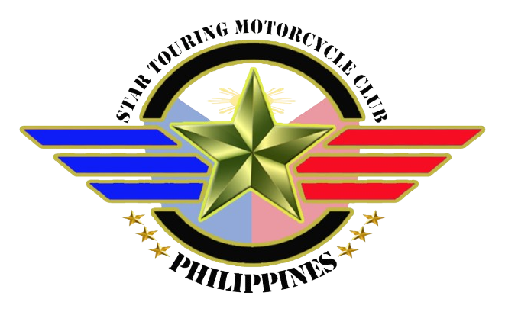
This is a digital copy for viewing only. For signed acknowledgment, please coordinate directly with the Club's administrator.

