

CS26/L – Software Fundamentals and Development
(4381)

Digital Reading Companion: A Multi-Feature Book Tracking System with Google Books API Integration

Submitted to:
Mary Iana Bennel Buisan

Submitted by:
King Ruzzel A. Liquin

December 2025
Table of Contents
The Project 3
Problem 1: Insufficient Reading Habit Development and Consistency Tracking 3
Solution 1: Integrated Habit Formation Through Streak Tracking and Visual Analytics 4
Problem 2: Low Retention and Passive Consumption 5
Solution 2: Integrated Review Management and Active Recall System 5
Problem 3: Digital Disorganization and Fragmentation 6
Solution 3: Centralized Personalization via Relational Database Architecture 6
Conclusion 7
Tools 7
Entity Relationship Diagram 8
Data Dictionary 9
User Interface 12
References 17
Appendix 18

List of Figures
Figure 1: Logo 3
Figure 2: Entity Relationship Diagram 8
Figure 3: Login Page 11
Figure 4: Register/Create Account Page 11
Figure 5: Forgot Password Dialog 12
Figure 6: Create New Password Dialog 12
Figure 7: Search Books Page 13
Figure 8: Currently Reading and Reading Streak Calendar Page 13
Figure 9: Finished Books Page 14
Figure 10: Favorite Books Page 14
Figure 11: Review Dialog 15
Figure 12: Edit Review Dialog 15
Figure 13: Review Details Dialog 16

List of Tables
Table 1: users 9
Table 2: user_books 10
Table 3: books 10
Table 4: reviews 11
Table 5: reading_streaks 11
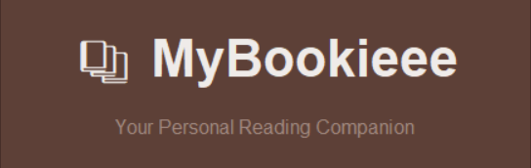

Figure 1: Logo

The Project
MyBookieee is a desktop-based book tracking and management system designed to help readers organize their personal libraries, monitor reading progress, and maintain consistent reading habits. The application addresses the growing need for digital solutions that enhance the reading experience beyond traditional physical bookmarks and paper logs. Its graphical user interface is built using Python’s Tkinter framework for its simplicity, intuitive experience and easy navigation. It also uses MySQL for database management, and integrates with Google Books API to provide a comprehensive platform for readers to search, catalog, and review books while tracking their reading journey.
The system consists of several interconnected modules such as user authentication, book search and exploration, tracking reading progress, managing reviews, and analyzing reading streaks. Due to the rapid rise of digital reading preferences and the abundance of books accessible on different platforms, the system offers readers a unified platform to manage their literary experiences while promoting steady reading habits with the use of gamification features

Problem 1: Insufficient Reading Habit Development and Consistency Tracking
Developing and maintaining consistent reading habits represents a significant challenge for many individuals, particularly in an era of competing digital distractions and demanding schedules which results to the noticeable drop of people being interested in reading specifically, among youths, other dilemmas arise due to consumption of media and instant gratification that leads to shorter attention spans, making it harder to engage in reading (Gore, 2025). To battle this, the tracking of reading books comes in which fosters accountability, goal setting and achievement. Keeping a log transforms reading from a transient activity into a tangible habit, making it more likely to complete books and reach reading goals because of feeling accountable to your own record. (Montalto, 2025). With today’s technology, the digital approach of tracking books is all over. It is now easy to list favorite books and track progress with just one tap, but some systems lack factors that enable users to efficiently manage their reading journey and truly build a consistent habit. These shortcomings in basic digital trackers mean they fail to address the core challenges of inconsistent reading patterns and lost momentum. Without robust accountability measures, like self-monitoring tools for streak maintenance or recognizing reading gaps, the reading habit remains fragile. This absence of a feedback loop limits self-awareness, preventing users from easily identifying their most productive reading times, optimal session durations, or the key factors contributing to their personal reading consistency, ultimately hindering the transformation of reading from a sporadic activity into a sustained and reliable habit.

Solution 1: Integrated Habit Formation Through Streak Tracking and Visual Analytics
MyBookieeee addresses the habit formation challenge through a Gamified Reading Streak Calendar and Analytics System that leverages contemporary behavioral psychology principles and evidence-based gamification mechanics to encourage consistent reading behavior. The system's design incorporates insights in line from the study conducted by Agarwal et al. (2022), who demonstrated through a systematic review of 140 studies that digital habit-tracking applications with visual streak indicators increase behavioral adherence by 47% compared to traditional self-monitoring methods, with particular effectiveness observed in activities requiring daily consistency. Additionally, the system's automated integration between reading progress updates and streak maintenance addresses what Caraban et al. (2019) describe as the "burden of behavior change tracking," wherein manual logging requirements serve as significant barriers to sustained app engagement; their research indicates that automatic tracking mechanisms increase 90-day retention rates by 68% compared to applications requiring manual user input.

Problem 2: Low Retention and Passive Consumption
A critical issue facing modern readers is the "forgetting curve," where reading becomes a passive consumption activity rather than a retention-based learning experience. In digital environments, the speed of interaction often discourages reflective thinking, leading users to consume content without committing it to long-term memory (Ali, 2025). Without a dedicated mechanism to synthesize information, readers often struggle to recall key narratives, themes, or character arcs shortly after finishing a book. Research suggests that writing reviews and maintaining reading notes serves as a form of "retrieval practice," a cognitive strategy that significantly strengthens neural pathways associated with memory (Risak, 2021). However, many general-purpose reading apps lack integrated, friction-free tools for documenting these reflections, forcing users to switch between reading apps and separate note-taking tools, which disrupts the workflow and discourages the habit of review.

Solution 2: Integrated Review Management and Active Recall System
To counter passive consumption, MyBookieee includes a dedicated Review and Rating Module built directly into the Tkinter GUI. This module prompts users to engage in active recall by assigning star ratings and writing textual reviews immediately upon marking a book as "Finished". The system utilizes a MySQL database to persistently store these user-generated reflections, linking them directly to the specific book entry. By effectively "forcing" a moment of reflection, the system transforms the user from a passive consumer into an active critic. As noted by Risak (2021), this act of documentation helps users "uncover paths" in their thinking and contextualize their reading experience. The application’s review interface is designed for simplicity, ensuring that the friction of logging a review is minimal, thereby encouraging consistent use of this retention-boosting feature.

Problem 3: Digital Disorganization and Fragmentation
As users migrate away from physical bookshelves, they often face the challenge of "digital clutter", a lack of spatial organization that makes it difficult to track what they own, what they intend to read, and what they have abandoned. Recent studies on digital library user experience highlight that complicated interfaces and poor personalization features are primary drivers of user dissatisfaction (Abu Bakar et al., 2021, as cited in Evaluating User Satisfaction, 2025). When reading lists are scattered across different platforms such as notes apps, browser bookmarks, e-commerce wishlists), users lose the visual and organizational cues that physical libraries provide. A systematic review of digital libraries confirms that users increasingly demand personalized environments that allow them to organize resources according to their specific behaviors and needs, rather than adhering to rigid, pre-set categories (Marzuki et al., 2025).

Solution 3: Centralized Personalization via Relational Database Architecture
MyBookieee addresses digital fragmentation through a robust Personalized Library Management System anchored by a relational MySQL backend. This architecture allows users to categorize books into distinct, custom statuses such as "Currently Reading", "Favorites", and "Finished".
The Tkinter-based GUI visualizes these database states as distinct "virtual shelves", mimicking the organizational clarity of a physical library while offering the sorting advantages of a digital database. This centralization satisfies the user need for a "personalized shared Web environment" identified in recent literature. By providing a single, unified source of truth for the user’s entire literary life, independent of where the book was purchased or in what format it is read. MyBookieee eliminates the anxiety of digital clutter and restores a sense of ownership and control over one's reading data.

Conclusion
The MyBookieee desktop application effectively tackles the main issues encountered by contemporary readers, specifically, inconsistent reading habits, passive content consumption, and digital library fragmentation. The application utilizes the reading streak calendar, applying gamification to promote accountability and goal attainment, converting irregular reading into a consistent habit by automatically monitoring progress and offering visual streaks. To combat the "forgetting curve" and poor retention, the review feature encourages users to partake in retrieval practice by requesting ratings and reviews after completion, thus changing them from passive consumers to active evaluators. Additionally, the system, using a relational MySQL backend, offers a remedy for "digital clutter". This system consolidates the user’s complete literary experience within the user-friendly Tkinter GUI, displaying book statuses as personalized "virtual shelves" that recapture the organizational clarity of a physical library while providing the comprehensive sorting benefits of a digital database. In conclusion, MyBookieee provides an all-in-one platform that not only organizes a reader's collection fostering a more active, involved reading lifestyle.

Tools
- Python 3.x
- Tkinter (GUI Framework)
- PIL/Pillow (Image Processing)
- MySQL Database
- XAMPP Control Panel V3.3.0
- Google Books API
- Google Browser
- Youtube
- Github

Entity Relationship Diagram
The Entity Relationship Diagram presents a visualization of the connections of the tables and data inside the database. The conceptual data model showcases the data entities, such as users, user_books, books, reviews, and reading streaks associated with its attributes to efficiently store data to the system.
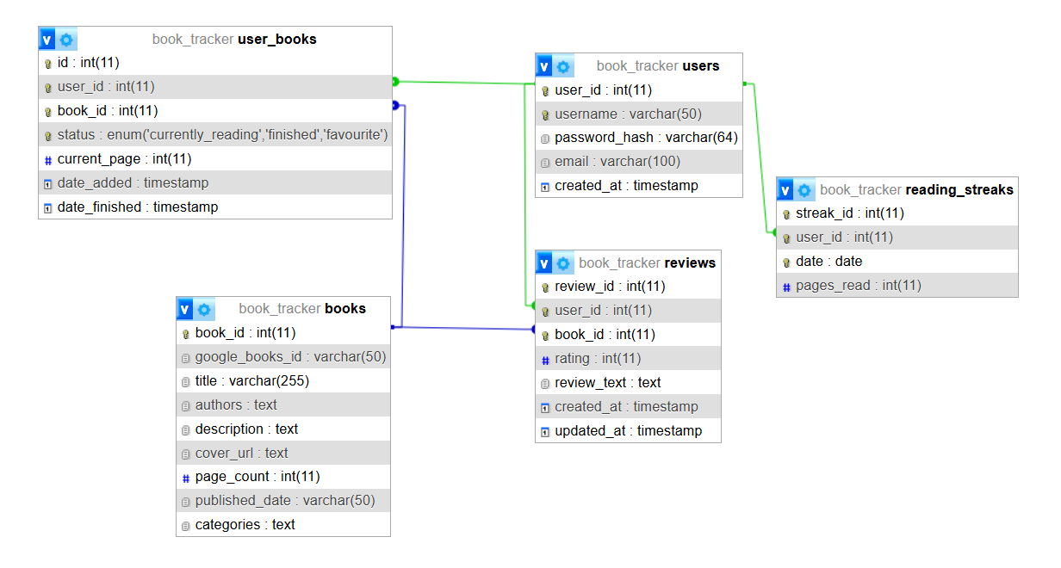

Figure 2: Entity Relationship Diagram

Data Dictionary

Table 1: users
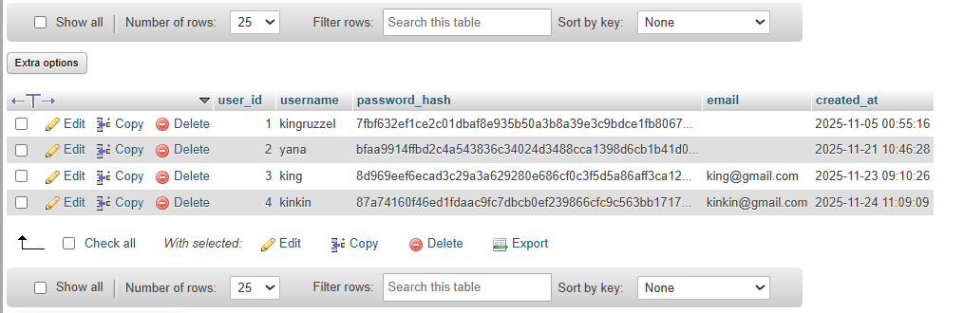

Table 2: user_books
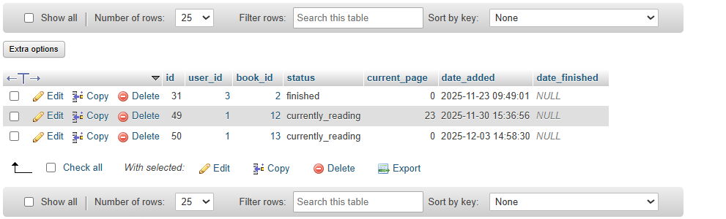

Table 3: books
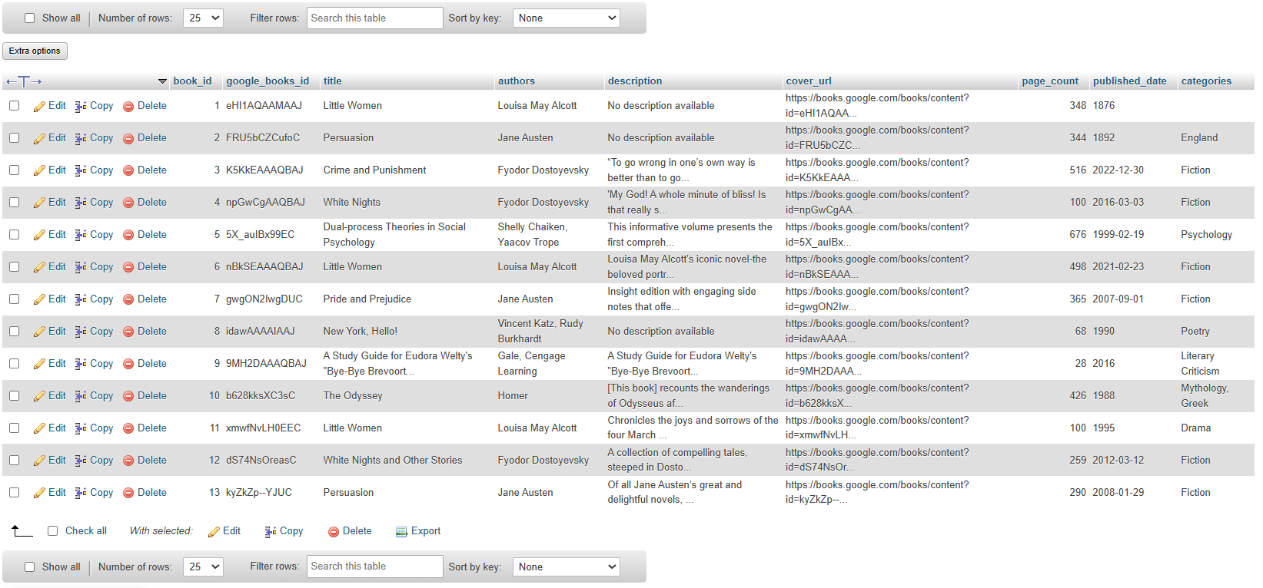

Table 4: reviews
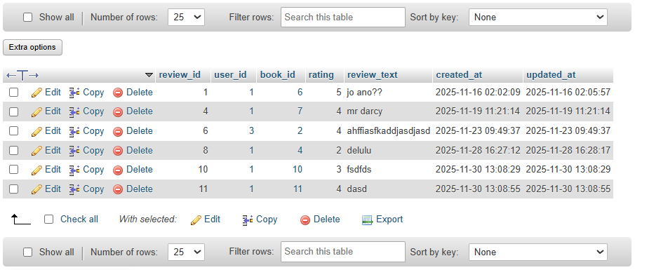

Table 5: reading_streaks
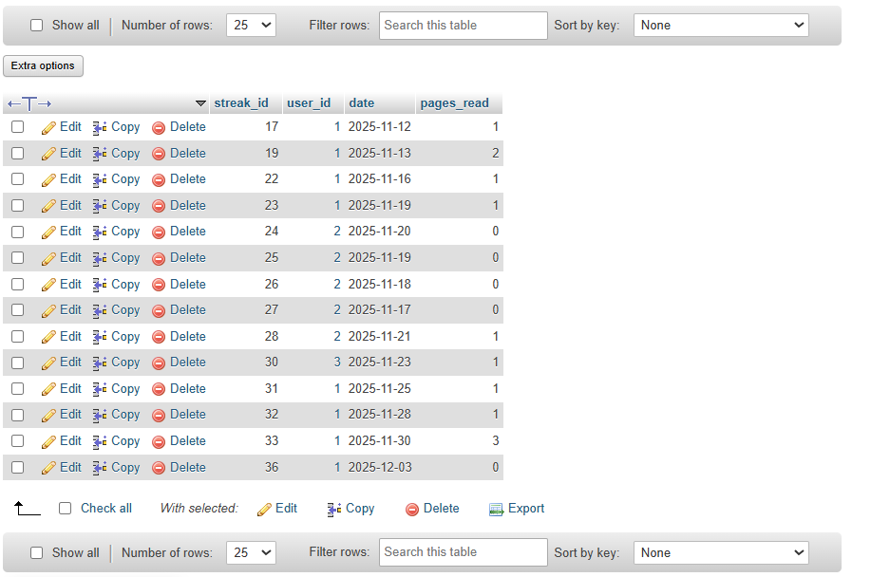

User Interface

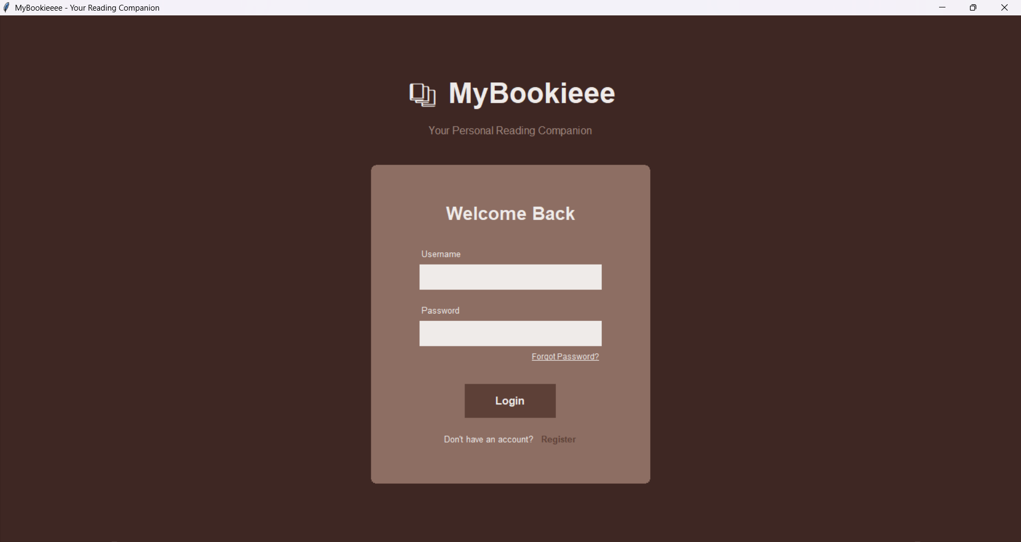

Figure 3: Login Page
Manages user access through a secure login and registration mechanism.
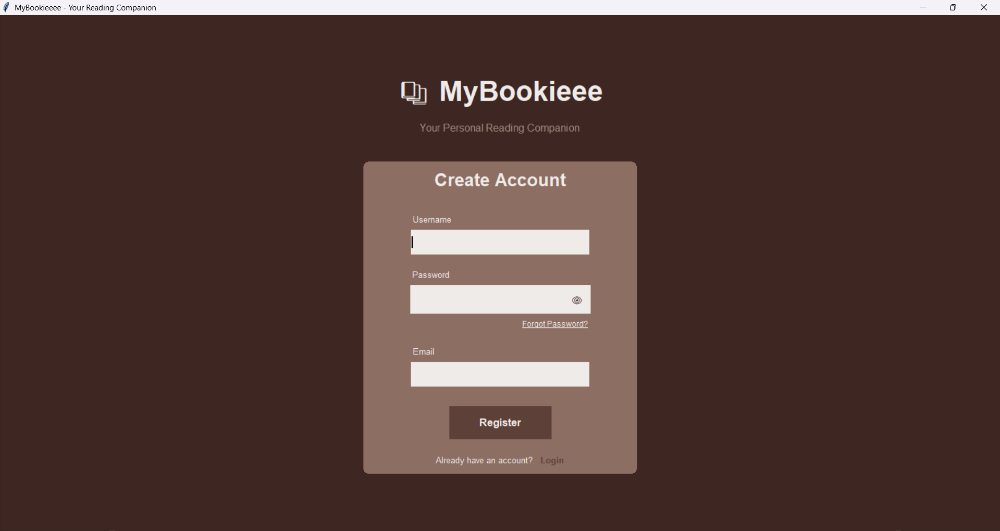

Figure 4: Register/Create Account Page
The registration function asks the user to create an account and stores the data to database.

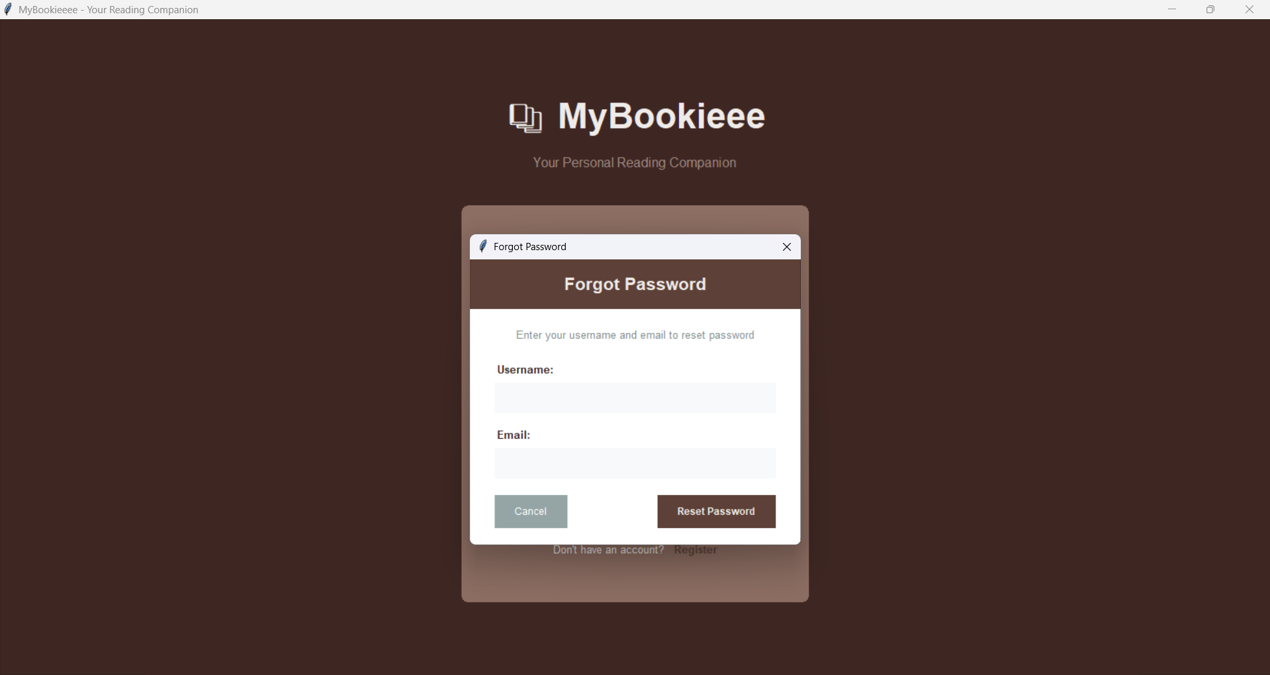

Figure 5: Forgot Password Dialog
When clicked, it asks the user to type the username and email of the account to reset password.
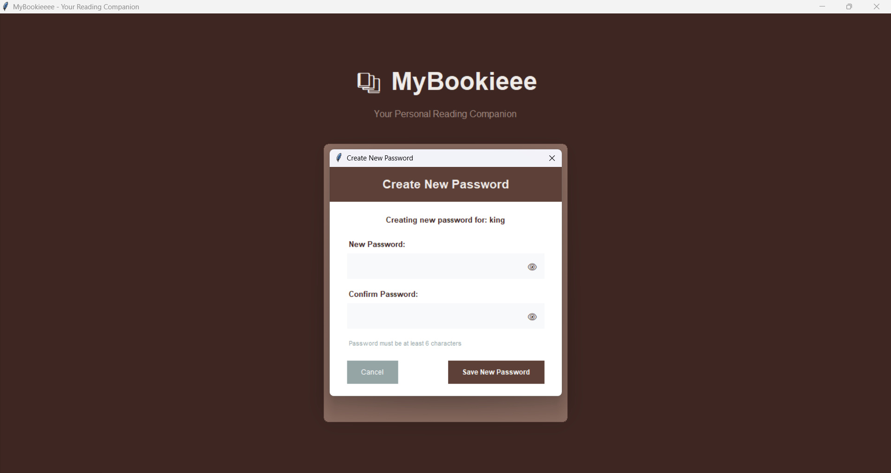

Figure 6: Create New Password Dialog
Ask the user to enter and confirm the password.

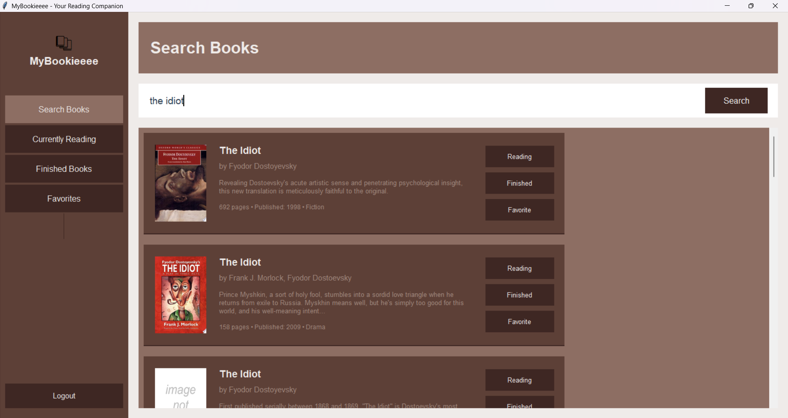

Figure 7: Search Books Page
Search books with the Google Books API to retrieve book information based on user queries.
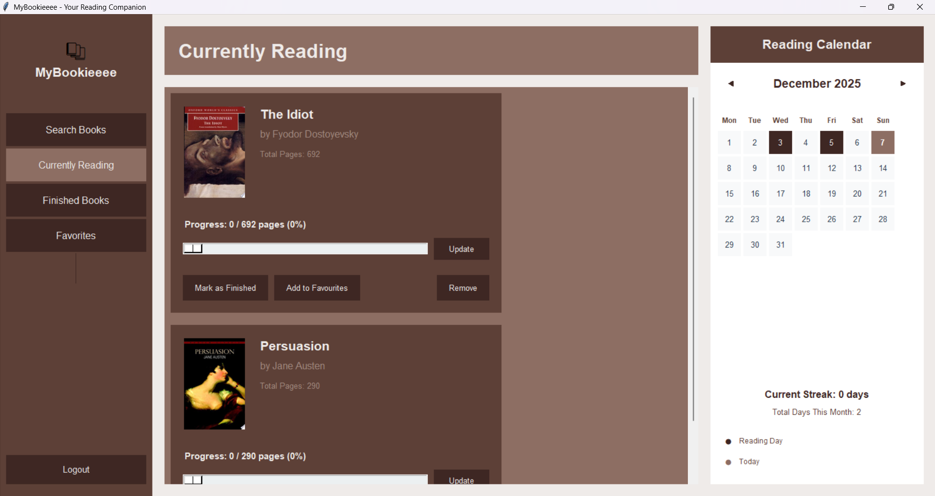

Figure 8: Currently Reading and Reading Streak Calendar Page
Displays the books the user currently reads to track progress with the reading streak calendar.
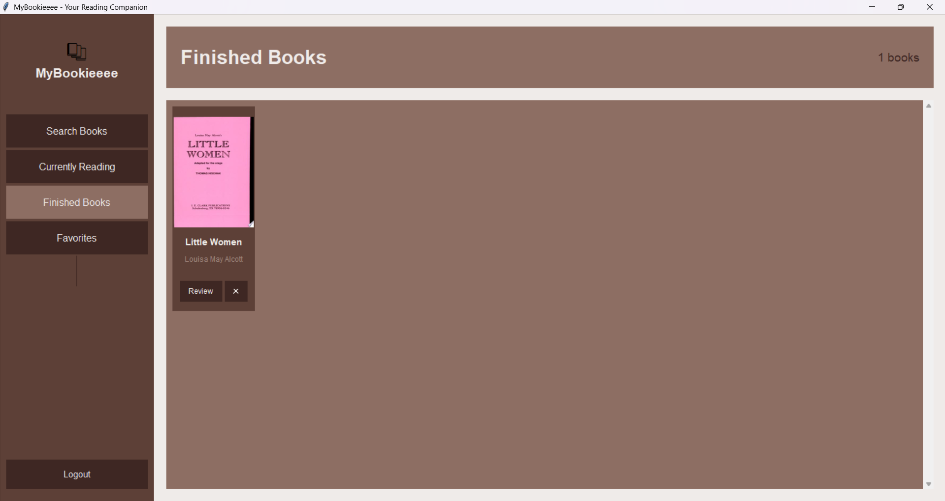

Figure 9: Finished Books Page
Display books the user finished reading and write a review by clicking on the ‘Review’ button.
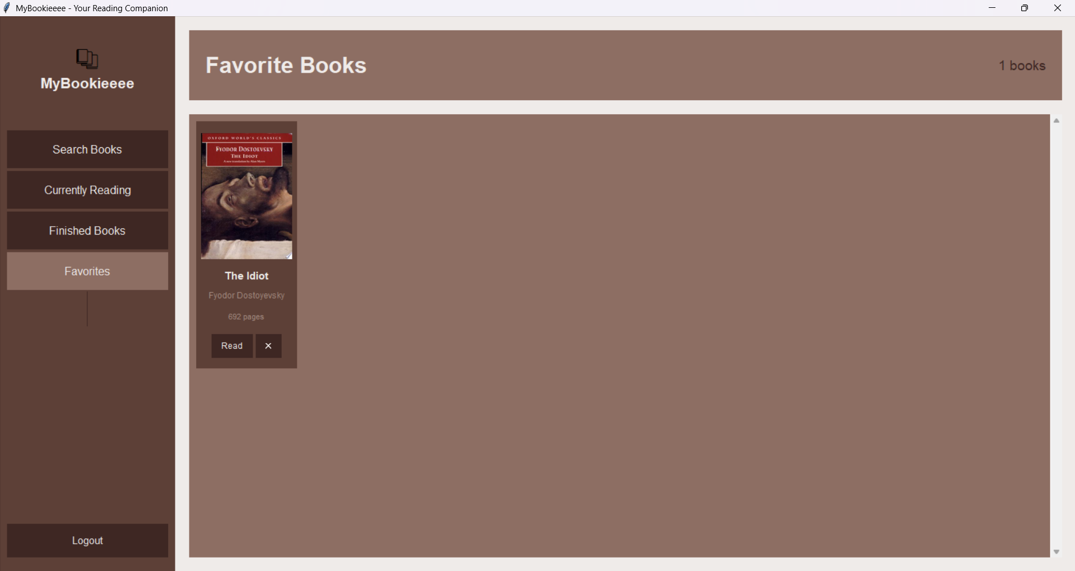
Figure 10: Favorite Books Page
Display books the user marked as favorite, can be put back to the ‘Currently Reading’ page just by clicking the ‘Read’ button.
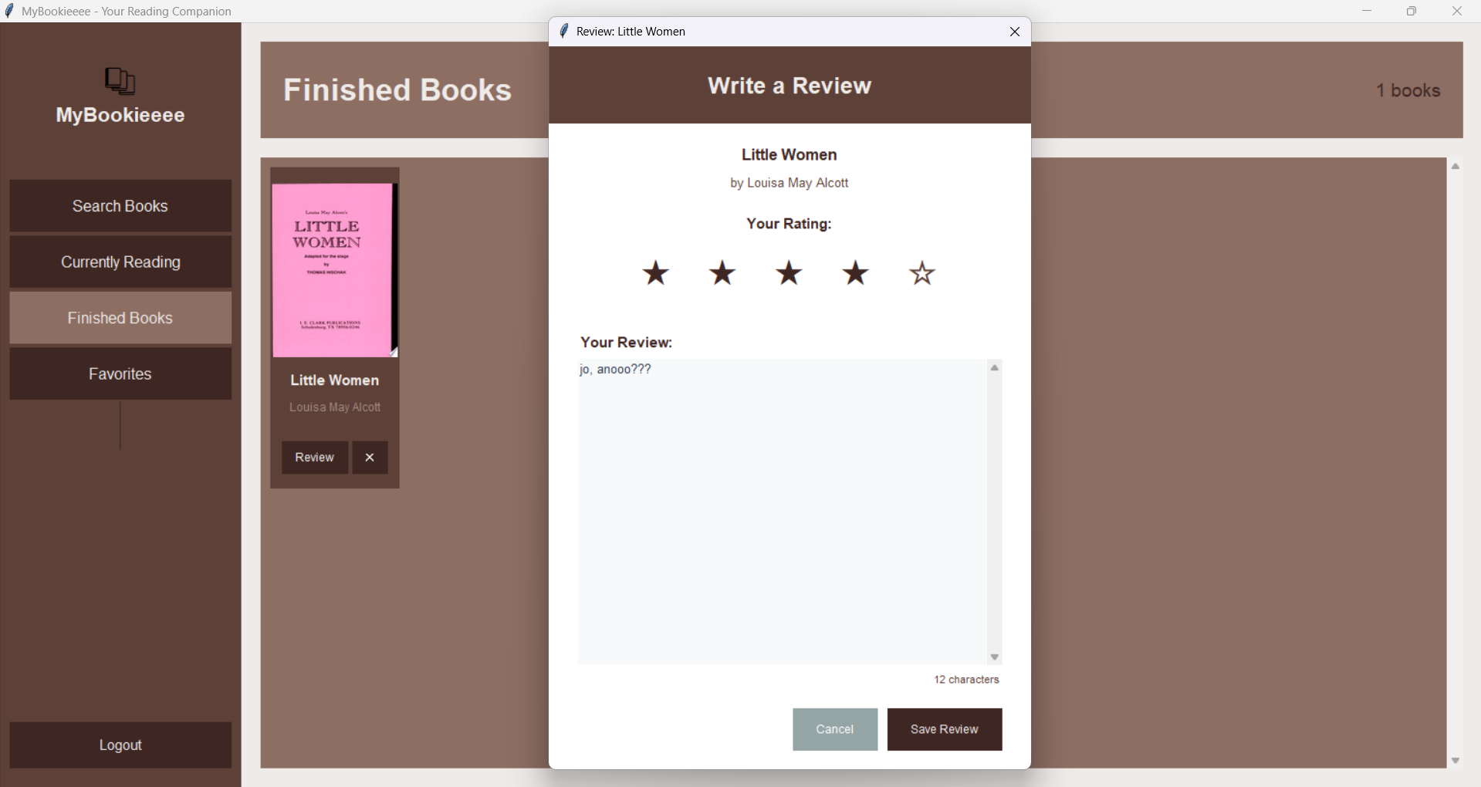

Figure 11: Review Dialog
Dialog where the user rate a book with stars, write a review and save.
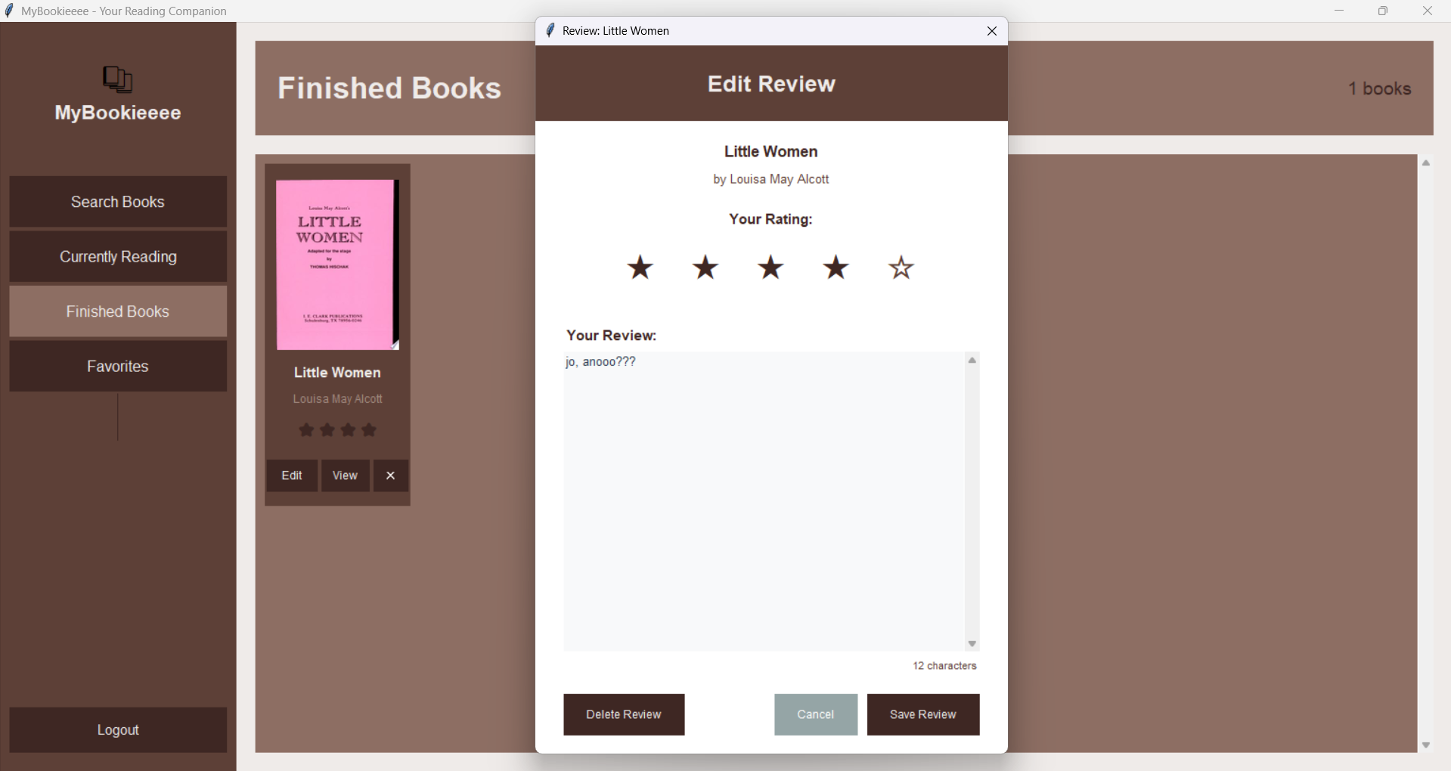
Figure 12: Edit Review Dialog
Dialog where the user can edit a review by clicking the ‘Edit’ button
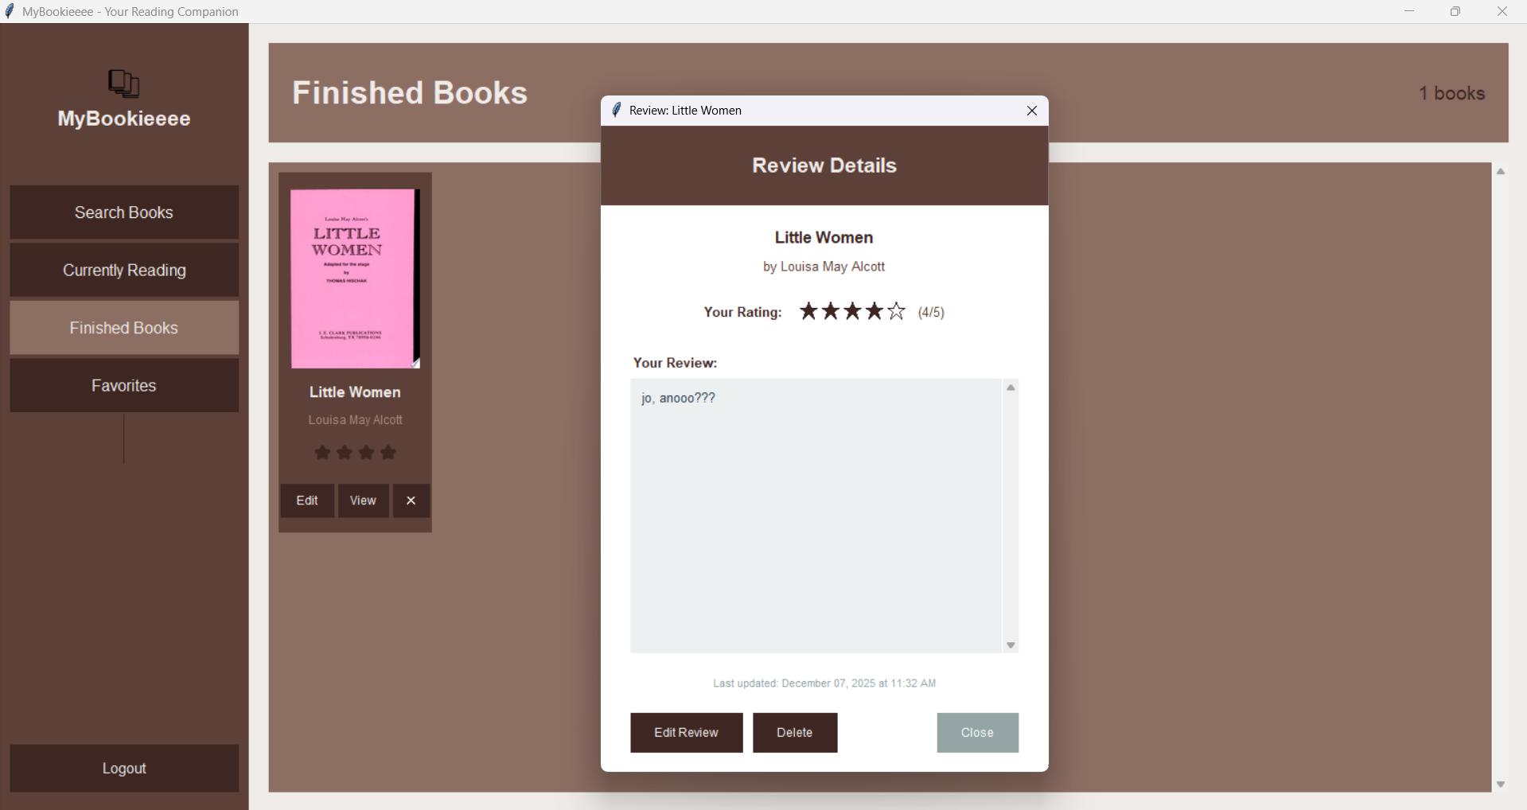

Figure 13: Review Details Dialog
Dialog to show the details of the user’s review by clicking the ‘View’ button

References
Gore, K. V. (2025). Evaluation of Promoting Reading Culture: Challenges and Opportunities. International Journal of Technology, Management and Social Sciences (IJTMSS), Volume 3(Issue 1).
Montalto, S. (2025). Why every reader should track their reading. Book Tracker. https://booktrack.app/blog/why-every-reader-should-track-their-reading/
Agarwal, S., LeFevre, A. E., Lee, J., L’Engle, K., Mehl, G., Sinha, C., & Labrique, A. (2022). Guidelines for reporting of health interventions using mobile phones: mobile health (mHealth) evidence reporting and assessment (mERA) checklist. BMJ, 352, i1174. https://doi.org/10.1136/bmj.i1174
Caraban, A., Karapanos, E., Gonçalves, D., & Campos, P. (2019). 23 Ways to Nudge. CHI Conference on Human Factors in Computing Systems, Paper No. 503, 1–15. https://doi.org/10.1145/3290605.3300733
Cognitive Biases in digital decision making: How consumers navigate information overload (Consumer behavior). (2025). Advances in Consumer Research. https://acr-journal.com/article/cognitive-biases-in-digital-decision-making-how-consumers-navigate-information-overload-consumer-behavior--889/
Risak, S. (2021). The benefits of writing book reviews. Writer'S Digest. https://www.writersdigest.com/write-better-nonfiction/the-benefits-of-writing-book-reviews
Evaluating User Satisfaction with Digital Library Services: A Study of Academic Libraries in Higher Education Institutions - International Journal of Research and Innovation in Social Science. (2025). International Journal of Research and Innovation in Social Science. https://rsisinternational.org/journals/ijriss/articles/evaluating-user-satisfaction-with-digital-library-services-a-study-of-academic-libraries-in-higher-education-institutions/
Marzuki, M., Azero, S. F. Z., Zamzuri, N. a. a. M., & Kadir, M. R. A. (2025). A Systematic Literature Review of User Behavior and Personalization in Digital Libraries. International Journal of Research and Innovation in Social Science, IX(I), 4830–4842. https://doi.org/10.47772/ijriss.2025.9010372
Appendix

