Synopsis-

Project Name – Online Quiz Portal

It’s a portal on which a student can go through a Quiz created by various companies or organization which are registered with the website

Student module -

A student first has to register and chose from the list of available exams. After the exam he/she view his/her performance in the form of bar charts and also the records of the previous exam given. He/she can also compare his/her performance with other students who have given the exams

Company module -

A company first has to register and the it can create any number of exam under their name and can also view how many students have given their exam and can also view the performance of the student who have appeared for the exam

Code Example –

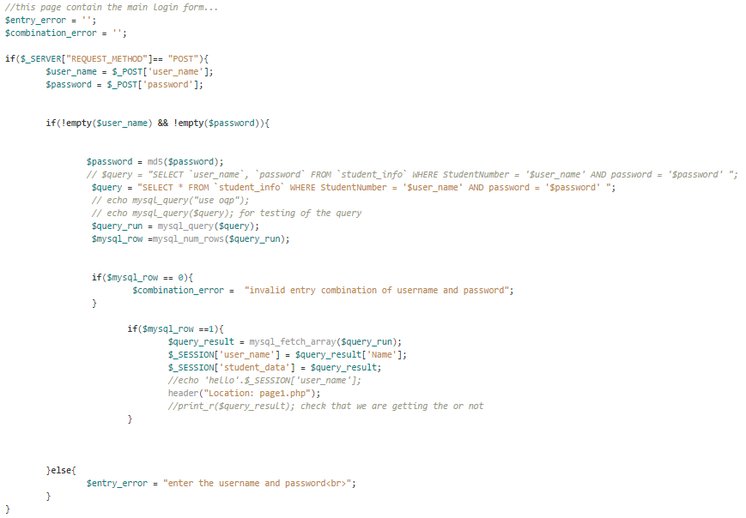

Contributors-

1.Rupanshu verma

2.Satvik Daga

3.Sagarika vishnoi