**Assignment–1**

Covid-19 Information Tracking System

Name: Rushil Venkateswar

Date: 23-Jan-23

## **Details of Entities**

1. Case: This entity denotes a confirmed Covid case (also known as patient). It has relations with the Person, Doctor and Hospital entities.
2. Doctor: This entity is self-descriptive. It has connections to the Case entity (supervisingDoctor), Hospital entity (worksAt).
3. Hospital: This entity is self-descriptive. It has admittedAt, worksAt and hospitalInventory relations.
4. VaccinationCenters: This entity is self-descriptive. It has vaccinationCenterInventory, vaccinationInfo relations. The vaccinationInfo itself has attributes like vaccinationDate and vaccineName.
5. TestingLab: This entity has labInventory and covidInfo relations. The covidInfo has attributes like hasCovid and testingDate.
6. Person: This entity is self-descriptive. It has vaccinationInfo, covidInfo and isPatient.
7. Inventory: This entity is self-descriptive. It has hospitalInventory, labInventory and vaccinationCenterInventory.

## Details of Relationships

1. admittedAt: admitDate and releaseDate(optional) attributes.
2. supervisingDoctor
3. worksAt
4. hospitalInventory
5. labInventory
6. vaccinationCenterInventory
7. covidInfo: hasCovid and testingDate attributes.
8. vaccinationInfo: vaccineName and vaccinationDate attributes.
9. isPatient

## Implementation of Features:

1. **Reporting the prevalence and progress of pandemic with time, among various patient profiles, geographical units like districts and states**:

The user can make queries to the Case entity to get the patient count based on Districts, States, Age, Gender. The count based on time can be obtained by the infectionDate attribute.

1. **Tracking symptoms and variants that are currently common**:

The case entity has symptop and variants attributes for this.

1. **Use of healthcare resources and inventory management for future readiness:**

The healthcare resources used by each entity like Hospital, VaccinationCenter and TestingLab is stored in the inventory. It can be accessed to get the relevant info.

1. **Contact tracing:**

Contact tracing can be done by finding the PIN code, district of the patient and then using their phone number and aadhar data along with the Aarogya Setu to perform contact tracing.

## ER Diagram

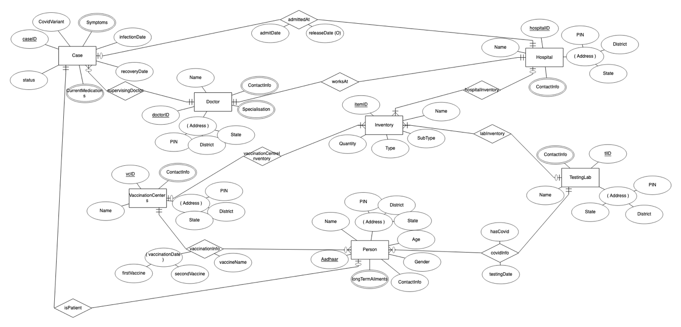

## Schema

