RESEARCH PROJECT REPORT
Reproducing Gradient-Based Learning for Handwritten Digit Recognition
Based on LeCun et al. (1998)
Student: Raj Verma
Program: Integrated M.Tech in Artificial Intelligence
VIT Bhopal University
Academic Year: 2026–27

Abstract
This project presents a small, reproducible implementation inspired by the research paper “Gradient-Based Learning Applied to Document Recognition” by LeCun, Bottou, Bengio and Haffner (1998). The paper established the effectiveness of convolutional neural networks (CNNs) for handwritten-character recognition. To make the research practical for a student-scale project, a compact CNN was implemented in PyTorch and trained on scikit-learn’s handwritten digits dataset. The dataset contains 1,797 grayscale 8×8 images across ten digit classes. After stratified train/validation/test splitting, the model achieved 96.94% accuracy and 96.92% weighted F1 on the held-out test set. The project demonstrates the core research idea—using convolutional layers to exploit two-dimensional image structure—without claiming to reproduce the original paper’s historical experiments exactly.

Keywords
Convolutional Neural Network, handwritten digit recognition, deep learning, backpropagation, image classification, PyTorch.

1. Introduction
Handwritten digit recognition is a classic pattern-recognition problem. A digit image contains local spatial structures such as edges, curves and strokes. CNNs are designed to learn such local patterns using shared convolutional filters, reducing the need for manually engineered features. LeCun et al. reviewed gradient-based learning for document recognition and showed the advantages of CNN-based approaches for two-dimensional character patterns.

2. Research Paper Selected
LeCun, Y., Bottou, L., Bengio, Y., & Haffner, P. (1998). Gradient-Based Learning Applied to Document Recognition. Proceedings of the IEEE, 86(11), 2278–2324. DOI: 10.1109/5.726791. The paper discusses multilayer neural networks, convolutional neural networks, handwritten character recognition, and globally trained document-recognition systems.

3. Problem Statement
Build a compact CNN that can classify handwritten digits and demonstrate, through an executable experiment, why convolutional architectures are appropriate for two-dimensional handwritten patterns.

4. Objectives
1) Study the main CNN ideas presented in the selected paper.
2) Build a small CNN from scratch using PyTorch.
3) Train and evaluate the model on a public handwritten-digit dataset.
4) Measure accuracy, precision, recall and F1-score.
5) Visualize training behavior and classification errors.
6) Produce a reproducible GitHub-ready implementation.

5. Dataset
The project uses scikit-learn’s `load_digits` dataset. It contains 1,797 samples, 10 classes and 64 pixel features corresponding to 8×8 grayscale images. Pixel values range from 0 to 16. The dataset is small enough to train quickly on a CPU and is suitable for demonstrating the CNN pipeline.

6. Methodology
The images are normalized by dividing pixel values by 16. The data is split using stratification: 68% training, 12% validation and 20% test. The CNN contains two convolutional blocks followed by a dense classifier. Each convolution uses a 3×3 kernel with padding, followed by ReLU activation and 2×2 max pooling. The extracted representation is flattened and passed through a 64-unit dense layer with ReLU and dropout, followed by a 10-class output layer. Cross-entropy loss and the Adam optimizer are used for training.

7. Architecture
Input: 1×8×8 image → Conv(1,16,3×3) → ReLU → MaxPool → Conv(16,32,3×3) → ReLU → MaxPool → Flatten → Dense(64) → ReLU → Dropout(0.2) → Dense(10). The final class is the digit with the highest output probability.

8. Experimental Setup
Framework: PyTorch. Dataset utility: scikit-learn. Evaluation: accuracy, weighted precision, weighted recall and weighted F1-score. Random seed: 42. Batch size: 64. Initial learning rate: 0.001. Optimizer: Adam. Maximum epochs: 30. Early stopping was configured with validation patience of 6 epochs.

9. Results
The trained model reached 96.94% test accuracy, 97.01% weighted precision, 96.94% weighted recall and 96.92% weighted F1. Training completed for 30 epochs. The confusion matrix and training-accuracy plot are included in the project repository. The result is an educational adaptation and should not be compared directly with the original paper’s historical benchmark numbers because the dataset and architecture are different.
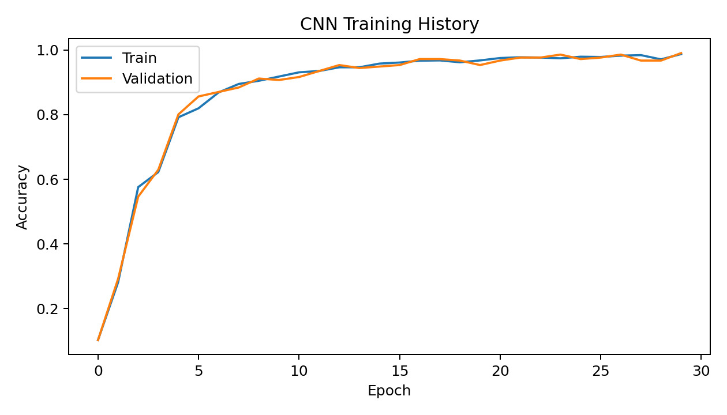
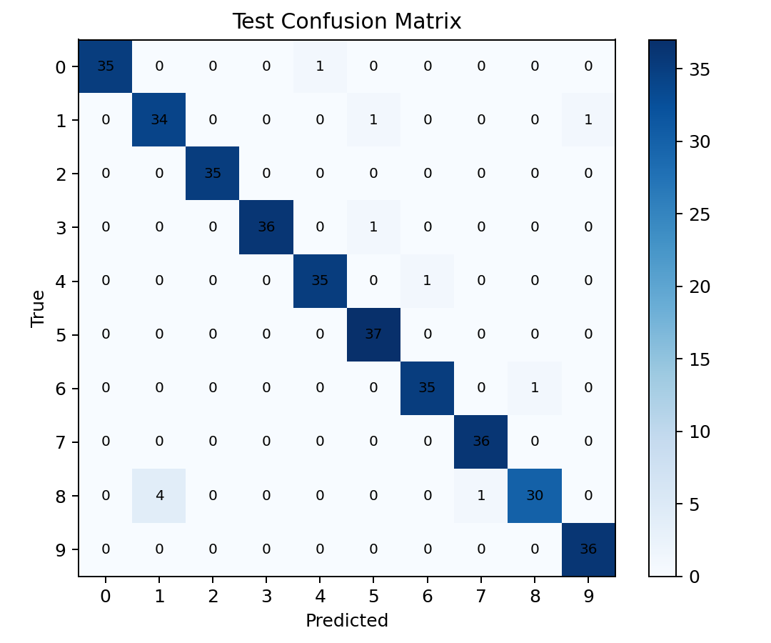

10. Discussion
The result shows that even a small CNN can learn useful spatial representations from handwritten digits. Convolution and pooling reduce the dimensionality while retaining local patterns. Most test examples are classified correctly; remaining errors are expected because some handwritten digits have similar shapes. The project also demonstrates a key research-to-project workflow: read the original idea, simplify the experimental setting, implement the central method, evaluate it, and state the limitations honestly.

11. Limitations
The implementation is not an exact reproduction of the original paper. The dataset is much smaller and the model is substantially simpler. The project does not reproduce the original document-recognition pipeline, cheque-reading system, or historical hardware/software environment. The scikit-learn digits dataset is also only 8×8 pixels, so it does not represent the complexity of modern document images.

12. Future Scope
The project can be extended to MNIST or EMNIST, higher-resolution images, data augmentation, batch normalization, deeper CNNs, transfer learning, an interactive drawing interface, and comparison against classical models such as SVM and Random Forest. A stronger research extension would evaluate robustness under image rotation, noise and blur.

13. Conclusion
A compact CNN was successfully implemented and evaluated for handwritten digit classification. The project achieved 96.94% held-out test accuracy and demonstrates the central practical idea behind the selected research paper: convolutional architectures are well suited to learning spatial patterns in handwritten characters. The complete implementation is reproducible and designed to run on a normal student laptop.

14. References
[1] Y. LeCun, L. Bottou, Y. Bengio, and P. Haffner, “Gradient-Based Learning Applied to Document Recognition,” Proceedings of the IEEE, vol. 86, no. 11, pp. 2278–2324, 1998, doi: 10.1109/5.726791.
[2] scikit-learn, “load_digits,” scikit-learn documentation.
[3] PyTorch documentation, neural-network and optimization APIs.

