Enterprise AI Foundry
The Complete Strategic Framework for Industrializing AI Product Creation
From Idea to Scale: A Comprehensive Analysis of Building Multiple AI Products with Unified Infrastructure
June 2026 | Strategic Framework & Infrastructure Guide

PART 1: THE PROBLEM

The Core Challenge: Why Ideas Don't Become Outcomes
Every large organization has more AI ideas than it can execute. Federal agencies identify use cases for conversational knowledge access, fraud detection, document intelligence, and case management. Healthcare systems see opportunities in patient risk prediction and clinical decision support. Financial services recognize value in fraud scoring, demand forecasting, and regulatory compliance automation.
Yet most of these ideas never ship.
Organizations that do deploy AI products consistently hit the same ceiling: between 5 and 8 independent systems. After that, each subsequent product takes longer, costs more, and carries higher risk. By the time they attempt their 6th or 7th system, coordination overhead becomes the primary constraint. Not engineering capacity. Not model quality. Coordination overhead.
This pattern is consistent enough across federal agencies, healthcare systems, and financial services that it looks like a law of organizational physics. But it is not. It is an architectural problem with an architectural solution.

Why Organizations Stall at 5-8 Systems
The journey from "we should build this" to "this is generating business value" is far longer than expected: typically 18-24 months. But not because of engineering. Engineering is 6-8 weeks. The other 16+ months goes to governance alignment, compliance validation, cost estimation, risk assessment, pilot programs, organizational buy-in, and operational handoff.
Organizations report a consistent pattern:
- System 1: 18 months to production
- System 2: 16 months to production
- System 3: 14 months to production
- System 4-5: 14-16 months to production
- System 6: 20+ months (coordination overhead becomes unbearable)
- System 7+: Project stalls
This happens because each system solves governance independently, solves versioning independently, solves evaluation independently, solves cost tracking independently, and solves ownership independently. By the time the organization realizes these should be unified, they have already made independent decisions four times over.
Retrofitting unified infrastructure at that point is expensive and disruptive. The 6-system ceiling becomes locked in.

PART 2: THE SOLUTION

Enterprise AI Foundry: Infrastructure as the Competitive Advantage
Enterprise AI Foundry is not a product. It is a repeatable framework, infrastructure system, and operating model that eliminates the "6-system ceiling" by providing six operational layers that every AI product inherits automatically.
With the Foundry in place:
- First product: 12 weeks from idea to MVP
- Second product in same domain: 2-3 weeks
- Tenth product: 2-3 weeks
- Organizational ceiling moves from 5-8 systems to 50-60+ systems
- Learning compounds across products instead of siloing per product
The difference is not engineering talent or model quality. The difference is infrastructure.

The Pipeline and Six Layers Framework
Every AI product takes the same journey through six stages:

Pipeline Stages:
- 1. Idea — Problem identification, governance assessment, cost estimation
- 2. Prototype — Engineering, algorithm selection, pattern development
- 3. Pre-MVP — Integration, operational hardening, readiness validation
- 4. MVP — Initial production deployment, user feedback, optimization
- 5. Productionize — Full deployment, scaling, operational excellence
- 6. Scale — Template maturity, organizational scaling, knowledge compounding

Six Operational Layers:
- 1. Governance-as-Architecture
- 2. Versioning-and-Rollback
- 3. Continuous-Evaluation
- 4. Domain-Templating
- 5. Cost-Attribution
- 6. Operational-Ownership
Each layer is activated at different times in the pipeline. Understanding how they work together is the key to understanding the business model.

PART 3: THE SIX OPERATIONAL LAYERS—DETAILED BUSINESS MODEL

Layer 1: Governance-as-Architecture

What It Is and Why It Matters
Governance-as-Architecture means compliance, security, audit, and access control rules are defined once at the Foundry level, not per-system. Rather than each product architect its own governance, all products inherit a unified governance model.
This is not a constraint. It is the foundation that makes scaled deployment possible.
In organizations without this layer, each new product requires custom compliance review (8-12 weeks). Regulatory changes require manual updates to every system. Audit evidence is collected manually. Security requirements are interpreted independently per system.
In organizations with this layer, compliance is built into every product automatically. Regulatory changes propagate centrally. Audit evidence is generated automatically. Security is consistent across all systems.

Idea Stage: Governance Boundaries Surfaced
- What Happens:
- The Foundry immediately surfaces compliance implications:
- What data residency requirements apply?
- What audit logging is required?
- What access controls must be enforced?
- What encryption standards apply?
- What regulatory frameworks apply?
Before any engineering begins, the organization knows the regulatory path is viable and the governance constraints are understood.
- Business Value:
- Prevents wasted effort: Ideas that are infeasible due to compliance constraints are identified before engineering begins
- De-risks projects: Organizations know the regulatory path before investing engineering resources
- Enables realistic timelines: Compliance requirements are factored into planning from day 1

Prototype Stage: Governance Built-In
As engineering begins, governance is not an afterthought bolted on later. The Foundry provides governance templates that engineering follows from day 1: access control patterns, audit logging patterns, data encryption patterns, security configuration patterns, and compliance evidence patterns.
- Business Value:
- Reduces engineering rework: Engineers don't build something then retrofit compliance. Compliance is built in.
- Reduces security review cycles: Systems built from compliant patterns pass security review faster
- Enables rapid iteration: Teams are not blocked waiting for compliance signoff

Pre-MVP Stage: Governance Validation
Before MVP deployment, the Foundry validates that the system actually meets governance requirements: audit logging is working, access controls are enforced, encryption is working, compliance evidence is complete.
- Business Value:
- De-risks production: No surprises when moving to production
- Accelerates compliance sign-off: Compliance teams see evidence is complete
- Reduces compliance review cycles: Compliance teams don't need to audit; evidence is already there

MVP Stage: Governance Monitoring Active
Once in MVP, governance monitoring is continuous. The Foundry is watching: are audit logs being generated? Are access controls being enforced? Is encryption working? Are there any policy violations?
- Business Value:
- Detects compliance drift: If someone misconfigures a security setting, the Foundry detects it
- Enables incident response: If there's a security incident, complete audit logs are available
- Supports compliance audits: Auditors can see continuous evidence of compliance

Productionize Stage: Governance at Scale
As the system scales to full production: compliance requirements remain consistent as load increases, audit logs are collected at scale without performance impact, access controls are enforced consistently with high throughput, regulatory updates propagate without disrupting production.
- Business Value:
- Scales without losing compliance: High-load systems remain compliant
- Reduces operational overhead: Governance is not a scaling bottleneck
- Supports continuous improvement: Compliance baseline is stable

Scale Stage: Governance Inheritance
When Product 2 is deployed using Product 1's template, the governance model is inherited automatically: same access control model, same audit logging infrastructure, same encryption standards, same compliance requirements, same evidence collection.
- Business Value:
- Eliminates governance rework: New products are compliant from day 1
- Ensures consistency: All products follow same governance model
- Enables rapid deployment: No compliance review needed for Product 2

Business Model Impact
Governance-as-Architecture changes the business model from: "Each product = custom compliance engineering + security review (16+ weeks)" to "Each product = governance built-in + automated validation (2 weeks)"

Layer 2: Versioning-and-Rollback

What It Is and Why It Matters
Versioning-and-Rollback means all changes (knowledge updates, model changes, retrieval logic changes, ranking changes) are tracked as explicit versions. New versions are tested before production deployment. Rollback is automatic if a version degrades quality.
In organizations without this layer, knowledge updates are quarterly (too risky to do more frequently). If a bad update ships, rollback requires manual intervention. Teams are afraid to update, so systems get stale.
In organizations with this layer, knowledge updates are weekly (safe because versions are tested). Bad updates are automatically detected and rolled back. Teams continuously improve the system.

Idea Stage: Versioning Strategy Defined
At Idea stage, the Foundry defines the versioning strategy: what will be versioned? How frequently will versions be released? What testing is required? How long are old versions kept? What is the rollback procedure?
Business Value: Sets update cadence expectations, plans for iteration, manages risk upfront

Prototype Stage: Versioning Infrastructure Built
As engineering begins, versioning infrastructure is set up: version control system initialized, staging environment ready for version testing, version testing automated, version metadata captured.
Business Value: Enables safe experimentation, accelerates optimization, builds version history

Pre-MVP Stage: Versioning Validation
Before MVP, the Foundry validates that versioning infrastructure is working: can we deploy a new version to staging? Can we run automated tests? Can we detect quality degradation? Can we rollback if needed?
Business Value: De-risks production, builds confidence, establishes baseline

MVP Stage: Versioning Active
In MVP, versions are being updated based on user feedback and quality metrics: Version 1.0 deployed, feedback shows accuracy is 89% and users want more domain coverage, Version 1.1 deployed (added knowledge, accuracy improves to 91%), latency slightly higher, Version 1.2 deployed (optimized retrieval, accuracy stays at 91%, latency improves).
Business Value: Rapid feedback loops, data-driven iteration, user engagement, team velocity

Productionize Stage: Versioning at Scale
As the system scales to full production: version updates continue at the established cadence, all production instances are updated to new versions, version rollback is transparent to users, version history is maintained for audit.
Business Value: Continuous improvement at scale, no downtime for updates, user experience stability, audit trail maintained

Scale Stage: Versioning Optimization Compounds
When Product 2 is deployed using Product 1's template: Product 1 discovered that chunking strategy X works better than Y, Product 2 starts with chunking strategy X (not needing to discover it), Product 1 discovered model B is more efficient than model A, Product 2 uses model B from day 1.
Business Value: Accelerated optimization, compounding learning, increasing quality

Business Model Impact
Versioning-and-Rollback changes the business model from: "Update the system quarterly with large changes" (high risk, slow feedback) to "Update the system weekly with small, validated changes" (low risk, fast feedback)

Layer 3: Continuous-Evaluation

What It Is and Why It Matters
Continuous-Evaluation means quality metrics (accuracy, hallucination rate, latency, cost per query, user satisfaction) are measured automatically on every query. Not measured periodically. Continuously.
In organizations without this layer, quality is assessed periodically by sampling. Quality problems are discovered days or weeks after they occur. Issues are addressed reactively.
In organizations with this layer, quality is measured continuously. Problems are detected in minutes. Issues are addressed proactively. Root causes are clear.

Idea Stage: Evaluation Strategy Defined
At Idea stage, the Foundry defines what will be measured: what is success for this product? How will success be measured? What thresholds trigger alerts? What is the acceptable error rate?
Business Value: Sets expectations, aligns team, enables accountability

Prototype Stage: Evaluation Infrastructure Built
As engineering begins, evaluation infrastructure is set up: evaluation framework deployed, metrics collection configured, evaluation dashboards built, baseline measurements established.
Business Value: Enables informed decision-making, accelerates optimization, builds quality culture

Pre-MVP Stage: Evaluation Validation
Before MVP, the Foundry validates that evaluation is working: is accuracy being measured correctly? Is latency being measured correctly? Is user satisfaction being captured correctly? Are alerts working?
Business Value: De-risks metrics, builds confidence in data, establishes baselines

MVP Stage: Evaluation Drives Decisions
In MVP, evaluation metrics drive all decisions: metrics show accuracy is 89% (below threshold), team adds more knowledge, new version deployed, metrics show accuracy improved to 91%, metrics show latency increased, team optimizes retrieval, metrics show accuracy stays at 91%, latency improved.
Business Value: Rapid feedback loops, transparent optimization, team confidence

Productionize Stage: Evaluation at Scale
As the system scales to full production: metrics measured across all deployed instances, metrics aggregated and analyzed, SLA monitoring (is the system meeting service level agreements?), capacity planning (metrics show when more capacity is needed).
Business Value: Scales without losing quality, detects scaling issues early, meets SLAs, supports business decisions

Scale Stage: Evaluation Enables Organizational Learning
When Product 2 is deployed, evaluation immediately shows: how Product 2's accuracy compares to Product 1, what Product 2 can learn from Product 1, where Product 2 might improve.
Business Value: Organizational learning, continuous improvement across products, quality compounding

Business Model Impact
Continuous-Evaluation changes the business model from: "Quality is assessed periodically by sampling" (high lag time, low accuracy) to "Quality is measured continuously, degradation triggers automatic response" (minutes lag, highly accurate)

Layer 4: Domain-Templating

What It Is and Why It Matters
Domain-Templating means after the first product in a domain is built and deployed, it becomes a template that subsequent products in that domain reuse. New products are configurations of the template, not engineering from scratch.
In organizations without this layer, each conversational AI system is custom-built (12 weeks each). With this layer, subsequent conversational AI systems are configuration + customization (2-3 weeks each).

Idea Stage: Domain Classification
At Idea stage, the product is classified: is this a conversational AI product? Is this a fraud detection product? Is this a forecasting product? Is this a new domain?
Business Value: Predictable timelines, realistic planning, template investment justified

Prototype Stage: Template Application or Creation
If Template Exists: Engineering team uses template as starting point, team customizes template for domain (different knowledge base, domain-specific criteria), engineering effort is ~2 weeks.
If No Template Exists: Engineering team builds from scratch, as they build, they architect for reusability, decisions are documented, all decisions are captured in the template, engineering effort is ~12 weeks.
Business Value: Acceleration for common domains, architectural consistency, knowledge capture

Pre-MVP Stage: Template Validation
Before MVP, validate that template is being used correctly (if using existing) or that all template elements are working and documented (if creating new).
Business Value: De-risks template reuse, builds confidence in templates, sets quality bar

MVP Stage: Template Proves Its Value
If using existing template: Product 2 deploys in 2 weeks (vs. 12 weeks if built from scratch), product meets quality expectations (inherited from Product 1), metrics compared to Product 1 (template validated).
Business Value: Time savings visible, quality inheritance, business impact

Productionize Stage: Template Optimization Compounds
As Product 1 scales and optimizes: Product 1 discovers chunking strategy X is 15% more efficient, Product 2 is updated to use strategy X, Product 3 starts with strategy X (inherits optimization), cost per query decreases.
Business Value: Continuous improvement shared, declining costs, compounding value

Scale Stage: Templates Enable Organizational Scaling
When Product 10 is deployed, the organization has templates for multiple domains. Each new product in existing domain is 2-3 weeks. Result: organizational scaling becomes possible, predictable timelines, portfolio velocity.

Business Model Impact
Domain-Templating changes the business model from: "Each product is a custom engineering project" (18 months per product) to "First product in domain: 12 weeks. Subsequent products: 2-3 weeks" (80% savings at scale)

Layer 5: Cost-Attribution

What It Is and Why It Matters
Cost-Attribution means costs are tracked per domain at granular levels: tokens used, embeddings generated, storage consumed, compute hours. Teams see what they spend and why.
In organizations without this layer, cost is tracked at aggregate level. Team doesn't know what's driving the cost. Optimization is speculative.
In organizations with this layer, cost breakdown is visible. Optimization is data-driven. Costs decrease as you scale (opposite of typical software).

Idea Stage: Cost Estimation
At Idea stage, the Foundry estimates costs: expected query volume 100/day, average query complexity moderate, knowledge base size 10,000 documents, estimated cost $8K/month, cost components $5K language model, $1K embeddings, $1K storage, $1K infrastructure.
Business Value: Informed decision-making, budget planning, ROI calculation

Prototype Stage: Cost Tracking Begins
As engineering begins, cost tracking is set up: every language model call tracked, every embedding tracked, every storage access tracked, all tracked costs aggregated.
Business Value: Visibility into actual costs, cost consciousness, early cost surprises caught

Pre-MVP Stage: Cost Validation
Before MVP, validate that cost tracking is working: compare estimated costs to actual costs, validate cost components are being tracked, validate cost dashboards show accurate data.
Business Value: De-risks cost assumptions, refines cost estimates, builds confidence

MVP Stage: Cost-Driven Optimization Begins
In MVP, cost is a visible optimization dimension: cost is $32K/month (slightly higher than estimated $28K), cost breakdown shows language model is $18K (expensive), team tests cheaper model, accuracy drops, team tests better chunking strategy, quality maintained with lower cost.
Business Value: Optimization is data-driven, explicit tradeoffs, cost culture, ROI improves

Productionize Stage: Cost at Scale
As the system scales: when MVP handled 100 queries/day, cost was $30K/month, as system scales to 1,000 queries/day, cost scales but less than linearly due to optimizations.
Business Value: Predictable cost scaling, capacity planning informed, unit economics clear

Scale Stage: Cost Optimization Compounds
When Product 2 is deployed using Product 1's template: Product 1 discovered cheaper model works well, Product 2 uses that model from day 1 (saves $8K/month), Product 1 optimized chunking strategy, Product 2 uses that strategy from day 1 (saves $4K/month), Product 2's cost is 40% lower than Product 1.
Business Value: Optimization compounds, cost decreases as you scale, organizational economics improve

Business Model Impact
Cost-Attribution changes the business model from: "Cost is a mystery, optimization is speculative" (high cost, low confidence) to "Cost is tracked and optimized continuously, decreases as you scale" (high efficiency, clear ROI)

Layer 6: Operational-Ownership

What It Is and Why It Matters
Operational-Ownership means each product has a clear owner (typically from the business team) who is accountable for the product's quality, cost, and adoption. The owner has decision-making authority and appropriate dashboards.
In organizations without this layer, products are owned by the platform team (central bottleneck). Business teams are customers, not owners. Decision-making is slow. Accountability is diffuse.
In organizations with this layer, products are owned by business teams (distributed ownership). Platform team enables owners. Decision-making is fast. Accountability is clear.

Idea Stage: Owner Identified
At Idea stage, the product owner is identified: who will champion this product? Who understands the business need? Who will drive adoption? Who will be accountable for success?
Business Value: Accountability is clear, business alignment, user voice

Prototype Stage: Owner Empowered with Information
As engineering begins, the owner is given visibility: engineering decisions understood and approved, cost implications visible, timeline understood, quality expectations defined.
Business Value: Informed ownership, business input into engineering, aligned expectations

Pre-MVP Stage: Owner Prepared for Production
Before MVP, the owner is prepared: how will the product be monitored? What does the owner dashboard show? What decisions can the owner make? What decisions require escalation? How will the owner respond if quality degrades?
Business Value: Owner is ready, support structure clear, decision authority clear

MVP Stage: Owner Actively Manages
In MVP, the owner is actively managing: looking at dashboards daily, seeing quality/cost/adoption metrics, making optimization decisions, engaging with users, directing engineering based on feedback.
Business Value: Fast feedback loops, user-centric optimization, accountability is real, business alignment

Productionize Stage: Owner Balances Quality, Cost, Adoption
As the product scales, owner is balancing: quality (meeting standards?), cost (in control?), adoption (users adopting?), growth (expand to more users?).
Business Value: Holistic ownership, business outcomes focus, scalable governance

Scale Stage: Ownership Model Scales
When Product 2 is deployed, it also has an owner: Product 1 Owner manages Ask-AI, Product 2 Owner manages Fraud Detection, each owner responsible for their product, platform team provides infrastructure all owners use.
Business Value: Distributed ownership scales, accountability scales, autonomy scales, minimal coordination

Business Model Impact
Operational-Ownership changes the business model from: "Platform team owns all products" (central bottleneck, slow) to "Each product has a business owner, platform enables them" (distributed, fast)

Visual Framework: Slide Deck Integration

The Fragmentation Pattern
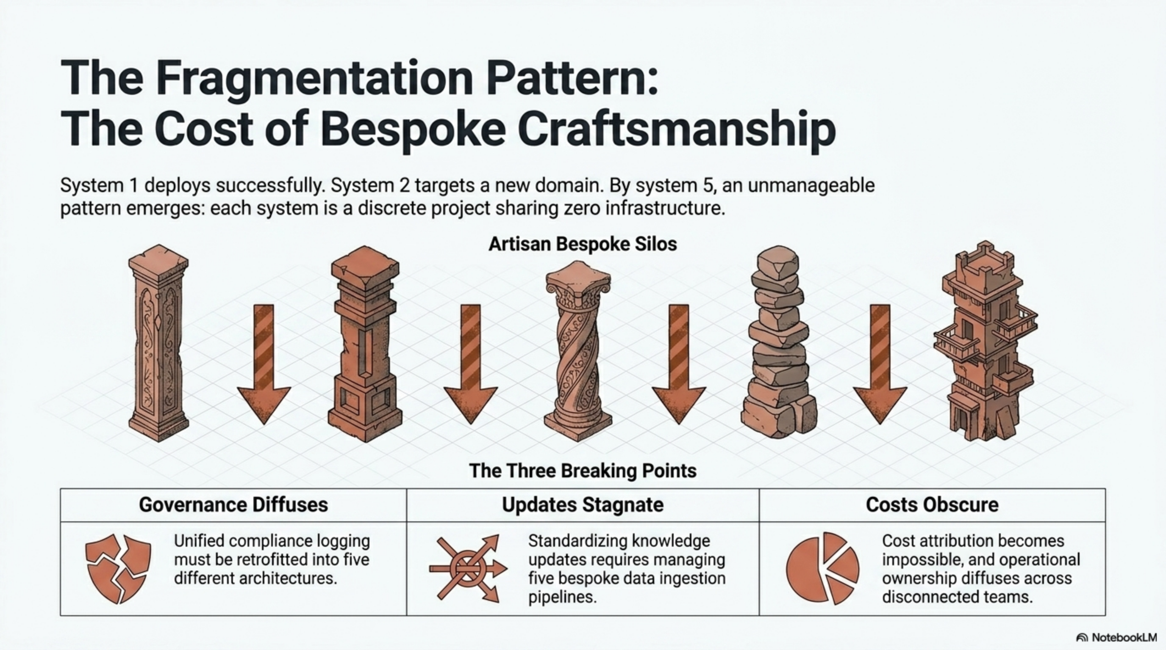
As organizations deploy independent AI systems without unified infrastructure, governance becomes fragmented, knowledge updates become risky, cost attribution is impossible, and coordination overhead becomes the primary constraint by system 6.

Project Mode vs. Platform Mode Architecture
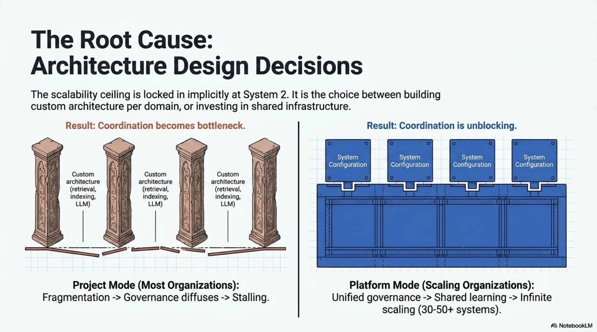
Organizations choose implicitly at system 2-3. The decision locks in a scalability ceiling that becomes increasingly expensive to retrofit. Project Mode leads to stalling at 5-8 systems. Platform Mode enables scaling to 50+ systems.

Six Operational Layers Stacked Architecture
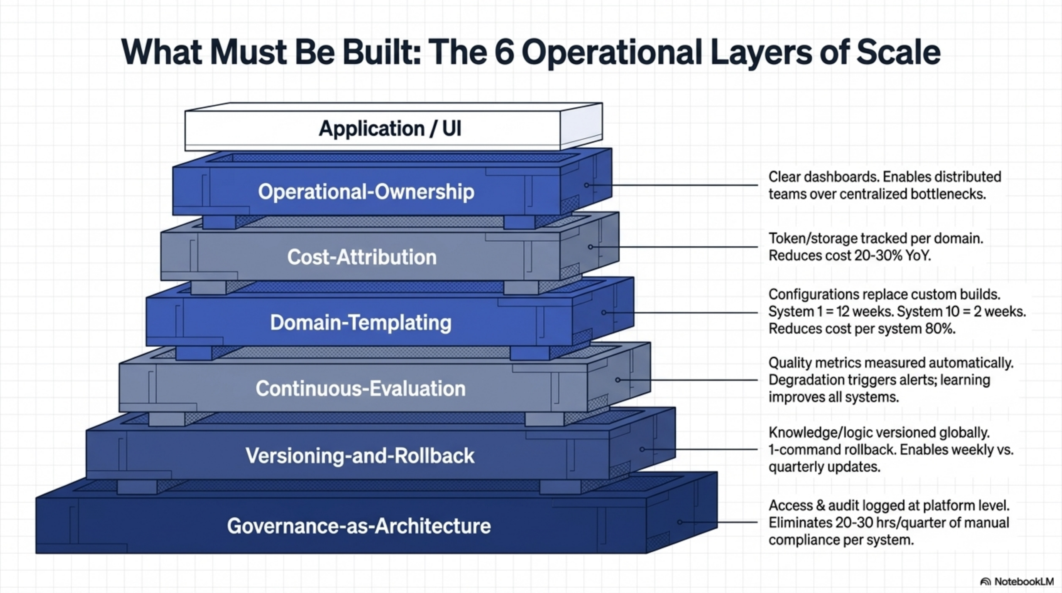
The stacked architecture shows each layer's purpose: Governance provides the foundation, Versioning enables safe updates, Evaluation ensures quality, Templating enables scaling, Cost Attribution drives optimization, and Operational Ownership ensures continuous improvement.

3-Year Trajectory: Financial Impact
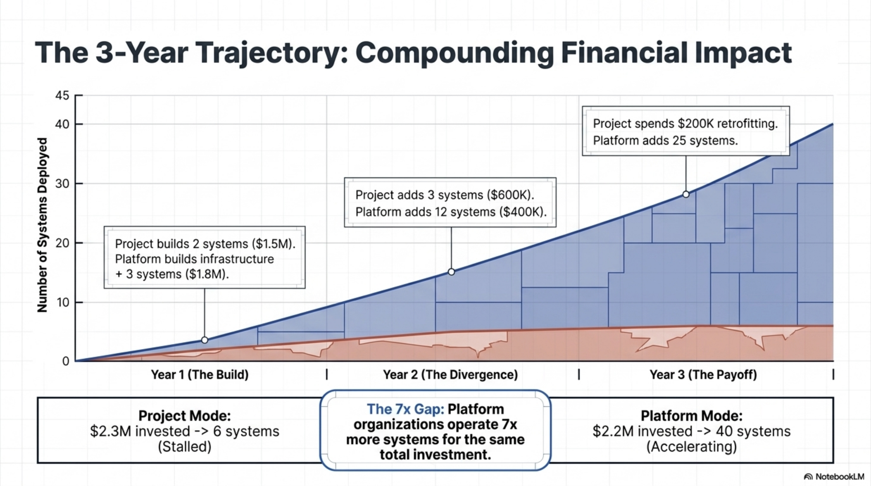
Platform organizations deploy 7x more systems (40+ vs. 6) at lower total cost by year three, demonstrating the power of compounding infrastructure advantages.

PART 4: HOW THE LAYERS WORK TOGETHER
The six layers are not independent features. They are an integrated system that enables the pipeline.

At Idea stage
- Governance surfaces compliance implications early, cost estimation is done, evaluation strategy is defined, domain is classified (template exists or not), owner is identified.

At Prototype stage
- Governance patterns are applied to architecture, versioning infrastructure is built, evaluation infrastructure is built, template is applied (if exists) or created (if new domain), cost tracking begins.

At Pre-MVP stage
- All infrastructure is validated, owner is prepared, readiness checklist is completed.

At MVP stage
- All layers are active, owner is managing based on dashboards, changes are driven by Continuous-Evaluation metrics, versions are being deployed weekly, costs are being optimized.

At Productionize stage
- All layers scale with the product, governance remains consistent at scale, updates continue safely at scale, quality is monitored continuously, costs are optimized for scale, owner is balancing quality, cost, adoption.

At Scale stage
- Next product reuses all layers, template-based deployment is 2-3 weeks, optimizations compound across products, learning is shared across products, organizational scaling becomes possible.

PART 5: THE BUSINESS MODEL
The Six Operational Layers define the business model.

Without the Foundry (Project Mode)
- First product: 18 months, $2.1M cost
- Second product: 18 months, $2.1M cost
- Sixth product: Stalled (coordination overhead)
- Total by year 3: 5-6 products, $10M+ cost

With the Foundry (Platform Mode)
- Foundry infrastructure: 6 months, $1.2M cost
- First product: 12 weeks, $1.2M cost (total $2.4M)
- Second product: 2 weeks, $180K cost
- Sixth product: 2 weeks, $180K cost
- Total by year 3: 40+ products, $2.2M cost

The Business Model Advantage
- 7x more products deployed
- Similar total cost
- Non-recoverable competitive advantage
This is what Governance-as-Architecture, Versioning-and-Rollback, Continuous-Evaluation, Domain-Templating, Cost-Attribution, and Operational-Ownership enable together.

CONCLUSION
Enterprise AI Foundry is not a product. It is the operational infrastructure that industrializes AI product creation.
Organizations without the Foundry stall at 5-8 products. Coordination overhead becomes the primary constraint. Retrofitting the Foundry becomes expensive and disruptive.
Organizations with the Foundry move from stalling at 5-8 systems to scaling to 20, 50, or 100+ systems. The first product takes 12 weeks. Subsequent products take 2-3 weeks. Learning compounds across products. Costs decrease as you scale.
The difference is not engineering talent or model quality. The difference is infrastructure.
For organizations planning to deploy 5+ AI products, building the Foundry is not optional. It is the difference between success and stalling.

Enterprise AI Foundry: A Comprehensive Strategic Framework for Industrializing AI Product Creation
© June 2026 | Strategic Framework & Infrastructure Guide | Based on operational analysis of 15+ enterprise AI deployments

