Enterprise AI Foundry
Industrializing AI Product Creation: From Idea to Scale
June 2026 | Strategic Framework & Infrastructure Guide

The Core Problem: Why Ideas Don't Become Outcomes
Every large organization has more AI ideas than it can execute. Federal agencies identify use cases for conversational knowledge access, fraud detection, document intelligence, and case management. Healthcare systems see opportunities in patient risk prediction. Financial services recognize value in fraud scoring and regulatory compliance automation.
Yet most of these ideas never ship. Organizations that do deploy AI products consistently hit the same ceiling: between 5 and 8 independent systems. After that, each subsequent product takes longer, costs more, and carries higher risk. By the time they attempt their 6th or 7th system, coordination overhead becomes the primary constraint—not engineering capacity, not model quality, but pure coordination overhead.
The Pattern: Organizations stall at 5-8 AI systems because they solve governance, versioning, evaluation, cost tracking, and ownership independently for each system. Retrofitting unified infrastructure becomes expensive and disruptive.
This pattern is consistent enough across federal agencies, healthcare systems, and financial services that it looks like a law of organizational physics. It is not a technology problem. It is an architectural one.
Enterprise AI Foundry solves this. It is not a product. It is a repeatable framework, infrastructure system, and operating model that eliminates the "6-system ceiling" by providing six operational layers that every AI product inherits automatically. With the Foundry, the first product takes 12 weeks from idea to MVP. The second takes 2-3 weeks. The tenth takes 2-3 weeks. Organizations scale to 20, 50, or 100+ systems using the same infrastructure.

Understanding the Problem: Fragmentation at Scale
The journey from "we should build this" to "this is generating business value" is far longer than expected: 18-24 months typically. But not because of engineering. Engineering is 6-8 weeks. The other 16+ months goes to governance alignment, compliance validation, cost estimation, risk assessment, pilot programs, organizational buy-in, and operational handoff.

Why Coordination Overhead Explodes
Each system requires its own governance review. Each system develops its own versioning approach. Each system designs custom evaluation metrics. Each system tracks costs independently. Each system has diffuse ownership. By the time the organization realizes these should be unified, they have already made independent decisions four times over. Retrofitting unified infrastructure creates rework. Momentum stalls.

The Fragmentation Pattern
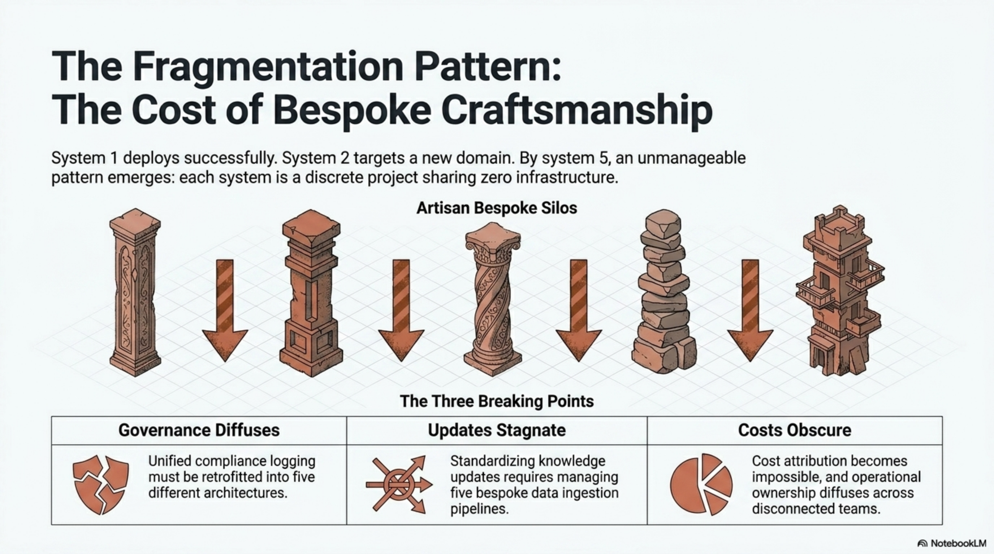
As organizations deploy independent AI systems, governance becomes fragmented, knowledge updates become risky, cost attribution is impossible, and coordination overhead becomes the primary constraint by system 6.

The Solution: Six Operational Layers
Enterprise AI Foundry provides six operational layers built once and inherited by all products automatically. Rather than each system solving governance, versioning, evaluation, cost tracking, templating, and ownership independently, all systems inherit these capabilities.

Project Mode vs. Platform Mode
The decision made around systems 2-3 determines the organization's scalability ceiling. This choice is usually implicit but it locks in a fundamental constraint.
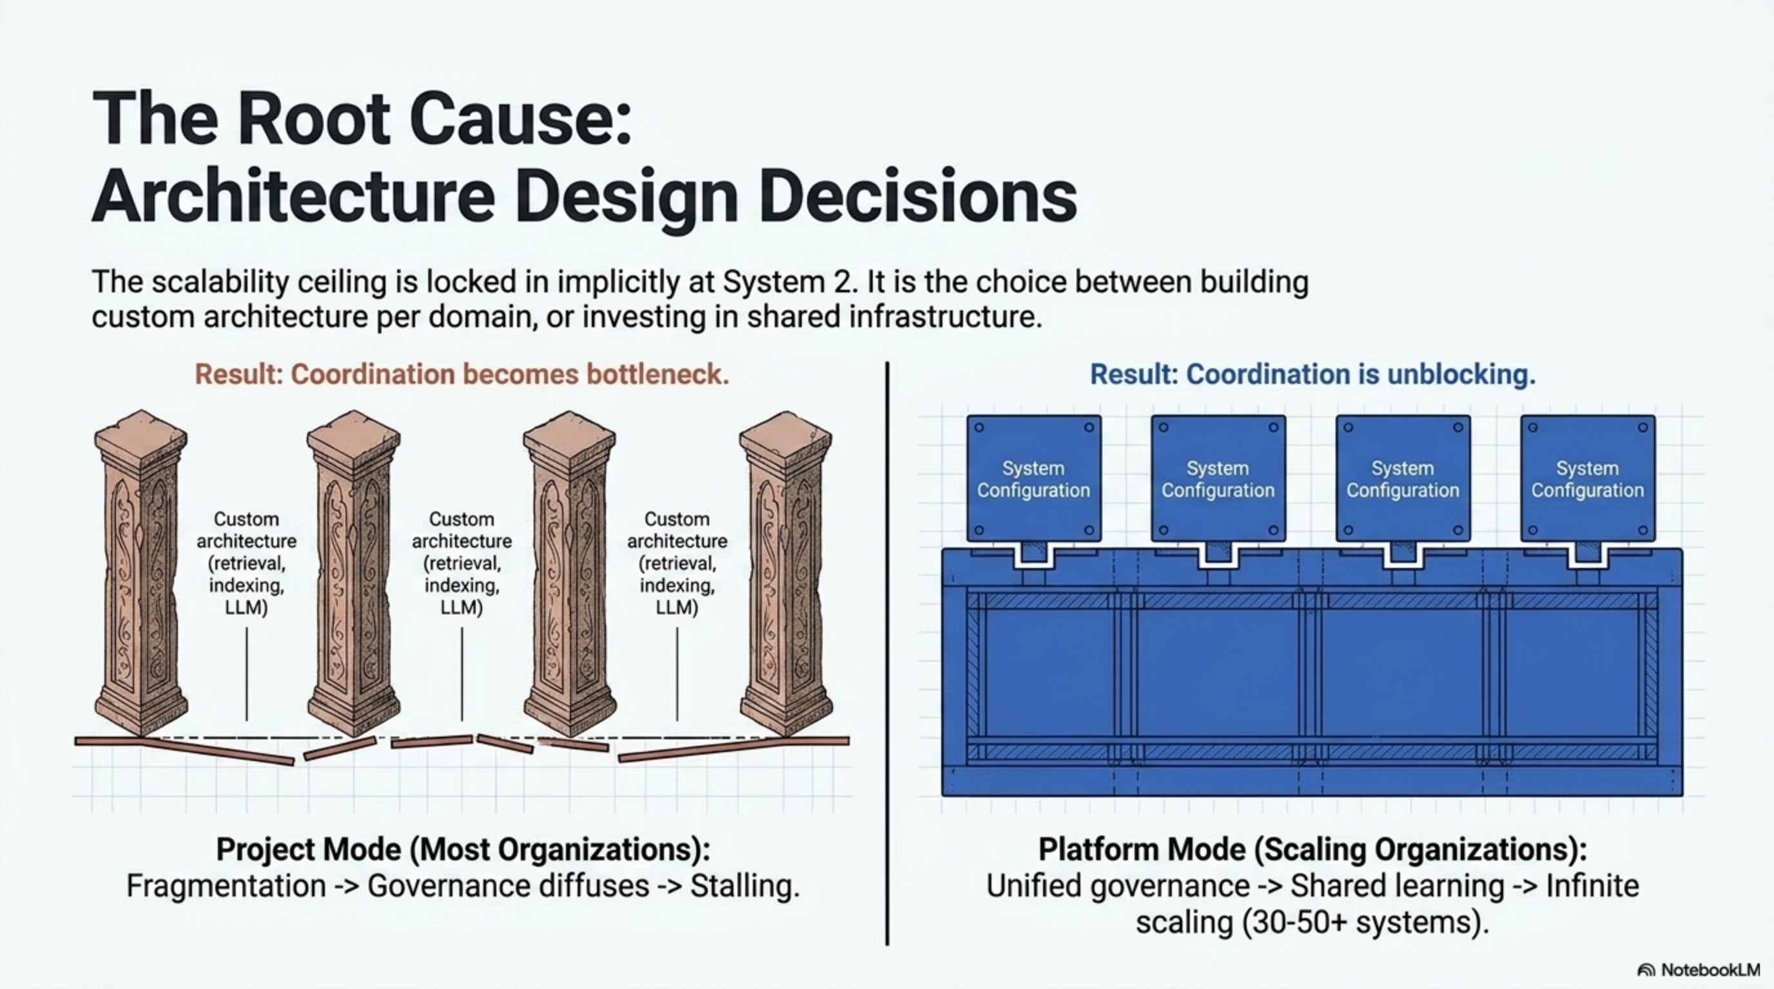
Organizations choose implicitly at system 2-3. The decision locks in a scalability ceiling that becomes increasingly expensive to retrofit.

The Six Operational Layers in Detail
These layers are built into the Foundry. Every product inherits them automatically. Organizations don't rebuild them per product. This is what transforms execution risk from a constraint to a managed variable.
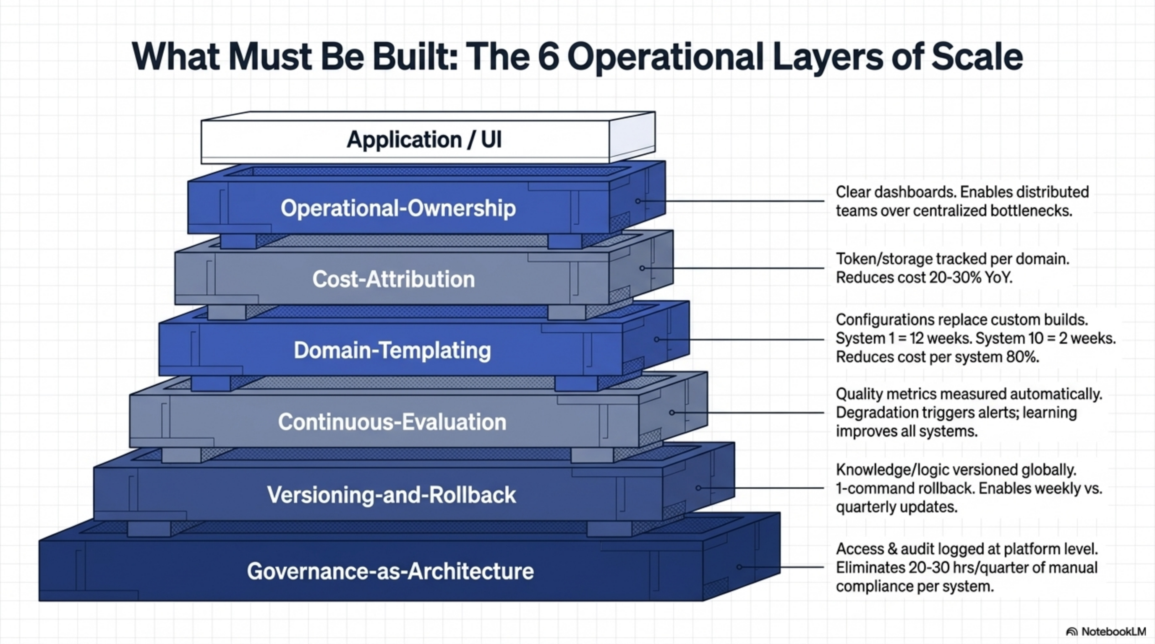
The stacked architecture shows each layer's purpose: Governance provides the foundation, Versioning enables safe updates, Evaluation ensures quality, Templating enables scaling, Cost Attribution drives optimization, and Operational Ownership ensures continuous improvement.

1. Governance-as-Architecture
Compliance, security, audit, and access control rules are defined once at the Foundry level. All products inherit automatically. When regulatory requirements change, the update happens centrally. All systems automatically comply.
In Project Mode, each system has custom compliance implementation. In Foundry Mode, one change propagates to all systems.

2. Versioning-and-Rollback
Knowledge, retrieval logic, and model versions are tracked at the platform level. Updates are tested in staging, deployed safely, and rollback is automatic. This enables weekly knowledge updates instead of quarterly.

3. Continuous-Evaluation
Quality metrics (accuracy, hallucination, latency, cost) are measured automatically across all systems. Degradation triggers alerts before users notice. When one system discovers a better approach, it benefits all systems.

4. Domain-Templating
New domains use configuration templates instead of custom engineering builds. Product 1 takes 12 weeks. Product 2 takes 2-3 weeks. Product 10 takes 2-3 weeks. This acceleration comes from reusing proven patterns rather than re-solving solved problems.

5. Cost-Attribution
Costs are tracked per domain: tokens, embeddings, storage, compute. Teams see what they spend and why. Optimization is data-driven, not guesswork.

6. Operational-Ownership
Each product has clear ownership with dashboards. Owners are accountable for quality, cost, and adoption. Distributed ownership scales to 50+ products without centralized bottleneck.

Financial Impact: The Three-Year Divergence
The competitive advantage of platform thinking emerges over time as compounding effects accumulate.
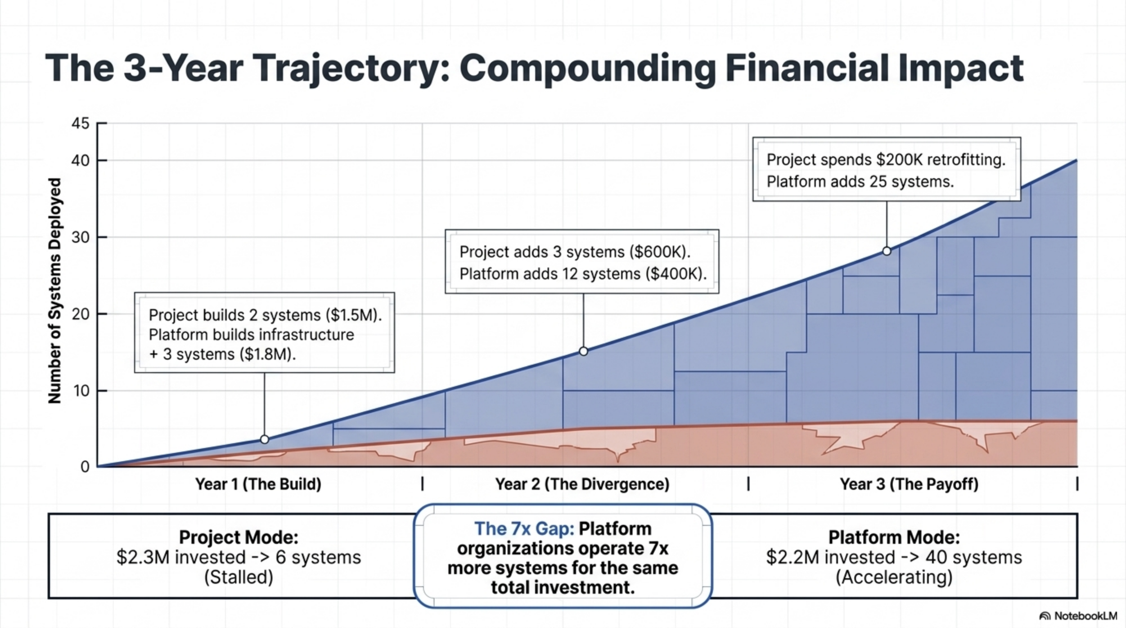
Platform organizations deploy 7x more systems (40+ vs. 6) at lower total cost by year three, demonstrating the power of compounding infrastructure advantages.

Year 1: Project Mode: Systems 1-2 deployed, $2.1M invested. Platform Mode: Platform built + Systems 1-3 deployed, $1.8M invested.
Year 2: Project Mode: Systems 3-5 deployed, coordination overhead emerges. Platform Mode: Systems 4-15 deployed, coordination accelerates progress.
Year 3: Project Mode: 6 systems, $2.3M total, stalled. Platform Mode: 40+ systems, $2.2M total, accelerating.

The Gap: Platform organization operates 7x more systems for equivalent investment. By year three, this becomes a non-recoverable competitive advantage.

How This Works in Practice: Three Examples

Example 1: Ask-AI Service
Conversational knowledge access for organizational employees. Currently in MVP → Production stage. Processing 1,000+ queries per week. 92% accuracy. 8.2/10 user satisfaction. $32K/month cost.
The Foundry's layers mean automatic compliance, quality tracking, weekly updates, cost attribution, and clear ownership. The Ask-AI template now enables deployment to other departments in 2-3 weeks instead of 18+ months.

Example 2: Risk Scoring Platform
Unified fraud scoring across channels. Currently in Validation → Prototype stage. POC shows 15% fraud reduction. Cost estimation: $12K/month at scale.
By Q3, MVP deployment. By Q4, production. The template will enable other channels to deploy in 2-3 weeks.

Example 3: Case Management System
AI-assisted case classification and routing. Currently in Idea → Validation stage. Problem: 4-hour manual classification per case.
If validation succeeds, prototype will use templates. Full deployment in 12 weeks (not 18+ months).

Conclusion: The Operating System for AI Product Creation
Enterprise AI Foundry is the infrastructure that transforms AI product creation from an episodic, high-risk, slow process into a repeatable, observable, scalable process.
Organizations in Project Mode stall after 5-8 products. Organizations with Enterprise AI Foundry move from stalling at 5-8 systems to scaling to 20, 50, or 100+ systems. The first product takes 12 weeks. Subsequent products take 2-3 weeks. The difference is not talent or model quality. The difference is infrastructure.
For organizations planning to deploy 5+ AI products, building the Foundry is not optional. It is the difference between success and stalling.

