**Class Diagram**

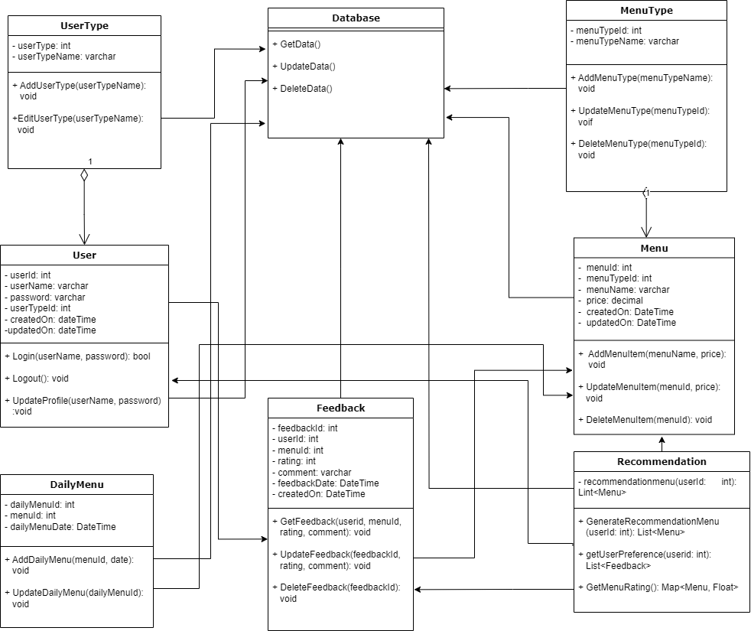

* **User Class**:
  + **Attributes**: **userID**, **username**, **password**
  + **Methods**: **login()**, **register()**, **UpdateProfile()**
  + **Explanation**: This class handles user-related operations such as logging in, registering new users, and allowing users to update their profile.
* **UserType Class**:
  + **Attributes**: **typeID**, **typeName**
  + **Methods**: **AddUserType(), EditUserType()**
  + **Explanation**: This class is responsible for defining user roles and assigning these roles to users, helping in managing access control within the system.
* **Menu Class**:
  + **Attributes**: **menuID**, **itemName**, **description**, **price**
  + **Methods**: **addItem()**, **removeItem()**, **updateItem()**
  + **Explanation**: This class manages the details of the menu items, including adding new items, removing existing ones, and updating the information of current items.
* **MenuType Class**:
  + **Attributes**: **typeID**, **typeName**
  + **Methods**: **AddMenuType()**
  + **Explanation**: This class categorizes the menu items into different types, which helps in organizing and displaying the menu more effectively.
* **DailyMenu Class**:
  + **Attributes**: **dailyMenuID**, **date**, **availableItems**
  + **Methods**: **AddDailymenu()**
  + **Explanation**: This class handles the creation and management of the daily menu, specifying which items are available on any given day.
* **Feedback Class**:
  + **Attributes**: **feedbackID**, **userID**, **menuItemID**, **comments**, **rating**
  + **Methods**: S**ubmitFeedback()**, V**iewFeedback()**
  + **Explanation**: This class captures user feedback on menu items and provides methods for submitting and viewing feedback to improve menu quality and customer satisfaction.