**Database schema**

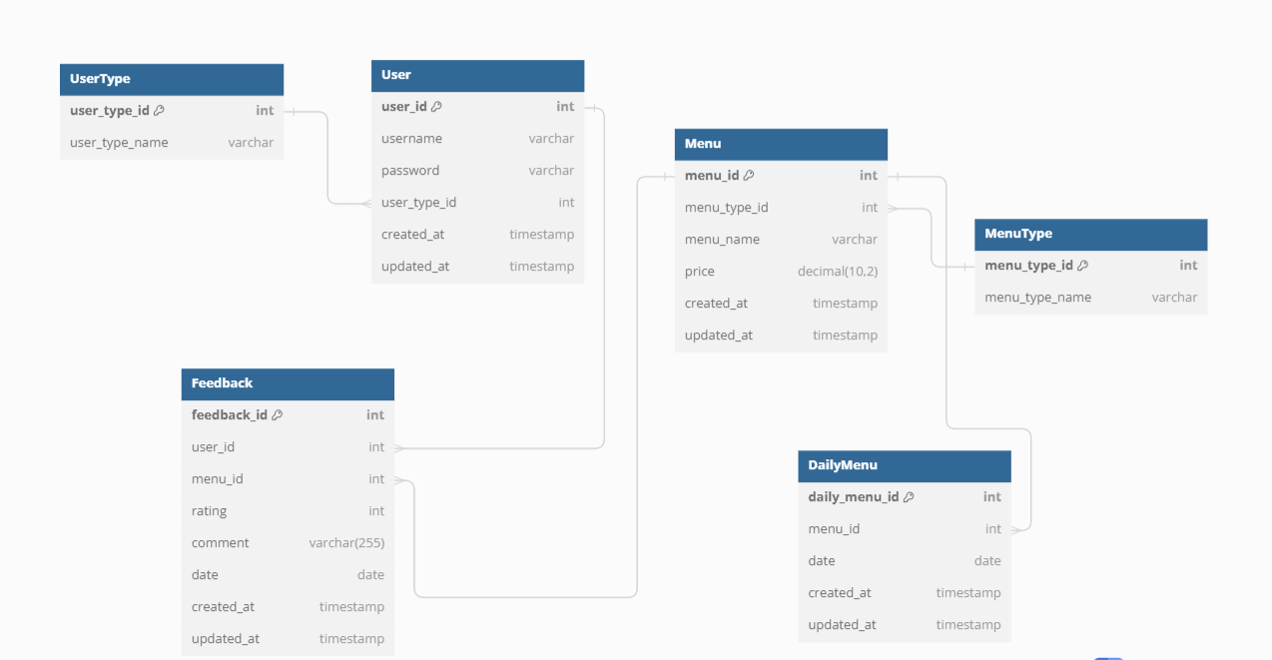

* + The Database schema consists of 6 tables named:
    - User
    - User Type
    - Menu
    - Menu Type
    - Daily Men
    - Feedback
* **User Table**: Contains user details such as username, password, and user ID. Essential for user authentication and personalization.
* **User Type Table**: Differentiates user roles (e.g., admin, user), impacting access levels and permissions.
* **Menu Table**: Stores menu items including item names, descriptions, and prices.
* **Menu Type Table**: Categorizes menu items (e.g., breakfast, lunch), helps in menu organization.
* **Daily Menu Table**: Lists daily available menu items, facilitating daily items and updates.
* **Feedback Table**: Collects user feedback on menu items, crucial for improving service quality and customer satisfaction.