**Recommendation Engine**

* Database schema:

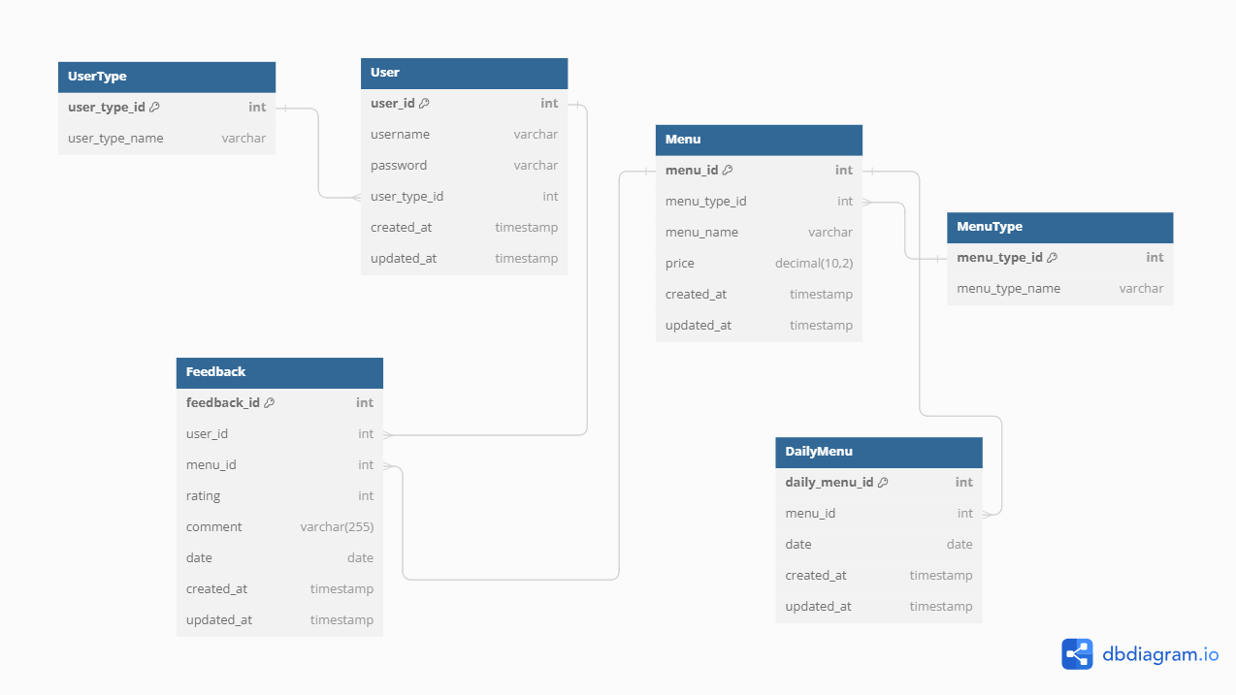

* + The Database schema consists of 6 tables named:
    - User
    - User Type
    - Menu
    - Menu Type
    - Daily Men
    - Feedback
* **User Table**: Contains user details such as username, password, and user ID. Essential for user authentication and personalization.
* **User Type Table**: Differentiates user roles (e.g., admin, user), impacting access levels and permissions.
* **Menu Table**: Stores menu items including item names, descriptions, and prices.
* **Menu Type Table**: Categorizes menu items (e.g., breakfast, lunch), helps in menu organization.
* **Daily Menu Table**: Lists daily available menu items, facilitating daily items and updates.
* **Feedback Table**: Collects user feedback on menu items, crucial for improving service quality and customer satisfaction.
* Use Case Diagram

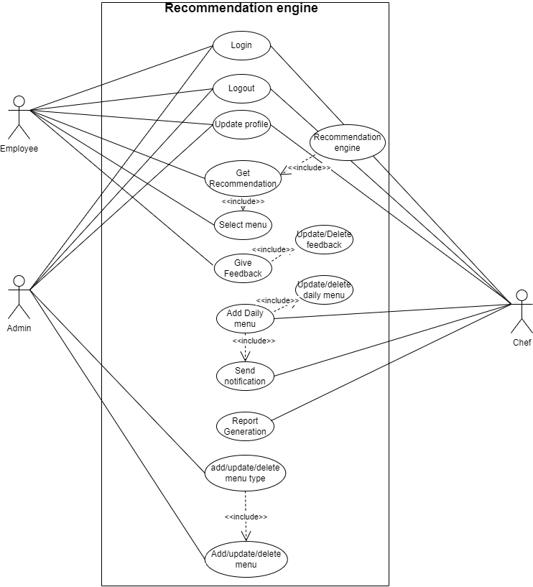

* Roles:
  + User: Interacts with the system to view menus, place orders, and provide feedback.
  + Admin: Manages menu items, reviews feedback, and updates the menu.
  + Chef: Prepares the daily menu and updates the status of menu items.
* Use cases:
  + **View Menu**: Users can browse available menu items.
  + **Place Order:** Users can order items from the menu.
  + **Provide Feedback**: Users submit feedback on menu items.
  + **Manage Menu**: Admins can add, edit, or remove menu items.
  + **Update Daily Menu**: Admins and chefs set daily specials and availability.
  + **Prepare Daily Menu**: Chefs prepare and finalize the daily menu items.
  + **Update Menu Status**: Chefs update the status (availability) of the menu items during the day.
* Class Diagram:

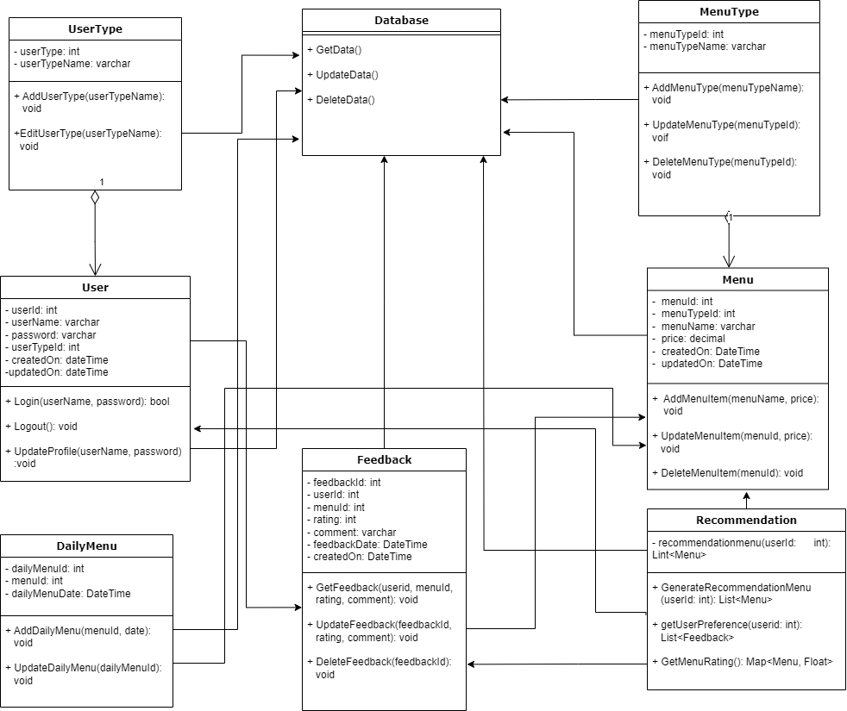

* **User Class**:
  + **Attributes**: **userID**, **username**, **password**
  + **Methods**: **login()**, **register()**, **UpdateProfile()**
  + **Explanation**: This class handles user-related operations such as logging in, registering new users, and allowing users to update their profile.
* **UserType Class**:
  + **Attributes**: **typeID**, **typeName**
  + **Methods**: **AddUserType(), EditUserType()**
  + **Explanation**: This class is responsible for defining user roles and assigning these roles to users, helping in managing access control within the system.
* **Menu Class**:
  + **Attributes**: **menuID**, **itemName**, **description**, **price**
  + **Methods**: **addItem()**, **removeItem()**, **updateItem()**
  + **Explanation**: This class manages the details of the menu items, including adding new items, removing existing ones, and updating the information of current items.
* **MenuType Class**:
  + **Attributes**: **typeID**, **typeName**
  + **Methods**: **AddMenuType()**
  + **Explanation**: This class categorizes the menu items into different types, which helps in organizing and displaying the menu more effectively.
* **DailyMenu Class**:
  + **Attributes**: **dailyMenuID**, **date**, **availableItems**
  + **Methods**: **AddDailymenu()**
  + **Explanation**: This class handles the creation and management of the daily menu, specifying which items are available on any given day.
* **Feedback Class**:
  + **Attributes**: **feedbackID**, **userID**, **menuItemID**, **comments**, **rating**
  + **Methods**: S**ubmitFeedback()**, V**iewFeedback()**
  + **Explanation**: This class captures user feedback on menu items and provides methods for submitting and viewing feedback to improve menu quality and customer satisfaction.