**Use Case Diagram**

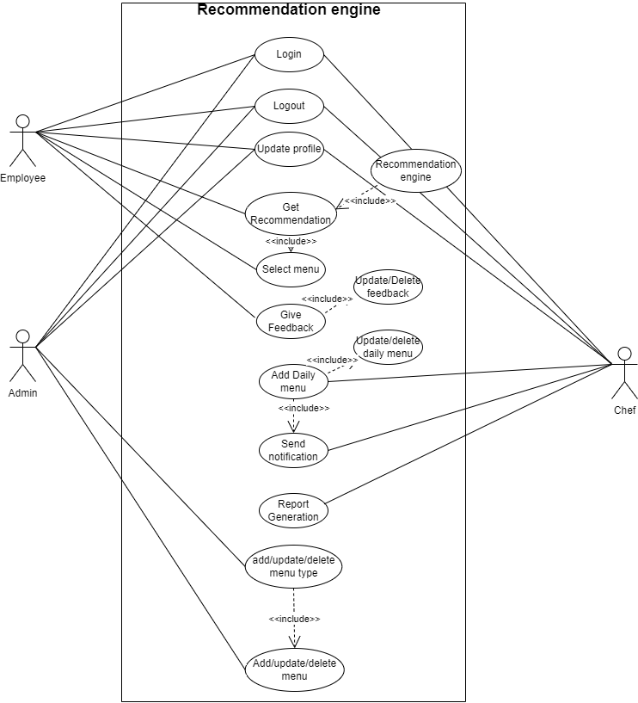

* **Roles:**
  + **User**: Interacts with the system to view menus, place orders, and provide feedback.
  + **Admin**: Manages menu items, reviews feedback, and updates the menu.
  + **Chef**: Prepares the daily menu and updates the status of menu items.
* **Use cases:**
  + **View Menu**: Users can browse available menu items.
  + **Place Order:** Users can order items from the menu.
  + **Provide Feedback**: Users submit feedback on menu items.
  + **Manage Menu**: Admins can add, edit, or remove menu items.
  + **Update Daily Menu**: Admins and chefs set daily specials and availability.
  + **Prepare Daily Menu**: Chefs prepare and finalize the daily menu items.
  + **Update Menu Status**: Chefs update the status (availability) of the menu items during the day.