SDM blockCV

Roozbeh Valavi

2022-06-14

Appendix S1 for *Valavi, R., Elith, J., Lahos-Monfort, J.J., Guillera-Arroita, G. (2022) Performance ranking of flexible species distribution modelling methods does not change with spatial cross-validation. Global Ecology and Biogeography.*

## 1- Evaluation metrics

We used $AUC_{ROC}$, $AUC_{PRG}$ and COR for evaluating the models. $AUC_{ROC}$ measures how well a model discriminates between presence and absence records in the test dataset. It can range from 0 to 1, with 1 indicating a model has perfect discrimination abilities and 0.5 showing discrimination is equivalent to that from random predictions (Pearce & Ferrier, 2000; Elith *et al.*, 2006). $AUC_{PRG}$ is similar to $AUC_{ROC}$, but less commonly used in ecology. It puts more focus on correctly predicted presences (Flach & Kull, 2015; Sofaer *et al.*, 2019). An $AUC_{PRG}$ value of 1 shows perfect discrimination, 0 indicates random discrimination and negative denotes worse than random. Since there is no lower limit for negative values in $AUC_{PRG}$, we only estimated ranks, not mean performance, for this metric. COR is the correlation between model predictions and the presence-absence testing data (Elith *et al.*, 2006).

## 2- Top rank models in different evaluations

In the main text, the mean performance and the average rank of performance metrics (i.e., $AUC_{ROC}$, $AUC_{PRG}$, and COR) were used to assess and compare models. However, this approach does not show how frequently a model was the top model or whether it was among the top 2-3 models. Here we calculated the percentage of species (171 species in our study) for which a model was in the top 1, top 2, or top 3 models (Figures 1 and 2). For example, for $AUC_{ROC}$ and random partitioning (Figure 1), the Ensemble model was within the top 3 models for 63.7% of the species.

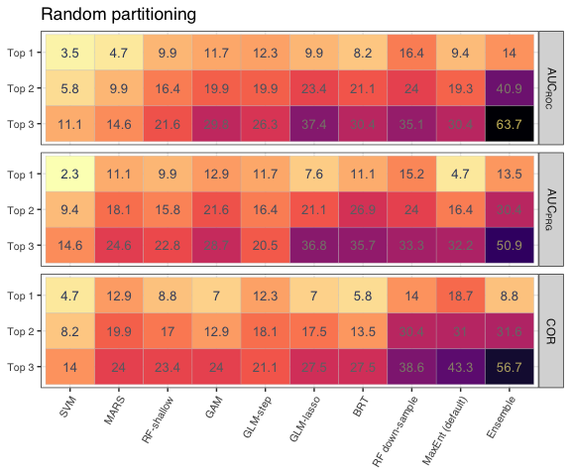

Top rank models in random partitioning.

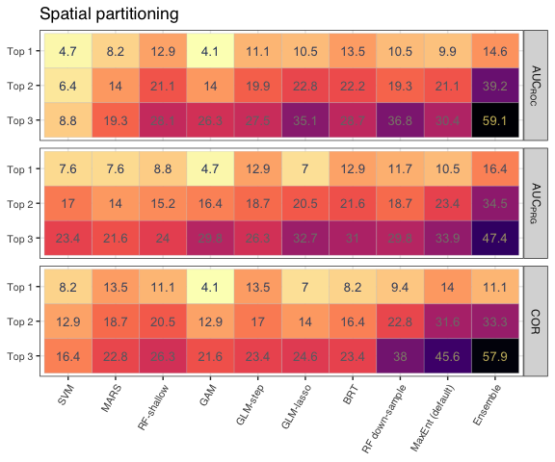

Top rank models in spatial partitioning

Notice that all methods performed the best (top 1) for at least a few species in both random and spatial partitioning. A noticeable result here is that while some models like GLM-step, MARS, or RF-shallow are average performers overall, they may be top models more frequently than better average performers (for example, GLM-step vs BRT in the top 1 models for random partitioning; or RF-shallow vs RF down-sample or MaxEnt in top 1 model for spatial partitioning).

Another highlight is that although the Ensemble model was no the top performer for many species, it was among the top 3 models for more than half of them in both partitioning strategies (Figures 1 and 2).

An interesting result is that although Ensemble model is the most frequent top performer in terms of $AUC_{ROC}$ and $AUC_{PRG}$ when predicting spatially separated testing data, and second best in terms of COR in spatial partitioning. Under random partitioning, Ensemble was the second or third best average performer. We explored further how Ensemble is performing compared to its component models in the following section.

## 3- Rank of the Ensemble vs its component models

Here we calculated the same plots but only for the Ensemble model and its component models i.e, GLM-lasso, GAM, MaxEnt (default), BRT, and RF down-sample (Figure 3). The Ensemble appeared in the top 2 and 3 models for more species than its component in both random and spatial partitioning. For top 1 models, it was only best for $AUC_{ROC}$ (along with RF down-sample) in random partitioning, but the best for both AUCs and the second-best for COR in spatial partitioning. The fact that Ensemble appears better than its component in spatial partitioning might be a piece of evidence that ensembling of tuned models can lead to better generalization.

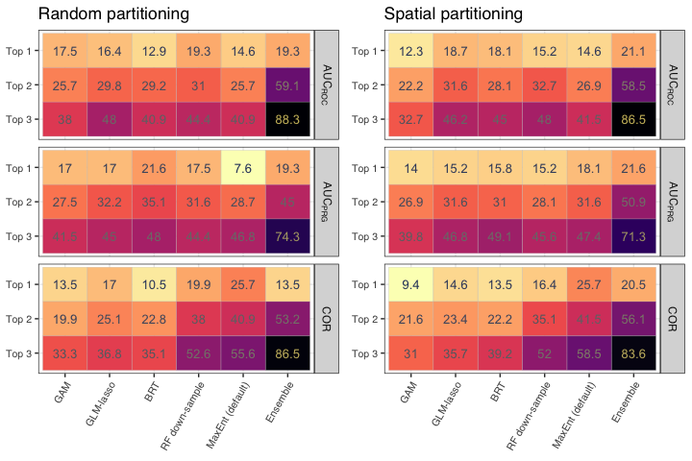

Top rank model among Ensemble and its component models.

To assess whether the Ensemble improves with respect to the best model in the set or not, we did further exploration (Figure 4) and realised that in all cases of “Top 1”, Ensemble actually somewhat outperformed its component (rather than being just as good as the best of its components). This could be an indication that the ensemble gains by combining “complementary” predictions.

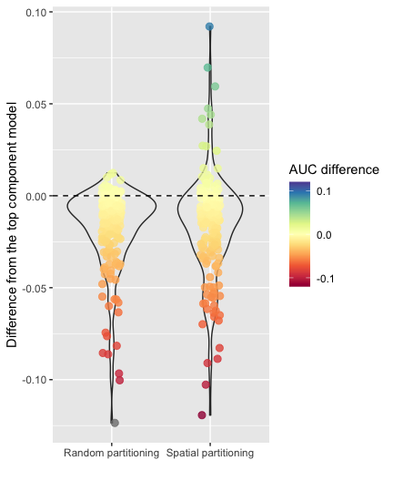

The differnce between $AUC_{ROC}$ of Ensemble and $AUC_{ROC}$ of the best component model.

## 4- Difference from average

To further highlight the difference between the performance of models (dispersion of validation metrics), we calculated, for each modelling method, the difference between the $AUC_{ROC}$ of each species and the average $AUC_{ROC}$ (figure 5) and the min $AUC_{ROC}$ (Figure 6).

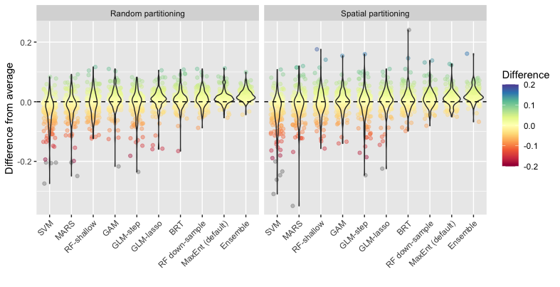

Difference from average $AUC_{ROC}$.

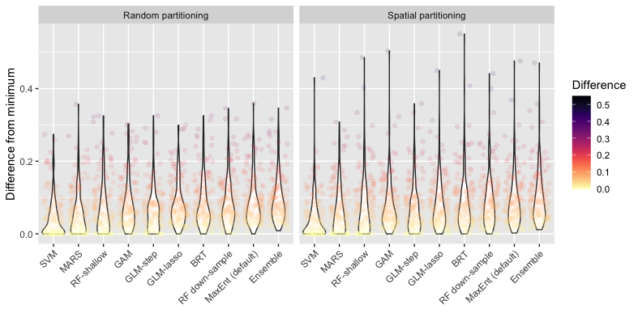

Difference from the minimum $AUC_{ROC}$.

## 5- Interactions in BRT and MaxEnt

To assess the impacts of interactions in flexible models, we compared two of our top methods, BRT and MaxEnt, with and without interactions. We implemented a BRT model with a limited tree-complexity of 1 also known as **stump**. The main difference between the BRT-stump and the default BRT (with tree-complexity 1 or 5) is that the default BRT can fit a higher level of interaction between the covariates. The implemented BRT model here (Elith *et al.* 2008) utilized internal cross-validation to find the right complexity for the model. Thus, by limiting tree-complexity to 1, the model adds more trees to find a similar balance in the fitted model as the BRT with tree-complexity 5.  
MaxEnt is also presented as two variants here, the MaxEnt with forced LQ features and one with LQP features. The main difference between these two is that MaxEnt-LQP accommodates interaction as the product of the linear features.

**The main BRT was modelled with a tree-complexity of 1 (stump) for 43% of the times.**

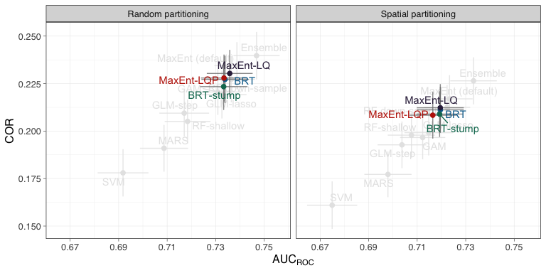

Perfromance of implementation of BRT and MaxEnt with forced limited flexibility.

There is a small and non significant difference between the average performance of the BRT vs BRT-stump and between MaxEnt-LQP vs MaxEnt-LQ. The MaxEnt-LQP had a lower mean $AUC_{ROC}$ and COR in both partitioning methods which could be because forced interaction in the model is too complex for some species with a very low number of presence records. On the other hand, BRT performed better than BRT-stump as the model uses cross-validation to regulate the appropriate amount of complexity with different parameter sets.

## 6- Extrapolation in testing blocks

It is useful to know whether extrapolation happens when models are used to predict to spatially separated points. Extrapolation occurs when the testing/predicting sites have environmental values outside of the range of environmental conditions used in the training samples. To measure the amount of extrapolation in testing sites we used Multivariate Environmental Similarity Surface (MESS) introduced by Elith *et al.* (2010). We used the mess function in the **dismo** R package for computing the MESS values for the records in the presence-absence evaluation dataset, using the training presence-TGB as the reference sites. We used only continuous covariates for this. For more explanation on MESS, see Elith *et al.* (2010).

In Figure 8, we summed the number of testing points with extrapolation (negative MESS values) for each species. This gives a good sense of how frequently species from a region experience extrapolation when predicting.

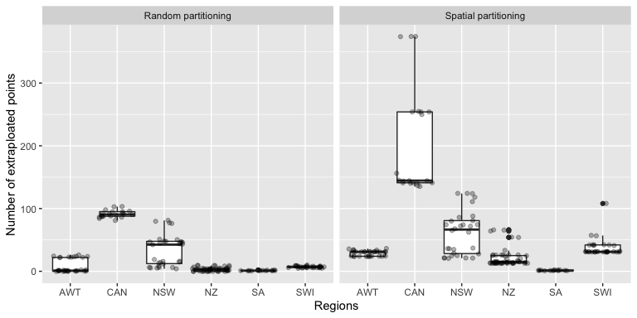

The sum of extrapolated points of each species in each region.

Figure 9 shows the number of extrapolated sites when using spatial partitioning compared to random partitioning.

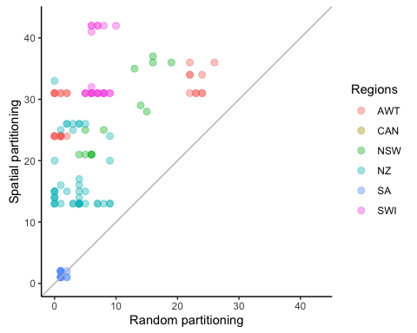

The sum of the number of extrapolated points in each species in random vs spatial partitioning.

## 7- Statistical tests

### 7.1- Statistical test for random partitioning

Here the statistical test on the differences between models in random partitioning are presented (Figure 10). The plots are $AUC_{ROC}$, $AUC_{PRG}$, and COR from top to bottom, respectively. The number on the top of the x-axis shows the range of the ranks of the models. The average rank of each model is indicated by the thin line connected to the axis. The lines (models) that are connected by the horizontal thick line are not statistically different at 0.05 significance level.

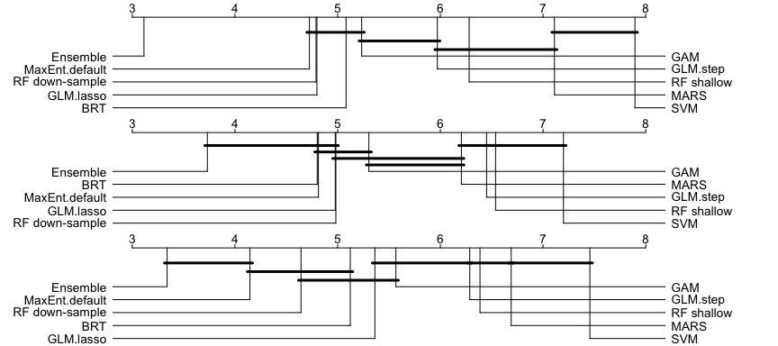

Average rank and statistical difference of the models in random partitioning.

### 7.2- Statistical test for MaxEnt variants in spatial partitioning

The Friedman’s Aligned Rank test indicated no significant difference among MaxEnt variants for $AUC_{PRG}$. Thus here we only plot the result of pairwise test for $AUC_{ROC}$ and COR (Figure 11). In general the differences between models are also insignificant for these statistics.

##   
## Friedman's Aligned Rank Test for Multiple Comparisons  
##   
## data: roc_maxents  
## T = 13.704, df = 4, p-value = 0.008303

##   
## Friedman's Aligned Rank Test for Multiple Comparisons  
##   
## data: prg_maxents  
## T = 7.7372, df = 4, p-value = 0.1017

##   
## Friedman's Aligned Rank Test for Multiple Comparisons  
##   
## data: cor_maxents  
## T = 16.766, df = 4, p-value = 0.002146

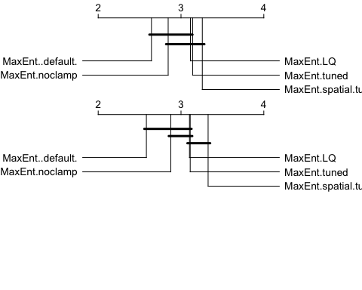

Average rank and statistical difference of the MaxEnt models in spatial partitioning.

## 8- Modelling methods parameters

A summary of model implementation settings are presented in Table 1. The “parameters” column shows model arguments in R programming that are selected in the modelling process. The “values” column shows the value or ranges of values selected for model fitting and tuning for each R function. All models are fitted in R v4.0.0.

Some models accept weights. GAM, GLMs, and BRT use case weights (i.e., there is a weight for each training sample), and SVM utilizes class weights (i.e., there is a weight for each class; here presence and background samples are the two classes so there are only two weights). The weights are generated by giving a weight of 1 to every presence point and giving the weights to the background in a way that the sum of the weights for the presence and background are equal. For class weights in SVM, an inverse proportional weight was used.

Parameters used for implementing different modes.

| Method | Parameter | Values | Description | R.packages |
| --- | --- | --- | --- | --- |
| GAM | method | REML | ﻿ smoothing parameter estimation method | mgcv v1.8-32 |
|  | k | 10 | the number of basis functions (for creating smoothing terms) specifies the possible maximum effective degree of freedom |  |
| GLM-step * | direction | both | step-selection direction (forward & backward) based on AIC | gam v1.20 |
| GLM-lasso * | alpha | 1 | lasso penalty | glmnet v4.0-2 |
| MARS | nprune | 2 to 20 | number of terms | earth v5.1.2 |
|  | degree | 1 | degree of interaction (1 means no interaction allowed) |  |
| MaxEnt (default) | args | nothreshold | auto select feature and exclude threshold feature | dismo v1.1-4 and maxent.jar v3.4.4 |
|  | betamultiplier | 1 | regularisation multiplier |  |
| BRT | tree.complexity | 1 or 5 | ﻿ depth of individual trees - two options depending on sample size | dismo v1.1-4 and gbm v2.1.5 |
|  | learning.rate | 0.001 | shrinkage or the weight applied to individual trees |  |
|  | bag.fraction | 0.75 | ﻿proportion of observations sampled to train each tree |  |
|  | n.folds | 5 | ﻿number of cross-validation folds |  |
| RF-shallow | mtry | sqrt(p) | number of variables randomly selected at each split | ranger v0.12.1 |
|  | num.trees | 2000 | number of trees |  |
|  | splitrule | “hellinger” | tree splitting criterion |  |
|  | max.depth | 2 | maximum depth of each tree (forcing shallow trees) |  |
|  | probability | TRUE | fitting probability trees |  |
| RF down-sampled | mtry | sqrt(p) | number of variables randomly selected at each split | randomForest v4.6-14 |
|  | sampsize | n. presences | number of bootstrap samples taken from each class |  |
|  | ntrees | 1000 | number of trees |  |
| SVM | kernel | radial | radial basis kernel | e1071 v1.7-3 |
| Ensemble |  |  | Rescale and average of individual modes implemented here: GAM, GLM-lasso, MaxEnt, BRT and RF down-sampled |  |

* GLM-step and GLM-lasso were fitted allowing linear and quadratic terms only, with no interactions.

Parameters of MaxEnt variants are presented in the following table.

Parameters of MaxEnt model in different MaxEnt variants.

| Method | Parameter | Values | Description |
| --- | --- | --- | --- |
| MaxEnt (default) | betamultiplier | 1 | regularization multiplier |
|  | args | nothreshold | auto select feature and exclude threshold feature |
| MaxEnt noclamp |  |  | the same as MaxEnt (default) with clammping set to off for prediction |
| MaxEnt LQ | betamultiplier | 1 | regularization multiplier |
|  | feature types | LQ | transformations of input covariates. L: linear, Q: quadratic |
| MaxEnt tuned and spatial-tuned | betamultiplier | 0.5, 1, 2, 3, 4 | regularization multiplier |
|  | feature types | L, LQ, H, LQH, LQHP | transformations of input covariates. L: linear, Q: quadratic, H: hinge, P: product |

## 9- Code and data availability

You can find species data in disdat R package (Elith *et al.,* 2020). To run the models, you can use the codes and data provide in [OSF](https://osf.io/g6dc3/?view_only=2f91390cb8f14ae3ba75c35427e017e4) repository.

To reproduce our results, you can used any of the followings (details below):

* Use the revn.lock file in OSF and retrieve the R package versions in your local system with [renv](https://rstudio.github.io/renv/articles/renv.html) package
* Use the pre-built [Docker image]((https://www.docker.com/)) (rvalavi_image.tar stored in OSF) and create a virtual environment with the same R packages
* Build a Docker image based on the Dockerfile provided in the OSF repository

### 9.1- renv packge recovery

First, create a new RStudio project and place the renv.lock file in it. Use the commands below to restore the R package for modelling.

install.packages("renve")  
  
renv::init()  
  
renv::restore()

You need to install a few other packages that are not listed in renv file.

install.packages('remotes')  
install.packages('rJava')  
  
remotes::install_github('meeliskull/prg/R_package/prg')  
remotes::install_github('b0rxa/scmamp')  
remotes::install_github('rvalavi/myspatial')  
  
remotes::install_version('gam', version = '1.20', repos = 'http://cran.us.r-project.org')  
remotes::install_version('gbm', version = '2.1.5', repos = 'http://cran.us.r-project.org')

### 9.2- Using Docker container

Here we explain how to use Dockers for creating a virtual system to reproduce our results. Docker can be installed on different platforms. You can find the instruction for installing Docker on different operating systems in their [website](https://docs.docker.com/get-docker/). Docker provides an RStudio installed and all the R and system packages required for running our analysis.

To use Docker, you can either load the pre-built image, or build a new image from Dockerfile. To load the Docker image, first download the files from OSF, then use:

docker load --input rvalavi_image.tar

If you want to build the image in your local system, you need to download all the files in OSF (except “docker” folder). Then run the following terminal commands. In Linux systems you might need to use sudo before docker commands.

Go to the directory of downloaded files from the OSF within terminal and run:

docker build -t rvalavi:4.0 .

Wait until the build is complete. Then check to see the images is created.

docker images

You should see rvalavi with TAG 4.0 listed as a Docker image.

After the image is created (or loaded), you need to run a container to get access to the RStudio and packages. The Docker container is a live instance of the image. Use the following command to run a container to access RStudio.

docker run --name rstudio -p 8787:8787 -e PASSWORD=123 -e USER=rstudio -d rvalavi:4.0

This code has several components:  
--name: name of the container  
-p: port on which container is running. We use this to connect to rstudio  
-e USER and -e PASSWORD: username and password for the rstudio server (use rstudio as username)  
-v: mapping a directory in the local system to a directory in the container (this was not used in the code above). This will allow you to save the generated files and code in local drive and also access to code/data inside your system.  
-d: run the container in the background  
rvalavi:4.0: name and tag of the Docker image

Now, run RStudio server from container. Open an Internet browser and go to localhost:8787 to open RStudio. Use the username and password you specified in the previous step (here user is “rstudio” and password is “123”) to open RStudio.

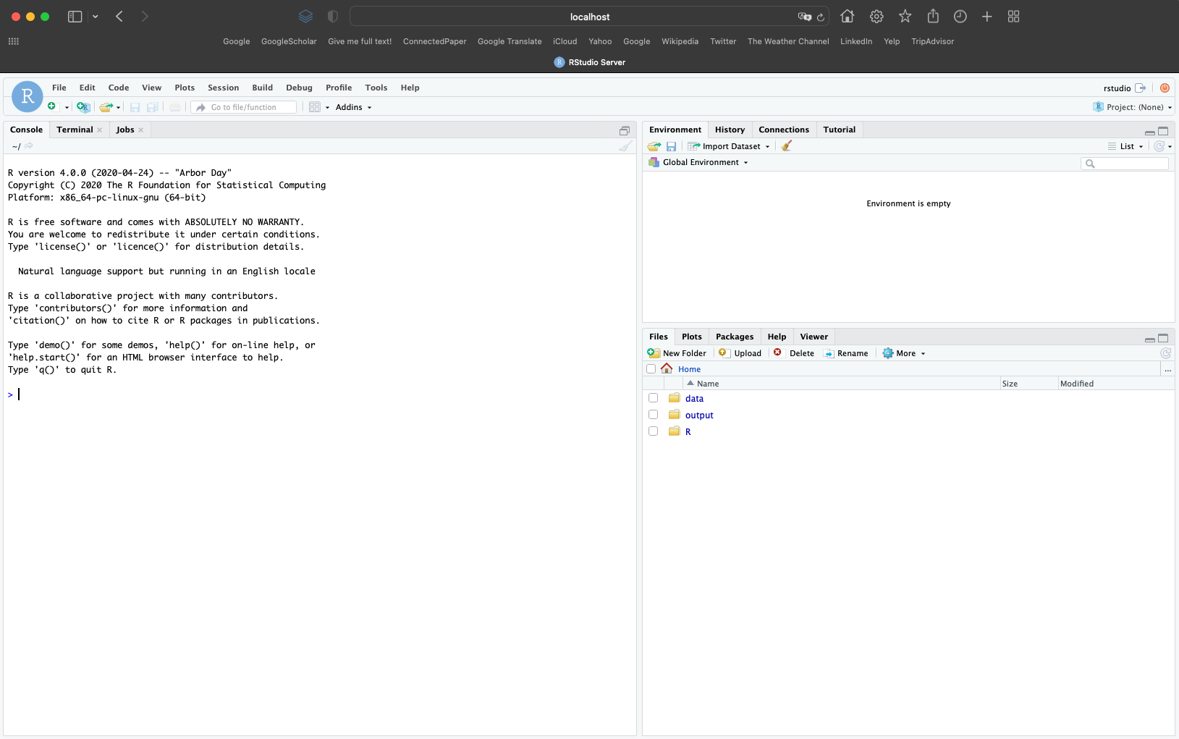

You can run models by running the R/nceas_modelling.R script.

## 10- Covariates and TGB samples

To model the presence-only data with background samples and deal with biases in these data, we used Target-Group-Background (TGB) samples introduced by Phillips *et al.* (2009). TGB provide a background sample with similar biases to that of the presence records. For each species, a background sample is generated by collating all presence records from the same biological group and region (including the target species), with minor adjustments to avoid multiple records per grid cell. For details see Phillips *et al.* (2009) and for code see Elith *et al.* (2020).

Table **3 to 8** show the environmental covariates used in each region. These are the variables that do not have a pairwise correlation of more than 0.8. You can find a complete list of variables with more details in Elith *et al.* (2020), and in the help of the [disdat](https://CRAN.R-project.org/package=disdat) R package.

Environmental vartiables for AWT region.

| Code | Description | Units | Type |
| --- | --- | --- | --- |
| bc04 | Temperature seasonality | NA | Continuous |
| bc05 | Max. temperature of warmest period | ˚C | Continuous |
| bc06 | Min. temperature of coldest period. | ˚C | Continuous |
| bc12 | Annual precipitation | mm | Continuous |
| bc15 | Precipitation seasonality | NA | Continuous |
| slope | Mean slope (derived from 9 second spatial resolution elevation data) | percent | Continuous |
| topo | Topographic position | NA | Continuous |
| tri | Terrain ruggedness index | NA | Continuous |

Environmental vartiables for CAN region.

| Code | Description | Units | Type |
| --- | --- | --- | --- |
| alt | Digital elevation | m | Continuous |
| asp2 | Aspect – ranges from -1 to 1 (sin transformation) | number (dimensionless unit) | Continuous |
| ontprec | Annual Precipitation | mm | Continuous |
| ontslp | Slope | degrees | Continuous |
| onttemp | Annual mean temperature | ˚C * 10 | Continuous |
| ontveg | Vegetation, from Ontario Land Cover Database (OLC) vegetation map, derived from a mosaic of Landsat images. | number (dimensionless unit) | Categorical |
| watdist | Distance from Hudson Bay | m | Continuous |

Environmental vartiables for NSW region.

| Code | Description | Units | Type |
| --- | --- | --- | --- |
| cti | compound topographic index- a quantification of the position of a site in the local landscape | number (dimensionless index) | Continous |
| disturb | disturbance (clearing, logging etc) | number (ordinal) | Continous |
| mi | moisture index. | number (dimensionless index) | Continous |
| rainann | mean annual rainfall | Mm | Continous |
| raindq | mean rainfall of the driest quarter | Mm | Continous |
| rugged | ruggedness | number (dimensionless index) | Continous |
| soildepth | mean soil depth | m *1000 | Continous |
| soilfert | soil fertility | number (ordinal) | Continous |
| solrad | annual mean solar radiation | MJm-2 day-1 * 10 | Continous |
| tempann | annual mean temperature | °C * 10 | Continous |
| topo | topographic position | m | Continous |

Environmental vartiables for NZ region.

| Code | Description | Units | Type |
| --- | --- | --- | --- |
| age | soil parent material: age since last major rejuvenation | number (category) | Categorical |
| deficit | mean October vapor pressure deficit at 0900 hours | kPa | Continous |
| hillshade | surrogate for slope and aspect | number (dimensionless index) | Continous |
| mas | mean annual solar radiation | MJm^-2 day^-1 * 100 | Continous |
| mat | mean annual temperature | °C * 10 | Continous |
| r2pet | average monthly ratio of potential evapotranspiration | number (dimensionless index) | Continous |
| slope | slope | degrees | Continous |
| sseas | solar radiation seasonality | number (dimensionless index) | Continous |
| toxicats | toxic cations in soil | number (category) | Categorical |
| tseas | temperature seasonality | number (dimensionless index) | Continous |
| vpd | annual vapor pressure deficit | kPa | Continous |

Environmental vartiables for SA region.

| Code | Description | Units | Type |
| --- | --- | --- | --- |
| sabio2 | mean diurnal range (mean of monthly (max temp - min temp)) | ˚C*10 | Continous |
| sabio4 | temperature seasonality (standard deviation *100) | number (dimensionless index) | Continous |
| sabio5 | max temperature of warmest month | ˚C*10 | Continous |
| sabio6 | min temperature of coldest month | ˚C*10 | Continous |
| sabio12 | annual precipitation | mm | Continous |
| sabio15 | precipitation seasonality (coefficient of variation) | number (dimensionless index) | Continous |
| sabio17 | precipitation of driest quarter | mm | Continous |
| sabio18 | precipitation of warmest quarter | mm | Continous |

Environmental vartiables for SWI region.

| Code | Description | Units | Type |
| --- | --- | --- | --- |
| BCC | broadleaved continuous cover | % cover | Continous |
| CALC | bedrock strictly calcareous vs other type | 1 (present) or 0 (absent) | Categorical |
| CCC | coniferous continuous cover | % cover | Continous |
| DDEG | growing degree-days above the threshold of 0°C | °C * days | Continous |
| NUTRI | soil nutrients index | D mval/cm2 | Continous |
| PDAY | number of days with rainfall > 1 mm | ndays | Continous |
| PRECYY | average yearly precipitation sum | mm | Continous |
| SFROYY | summer frost frequency – number of days | days | Continous |
| SLOPE | slope | degrees x 10 | Continous |
| SRADYY | potential yearly global radiation (daily average) | kJm-2day-1 | Continous |
| SWB | site water balance | mm | Continous |
| TOPO | topographic position | number (dimensionless index) | Continous |

## 11- List of species used in modelling

For creating spatial blocks some species did not have enough data to fit and evaluate models. Here, we provide the list of species we used in our study.

List of species used for modelling. PO is the number of presence-only recods in the tarining dataset, TGBs is the number of Target-Group-Background samples, and Presence/Absence are the number of records in the evaluation dataset.

|  | Region | Species | PO | TGBs | Presence | Absence |
| --- | --- | --- | --- | --- | --- | --- |
| 1 | AWT | awt01 | 178 | 714 | 92 | 248 |
| 2 | AWT | awt02 | 149 | 714 | 105 | 235 |
| 3 | AWT | awt03 | 219 | 714 | 129 | 211 |
| 4 | AWT | awt04 | 216 | 714 | 158 | 182 |
| 5 | AWT | awt05 | 114 | 714 | 47 | 293 |
| 6 | AWT | awt06 | 265 | 714 | 187 | 153 |
| 7 | AWT | awt07 | 158 | 714 | 81 | 259 |
| 8 | AWT | awt08 | 231 | 714 | 137 | 203 |
| 9 | AWT | awt09 | 112 | 714 | 46 | 294 |
| 10 | AWT | awt10 | 122 | 714 | 102 | 238 |
| 11 | AWT | awt11 | 82 | 714 | 13 | 327 |
| 12 | AWT | awt12 | 32 | 714 | 16 | 324 |
| 13 | AWT | awt13 | 122 | 714 | 102 | 238 |
| 14 | AWT | awt14 | 99 | 714 | 65 | 275 |
| 15 | AWT | awt15 | 254 | 714 | 214 | 126 |
| 16 | AWT | awt16 | 144 | 714 | 64 | 276 |
| 17 | AWT | awt17 | 184 | 714 | 103 | 237 |
| 18 | AWT | awt18 | 242 | 714 | 137 | 203 |
| 19 | AWT | awt19 | 78 | 714 | 64 | 276 |
| 20 | AWT | awt20 | 104 | 714 | 80 | 260 |
| 21 | AWT | awt21 | 17 | 379 | 20 | 82 |
| 22 | AWT | awt25 | 12 | 379 | 24 | 78 |
| 23 | AWT | awt27 | 41 | 379 | 27 | 75 |
| 24 | AWT | awt31 | 14 | 379 | 62 | 40 |
| 25 | AWT | awt33 | 18 | 379 | 24 | 78 |
| 26 | AWT | awt35 | 44 | 379 | 52 | 50 |
| 27 | AWT | awt36 | 56 | 379 | 51 | 51 |
| 28 | AWT | awt37 | 28 | 379 | 21 | 81 |
| 29 | AWT | awt38 | 42 | 379 | 16 | 86 |
| 30 | AWT | awt39 | 20 | 379 | 32 | 70 |
| 31 | CAN | can01 | 16 | 3298 | 230 | 14341 |
| 32 | CAN | can02 | 740 | 3298 | 2682 | 11889 |
| 33 | CAN | can03 | 165 | 3298 | 703 | 13868 |
| 34 | CAN | can04 | 42 | 3298 | 887 | 13684 |
| 35 | CAN | can05 | 138 | 3298 | 846 | 13725 |
| 36 | CAN | can06 | 27 | 3298 | 53 | 14518 |
| 37 | CAN | can07 | 221 | 3298 | 333 | 14238 |
| 38 | CAN | can08 | 322 | 3298 | 2600 | 11971 |
| 39 | CAN | can09 | 119 | 3298 | 163 | 14408 |
| 40 | CAN | can10 | 234 | 3298 | 1251 | 13320 |
| 41 | CAN | can11 | 478 | 3298 | 4512 | 10059 |
| 42 | CAN | can12 | 312 | 3298 | 2045 | 12526 |
| 43 | CAN | can13 | 39 | 3298 | 735 | 13836 |
| 44 | CAN | can14 | 18 | 3298 | 400 | 14171 |
| 45 | CAN | can15 | 721 | 3298 | 3025 | 11546 |
| 46 | CAN | can16 | 57 | 3298 | 316 | 14255 |
| 47 | CAN | can17 | 313 | 3298 | 2758 | 11813 |
| 48 | CAN | can18 | 612 | 3298 | 1184 | 13387 |
| 49 | CAN | can19 | 109 | 3298 | 24 | 14547 |
| 50 | CAN | can20 | 380 | 3298 | 893 | 13678 |
| 51 | NSW | nsw01 | 26 | 147 | 120 | 450 |
| 52 | NSW | nsw03 | 12 | 147 | 21 | 549 |
| 53 | NSW | nsw05 | 22 | 147 | 40 | 530 |
| 54 | NSW | nsw07 | 28 | 147 | 44 | 526 |
| 55 | NSW | nsw08 | 129 | 1351 | 20 | 682 |
| 56 | NSW | nsw09 | 426 | 1351 | 77 | 625 |
| 57 | NSW | nsw11 | 48 | 1351 | 19 | 683 |
| 58 | NSW | nsw12 | 139 | 1351 | 27 | 675 |
| 59 | NSW | nsw13 | 155 | 1351 | 25 | 677 |
| 60 | NSW | nsw14 | 315 | 1351 | 161 | 541 |
| 61 | NSW | nsw15 | 236 | 1351 | 123 | 579 |
| 62 | NSW | nsw16 | 120 | 1351 | 143 | 994 |
| 63 | NSW | nsw17 | 148 | 1351 | 141 | 996 |
| 64 | NSW | nsw18 | 69 | 569 | 440 | 1635 |
| 65 | NSW | nsw23 | 60 | 569 | 480 | 1595 |
| 66 | NSW | nsw24 | 68 | 569 | 184 | 1891 |
| 67 | NSW | nsw25 | 23 | 569 | 87 | 1988 |
| 68 | NSW | nsw27 | 23 | 569 | 445 | 864 |
| 69 | NSW | nsw28 | 53 | 569 | 512 | 797 |
| 70 | NSW | nsw31 | 24 | 569 | 653 | 656 |
| 71 | NSW | nsw32 | 28 | 569 | 22 | 1287 |
| 72 | NSW | nsw33 | 15 | 569 | 513 | 796 |
| 73 | NSW | nsw39 | 16 | 569 | 414 | 622 |
| 74 | NSW | nsw40 | 14 | 569 | 359 | 677 |
| 75 | NSW | nsw43 | 42 | 569 | 216 | 693 |
| 76 | NSW | nsw45 | 22 | 569 | 138 | 771 |
| 77 | NSW | nsw49 | 110 | 530 | 169 | 839 |
| 78 | NSW | nsw52 | 186 | 530 | 165 | 843 |
| 79 | NSW | nsw53 | 34 | 530 | 27 | 981 |
| 80 | NSW | nsw54 | 118 | 530 | 13 | 995 |
| 81 | NZ | nz01 | 23 | 2503 | 66 | 19054 |
| 82 | NZ | nz02 | 80 | 2503 | 5130 | 13990 |
| 83 | NZ | nz03 | 32 | 2503 | 217 | 18903 |
| 84 | NZ | nz04 | 48 | 2503 | 1776 | 17344 |
| 85 | NZ | nz05 | 211 | 2503 | 3233 | 15887 |
| 86 | NZ | nz06 | 35 | 2503 | 1374 | 17746 |
| 87 | NZ | nz07 | 65 | 2503 | 42 | 19078 |
| 88 | NZ | nz08 | 124 | 2503 | 1767 | 17353 |
| 89 | NZ | nz09 | 36 | 2503 | 216 | 18904 |
| 90 | NZ | nz10 | 27 | 2503 | 1032 | 18088 |
| 91 | NZ | nz11 | 21 | 2503 | 741 | 18379 |
| 92 | NZ | nz12 | 25 | 2503 | 3727 | 15393 |
| 93 | NZ | nz13 | 21 | 2503 | 2745 | 16375 |
| 94 | NZ | nz14 | 19 | 2503 | 6458 | 12662 |
| 95 | NZ | nz17 | 94 | 2503 | 5537 | 13583 |
| 96 | NZ | nz18 | 43 | 2503 | 510 | 18610 |
| 97 | NZ | nz19 | 127 | 2503 | 800 | 18320 |
| 98 | NZ | nz20 | 33 | 2503 | 477 | 18643 |
| 99 | NZ | nz21 | 21 | 2503 | 842 | 18278 |
| 100 | NZ | nz22 | 130 | 2503 | 689 | 18431 |
| 101 | NZ | nz23 | 23 | 2503 | 3119 | 16001 |
| 102 | NZ | nz24 | 22 | 2503 | 60 | 19060 |
| 103 | NZ | nz25 | 113 | 2503 | 489 | 18631 |
| 104 | NZ | nz26 | 22 | 2503 | 238 | 18882 |
| 105 | NZ | nz27 | 40 | 2503 | 1102 | 18018 |
| 106 | NZ | nz28 | 18 | 2503 | 69 | 19051 |
| 107 | NZ | nz29 | 21 | 2503 | 3382 | 15738 |
| 108 | NZ | nz30 | 101 | 2503 | 7490 | 11630 |
| 109 | NZ | nz32 | 105 | 2503 | 1119 | 18001 |
| 110 | NZ | nz33 | 19 | 2503 | 781 | 18339 |
| 111 | NZ | nz34 | 42 | 2503 | 534 | 18586 |
| 112 | NZ | nz35 | 24 | 2503 | 10581 | 8539 |
| 113 | NZ | nz36 | 170 | 2503 | 6848 | 12272 |
| 114 | NZ | nz37 | 22 | 2503 | 2496 | 16624 |
| 115 | NZ | nz38 | 147 | 2503 | 1351 | 17769 |
| 116 | NZ | nz39 | 21 | 2503 | 33 | 19087 |
| 117 | NZ | nz40 | 19 | 2503 | 779 | 18341 |
| 118 | NZ | nz41 | 20 | 2503 | 40 | 19080 |
| 119 | NZ | nz42 | 27 | 2503 | 5845 | 13275 |
| 120 | NZ | nz43 | 137 | 2503 | 47 | 19073 |
| 121 | NZ | nz44 | 65 | 2503 | 2790 | 16330 |
| 122 | NZ | nz45 | 26 | 2503 | 301 | 18819 |
| 123 | NZ | nz46 | 36 | 2503 | 22 | 19098 |
| 124 | NZ | nz47 | 87 | 2503 | 2536 | 16584 |
| 125 | NZ | nz48 | 43 | 2503 | 889 | 18231 |
| 126 | NZ | nz49 | 37 | 2503 | 125 | 18995 |
| 127 | NZ | nz50 | 131 | 2503 | 959 | 18161 |
| 128 | NZ | nz51 | 42 | 2503 | 562 | 18558 |
| 129 | NZ | nz52 | 174 | 2503 | 555 | 18565 |
| 130 | SA | sa01 | 120 | 1221 | 15 | 137 |
| 131 | SA | sa02 | 150 | 1221 | 23 | 129 |
| 132 | SA | sa09 | 49 | 1221 | 10 | 142 |
| 133 | SA | sa10 | 99 | 1221 | 29 | 123 |
| 134 | SA | sa12 | 203 | 1221 | 15 | 137 |
| 135 | SA | sa15 | 88 | 1221 | 15 | 137 |
| 136 | SA | sa17 | 37 | 1221 | 11 | 141 |
| 137 | SA | sa18 | 123 | 1221 | 19 | 133 |
| 138 | SA | sa20 | 54 | 1221 | 10 | 142 |
| 139 | SA | sa21 | 27 | 1221 | 13 | 139 |
| 140 | SA | sa22 | 57 | 1221 | 11 | 141 |
| 141 | SA | sa24 | 138 | 1221 | 21 | 131 |
| 142 | SA | sa26 | 216 | 1221 | 27 | 125 |
| 143 | SWI | swi01 | 482 | 11429 | 107 | 9906 |
| 144 | SWI | swi02 | 1245 | 11429 | 298 | 9715 |
| 145 | SWI | swi03 | 291 | 11429 | 142 | 9871 |
| 146 | SWI | swi04 | 710 | 11429 | 119 | 9894 |
| 147 | SWI | swi06 | 5822 | 11429 | 6953 | 3060 |
| 148 | SWI | swi07 | 857 | 11429 | 222 | 9791 |
| 149 | SWI | swi08 | 1452 | 11429 | 477 | 9536 |
| 150 | SWI | swi09 | 937 | 11429 | 306 | 9707 |
| 151 | SWI | swi10 | 2830 | 11429 | 1366 | 8647 |
| 152 | SWI | swi11 | 749 | 11429 | 104 | 9909 |
| 153 | SWI | swi12 | 37 | 11429 | 20 | 9993 |
| 154 | SWI | swi13 | 3357 | 11429 | 3326 | 6687 |
| 155 | SWI | swi14 | 2142 | 11429 | 978 | 9035 |
| 156 | SWI | swi15 | 297 | 11429 | 134 | 9879 |
| 157 | SWI | swi16 | 734 | 11429 | 395 | 9618 |
| 158 | SWI | swi17 | 458 | 11429 | 308 | 9705 |
| 159 | SWI | swi18 | 382 | 11429 | 26 | 9987 |
| 160 | SWI | swi19 | 36 | 11429 | 19 | 9994 |
| 161 | SWI | swi20 | 613 | 11429 | 271 | 9742 |
| 162 | SWI | swi21 | 426 | 11429 | 224 | 9789 |
| 163 | SWI | swi22 | 560 | 11429 | 182 | 9831 |
| 164 | SWI | swi23 | 986 | 11429 | 1493 | 8520 |
| 165 | SWI | swi24 | 293 | 11429 | 278 | 9735 |
| 166 | SWI | swi25 | 279 | 11429 | 238 | 9775 |
| 167 | SWI | swi26 | 89 | 11429 | 22 | 9991 |
| 168 | SWI | swi27 | 468 | 11429 | 391 | 9622 |
| 169 | SWI | swi28 | 5528 | 11429 | 4246 | 5767 |
| 170 | SWI | swi29 | 154 | 11429 | 100 | 9913 |
| 171 | SWI | swi30 | 2800 | 11429 | 1520 | 8493 |

## 12- References

* Elith, J., Graham, C., Valavi, R., Abegg, M., Bruce, C., Ferrier, S., Ford, A., Guisan, A., Hijmans, R.J., Huettmann, F., Lohmann, L., Loiselle, B., Moritz, C., Overton, J., Peterson, A.T., Phillips, S., Richardson, K., Williams, S., Wiser, S.K., Wohlgemuth, T. & Zimmermann, N.E. (2020) Presence-only and Presence-absence Data for Comparing Species Distribution Modeling Methods. *Biodiversity Informatics*, 15, 69–80.
* Elith, J., Kearney, M. & Phillips, S. (2010) The art of modelling range-shifting species. *Methods in ecology and evolution*, 1, 330–342.
* Elith, J., Leathwick, J.R. & Hastie, T. (2008) A Working Guide to Boosted Regression Trees. *Journal of Animal Ecology*, 77, 802–813.
* Flach, P. & Kull, M. (2015) Precision-Recall-Gain Curves: PR Analysis Done Right. *Advances in Neural Information Processing Systems*, pp. 838–846. Curran Associates, Inc.
* Pearce, J. & Ferrier, S. (2000) Evaluating the predictive performance of habitat models developed using logistic regression. *Ecological modelling*, 133, 225–245.
* Phillips, S.J., Dudík, M., Elith, J., Graham, C.H., Lehmann, A., Leathwick, J. & Ferrier, S. (2009) Sample selection bias and presence-only distribution models: implications for background and pseudo-absence data. *Ecological applications*, 19, 181–197.
* Sofaer, H.R., Hoeting, J.A. & Jarnevich, C.S. (2019) The area under the precision-recall curve as a performance metric for rare binary events. *Methods in Ecology and Evolution*.
* Valavi, R., Guillera‐Arroita, G., Lahoz‐Monfort, J.J. & Elith, J. (2022) Predictive performance of presence‐only species distribution models: a benchmark study with reproducible code. *Ecological Monographs*, 92, 1–27.