Rick Vandercar
Date: 11/17/20
IT FDN 110A Intro to Programming (Python)
Assignment05

Lists, Dictionaries, Files and more
Introduction
This week we learned about various ways to create, use and manipulate lists and dictionaries. We also learned how to read and write from files on our computer. The labs and project exercised all that knowledge as well as taking using input. We also learned some basics about github and how to load files up to it.

To do list script

This week has been quite the challenge. I have had two interviews for a job. I had to do research on the companies, and also do the homework assignments they gave me. Also, I had a friend of 20 year pass away. All of that has taken up so much of my time.

In addition to all that, I found this script quite challenging. There were a lot of ideas floating around in my head as to how to handle things.

I know that I am late in turning this in, so I’m not going to write about it. I will simply show you what I have and how it ran. I’ll take the hit this week and hopefully be back in the swing of things next week.

Start of script in PyCharm
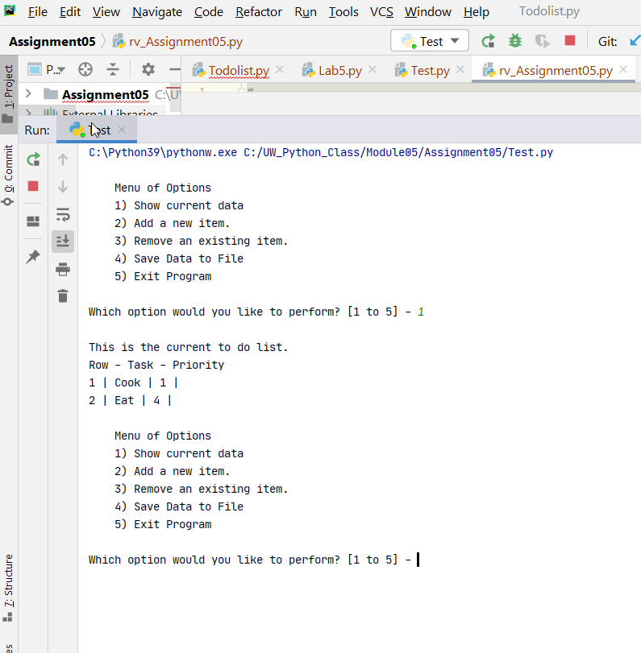

Second option in PyCharm
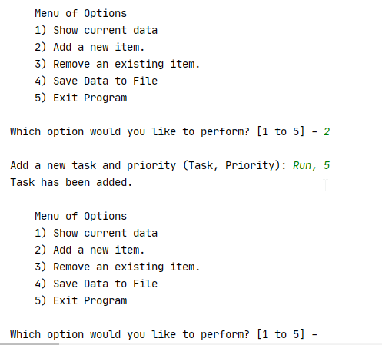

Option 3 in PyCharm
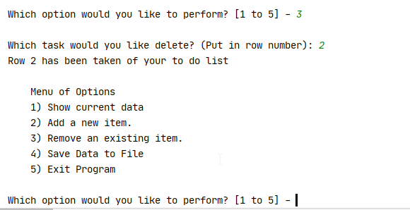

Option 4 in PyCharm

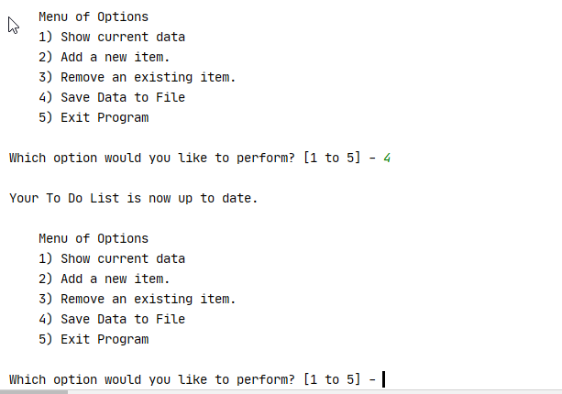

Option 5 in PyCharm

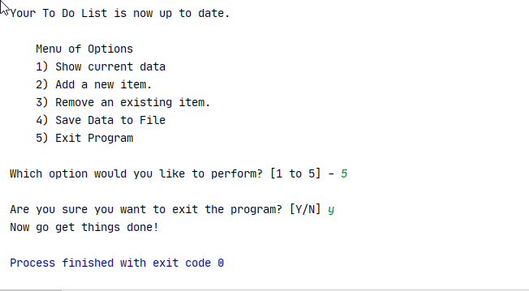

Option 1 in terminal
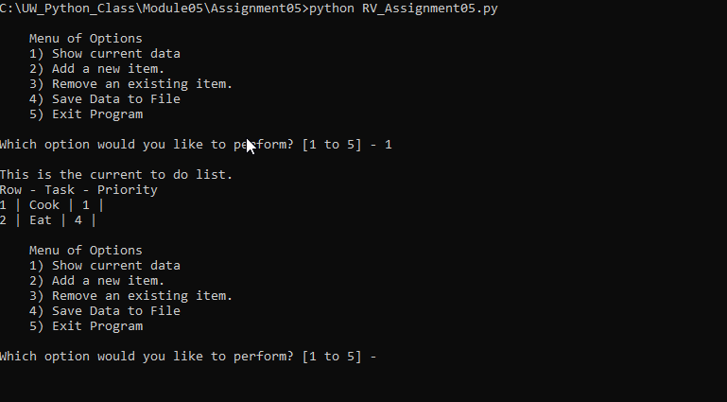

Option 2 in terminal
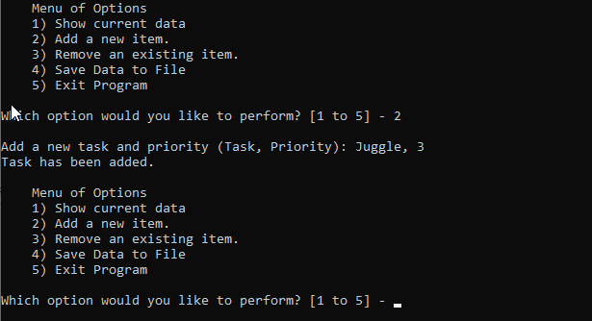

Option 3 in terminal
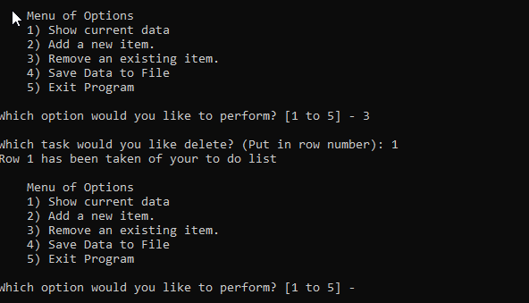

Option 4 in terminal
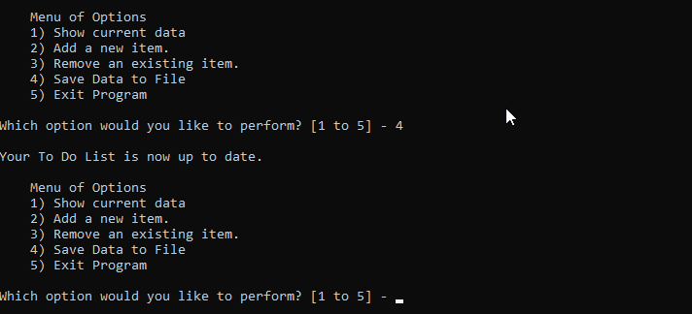

Option 5 in terminal
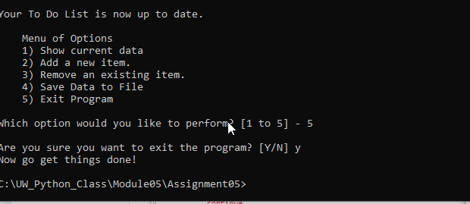

Summary
There were a lot of things covered this week. With all that we have learned, I am finding that there are usually a couple of ways to accomplish basically the same things. Sometimes I could use a while statement, and other times I could use a for or a try statement. It’s challenging to try to find the right one to make it the most efficient. I’m looking forward to learning more and honing the skills.

