Rick Vandercar
11/22/20
IT FDN 110A Intro to Programming (Python)
Assignment06
https://github.com/rvandercar/IntroToProg-Python-Mod06

The Infamous Assignment 06
Introduction
We went over a lot of things this week. We went into greater detail about functions, parameters and arguments. We concentrated on using functions to organize code into better “separations of concerns” pattern. We also covered creating a GitHub webpage

Advanced To Do program
When I first opened up the starter file, I was a bit overwhelmed. Then I decided to just try to run it and see what happened. I received an error that pointed me to some problematic lines. It basically came down to a file not being found, so I created a file and was able to get the menu to show up.

The second thing I did to try to get a handle on this program is to close down each section to try to get a feel for the program flow. That helped out a lot. I could see that the main body of the program made a few if/elif calls to the IO part of the program, so I started to look at that section. I recognized that this section was mainly used to gather data from the user.

I also noticed that after it used the IO functions, it tended to call the processor section. So, I tried to work with a section of the main body, one at a time. I would look at a function, then follow the logic as it went from one section to the next.

I added some document headers to some of the functions for clarity.

It was interesting to see that I could just re-use some of the functions like IO.input_press_to_continue.

This was a program that I struggled with. I had many errors along the way. This actually helped me to learn a lot though. There was one particular bug that drove me crazy. I would start the program then delete a task. Then I would add a task. All of this worked great. Then when I tried to delete a task again, it would do so, but also print the message I had for adding a task. Weird. I never did figure out why that happened. I basically just deleted those sections and did it again.

There was a lot of error checking that I wanted to add when I first started this, like making sure the item was in the task list when deleting and verifying that the menu selection was appropriate, but once I had so many issues, I decided to strip things down to do just what was asked. I’m going to keep playing around with this though so I can learn more.

Starting program in PyCharm
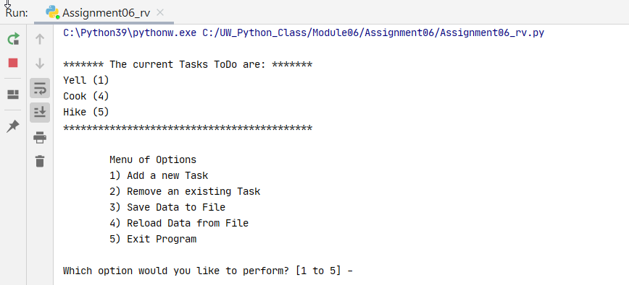

Adding a new task in PyCharm
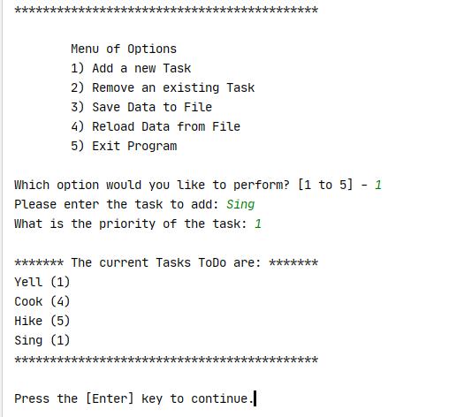
Deleting a task in PyCharm
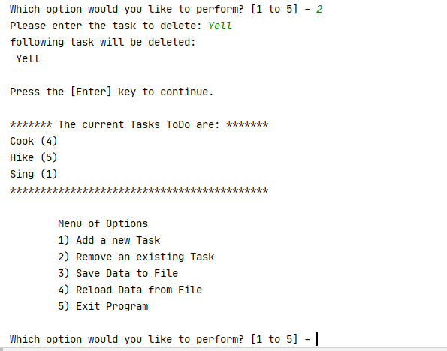

Saving data to a file in PyCharm
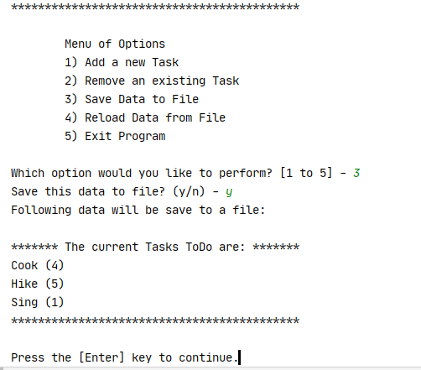

Reloading data from file in PyCharm
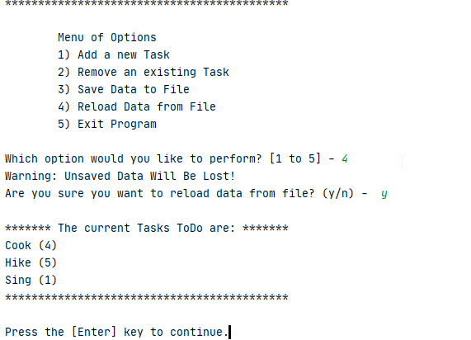

Exiting program in PyCharm
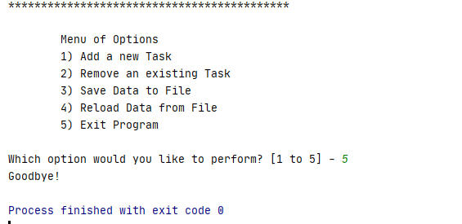

Staring program interinal
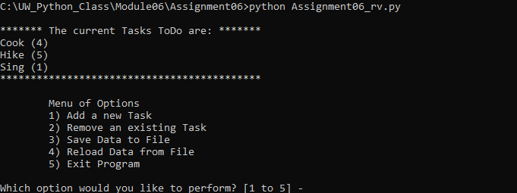

Adding a task in terminal
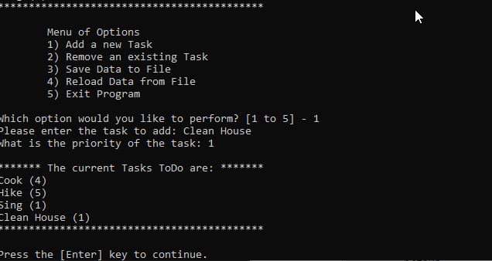

Removing a task in terinal
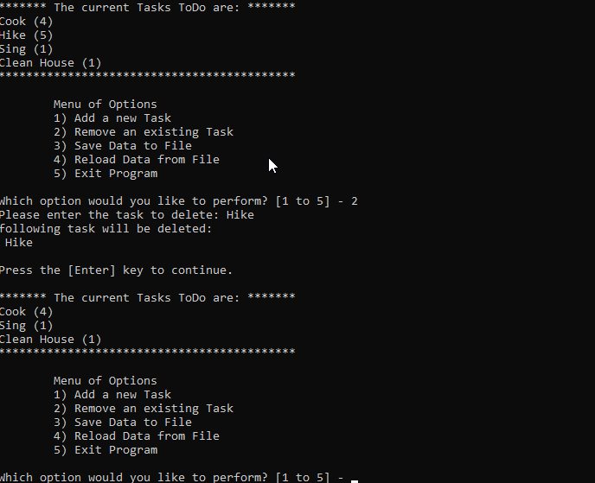

Saving data to disk in terminal
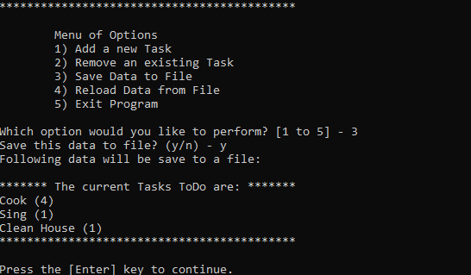

Reloading data from file in terminal
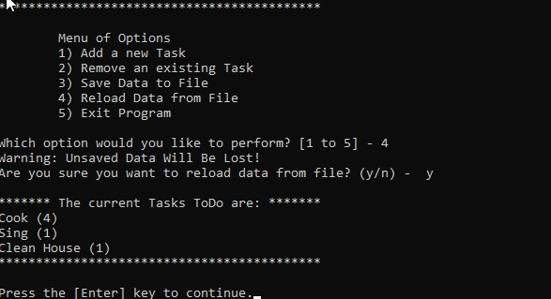

Exiting program in terinal
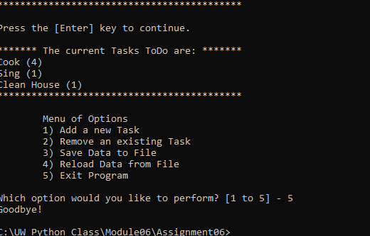

Resulting text file
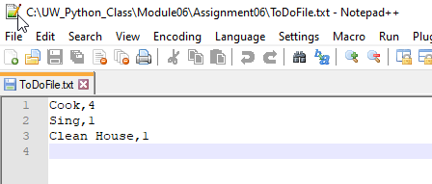

Summary
This week was easily the most challenging for me. With all my job interviews going on, my time was limited. I do believe this script was the most advanced so far also, so the combination made this a week of stress and challenges. I learned a lot with this one though. I think the biggest lesson from this one is using Classes and Functions. I can certainly see the power and the challenges in working with them. They can certainly make the code more organized, readable, and easier to reuse.

