Rick Vandercar
12/13/20
IT FDN 110A Intro to Programming (Python)
Assignment 08

All the classes
Introduction
In this module, we are focusing on classes. We covered how a class can be used directly or indirectly. We also covered the basic design pattern that a script can use. These include fields, constructors, attributes, properties and methods. We also covered the importance of using self and forcing private use of properties.

We also covered using the Git desktop app. I was used to using the command line so it was interesting for me to use a GUI for this.

Product Script

I started writing this script and tried to test along the way as suggested. This helped me to find a lot of things early.

Some of the things that I learned in writing this script is the importance of indenting. That was the biggest struggle I had. At one point I spent a few hours trying to get the script to work, only to find a couple of simple fixes. One was indenting, and the other was trying to open the file with w instead of r.

One thing that I tried for this script, is to use the darcula mode in PyCharm. I really liked this look a lot more. It seemed to make things a lot more clear to me.

Start of script in PyCharm:
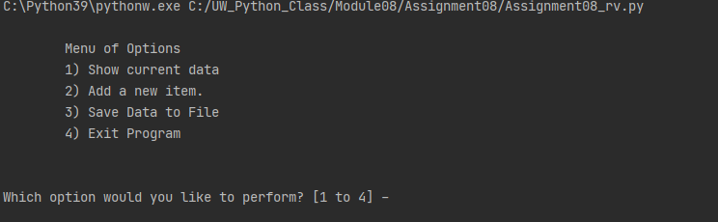

Adding data using PyCharm:
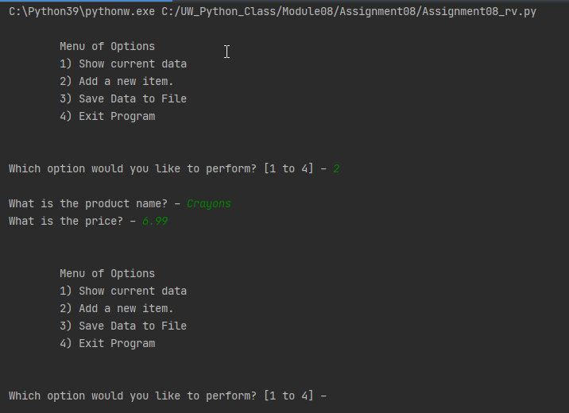

Showing current data in PyCharm:
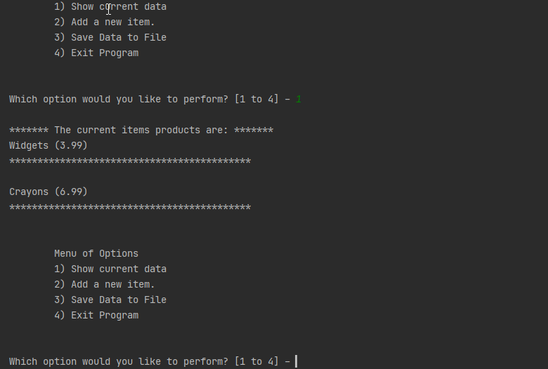

Saving data to file via PyCharm:
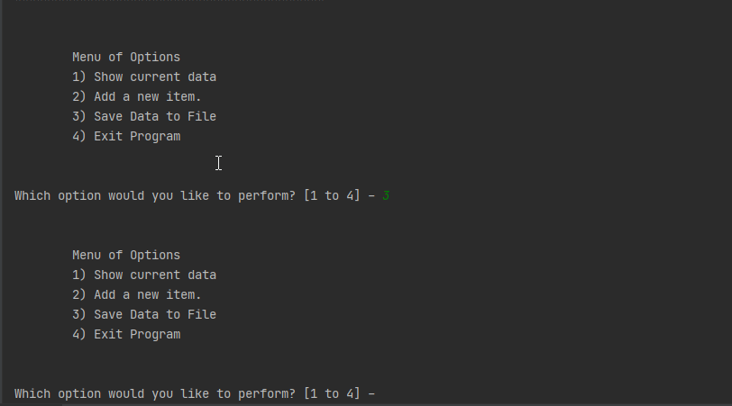

Exiting program via PyCharm:
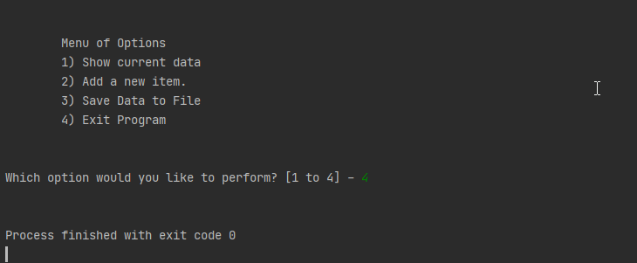

Start of script in Terminal:
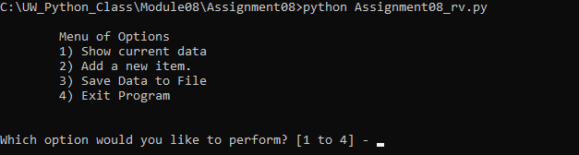

Adding data using Terminal:
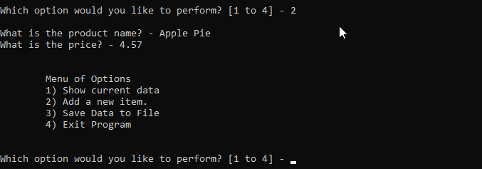

Showing current data in Terminal:
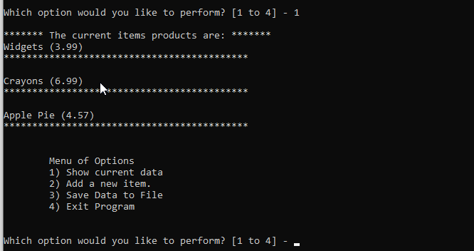

Saving data to file via Terminal:
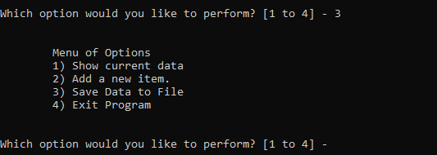

Exiting program via Terminal:
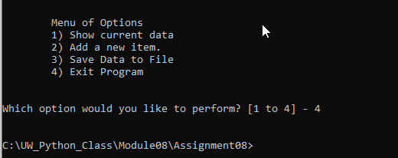

Summary
This was a fun yet challenging module. I will have much to review to really have this information sink in. I am going to enjoy continuing to play around with classes.

Using classes is a really good way to be able to re-use code without having to re-write it. If a change is mad in a class, it will affect everywhere it is referenced which can be a real time saver.

