Digital Alloy Preliminary Data Analysis
This report has two sections.
1. Network Traffic Analysis – This are simple statistics about hit rates and various frequencies.
2. Correlation Analysis – This part is about the analysis of relationship between users and their leadership status with it the social sub groups. This is the most value added section.

NETWORK TRAFFIC ANALYSIS

Summary Observations
- There is an unexpected spike in traffic each day at 12:00 EST.

File Statistics
Digital Alloy supplied two data files, Web logs and CDN logs. Here are some basic statistics from the files. The file statistics reported here are similar to what could be gathered through numerous other methods, so we don't expect any surprises or insight. It's mainly to verify some level of sanity in the data.

 | Web Log | CDN Log
Zip File Size | 1,333,833,580 | 69,599,408 (?)
File size | 9,107,169,115 | 61,435,871,232
Number of records in file | 25,728,210 | 52,885,578
Start DateTime | 21/Sep/2013:06:32:01 -0400 | 21/Sept/2013:00:00:00 Z
End DateTime | 29/Sep/2013:06:25:01 -0400 | 22/Sep/2013:13:14:01 Z
Importable records | 25,728,210 | 52,885,529
Imported Start | 2013-09-21T10:32:01Z | 2013-09-21T00:00:00Z
Imported End | 2013-09-29T10:25:01Z | 2013-09-22T13:14:01Z
Time Span (Seconds) | 777180 | 54121
Hit Rate (hits/sec.) | 33.1 | 977.2

Hit Rates
The hit rates are taken from the WebLogs only; the CDN hits are not considered. Like the file statistics, these measures should not be surprising since they can be found with a variety of commonly available tools.

Hit Rates per day

Date | Hours | Minutes | Count | Hits/Minute
Saturday / Sept 21 | 13:28 (13.47) | 797 | 1839864 | 2308
Sunday / Sept 22 | 24:00 | 1440 | 2709081 | 1881
Monday / Sept 23 | 24:00 | 1440 | 3136865 | 2178
Tuesday / Sept 24 | 24:00 | 1440 | 3591921 | 2494
Wednesday / Sept 25 | 24:00 | 1440 | 4060703 | 2820
Thursday / Sept 26 | 24:00 | 1440 | 3453893 | 2399
Friday / Sept 27 | 24:00 | 1440 | 3261886 | 2265
Saturday / Sept 28 | 24:00 | 1440 | 2768672 | 1923
Sunday / Sept 29 | 10:25 (10.42) | 625 | 905325 | 1449

The graph below shows the hit rate of unique IP address requesters each minute over the course of a day. The count is the sum of the number of hits for each of the days in the sample. There is a notable spike at 16:00Z (12:00 EST)

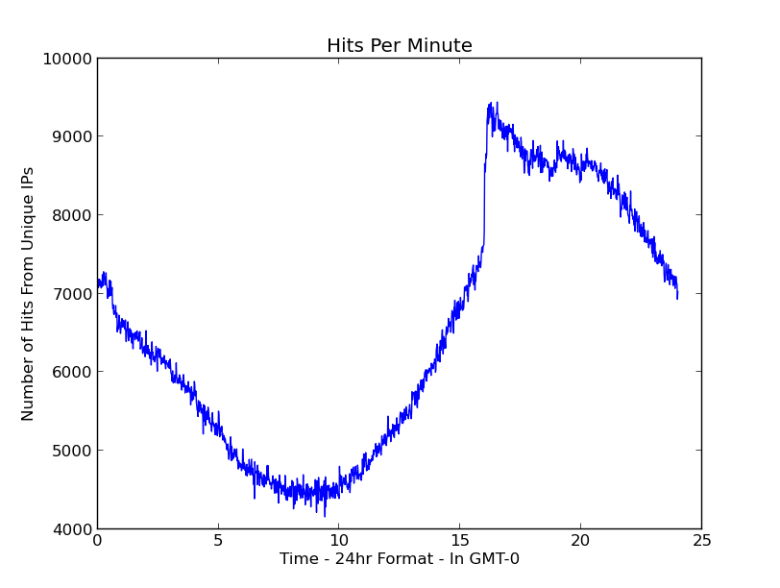

Data Statistics
These statistics are based on the web log data only. CDN data is not included in this.

Verb Frequency
Verb | Count
GET | 24,592,501
POST | 1,016,244
HEAD | 119,293
PROPFIND | 42
OPTIONS | 118
PUT | 6
Undefined | 6
TOTAL | 25,728,210

Status Code Frequency
Status Code | Count
200 | 23,140,540
206 | 93,157
301 | 1,508,513
302 | 745,402
304 | 126,934
400 | 35
401 | 491
403 | 14,488
404 | 94,368
405 | 1
406 | 2
416 | 1
500 | 4278
Total | 25728210

Unique Requestors and Referrers
IP Type | Count
Unique Requesting IP | 1,253,908
Average number of requests per Requester | 20.5
Unique Referring IP | 494,001
Escapist referrals | 396,463

CORRELATION ANALYSIS

User Relationships
The image below shows a simple clustering of users for a a small 2 hour period. The analysis can be done for longer periods, but the graph gets so cluttered that it has no visual value. The graph only shows users that are in cliques, not the users that are in a clique of one.

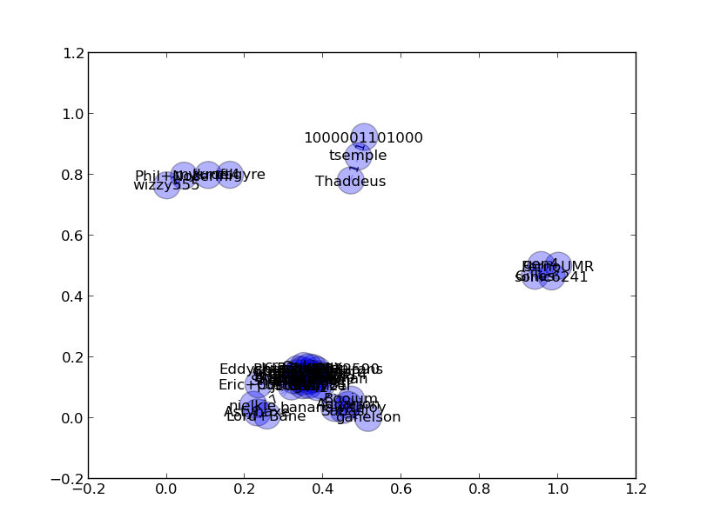
The next image is a zoom-in of one portion of the graph to show the details. The numbers on the edges show the weight of the relationship.

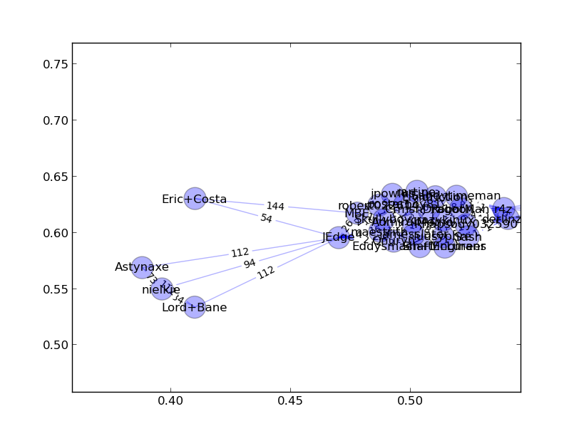

This last network shows some of the connections inside of the large cluster so that we can make the connections with video watches.

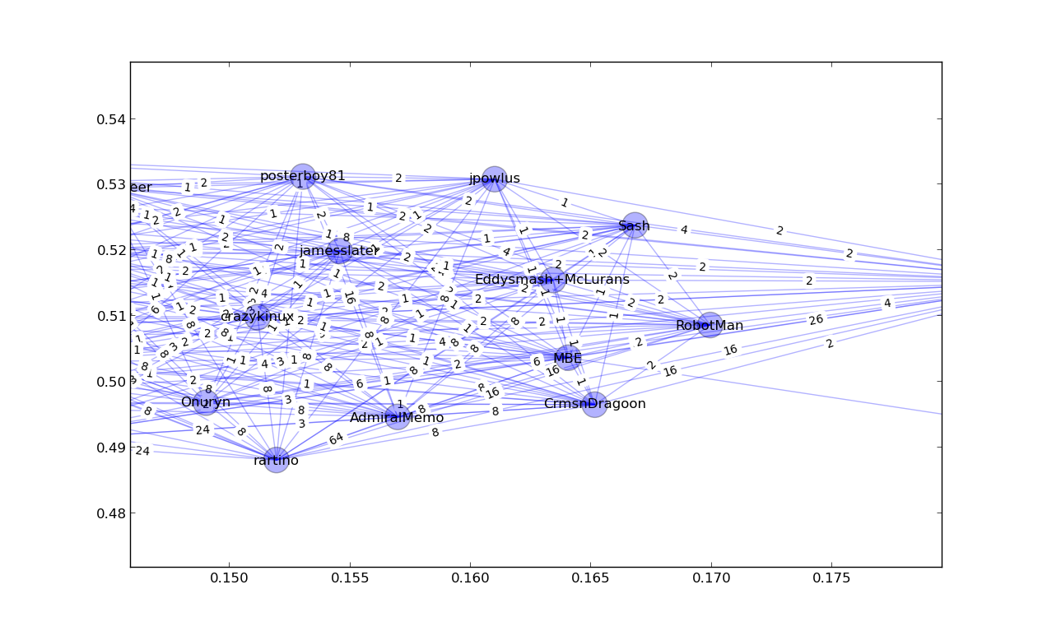

When we run some correlation analysis, we found that (in a limited time interval),
  - jamesslater watched 6 movies
  - AdmiralMemo watched 2 of the same movies
  - In all cases, AdmiralMemo watched the movie first
  - MBE watched 4 movies
  - AdmiralMemo watched 3 of the same movies
  - Again, in all cases, AdmiralMemo watched the movie first.

Next Steps
We have extracted each video description and be able to find which users watched which type of movie reviews. Since we were able to identify the community leaders as show above next step would be to do correlation analysis between sub social groups and the types of movie reviews that they have watched and which leader have influenced the sub social group by watching what type of movie reviews.
Of course having access to user demographic information through digitalalloy's user database would allow us to generate better results since now we can use this information in our correlation analysis and be able to give more insight about the user interaction.

The CDN log files were not used in all analysis and only a partial sample was needed. The cdnweek_sorted.log.2 file contained all of the 184,233,070 records ending 25/Sep/2013:16:07:46 Z. The cdnweek.log is a one day sample with 3,079,978 records and ends 21/Sept/2013:19:15:41 Z.

