Title

Author

Date

First Paragraph

Body Text

# Heading 1

First Paragraph

Body Text

# Heading 1

## Heading 2

First Paragraph

Body Text

## Heading 2

### Heading 3

First Paragraph

Body Text

# Tables

Table Caption

|  |  |  |  |
| --- | --- | --- | --- |
| Variable | Source | Temporal extent | Citation |
| Plant species occurrences | GBIF | TODO | TODO |

# Figures

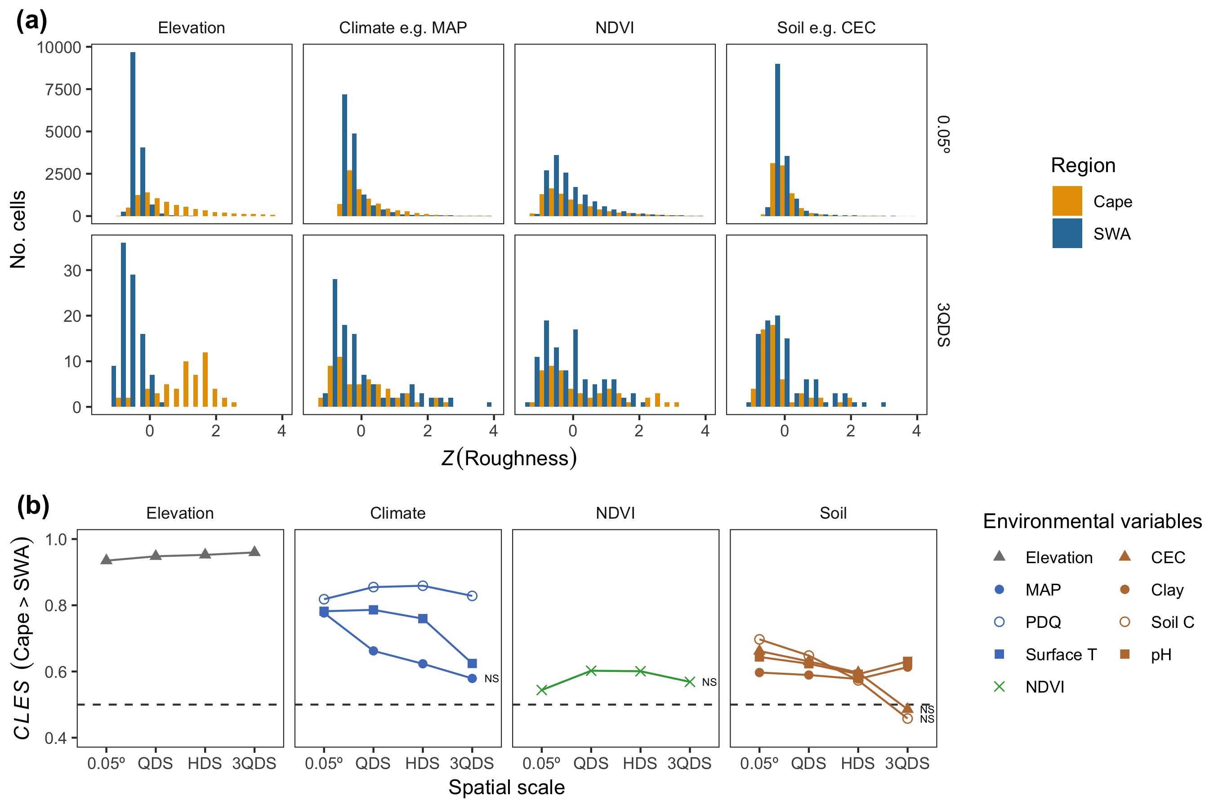

Image Caption

# References

Bibliography