Similar axes of environmental heterogeneity associated with plant species richness in two hyper-diverse floras

Running title: Environmental heterogeneity and plant species richness

Ruan van Mazijk, Michael D. Cramer and G. Anthony Verboom

Department of Biological Sciences, University of Cape Town, Rondebosch, South Africa

Corresponding author: RvM, [ruanvmazijk@gmail.com](mailto:ruanvmazijk@gmail.com)

# Acknowledgements

RvM is grateful to the National Research Foundation and the South African Association of Botanists for bursaries during the course of this work.

# Abstract

[Journal of Biogeography style]

**Aim:** To assess whether the difference in species richness per unit area between two mediterranean-type biodiversity hotspots is explained by differences in environmental heterogeneity.

**Location:** The Greater Cape Floristic Region, South Africa (GCFR) and Southwest Australian Floristic Region (SWAFR)

**Taxon:** Vascular plants (tracheophytes)

**Methods:** Comparable, geospatially-explicit environmental and species occurrence data were obtained for both regions and used to generate environmental heterogeneity and species richness raster layers. Heterogeneity in multiple environmental variables and species richness per unit area, were compared between the two regions at a range of spatial scales. At each scale species richness was also regressed against a major axis of environmental heterogeneity, derived by principal component analysis (PCA), and, using multiple regression, against heterogeneity in individual environmental variables.

**Results:** The GCFR is generally more environmentally-heterogeneous and species-rich than the SWAFR. Species richness per unit area is significantly related to the major axis of heterogeneity across both regions, which explains ca. 38–42% of overall heterogeneity, the slope of this relationship differing between the two regions only at the finest spatial scale. Multivariate regressions, and the residual variation in heterogeneity remaining from the first axis of the PCAs, revealed variations in the dependence of species richness on environmental heterogeneity that differed between the two regions.

**Main conclusions:** We have evidence for a common positive relationship between floristic richness and environmental heterogeneity across the GCFR and SWAFR, broadly independent of spatial-scale. Though there are region-specific effects, […]

*Keywords:* biodiversity, environmental heterogeneity, fynbos, Greater Cape Floristic Region, kwongan, macroecology, species richness, species turnover, vascular plants, Southwest Australian Floristic Region

# 1: Introduction

The species richness of a region is a function of its biogeographic context (e.g. proximity to potential immigrant sources), its diversification history and any locally-deterministic, environmental features (e.g. productivity, heterogeneity) that influence species persistence and coexistence (Ricklefs, 1987, 2004; Bøhn & Amundsen, 2004). Since all three effects are potentially influenced by environmental heterogeneity, the latter may be a particularly important driver of regional species richness variation (refs), with physically-heterogeneous regions tending to be more species-rich (refs). For example, given that the recruitment success of immigrant lineages into a region is often dictated by the pre-adaptations of those lineages (Ackerly, Donoghue & Crisp), a physically-heterogenous environment may promote diversity by admitting a more functionally-diverse array of immigrant lineages (ref). In addition, by virtue of its central role in powering adaptive divergence and/or promoting population isolation, environmental heterogeneity is a critical requirement for speciation under most models (Wiens, 2004a,b; Sobel et al., 2010). Likewise, in the context of long-term environmental change, physical heterogeneity may offer refugia to a wider array of lineages and so confer a greater level of buffering against lineage extinction (Byrne 2008). Finally, environmental heterogeneity has repeatedly been shown to facilitate species coexistence at a variety of scales, enhancing regional species richness (refs). Differences in environmental heterogeneity may, therefore, be critically important in accounting for variation in regional species richness, particularly where the regions under comparison are similar in terms of area, their physical properties and the timeframes within which their biotas have assembled.

The floristically-rich South Western Australian Floristic Region (SWAFR; Hopper & Gioia, 2004) and Greater Cape Floristic Region of South Africa (GCFR; Born, Linder, & Desmet, 2007) constitute a case in point. Situated on the southwestern corners of their respective continents, the climates of both these regions have been oceanically-moderated at least since the Cretaceous, and both are dominated by a contemporary mediterranean-type climate whose origin can be traced to the Early-Middle (SWAFR: Rundel et al., 2016; Lamont & He, 2017) or Late Miocene (GCFR: Dupont, Linder, Rommerskirchen, & Schefuss, 2011; Hoffmann, Verboom, & Cotterill, 2015). In addition, both regions have been unglaciated since the Permian and are dominated by ancient, weathered landscapes whose soil-nutritional status is amongst the lowest of any landscape on Earth (Stock & Verboom, 2012), hence their designation as old, climatically-buffered infertile landscapes (OCBILs; Hopper, 2009). Owing to these environmental similarities, the SWAFR and GCFR floras are very similar with respect to their plant functional trait spectra (Cowling & Witkowski, 1994), although the presence of a significant tree component in the SWAFR underpins a striking difference in vegetation physiognomy (Milewski 1981; Beard et al. 2000). Moreover, the long-term climatic and geological stability of the two regions ensures that the native floras of both reflect long histories of assembly, extending back to the Palaeocene and possibly even earlier (refs), with evidence of a long history of transoceanic dispersal between them (Bergh & Linder 2009). In this context, it is unsurprising that the two floras show strong taxonomic affinities and that both are species-rich with high levels of regional endemism (refs).

Notwithstanding these similarities, the SWAFR and GCFR differ markedly in terms of their vascular plant species richness, particularly when considered in relation to geographical area. Where the SWAFR accommodates ca. 7,380 species in an area of ca. 302,600 km2 (i.e. 0.024 species km-2; Hopper & Gioia, 2004), the GCFR is home to ca. 11,430 species in an area of ca. 189,700 km2 (i.e. 0.060 species km-2; Snijman, 2013). Although on-going identification of new species may change these statistics (e.g. Gioia et al., 2017), the overall differences in species km-2 are quite dramatic. One possible explanation for this striking 2.5-fold species richness difference (per unit area) relates to differences in the physical heterogeneity of the two regions. Where much of the GCFR, particularly the hyper-diverse (ca. 9,400 species in ca. 90,800 km2; 0.104 species km-2) “core” Cape Floristic Region (CFR; Goldblatt, 1978), is rugged and mountainous, the SWAFR landscape is much more subdued, comprising an ancient, weathered plateau. Indeed, of the world’s five mediterranean-climate regionsCFR has, being surpassed only by the Mediterranean Critically, since the strong relief of the GCFR underlies steep climatic and edaphic gradients (refs), its climatic and edaphic heterogeneity is correspondingly high. The central aim of this paper, then, is to test the hypothesis that the observed difference in species richness (per unit area) between the SWAFR and GCFR is a consequence of differences in the physical heterogeneity of these regions. Focusing on the quarter-degree square (QDS), half-degree square (HDS) and degree square (DS) scales (sensu Larsen, Holmern, Prager, Maliti, & Røskaft, 2009), we first compare the distribution of species richness between the two regions, and in each region decompose broader-scale richness into average finer-scale richness and between-square turnover. Thereafter, we compare environmental heterogeneity between the two regions at a range of spatial scales. Finally, we use linear models to assess whether differences in environmental heterogeneity are sufficient to explain observed differences in species richness between the two regions.

# 2: Materials and methods

## 2.1: Comparing species richness

To compare vascular plant species richness between the GCFR and SWAFR, geospatially-explicit occurrence records of tracheophytes from within the borders of each region were obtained from the Global Biodiversity Information Facility (GBIF; Table 1). For this purpose, the GCFR was treated as the area occupied by the Succulent Karoo and Fynbos Biomes (Mucina & Rutherford, 2006), while the SWAFR was treated as the area occupied by Southwest Australia Savanna, Swan Coastal Plain Scrub and Woodlands, Jarrah-Karri Forest and Shrublands, Southwest Australia Woodlands, Esperance Mallee, and Coolgardie Woodlands (Olson et al., 2001) in order to match the current delimitation of the SWAFR (Gioia & Hopper, 2017; Hopper & Gioia, 2004). The downloaded occurrence data were then cleaned using the “taxize” package (Chamberlain et al., 2016) in R (ref) (SI). Despite spatial variability in collection effort in both regions, we used raw species counts to estimate QDS-scale species richness on the basis that the application of rarefaction techniques severely distorts known richness patterns when applied to the South African flora (Cramer & Verboom, 2016). The final numbers of unique species thus identified as occurring in the GCFR and SWAFR, respectively, were 8,578 and 6,558.

Using R, the cleaned species occurrence record data were collated into QDS, HDS and DS. To compare species richness across equally sized areas, we only made comparisons between squares consisting of all four sub-squares (e.g. four QDS in an HDS). In addition, following Whittaker’s (ref) original additive decomposition of *γ*-diversity, we decomposed the species richness of each HDS (*S*HDS) and DS (*S*DS) into its *α* (“plot” richness) and *β* (turnover) components, using the equations

$$S_{HDS}={\overline{S}}_{QDS}+T_{QDS}$$

$$S_{DS}={\overline{S}}_{HDS}+T_{HDS}$$

where QDS and HDS are the average species richness of the four constituent squares in each HDS and DS, respectively (i.e. mean *α* richness), and *T*QDS and *T*HDS represent the residual (i.e. turnover-based) *β* richness, determined as *γ* − *α*.

## 2.2: Comparing environmental heterogeneity

To compare environmental heterogeneity between the GCFR and SWAFR, we acquired a broad suite of geospatially-explicit environmental data in the form of raster layers. For the purpose of analysis, we then selected a subset of nine variables (Table 1) to represent topographic (elevation), climatic (surface T, MAP, PDQ), edaphic (clay content, soil C, pH, CEC) and vegetational (NDVI) gradients. As far as possible, these variables were selected to represent environmental axes which are considered regionally important and nominally independent. For example, the inclusion of PDQ in addition to MAP is justified on the basis that, where the latter captures variation in overall rainfall amount, the former measures the intensity of seasonal aridity, a key feature of mediterranean-type climates (ref). Variable selection was, however, constrained by the availability of suitable raster-layers. Thus, although soil [P] is probably an important determinant of plant distribution in both the GCFR and SWAFR (refs), this variable could not be included owing to a lack of comparable data layers for the two regions. Indeed, wherever possible, we made use of remote sensing derived layers. Where soil variables were summarised as depth-interval weighted averages, climatic and spectral variables were summarised as annual means, both using the “raster” package for R (Hijmans, 2016). All layers were then projected to a common coordinate reference system (WGS84) using the “rgdal” package (Bivand, Keitt, & Rowlingson, 2017) and resampled to 0.05º resolution using the “resample” function in “raster,” with the “bilinear” method.

In order to quantify heterogeneity in these environmental variables, we developed an index that would account for the spatial configuration of environmental conditions. Our index, based on raster data, employs nested squares at various spatial scales. We quantified the environmental heterogeneity of a given square (i.e. 0.10°×0.10°-, QDS-, HDS- and DS-scale) as the variance of the environmental conditions of the four sub-squares (i.e. 0.05°×0.05°-, eighth-degree square-, QDS- and HDS-scale) nested within it. This was done using the “aggregate” function in the R package “raster” (Hijmans, 2016), with variance set as the aggregation function. Since our index measures within-square heterogeneity at each spatial scale, it can be related directly to species richness at the QDS-, HDS- and DS-scales.

We used principal components analysis (PCA), applied to the nine environmental variables across both regions, to extract a major axis of environmental heterogeneity. For this purpose, the layers describing heterogeneity in the nine environmental variables at each spatial scale were first log10-transformed to ensure normality. A separate PCA was then run at each spatial scale. The first axis (PC1) thus extracted from each of the four PCAs represents the major axis of heterogeneity across the nine environmental heterogeneity variables considered.

To compare heterogeneity in the nine environmental variables and in the major axis of heterogeneity between the two regions, we employed common language effect sizes (*CLES*) using the R package “canprot” (ref). The *CLES* describes the proportion of pairwise comparisons of a variable between two categories in which the value in one category exceeds that in the other. Additionally, we tested for differences in regional heterogeneity values using two-sided Mann-Whitney *U*-tests (ref) as implemented in R. Both analyses were done at all four spatial scales. This enabled us to assess scale-dependence in heterogeneity and to ascertain the spatial scale at which regional environmental heterogeneity differences are most pronounced.

## 2.3: Environmental heterogeneity as an explanation of species richness

We used linear models to assess the explanatory power of heterogeneity in the nine selected environmental variables, and the major heterogeneity axis represented by PC1, as determinants of species richness across the two regions.

We first used analyses of covariance (ANCOVA), at the QDS-, HDS- and DS-scales, to relate species richness to the heterogeneity of each environmental variable, and to the major axis of heterogeneity, across the two regions. In order to assess whether these relationships are identical in form across the two regions, we fitted three nested models for each heterogeneity predictor *X*, as follows: a “main effect only” model (*S* ~ *β*0 + *β*1*X*), a “main effect + region” model (*S* ~ *β*0 + *β*1*X* + *β*2*Region*) and a “main effect × region” model which includes an interaction between heterogeneity and region (*S* ~ *β*0 + *β*1*X* + *β*2*Region* + *β*3(*X × Region*)). For each of the ten predictors, the best fitting model was determined using Akaike’s information criterion (*AIC*; ref), as the simplest model with *∆AIC* < 2 (ref).Where the “main effect only” model describes heterogeneity as having a uniform effect on species richness across the two regions (i.e. a common relationship), the “main effect + region” and “main effect × region” models describe the relationships of species richness to heterogeneity as being region-dependent. Specifically, where the “main effect + region” model describes these relationships as being identical in terms of slope but not intercept, the “main effect × region” describes them as differing in both intercept and slope.

We then used multiple linear regressions to model species richness as a function of region and heterogeneity in all nine environmental variables simultaneously. As with the simple regressions, this was done at all three spatial scales. Starting from a 19-predictor model, including region, the heterogeneities of all nine environmental variables and the interactions of the latter with region, model simplification was done using reverse stepwise regression model selection (ref) based on *AIC*-scores. In the final model, the retention of significant heterogeneity-region interaction terms indicates that the dependence of species richness on heterogeneity differs between the two regions. Conversely, where only the main effect is significant the dependence of species richness on heterogeneity is inferred to be uniform across the two regions.

## 2.4: Species richness hotspots

To identify hotspots of exceptional richness, i.e. squares whose species richness exceeds that expected on the basis of their environmental heterogeneity, we used the residuals associated with the PC1-based ANCOVA models (Figure 3) and the multiple regression models (Figure 4), at all three spatial scales, to identify outlier points. For this purpose outliers were defined as any points with residual species richness more than two standard deviations from the mean. We also used an *F*-test to assess whether the variances of the residuals associated with ANCOVA and multiple regressions differed between the GCFR and SWAFR. Finally, to assess whether the exceptional richness of hotspots is best explained by factors other than environmental heterogeneity, we repeated the ANCOVA and multiple regression analyses with hotspots omitted, and compared the coefficients of determination.

# 3: Results

## 3.1: Comparing species richness

Vascular plant species richness varies spatially in both the GCFR and SWAFR, with both regions possessing a hotspot of exceptional richness (the Kogelberg Centre in the GCFR; Greater Perth in the SWAFR) and declining species richness towards its interior margin (Figure 5a, b). Comparisons of species richness between the regions using two-sided Mann-Whitney *U* tests reveal that species richness per unit area is similar at the QDS- (Figure 2a; *P* = 0.402, *CLES* = 0.516) and HDS-scales (Figure 2b; *P* = 0.275, *CLES* = 0.542), but that the GCFR is significantly more species-rich than the SWAFR at the DS-scale (SI, Figure S1a; *P* = 0.038, *CLES* = 0.658).

Partitioning *S*HDS into its *α*- and *β*-components (QDS and *T*QDS respectively; Figure 2c), we found that the proportional contribution of floristic turnover (i.e. *T*QDS/*S*HDS; Figure 2d) is greater in the GCFR (0.64) than in the SWAFR (0.60) (two-sided Mann-Whitney *U* test, *P* < 0.001; *CLES* = 0.696). This is also the case at the DS-scale (SI, Figure S1b; *T*QDS/*S*HDS GCFR:0.55, SWAFR: 0.48; two-sided Mann-Whitney *U* test, *P* = 0.001, *CLES* = 0.741).

## 3.2: Comparing environmental heterogeneity

With a few exceptions (MAP, NDVI and CEC at the DS-scale; Figure 1b, e, f), *CLES* comparisons revealed the GCFR to be more heterogeneous than the SWAFR in all nine environmental variables, and across the full range of spatial scales (Figure 1). The same was true for the major axis of heterogeneity described by PC1 (Figure 1j; Figure 5c, d), which accounted for between 38% (at the 0.10°×0.10°-degree scale) and 42% (at the QDS-scale) of the variance in all nine heterogeneity variables. In general the disparity in heterogeneity between the two regions is greater for topographic and climatic (all *CLES* > 0.60; Figure 1a–d) than edaphic variables (all *CLES* < 0.75; Figure 1f–i).

Regressions indicate that the degree to which the GCFR is more environmentally heterogeneous than the SWAFR is largely scale-independent, with the notable exceptions of MAP (Figure 1b), in which the GCFR is disproportionately more heterogeneous at fine scales, and NDVI and clay (Figure 1e, g), in which the GCFR is disproportionately more heterogeneous at coarse spatial scales. The major axis of heterogeneity (PC1) reflects the scale-independence of most forms of heterogeneity, with its *CLES* being more or less uniform across spatial scales (Figure 1j).

## 3.3: Environmental heterogeneity as an explanation of species richness

The ANCOVA results show that heterogeneity in each of the nine environmental variables, as well as the main axis of heterogeneity (PC1), influence species richness in a consistently positive manner across the two study regions. In addition, they show that, at the HDS- and DS-scales, the effect of heterogeneity in each environmental variable, and of PC1, on species richness is uniform across the two regions (i.e. “main effect only” model favoured: Table 2b, c; Figure 3b, c). By contrast, the relationship of species richness to heterogeneity at the QDS-scale is generally region-dependent, the “main effect × region” model being favoured for three environmental variables and PC1, and the “main effect + region” model for four variables (Table 2a). However, the coefficients of the significant interaction (24.6 to 89.4) and region (50.5 to 72.6) terms are small in magnitude relative to the spread of residual species richness at the QDS-scale within each region (*SD*GCFR = 335.2; *SD*SWAFR = 247.4). This indicates that regional differences in the form of the QDS-scale species richness-heterogeneity relationship, while statistically significant, are subtle (see also SI. Figure A).

With the exception of pH at all spatial scales and elevation at the DS-scale, the partial main effects of all heterogeneity predictors retained in the optimal multiple regression models are consistently positive, corroborating the generally positive influence of heterogeneity on species richness. Moreover, where these partial effects are negative this is almost certainly due to collinearities of pH and elevation with the other variables retained in the models, particularly MAP which has the greatest explanatory power in all models (SI Figure). In contrast to the optimal ANCOVA models, multiple regression models suggest region-dependence in the relationships of species dependence to environmental heterogeneity at all three spatial scales. However, the coefficients associated with the significant interaction terms are small in magnitude at both the QDS- (54.2 to 65.8) and HDS-scales (200.8, 210.8), relative to the spread of residual species richness within each region (QDS: *SD*GCFR = 315.5; *SD*SWAFR = 230.1; HDS: *SD*GCFR = 540.2; *SD*SWAFR = 337.3). As before, this suggests that regional differences in the relationship of species richness to heterogeneity at these scales, while statistically significant, are subtle. At the DS-scale, however, the significant coefficients are large (500.0 to 1622.9) relative to the spread of residual species richness within each region (*SD*GCFR = 638.4; *SD*SWAFR = 353.9). Where the significant negative coefficients associated with surface T and clay heterogeneity imply that these variables exert a greater positive influence on species richness in the GCFR than in the SWAFR, the positive coefficients associated with elevation and pH heterogeneity have the effect of cancelling (in the SWAFR) the partial main effects of these variables, both of which are a consequence of collinearities.

That the coefficients of determination associated with the optimum regression models (Figure 4: *R*­2 = 0.24, 0.33 and 0.61) are consistently greater than those associated with the optimal ANCOVA models based on PC1 (Figure 3: *R*­2 = 0.14, 0.19 and 0.28) is because PC1 does not capture some environmental heterogeneity relevant to the prediction of species richness.

## 3.4: Species richness hotspots

Residual-based outlier identification yielded very similar results for the PC1-based ANCOVA and multiple regression models at all spatial scales (Figure 5; Suppl. Figure ***). For both the GCFR and SWAFR, outliers are geographically clustered, in areas corresponding to recognized diversity centres. At the QDS-scale, for example, GCFR outliers are concentrated in the Kogelberg-Hottentots-Holland and Cederberg areas, while SWAFR outliers are concentrated in the Mt Lesueur, Perth, Stirling-Albany and Fitzgerald River areas. Fewer hotspots are necessarily resolved at the HDS-scale (i.e. the Kogelberg-Hottentots-Holland area in the GCFR and the Perth area in the SWAFR) and only one at the DS-scale (the Hottentots Holland area in the GCFR). Omission of outliers from the ANCOVA and multiple regressions yielded qualitatively similar models as before, but generally with slightly improved coefficients of determination (Suppl. Materials).

# 4: Discussion

Consistent with a recent meta-analysis identifying environmental heterogeneity as a universal driver of species richness (Stein et al. 2014), we found heterogeneity to have a consistently positive influence on species richness in the GCFR and SWAFR. Except for the partial coefficients of pH and elevation in the multiple regressions, which are negative on account of their collinearity with other variables, all significant coefficients associated with environmental heterogeneity terms in our ANCOVA and multiple regression models are positive. Thus, we find no evidence for the hump-backed response of species richness to heterogeneity anticipated by some authors (Allouche et al. 2012; Carnicer et al. 2013). Additionally, and also consistent with Stein et al. (2014), we find the strength of the heterogeneity-species richness relationship to associate positively with spatial scale (grain), as evidenced by that fact that the coefficients of determination associated with our ANCOVA and multiple regression models were greatest at the DS-scale and smallest at the QDS-scale. One possible explanation of this effect is the fact that larger areas accommodate more environmental variability (Wuest et al. 2019), and so facilitate stronger heterogeneity-species richness relationships (Van Rensburg et al. 2002). In speciation hotspots like the GCFR or the SWAFR, however, an important additional consideration is the spatial scale of speciation (Stein et al. 2014), with the stronger coupling of species richness to heterogeneity at the DS-scale possibly arising because the DS, in contrast to the QDS and HDS, is sufficiently large to capture allopatric speciation processes.

The observation that species richness responds to environmental heterogeneity in a uniform manner across the GCFR and SWAFR or at least, where this is not the case, that regional differences in the form of the richness-heterogeneity relationship are subtle, suggests that the greater vascular plant species richness of the GCFR is partly attributable to the greater physiographic heterogeneity of this region. As noted by Cowling et al. (2015) the lower heterogeneity of SWAFR, both now and during the Tertiary, would have constrained opportunities for radiation, thereby producing a flora that is generally less diverse. In addition, the greater heterogeneity of the GCFR might facilitate denser species packing, through the provision of greater niche diversity, at a range of scales (refs). Our data reveal that, despite its significantly greater DS-scale species richness, the GCFR does not have significantly greater QDS- and HDS-scale species richness than the SWAFR. This pattern, which reflects higher rates of QDS- and HDS-scale species turnover in the GCFR, implies a greater role for dispersal limitation and local species differentiation in driving high DS-scale richness in the Cape. This interpretation is consistent with evidence for a much high frequency of single-site endemic taxa in the Cape than in the Australian flora (Linder 2019).

Although our data confirm a broad dependence of GCFR and SWAFR plant species richness on environmental heterogeneity, as defined by the nine environmental variables examined, the generally low coefficients of determination associated with these relationships indicate a role for other factors. Firstly, species richness is almost certainly influenced by heterogeneity in other environmental variables, some of which may vary at spatial scales beyond the resolution of available environmental layers. Cramer et al. (2019), for example, recently highlighted the superiority of locally-modelled soil layers, which also include aspects of soil chemistry, as predictors of vegetation type in the GCFR, compared with the globally-modelled layers used in this study. Unfortunately, we were unable to make use of these layers as comparable data are lacking for the SWAFR. In any event, despite the obvious importance of soil variables as determinants of plant distribution, their inclusion in broad-scale spatial modelling exercises remains problematic since the spatial scale at which soils vary is typically much finer than the spatial resolution of modelled layers (Figueiredo et al. 2018). Similarly, the association of many point-endemics in the GCFR with highly-localized bogs, whose distributions are geomorphologically- rather than climatically-determined, presents challenges for species distribution modelling on account of their small size (Born and Linder 2019). The same may well be true for the SWAFR flora where phylogenetically-relictual species typically inhabit waterlogged situations (Hopper and Gioia 2004).

A second factor potentially compromising the explanatory power of our models is the inclusion of only the heterogeneities of environmental variables and not their absolute values. Although the absolute values of certain environmental variables, particularly those influencing biological productivity (energy-water theory), have often been found to correlate positively with species richness at broad scales (Currie 1991; Hawkins et al. 2003; Kreft and Jetz 2008), we elected to omit these variables from our analyses because we wished explicitly to assess the ability of heterogeneity to account for species richness variation across the GCFR and SWAFR. Besides, as noted by Cowling et al. (2017), energy-water theory does not appear to hold in the GCFR where species richness is maximized in cool, nutrient-impoverished areas. The same appears to be true for the SWAFR (ref***).

A third factor underpinning the unexplained variance in our models is spatial variation in collection effort and its consequences for species richness estimates. Although some authors have argued for the application of sample- (Gotelli and Colwell, 2001) or coverage-based rarefaction techniques (Chao and Jost, 2012) to correct for variable collection effort (Engemann et al., 2015), the application of these approaches to systematically-biased collection data is potentially problematic (refs). These techniques, however, assume that the relationship between the true species richness and sampling effort is weak. In contrast, herbarium collectors commonly focus their efforts on rare species, and many herbaria do not accept material indiscriminately, being reluctant to accept multiple accessions of the same species from a single area. We have desisted from applying these techniques because, at least for the South African flora, these methods severely distort known species richness (Cramer and Verboom 2017). Use of rarefaction may artificially inflate species richness in areas of low collection, where collections are low not because of inaccesability, but because species richness is low. Indeed, Cramer and Verboom (2017) found that the cumulative species richness provided a reasonable estimate of the biome-level floral richness, and that these numbers were consistent with results from an exhaustive atalassing project (i.e. Protea Atlas; Rebelo, 2001) with low collecting bias (Merow et al 2013).

A fourth and final factor potentially compromising the strength of the species richness-heterogeneity relationship is the existence of diversity hotspots whose high species richness is not directly linked to physiographic heterogeneity. This is a potentially significant issue in both the GCFR and SWAFR where species richness is often concentrated in hotspots (cf. Oliver et al. 1983; Gioia and Hopper 2017) whose exceptional richness, at least in some instances, may be a consequence of paleoenvironmental history. In the Cape Floristic Region (CFR; *sensu* Goldblatt 1978), for example, higher species richness in the west has been attributed to reduced rates of extinction, associated with greater climatic stability through the Pleistocene (Cowling and Lombard 2002; Cowling et al. 2017). In this study, we used the residuals derived from PC1-based ANCOVA and multiple regression models to identify hotspots whose species richness exceeds that expected on the basis of their underlying heterogeneities. At least some of the hotspots identified in this manner correspond to centres of long-term environmental stability. In the GCFR, for example, the southwestern mountains (Kogelberg-Hottentots Holland) have been identified as a long-term climatic and hydrological refugium, especially for moisture-loving species which inhabit the numerous bogs and seeps found there (Wuest et al. 2019; Linder 2019). Similarly, pollen and midden-based isotope data provide evidence of relatively muted Pleistocene climate change in the Cederberg (Meadows and Sugden 1991, 1993; Meadows et al. 2010). Although the biota of the SWAFR also shows evidence of climatically-forced range contraction in the Pleistocene (Byrne and Hines 2004; Byrne 2008), the exact position of putative refugia in the SWAFR is somewhat unclear. Maps in Byrne (2008; Fig. 2), however, identify one refugium in the vicinity of Perth and a second in the vicinity of Fitzgerald River.

In summary, although the existence of a common species richness-environmental heterogeneity relationship across the GCFR and SWAFR suggests that the greater species richness of the GCFR is partly attributable to it greater physiographic heterogeneity, the generally low coefficients of determination associated with this relationship indicate a significant role for other factors. Foremost amongst these, perhaps, is the influence of localized diversity hotspots whose richness is a consequence of long-term climatic and hydrological stability. Given that such hotspots are essential for the long-term persistence of plant species richness (McLaughlin et al. (2017), their accurate identification and effective protection is an important conservation objective, particularly in the face of contemporary climatic deterioration. In the context of the GCFR or CFR, therefore, it is important to establish whether the high species richness in the west is in fact attributable to a broad longitudinal effect, as implied by some authors (Cowling and Lombard 2002; Verboom et al. 2014; Cowling et al. 2017), or whether it is tied to the presence of hotspots whose exceptional richness is attributable to effects that are more local in nature. Our data, perhaps, point towards the second interpretation, with the Kogelberg-Hottentots Holland area emerging as a particularly important refugium for Cape plant diversity. Given that much of the locally-endemic diversity of this area is associated with bog and seepage habitats (Linder 2019), recent proposals to abstract water from the Table Mountain Group aquifer which feeds these bogs, present a serious threat to the continued persistence of Cape floristic diversity, particularly since the hydrological consequences of such abstraction remain poorly understood (Slingsby et al. 2018).

END

Conclusion?

Overall, the GCFR and the SWAFR represent geographically distinct examples of floras, the species richness of which exist along a similar continuum of environmental heterogeneity that is required to enable species coexistence. While regional environmental and evolutionary history and rates of speciation/extinction are clearly important, without environmental heterogeneity the species pool cannot persist. Therefore, the smaller scale heterogeneity of the GCFR results in a greater density of species richness, whereas the larger scale heterogeneity of the SWAFR results in lower density, but a wider area of species richness. This therefore represents an attempt at unification of conceptual thinking about the drivers of species richness between the two regions, without disregarding the important regional peculiarities, such as the hotspots of species richness.

Broadly, we found support for the hypothesis that differences in the observed species richness (per unit area) between the GCFR and SWAFR are associated with differences in these regions’ environmental heterogeneity, over a variety of environmental axes. This is corroborated by the greater levels of floristic turnover exhibited within the GCFR compared to the SWAFR. We thus conclude there to be an underlying common relationship between species richness and environmental heterogeneity. Much prior macroecological work has investigated the importance of environmental heterogeneity alongside absolute environmental conditions (sensu energy-water theory; refs) in explaining regional species richness, while our study identifies some forms of heterogeneity of which are correlated with greater species richness in two geographically distinct floras. The spatial distribution of species richness, across a variety of taxa, has previously been linked to spatially-configured habitat heterogeneity (e.g. Thuiller et al., 2006; Mouchet et al., 2015; Cramer & Verboom, 2016; Rensburg et al., 2002; Kerr et al., 2001; Levin et al., 2010; Lobo et al., 2004; Kreft & Jetz, 2007) [sort references]. Relevant to our study [reword], models that include environmental heterogeneity yield more accurate estimates of the floristic richness of the Cape flora (e.g. Thuiller et al., 2006; Cramer & Verboom, 2016). Though, in the models developed by Cramer & Verboom (2016) for South Africa, topographic heterogeneity was largely superseded as an important predictor of species richness by other forms of heterogeneity. The high levels of plant diversity in mediterranean-type ecosystems are thought to arise, mechanistically, due to the greater levels of evolutionary diversification and coexistence (both necessary for species accumulation by immigration or in situ speciation) and long-term environmental stability in these regions (Cook et al., 2015, Pinto-Ledezma et al., 2018). Future research should be aimed at distinguishing the relative roles of ecological speciation and species coexistence associated with heterogeneity across mediterranean-type ecosystems. Though the latter is a necessity biodiversity at both short (ecological) and long (evolutionary) timescales, the former would only operate at geologic timescales. Thus, the role of environmental stability through time is key, both by allowing more continuous species accumulation when habitats persist through and by providing environmental gradients stable for long enough to constitute potential barriers to gene flow such that ecological speciation can occur. In the contexts of the GCFR and SWAFR, this long-term environmental stability, and thus the stability of spatially-configured heterogeneity through time, evidently contributes to these regions’ biodiversity (Hopper, 1979; Cowling et al., 1996). [expand on degree of climatic buffering?] [This feels relevant to this paragraph, and indeed our results agree with this to an extent, but I’m not 100% sure where to work it in: “Oligtrophic soils can stimulate an increase in functional diversity, through the evolution of diverse nutrient acquisition strategies (Lambers et al., 2010; Verboom et al., 2017)—e.g. sclerophylly (Cramer et al., 2014; Cook et al., 2015).”] [Also this: “SWAFR richness > than GCFR given heterogeneity (Figure 4).”]

The five mediterranean-type ecosystems differ with respect to the degree to which environmental heterogeneity is an important driver of plant species richness relative to other environmental factors (i.e. productivity, resource availability, stability, disturbance regimes). Additionally, the environmental axes along which heterogeneity is meaningfully associated with species richness may differ between the five regions. While we conclude there to be a common suite of heterogeneity-axes correlated with floristic richness across both the GCFR and SWAFR, these regions are not without their idiosyncrasies (Figure 4). [expand on other MTEs’ heterogeneity?] Moreover, non-mediterranean-type systems, and global ecosystems more generally, may or may not exhibit the association between richness and heterogeneity as strongly, regardless of which axes of heterogeneity. In fact, when analyses are unconstrained in spatial extent to concern global patterns, mediterranean-type regions such as the GCFR outlie general patterns [think energy-water hypotheses] (Kreft & Jetz, 2007). Though notably, this is also attributable to Kreft & Jetz’s (2007) models’ using primarily absolute environmental variables leading to an underestimated richness of the Cape flora. Though Kreft & Jetz (2007) did include topographic heterogeneity in their predictor set, topography is often a proxy for more biologically meaningful variables (Cramer & Verboom, 2016). [merge these last 2 sentences better with the sentences before?] In addition to the spatial extent of ecosystems, the spatial scale of heterogeneity (or “grain”) has bearing on the generality of richness-heterogeneity relationships, as forms of environmental heterogeneity we found to correlate with species richness varied in strength across spatial scales (Figure 3,4) [Re: Greater disparity in topographic and climatic heterogeneity than in edaphic heterogeneity between the regions?]. Spatial scale in absolute environmental conditions has been explored previously (Kerr et al., 2001; Baudena et al., 2015; Mouchet et al., 2015), and species coexistence and biodiversity maintenance are suggested to be scale-dependent (Hart et al., 2017). Thus, the spatial scale of environmental heterogeneity is likely of great utility.

[Paragraph 3: History, outliers & evolutionary mechanisms] Just as biodiversity hotspots such as the GCFR and SWAFR, and indeed mediterranean-type flora more generally, are often outliers in global-scale comparisons of species richness and environmental conditions, within our focussed analysis of the GCFR and SWAFR we also found areas that are themselves outliers to the general patterns. […] (Figure 5) […]

Heterogeneity-determinism-unexplained richness = history

* Cf. absolute environmental conditions (map?)
* Cf. Outliers in the residuals!
  + Re: drought refugia?
  + Re: Linder 2009 Restionaceae paper
    - Distance from the Kogelberg
      * S ~ DK vs ResPC1 ~ DK
    - Is there a SWAFR equivalent? Likely not…
* Phylogenetic diversity (as a response variable in a similar type of study) as an innings to studying heterogeneity’s evolutionary component?
  + Community-weighted measures of biodiversity (e.g. Shannon’s *H*) might even be useful, a.o.t. straight richness?
    - (Thankfully) our data not suitable for this
* Expanding on the importance of temporally-stable heterogeneity?
  + Re: Cook et al. accumulation hypothesis?

# Tables

**Table 2:** Signs and significances1 of coefficients from univariate regressions of vascular plant species richness against different axes of environmental heterogeneity2 (log10-transformed) and overall environmental heterogeneity (PC1) across the GCFR and SWAFR at the (a) QDS-, (b) HDS- and (c) DS-scales.

|  |  |  |  |  |  |  |  |  |
| --- | --- | --- | --- | --- | --- | --- | --- | --- |
| Response | Model type | Predictor | Main effect | | SWAFR effect | | SWAFR interaction | |
| (a) *S*QDS | Main effect × region | MAP | 192.1 | *** | 66.4 | ** | -74.0 | *** |
|  |  | NDVI | 137.5 | *** | -42.1 | * | -89.4 | *** |
|  |  | Soil C | 113.9 | *** | -4.2 |  | -72.4 | ** |
|  |  | PC1 | 79.4 | *** | 89.6 | *** | -24.6 | * |
|  | Main effect + region | Elevation | 96.9 | *** | 72.6 | ** |  |  |
|  |  | PDQ | 112.1 | *** | 57.6 | * |  |  |
|  |  | CEC | 25.0 | * | -50.5 | * |  |  |
|  |  | Clay | 27.0 | ** | -53.4 | * |  |  |
|  | Main effect only | Surface T | 74.6 | *** |  |  |  |  |
|  | Region only | pH | 18.5 | ~ | -53.6 | * |  |  |
| (b) *S*HDS | Main effect only | Elevation | 119.3 | ** |  |  |  |  |
|  |  | MAP | 266.1 | *** |  |  |  |  |
|  |  | PDQ | 189.4 | *** |  |  |  |  |
|  |  | Surface T | 130.6 | *** |  |  |  |  |
|  |  | NDVI | 253.6 | *** |  |  |  |  |
|  |  | Clay | 129.7 | *** |  |  |  |  |
|  |  | Soil C | 140.3 | *** |  |  |  |  |
|  |  | pH | 54.4 |  |  |  |  |  |
|  |  | PC1 | 131.0 | *** |  |  |  |  |
|  | Region only | CEC | -13.4 |  | -161.4 | * |  |  |
| (c) *S*DS | Main effect only | Elevation | 289.5 | ** |  |  |  |  |
|  |  | MAP | 535.4 | *** |  |  |  |  |
|  |  | PDQ | 441.9 | *** |  |  |  |  |
|  |  | NDVI | 400.6 | ** |  |  |  |  |
|  |  | Clay | 405.8 | *** |  |  |  |  |
|  |  | PC1 | 247.5 | *** |  |  |  |  |
|  | Region only | Surface T | 197.7 | ~ | -484.0 | * |  |  |
|  |  | CEC | -29.8 |  | -564.0 | * |  |  |
|  |  | Soil C | 181.3 |  | -474.2 | * |  |  |
|  |  | pH | 95.1 |  | -511.6 | * |  |  |

1 Represented as follows: ***, *P* < 0.001; **, *P* < 0.01; *, *P* < 0.05; ~, *P* < 0.1; blank, NS.

2 Abbreviations are as follows: NDVI, normalized difference vegetation index; T, temperature; MAP, mean annual precipitation; PDQ, precipitation in the driest quarter; CEC, cation exchange capacity; C, carbon.

**Table 3:** Pearson’s *r* correlation coefficients comparing the predictions and residuals of regressions of species richness (*S*)against the major axis of environmental heterogeneity (PC1; Table 2, Figure 3) and the multivariate regressions (Figure 4). All correlation coefficients were significant (*P* < 0.001; two-sided *t*-test).

|  |  |  |
| --- | --- | --- |
|  | Correlation | |
| Spatial scale | Predicted *S* | Residual *S* |
| QDS | 0.743 | 0.934 |
| HDS | 0.711 | 0.878 |
| DS | 0.638 | 0.656 |

# Figures

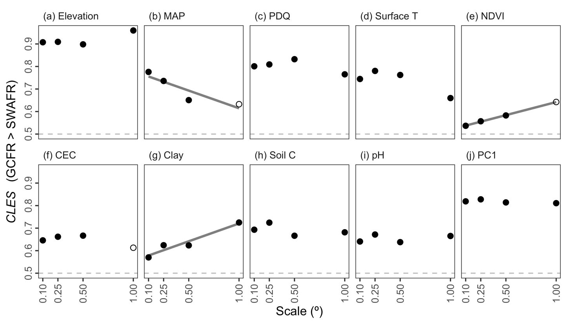

**Figure 1:** The common language effect size (*CLES*) of (a–i) various forms of environmental heterogeneity (log10-transformed) and (j) the major axis thereof (PC1) in the GCFR and SWAFR. *CLES* here is treated as the effect of GCFR relative to SWAFR values. Filled points represent comparisons where the GCFR and SWAFR significantly differed in heterogeneity (*P* < 0.05; two-sided Mann-Whitney *U*-tests), while unfilled points represent those that were not significant. Following simple linear regressions of *CLES* against scale, we found some evidence for relationships (depicted by lines) for MAP (slope = –0.157; *P* = 0.098), NDVI (slope = 0.116; *P* < 0.001) and Clay (slope = 0.158, *P* = 0.037). Abbreviations are as in Table 2.

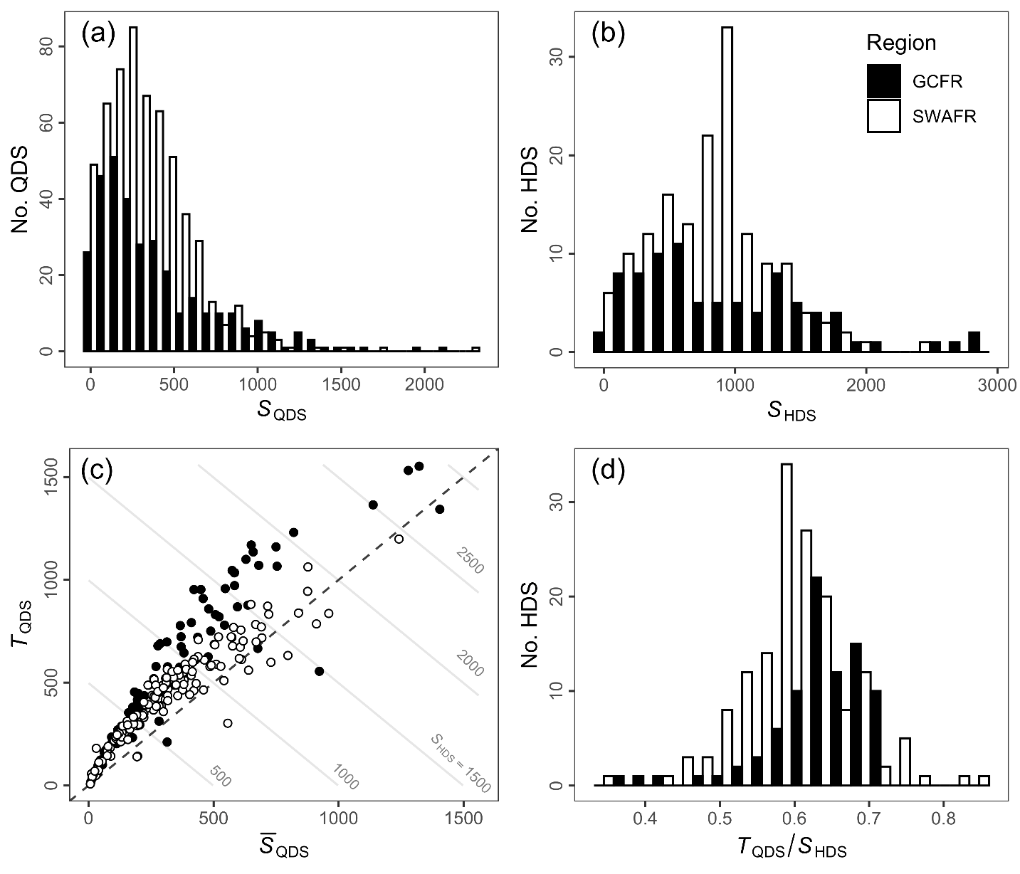

**Figure 2:** Frequency distributions of (a) QDS- and (b) HDS-scale vascular plant species richness in the GCFR and SWAFR. (c) Scatter plot of mean QDS-scale richness (QDS) and turnover (*T*QDS) with contour lines denoting the *S*HDS that arises as their sum. (d) The distribution of the turnover partition of *S*HDS expressed as a proportion (*T*QDS / *S*HDS).

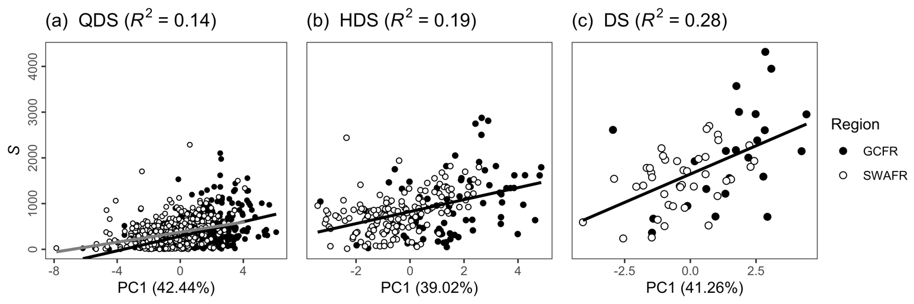

**Figure 3:** Simple linear regressions of vascular plant species richness as (a) *S*QDS, (b) *S*HDS and (c) *S*DS against each respective scale’s major axis of environmental heterogeneity (PC1) across the GCFR and SWAFR. These three linear models are presented in Table 2, all with highly significant slopes (*P* < 0.001). For *S*QDS, the separate fits for the GCFR (black) and SWAFR (grey) are presented, following the best fitting model at that scale (see Table 2a). The *R*2-values of each model and the variation in environmental heterogeneity explained by PC1 from each of the three PCAs are noted in parentheses in the panel and horizontal axis headings respectively.

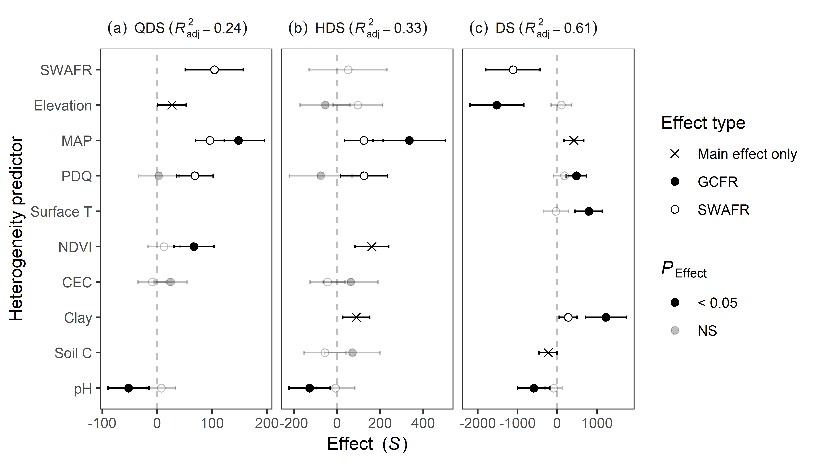

**Figure 4:** Slope estimates from multiple linear regressions of vascular plant species richness as (a) *S*QDS, (b) *S*HDS and (c) *S*DS against the various forms of environmental heterogeneity (log10-transformed and scaled) across GCFR and SWAFR. Points with error bars denote partial effect estimates and their 95% confidence intervals. Filled and empty points represent effect estimates for the GCFR and SWAFR respectively when region-interaction terms were retained during stepwise model selection, while crosses represent main effects (i.e. no region-interaction term retained). Estimates illustrated in black were significant (*P* < 0.05), while those in grey were not, but still retained during stepwise model selection. The multiple adjusted *R*2-values of each model are noted in parentheses in the panel headings. Abbreviations of variables are as in Table 2 and Figure 1.

**Figure 5:** HDS-scale maps for the GCFR and SWAFR of (a,b) vascular plant species richness, (c,d) the major axis of environmental heterogeneity (PC1) from the PCA of nine forms of environmental heterogeneity (log10-transformed), residuals from regressions of species richness against (e,f) PC1 (Figure 3b) and (g,h) the multivariate (MV) model (Figure 4b). Map projection used: WGS84. QDS- and DS-scale equivalents of these maps are available in the online version (SI).

# Data availability statement

[…]

# ORCID

Ruan van Mazijk: <https://orcid.org/0000-0003-2659-6909>

Michael D. Cramer: <https://orcid.org/0000-0003-0989-3266>

G. Anthony Verboom: <https://orcid.org/0000-0002-1363-9781>

# References

Bivand, R., Keitt, T., & Rowlingson, B. (2017). rgdal: Bindings for the Geospatial Data Abstraction Library. R package version 1.2-7. Retrieved from https://cran.r-project.org/package=rgdal

Born, J., Linder, H. P., & Desmet, P. (2007). The Greater Cape Floristic Region. *Journal of Biogeography*, *34*(1), 147–162. https://doi.org/10.1111/j.1365-2699.2006.01595.x

Chamberlain, S., Szocs, E., Boettiger, C., Ram, K., Bartomeus, I., Baumgartner, J., … O’Donnell, J. (2016). taxize: Taxonomic information from around the web. R package version 0.7.8. Retrieved from https://github.com/ropensci/taxize

Cramer, M. D., & Verboom, G. A. (2016). Measures of biologically relevant environmental heterogeneity improve prediction of regional plant species richness. *Journal of Biogeography*, *44*(3), 1–13. https://doi.org/10.1111/jbi.12911

Dupont, L. M., Linder, H. P., Rommerskirchen, F., & Schefuss, E. (2011). Climate-driven rampant speciation of the Cape flora. *Journal of Biogeography*, *38*(6), 1059–1068. https://doi.org/10.1111/j.1365-2699.2011.02476.x

Gioia, P., & Hopper, S. D. (2017). A new phytogeographic map for the Southwest Australian Floristic Region after an exceptional decade of collection and discovery. *Botanical Journal of the Linnean Society*, *184*(1), 1–15. https://doi.org/10.1093/botlinnean/box010

Hijmans, R. J. (2016). raster: Geographic Data Analysis and Modeling. R package version 2.5-8. Retrieved from https://cran.r-project.org/package=raster

Hoffmann, V., Verboom, G. A., & Cotterill, F. P. D. (2015). Dated plant phylogenies resolve Neogene climate and landscape evolution in the cape floristic region. *PLoS ONE*, *10*(9), 1–25. https://doi.org/10.1371/journal.pone.0137847

Hopper, S. D., & Gioia, P. (2004). The Southwest Australian Floristic Region : Evolution and Conservation of a Global Hot Spot of Biodiversity. *Annual Review of Ecology, Evolution, and Systematics*, *35*(1), 623–650. https://doi.org/10.1146/annurev.ecolsys.35.112202.130201

Larsen, R., Holmern, T., Prager, S. D., Maliti, H., & Røskaft, E. (2009). Using the extended quarter degree grid cell system to unify mapping and sharing of biodiversity data. *African Journal of Ecology*, *47*(3), 382–392. https://doi.org/10.1111/j.1365-2028.2008.00997.x

Mucina, L., & Rutherford, M. C. (2006). *The vegetation of South Africa, Lesotho and Swaziland.* South African National Biodiversity Institute.

Rundel, P. W., Arroyo, M. T. K., Cowling, R. M., Keeley, J. E., Lamont, B. B., & Vargas, P. (2016). Mediterranean Biomes: Evolution of Their Vegetation, Floras, and Climate. *Annual Review of Ecology, Evolution, and Systematics*, *47*(1), 383–407. https://doi.org/10.1146/annurev-ecolsys-121415-032330

Chao A. & Jost L. (2012) Coverage-based rarefaction and extrapolation: Standardizing samples by completeness rather than size. *Ecology*, **93**, 2533–2547.

Colville, J.C., Potts A.J., Bradshaw P.L., Measey J., Snyman D., Picker M.D. Procheş S., Bowie R.C.K. & Manning J.C. (2014) Floristic and faunal Cape biochoria: do they exist. *Fynbos: ecology, evolution, and conservation of a megadiverse region* (ed. by N. Allsopp, J.F. Colville, G.A. Verboom and R.M. Cowling), pp. 73–93, Oxford University Press, Oxford.

Engemann K., Enquist B.J., Sandel B., Boyle B., Jørgensen P.M., Morueta-Holme N., Peet R.K., Violle C., & Svenning J.-C. (2015) Limited sampling hampers “big data” estimation of species richness in a tropical biodiversity hotspot. *Ecology and Evolution*, **5**, 807–820.

Gotelli N.J. & Colwell R.K. (2001) Quantifying biodiversity: Procedures and pitfalls in the measurement and comparison of species richness. *Ecology Letters*, **4**, 379–391.

Merow C., Smith M.J., & Silander J.A. (2013) A practical guide to MaxEnt for modeling species’ distributions: What it does, and why inputs and settings matter. *Ecography*, **36**, 1058–1069.

Rebelo T. (2001) *Proteas: A Field Guide to the Proteas of Southern Africa*. Fernwood Press, Cape Town.

# Biosketches

**Ruan van Mazijk** is […]

**Michael D. Cramer** is an ecophysiologist interested in physiological specialization in the hyper‐diverse Cape flora and the link between nutrient‐impoverished soils and species richness.

**G. Anthony Verboom** works on the assembly of the hyper‐diverse Cape flora, its vegetation organization and the role of speciation and extinction in its radiation.

# Author contributions

MDC and GAV conceived the study question, which RvM investigated and developed under their supervision for his BSc Hons project. RvM collated the data and carried out the GIS work. All authors contributed to the analyses, which were then carried out by RvM, who wrote the first draft of the manuscript. All authors contributed equally to the writing thereafter.

# Supplementary Information

## Species occurrence data cleaning

Firstly, we retained only records identified to the species level, and ignored intraspecific taxa. This resulted in the retention of XXX and XXX unique species names for the GCFR and SWAFR, respectively. The R package “taxize” (Chamberlain et al., 2016) was then used to query each species name against two major taxonomic databases, the Global Name Resolver (GNR; ref?) and the Taxonomic Name Resolution Service (TNRS; ref?). Where either or both databases returned a match for a name, the name was retained; where not, it was excluded. Although the number of species thus excluded is high (GCFR: XXX; SWAFR: XXX), the geographically-random distribution of the records associated with these names suggests that exclusion of these names will not significantly influence spatial patterns of species richness.

In order to ensure that no species were listed under multiple synonyms, the retained names were then queried against the Tropicos and Integrated Taxonomic Information System (ITIS; ref?) for known synonyms, again using “taxize.” We removed all records of species identified as non-native, using lists of invasive plants for South Africa and Australia from the IUCN’s Global Invasive Species Database (<http://www.iucngisd.org/gisd/>). Finally, we removed species with fewer than five total collection records in total, in order to discount low-confidence collections [reword].

## Supplementary tables

**Table 1:** Georeferenced environmental data1 and vascular plant species occurrence data sources used in this study. Data were acquired for the GCFR and SWAFR, with the temporal extent of data products used described where applicable.

|  |  |  |  |
| --- | --- | --- | --- |
| Dataset(s) | Source | Temporal extent | Citation(s) |
| Plant species occurrences | GBIF |  | GBIF (2017a,b) |
| Elevation | SRTM (v2.0) |  | Farr et al. (2007) |
| NDVI, Surface T | MODIS (v[Version]) | Feb. 2000 to Apr. 2017 | NASA (2017a.b) |
| MAP, PDQ | CHIRPS (v2.0) | Jan. 1981 to Feb. 2017 | Funk et al. (2015) |
| CEC, clay, soil C, pH | SoilGrids250m |  | Hengl et al. (2017) |

1 Abbreviations are as follows: NDVI, normalized difference vegetation index; T, temperature; MAP, mean annual precipitation; PDQ, precipitation in the driest quarter; CEC, cation exchange capacity; C, carbon.

## Supplementary figures

## Supplementary references

Chamberlain, S., Szocs, E., Boettiger, C., Ram, K., Bartomeus, I., Baumgartner, J., … O’Donnell, J. (2016). taxize: Taxonomic information from around the web. R package version 0.7.8. Retrieved from <https://github.com/ropensci/taxize>

Farr, T., Rosen, P., Caro, E., Crippen, R., Duren, R., Hensley, S., Kobrick, M., Paller, M., Rodriguez, E., Roth, L., Seal, D., Shaffer, S., Shimada, J., Umland, J., Werner, M., Oskin, M., Burbank, D., & Alsdorf, D. (2007). The shuttle radar topography mission. *Reviews of Geophysics*, 45, 1–33. DOI: […]

Funk, C.C., Peterson, P.J., Landsfeld, M., Pedreros, D.H., Verdin, J., Shukla, S., Husak, G., Rowland, J.D., Harrison, L., Hoell, A., & Michaelsen, J. (2015). The climate hazards infrared precipitation with stations—a new environmental record for monitoring extremes. *Scientific Data*, 2, 150066. DOI: […]

GBIF (2017a). GBIF Occurrence Download. DOI: […]

GBIF (2017b). GBIF Occurrence Download. DOI: […]

Hengl, T., Mendes de Jesus, J., Heuvelink, G.B.M., Ruiperez Gonzalez, M., Kilibarda, M., Blagoti?, A., Shangguan, W., Wright, M.N., Geng, X., Bauer-Marschallinger, B., Guevara, M.A., Vargas, R., MacMillan, R.A., Batjes, N.H., Leenaars, J.G.B., Ribeiro, E., Wheeler, I., Mantel, S., & Kempen, B. (2017) SoilGrids250m: Global gridded soil information based on machine learning. *PLoS ONE*, 12, e0169748. DOI: […]

NASA (2017a). Vegetation indices monthly l3 global 0.05Deg cmg (MOD13C2) v[Version]. NASA EOSDIS Land Processes DAAC, USGS Earth Resources Observation and Science (EROS) Center, Sioux Falls, South Dakota, U.S.A. DOI: […]

NASA (2017b). Land surface temperature/emissivity monthly l3 global 0.05Deg cmg (MOD11C3) v[Version]. NASA EOSDIS Land Processes DAAC, USGS Earth Resources Observation and Science (EROS) Center, Sioux Falls, South Dakota, U.S.A. DOI: […]