(e.g. *EH*1(QDS) = Var(EDS)) (Equation 1)

$EH_{2}\left(X_{b}\right)=Var\left(X_{0.05° × 0.05°}\right)$ (Equation 2)

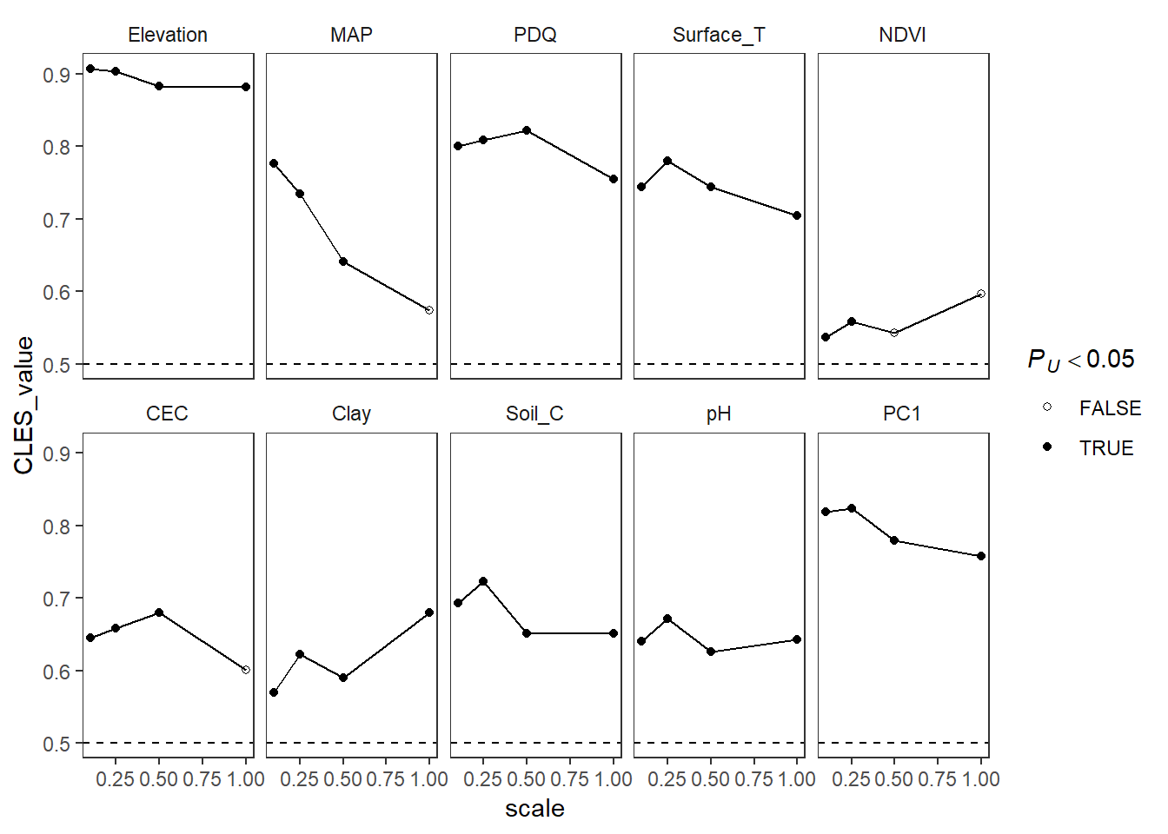

Figure 1: *CLES*-values (GCFR > SWAFR) of *EH*1-values (Equation 1) across spatial scales. Filled points represent ­*CLES­*-values from comparisons where the GCFR and SWAFR differed significantly (*P* < 0.05, Mann-Whitney *U*-tests). Following simple linear regressions of *CLES* against scale, negative relationships were found for MAP (slope = -0.224, *P* = 0.028) and PC1 (slope = -0.076, *P* = 0.059).

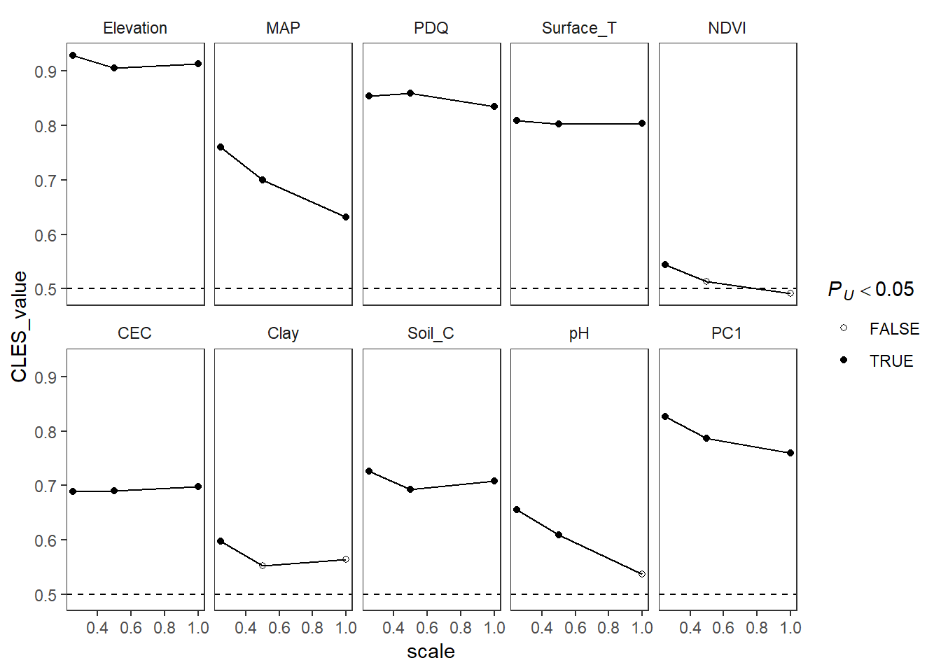

Figure 2: As for Figure 1, but for *EH*2-values (Equation 2). Following simple linear regressions of *CLES* against scale, negative relationships were found for MAP (slope = -0.166, *P* = 0.098) and PC1 (slope = -0.115, *P* = 0.041).

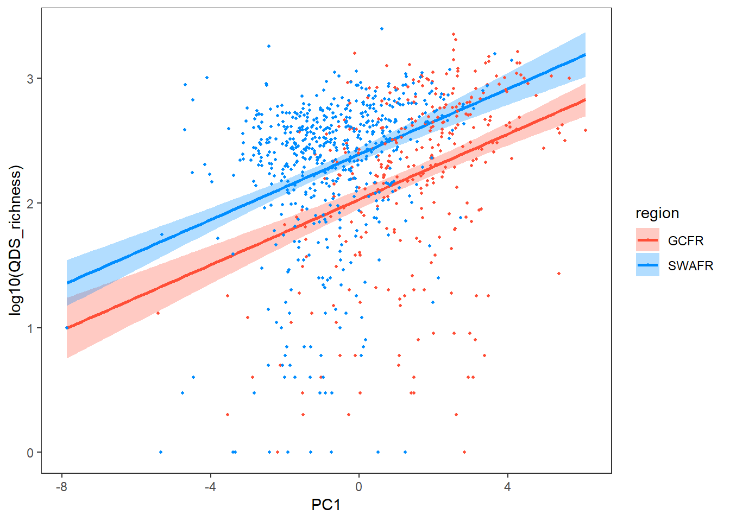

Figure 3: $log_{10}\left[S_{QDS}\right] \sim { β}_{0}+β_{1}PC1\left(EH_{1}\right)+β_{2}Region+ϵ$.

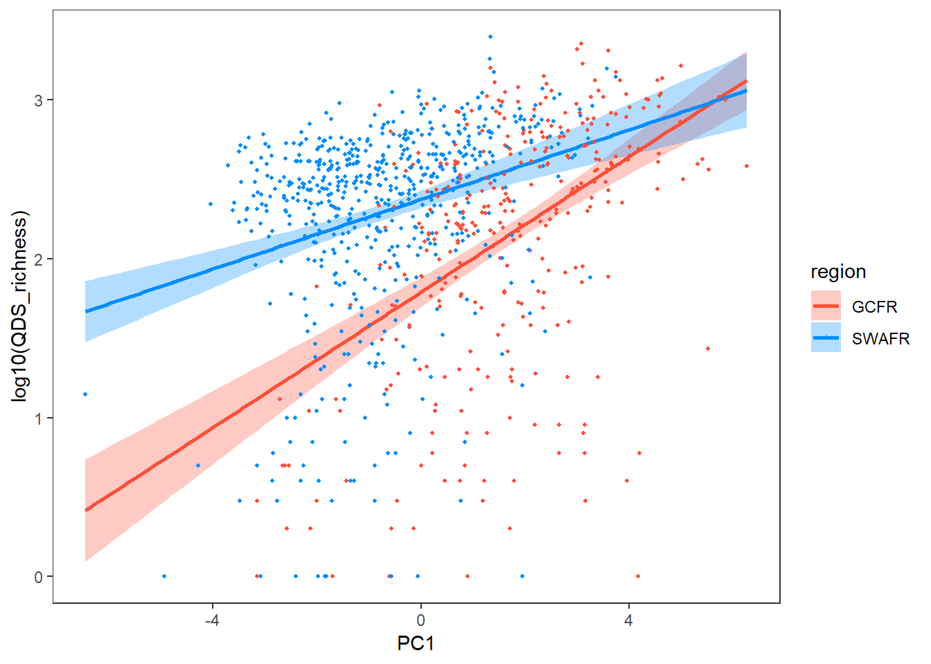

Figure 4: As for Figure 3, but for *EH*2-values (Equation 2)

(i.e.: $log_{10}\left[S_{QDS}\right] \sim { β}_{0}+β_{1}PC1\left(EH_{2}\right)+β_{2}Region+β_{3}(PC1\left(EH_{2}\right)×Region)+ϵ$).

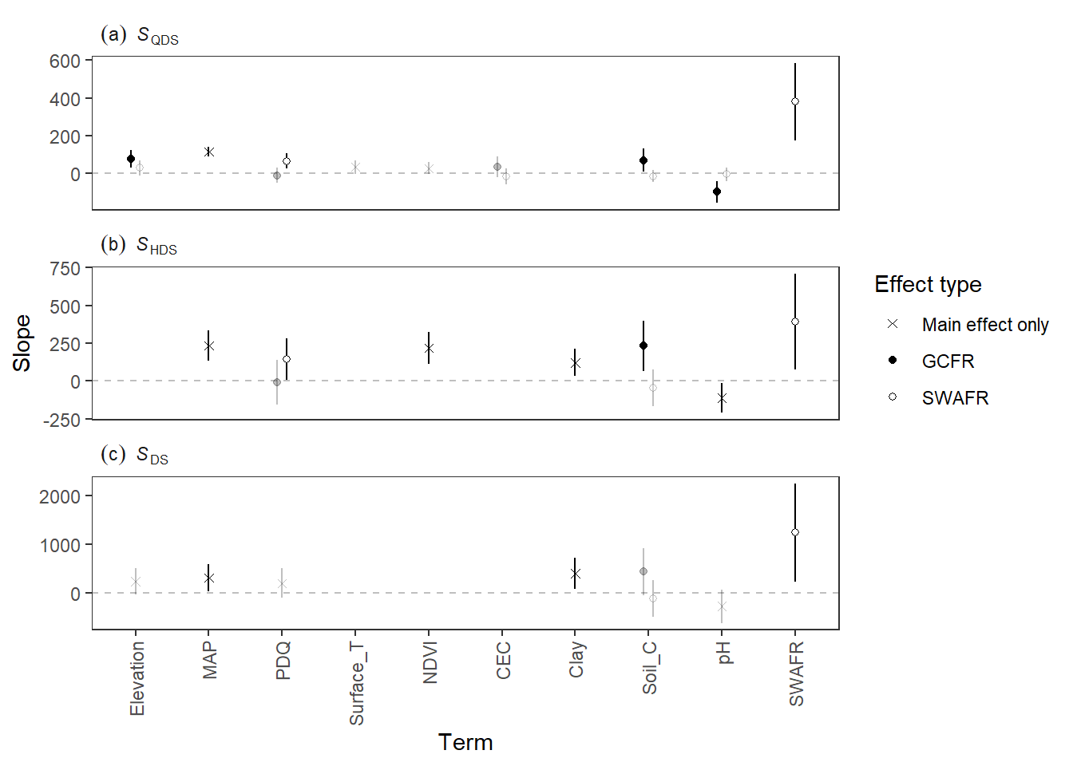

Figure 5: Results of the multiple linear regression analyses using *EH*1 (Equation 1).

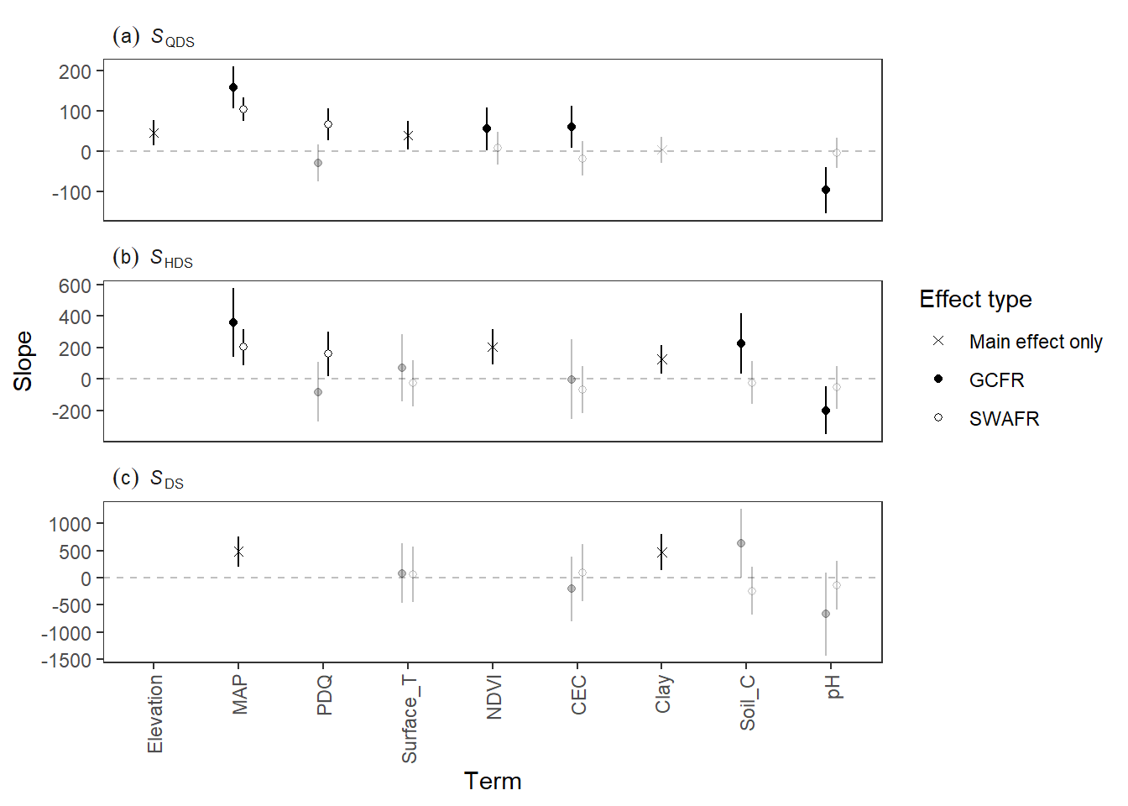

Figure 6: As for Figure 5, but using *EH*2 (Equation 2), and not plotting the SWAFR main effect (makes it easier to see the other effects).

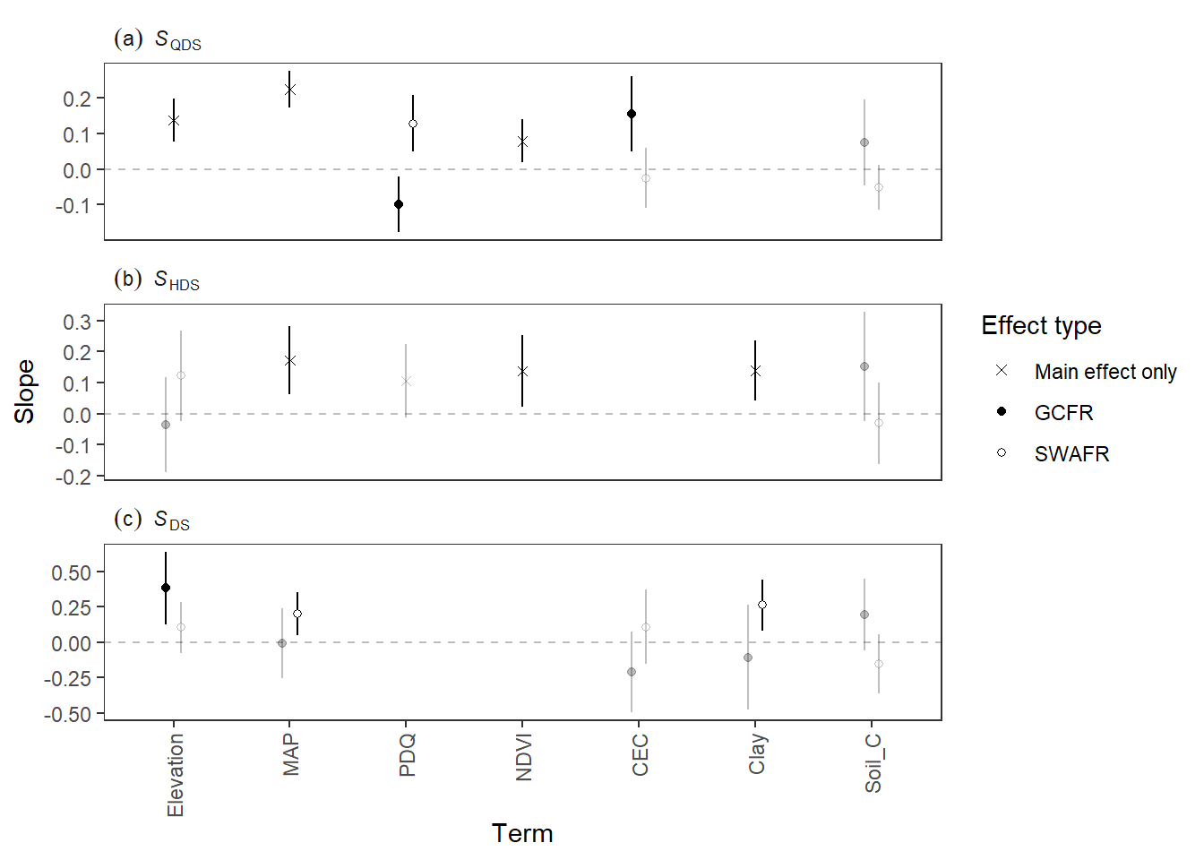

Figure 7: As for Figure 5, but log10*S* as the response (*much* better AIC than linear), and not plotting the SWAFR main effect (makes it easier to see the other effects).

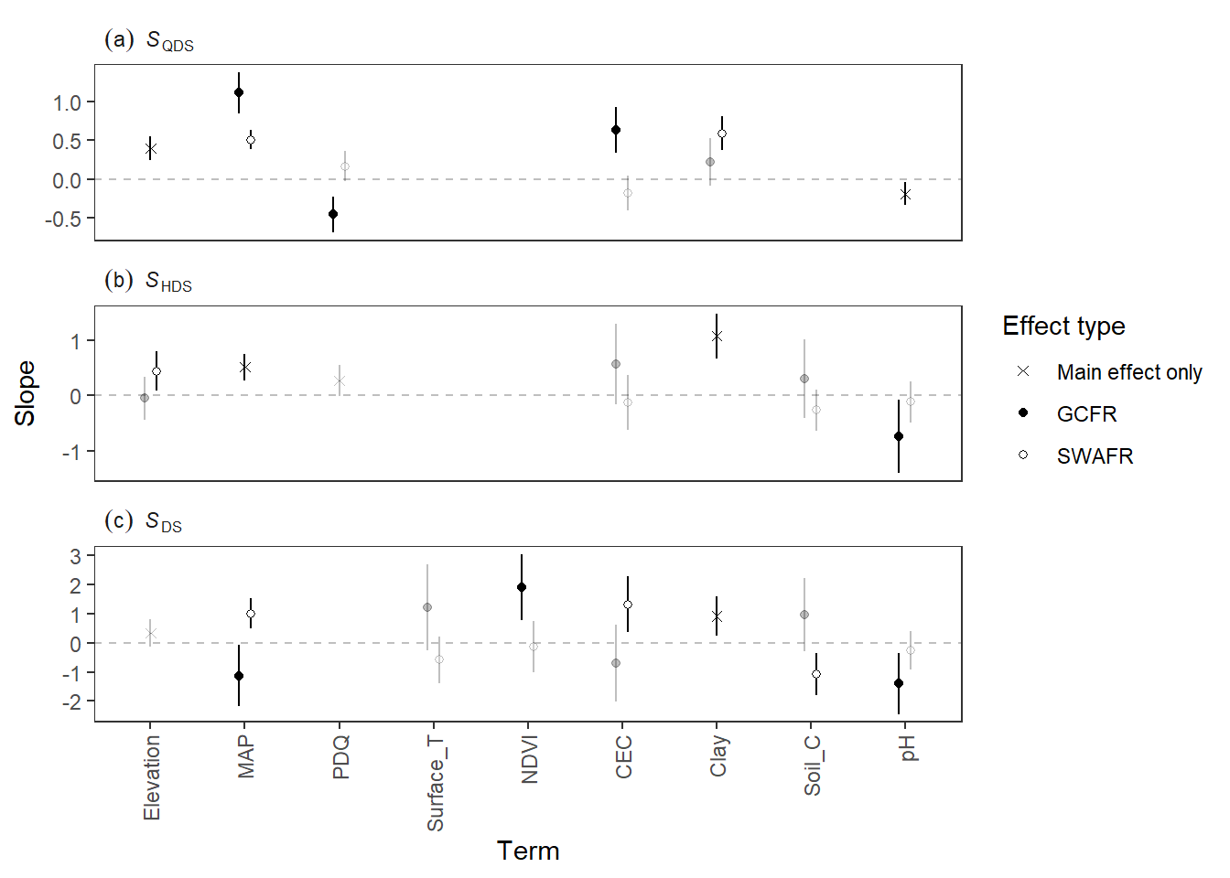

Figure 8: As for Figure 6, but log10*S* as the response (*much* better AIC than linear), and not plotting the SWAFR main effect (makes it easier to see the other effects).