Analyses & results

GCFR vs SWAFR manuscript

Ruan van Mazijk

2019-08-29

# 1. Comparing environmental heterogeneity

Slopes of *CLES* against …

|  |  |  |  |
| --- | --- | --- | --- |
| Variable | Slope | *P* |  |
| Elevation | -0.029 | 0.135 |  |
| MAP | -0.224 | 0.028 | * |
| PDQ | -0.055 | 0.260 |  |
| Surface_T | -0.062 | 0.207 |  |
| NDVI | 0.059 | 0.134 |  |
| CEC | -0.054 | 0.361 |  |
| Clay | 0.104 | 0.143 |  |
| Soil_C | -0.065 | 0.270 |  |
| pH | -0.013 | 0.729 |  |
| PC1 | -0.076 | 0.059 | . |

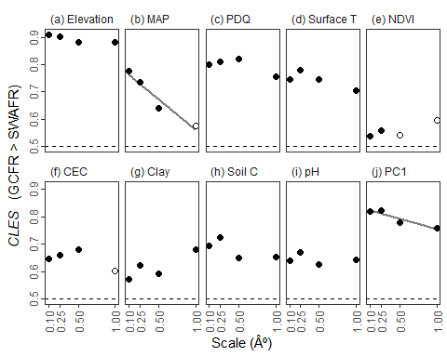

The common language effect size (*CLES*) of (a–i) various forms of environmental heterogeneity (log10-transformed) and (j) the major axis thereof (PC1) in the GCFR and SWAFR. The *CLES* here is treated as the effect of GCFR relative to SWAFR values. Filled points represent comparisons where the GCFR and SWAFR significantly differed in heterogeneity (*P* â‰¤ 0.05, Mann-Whitney U-tests), while unfilled points represent those that were not significant (*P* > 0.05). Following simple linear regressions of CLES against scale, negative relationships (depicted by lines) were found for MAP (slope = -0.224, P = 0.028) and PC1 (slope = -0.076, P = 0.059). Abbreviations are as in Table 1.

# 2. Comparing species richness

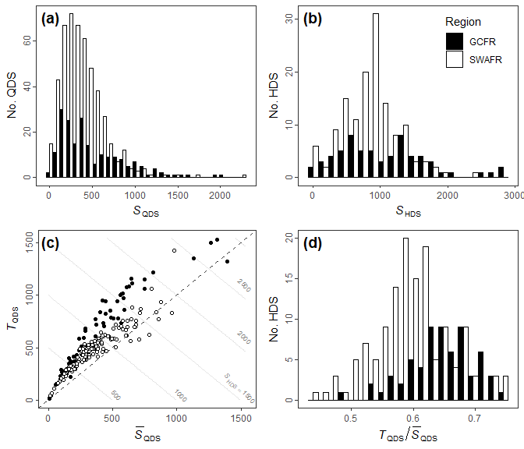

Distributions of (a) QDS- and (b) HDS-scale vascular plant species richness in the GCFR and SWAFR. (c) Scatter plot of mean QDS-scale richness (QDS) and turnover (*T*QDS; Equation 1) with contour lines denoting the *S*HDS that arises as their sum. (d) The distribution of the turnover partition of *S*HDS (*T*QDS; in c) expressed as a proportion (*T*QDS / HDS).

…

|  |  |  |
| --- | --- | --- |
| metric | P_U | CLES_value |
| QDS_richness | 0.0002828 | 0.5882409 |
| HDS_richness | 0.0454020 | 0.5875460 |
| DS_richness | 0.0067394 | 0.7318339 |
| QDS_turnover_prop | 0.0000000 | 0.7400046 |
| HDS_turnover_prop | 0.0001875 | 0.8114187 |

# 3. Environmental heterogeneity as an explanation of species richness

## 3.1. Univariate models

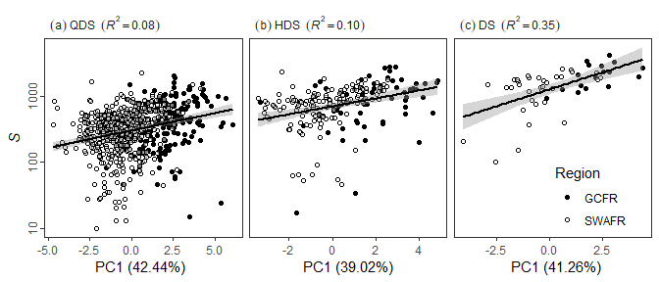

…

Summarised results of the best fitting separate simple linear regressions of log10[*S*QDS] against environmental heterogeneity.

|  |  |  |  |  |  |
| --- | --- | --- | --- | --- | --- |
| Model type | Heterogeneity predictor | Slope |  | SWAFR effect |  |
| Main effect + region | NDVI | + | *** | - | ** |
|  | Soil C | + | ** | - | * |
| Main effect only | Elevation | + | *** |  |  |
|  | MAP | + | *** |  |  |
|  | PDQ | + | *** |  |  |
|  | Surface T | + | *** |  |  |
|  | PC1 | + | *** |  |  |
| Region only | CEC | - |  | - | *** |
|  | Clay | + |  | - | *** |
|  | pH | - |  | - | *** |

Summarised results of the best fitting separate simple linear regressions of log10[*S*HDS] against environmental heterogeneity.

|  |  |  |  |
| --- | --- | --- | --- |
| Model type | Heterogeneity predictor | Slope |  |
| Main effect only | Elevation | + | * |
|  | MAP | + | *** |
|  | PDQ | + | *** |
|  | Surface T | + | * |
|  | NDVI | + | *** |
|  | CEC | - |  |
|  | Clay | + | ** |
|  | Soil C | + | * |
|  | pH | + |  |
|  | PC1 | + | *** |

Summarised results of the best fitting separate simple linear regressions of log10[*S*DS] against environmental heterogeneity.

|  |  |  |  |  |  |
| --- | --- | --- | --- | --- | --- |
| Model type | Heterogeneity predictor | Slope |  | SWAFR effect |  |
| Main effect only | Elevation | + | ** |  |  |
|  | MAP | + | *** |  |  |
|  | PDQ | + | *** |  |  |
|  | Clay | + | *** |  |  |
|  | Soil C | + | * |  |  |
|  | PC1 | + | *** |  |  |
| Region only | Surface T | + |  | - | * |
|  | NDVI | + |  | - | . |
|  | CEC | - |  | - | ** |
|  | pH | + |  | - | * |

## 3.2. Multivariate models



