# Table 1

|  |  |  |  |  |  |  |  |  |
| --- | --- | --- | --- | --- | --- | --- | --- | --- |
| Response | Model type | Predictor | Main effect | | SWAFR effect | | SWAFR interaction | |
| (a) *S*QDS | Main effect × region | Elevation | 140.2 | *** | 124.4 | *** | -56.1 | * |
|  |  | MAP | 172.0 | *** | 54.5 | ** | -54.1 | ** |
|  |  | PDQ | 73.4 | *** | 55.6 | * | 61.9 | ** |
|  |  | NDVI | 154.9 | *** | -7.8 |  | -102.2 | *** |
|  | Main effect + region | PC1 | 67.0 | *** | 92.5 | *** |  |  |
|  | Main effect only | Surface T | 62.1 | *** |  |  |  |  |
|  |  | CEC | 14.7 |  |  |  |  |  |
|  |  | Clay | 42.1 | *** |  |  |  |  |
|  |  | Soil C | 62.9 | *** |  |  |  |  |
|  |  | pH | 21.9 | * |  |  |  |  |
| (b) *S*HDS | Main effect × region | MAP | 399.0 | *** | -41.5 |  | -185.0 | ** |
|  |  | Clay | -12.8 |  | -216.1 | ** | 173.6 | * |
|  | Main effect only | Elevation | 163.7 | *** |  |  |  |  |
|  |  | PDQ | 226.3 | *** |  |  |  |  |
|  |  | Surface T | 135.9 | *** |  |  |  |  |
|  |  | NDVI | 246.6 | *** |  |  |  |  |
|  |  | Soil C | 159.4 | *** |  |  |  |  |
|  |  | PC1 | 123.1 | *** |  |  |  |  |
|  | Region only | CEC | -26.3 |  | -251.9 | ** |  |  |
|  |  | pH | 53.8 |  | -193.0 | * |  |  |
| (c) *S*DS | Main effect × region | Elevation | -1455.9 | * | -2278.4 | ** | 1668.5 | * |
|  |  | MAP | 683.3 | *** | -519.1 | ** | -382.1 | * |
|  |  | CEC | -933.3 | ** | -1043.4 | *** | 837.1 | * |
|  | Main effect + region | Clay | 273.0 | * | -542.8 | * |  |  |
|  |  | Soil C | 246.5 | * | -615.4 | * |  |  |
|  | Main effect only | PDQ | 363.1 | ** |  |  |  |  |
|  |  | Surface T | 336.7 | ** |  |  |  |  |
|  |  | NDVI | 475.3 | *** |  |  |  |  |
|  |  | pH | 448.4 | *** |  |  |  |  |
|  |  | PC1 | 231.1 | *** |  |  |  |  |

# **Table 2** […] All correlation coefficients were significant (*P* < 0.05; two-sided *t*-test).

|  |  |  |
| --- | --- | --- |
|  | Correlation | |
| Spatial scale | Predicted *S* | Residual *S* |
| QDS | 0.680 | 0.908 |
| HDS | 0.699 | 0.834 |
| DS | 0.723 | 0.369 |

# Figure 2

# Figure 3

# Figure 4

# Figure 5

# Table S2

|  |  |  |  |  |
| --- | --- | --- | --- | --- |
| Response | Term | Variance explained | | |
| (a) *S*QDS | (Residuals) | 0.72 |  | - |
|  | MAP | 0.13 |  | *** |
|  | Elevation | 0.06 |  | *** |
|  | NDVI | 0.03 |  | *** |
|  | PDQ × Region | 0.02 |  | *** |
|  | region | 0.02 |  | *** |
|  | NDVI × Region | 0.01 |  | *** |
|  | Clay | 0.01 |  | ** |
|  | pH | 0.01 |  | ** |
|  | CEC | 0.01 |  | * |
|  | pH × Region | 0.01 |  | * |
|  | PDQ | < 0.01 |  |  |
|  | MAP × Region | < 0.01 |  |  |
| (b) *S*HDS | (Residuals) | 0.54 |  | - |
|  | MAP | 0.21 |  | *** |
|  | Elevation | 0.1 |  | *** |
|  | pH × Region | 0.04 |  | *** |
|  | NDVI | 0.02 |  | ** |
|  | MAP × Region | 0.02 |  | ** |
|  | pH | 0.02 |  | * |
|  | Clay | 0.02 |  | * |
|  | PDQ | 0.02 |  | * |
|  | Surface T × Region | 0.01 |  | * |
|  | Surface T | 0.01 |  |  |
|  | Soil C: × Region | < 0.01 |  |  |
|  | region | < 0.01 |  |  |
|  | Soil C | < 0.01 |  |  |
| (c) *S*DS | NDVI | 0.17 |  | *** |
|  | Elevation | 0.15 |  | *** |
|  | PDQ | 0.14 |  | *** |
|  | pH × Region | 0.11 |  | *** |
|  | Clay | 0.07 |  | *** |
|  | (Residuals) | 0.07 |  | - |
|  | NDVI × Region | 0.06 |  | ** |
|  | Clay × Region | 0.06 |  | ** |
|  | Soil C × Region | 0.04 |  | ** |
|  | Surface T | 0.04 |  | ** |
|  | CEC | 0.03 |  | * |
|  | Soil C | 0.02 |  | . |
|  | Elevation × Region | 0.02 |  | . |
|  | PDQ × Region | 0.01 |  |  |
|  | pH | 0.01 |  |  |
|  | Surface T × Region | < 0.01 |  |  |
|  | region | < 0.01 |  |  |
|  | CEC × Region | < 0.01 |  |  |

# Table S3 […] All pairs of GCFR and SWAFR *SD*-values differed significantly (*P* < 0.01; two-sided *F*-tests).

|  |  |  |  |  |  |  |  |
| --- | --- | --- | --- | --- | --- | --- | --- |
|  |  |  | *SD* of model residuals | | | | |
|  |  |  | Including hotspots | |  | Excluding hotspots | |
| Scale | Region |  | PC1 | MV |  | PC1 | MV |
| (a) QDS | GCFR |  | 343.46 | 312.89 |  | 234.93 | 217.56 |
|  | SWAFR |  | 245.77 | 223.05 |  | 203.91 | 174.97 |
| (b) HDS | GCFR |  | 638.62 | 519.19 |  | 460.39 | 360.47 |
|  | SWAFR |  | 334.15 | 290.90 |  | 326.06 | 273.31 |
| (c) DS | GCFR |  | 811.89 | 6.22 |  | 588.58 | *NA* |
|  | SWAFR |  | 311.80 | 226.50 |  | 297.22 | *NA* |

# Figure S1

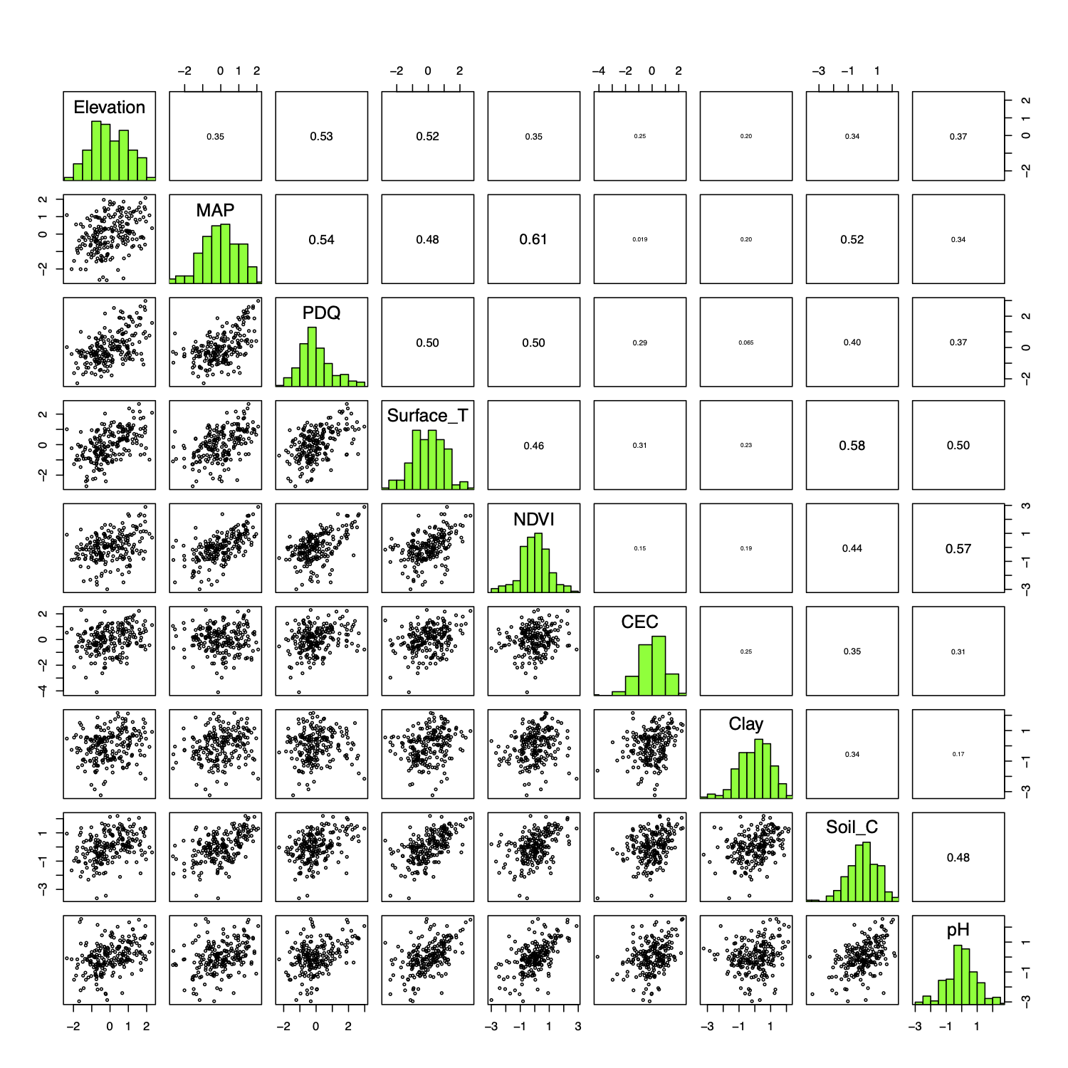

# Figure S2

# Figure S3

# A close up of a map Description automatically generatedFigure S4 […] Environmental heterogeneity variables’ loadings are labelled as follows: 1, elevation; 2, MAP; 3, PDQ; 4, surface T; 5, NDVI; 6, CEC; 7, clay; 8, soil C; 9, pH.

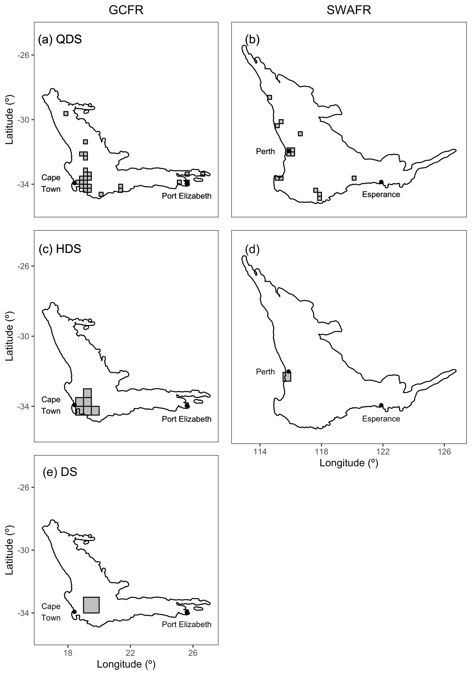

# Figure S5 […] PC1-outliers

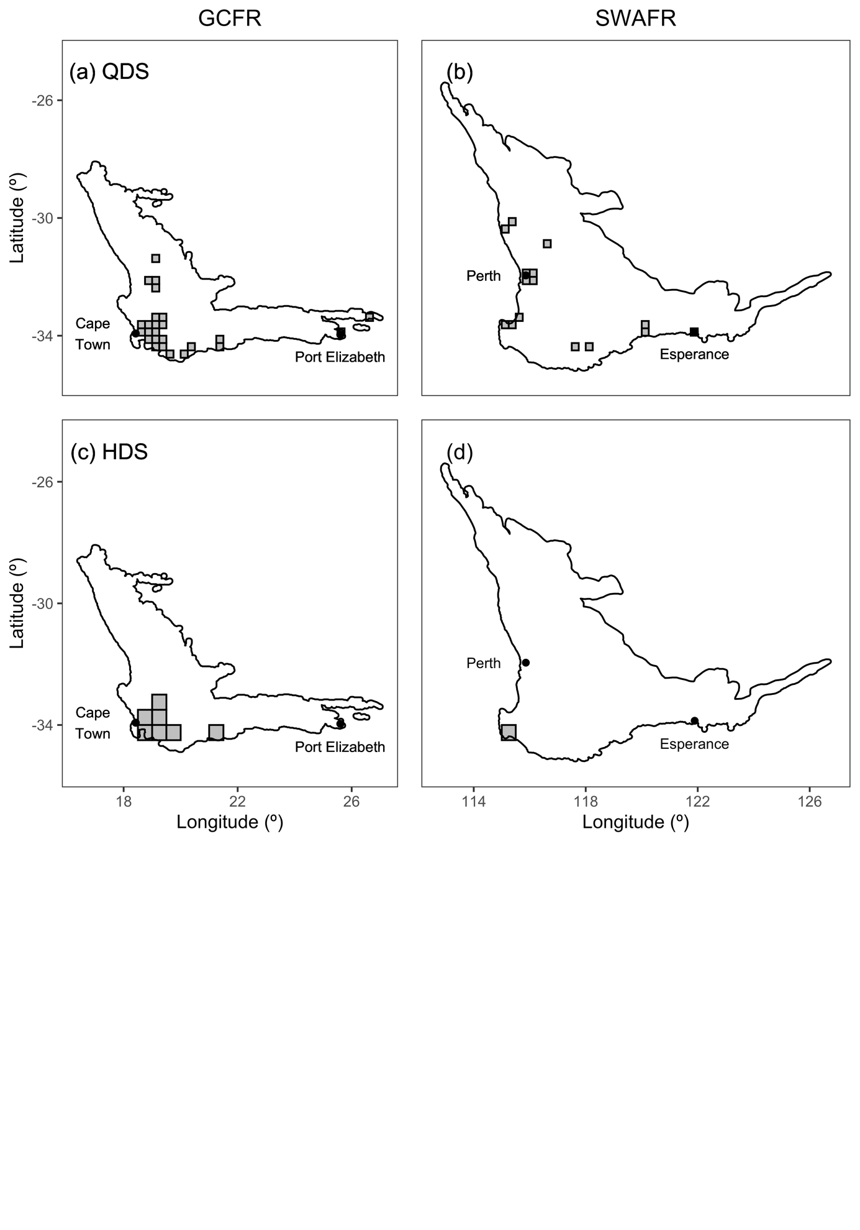

# Figure S6 […] MV-outliers

…

# Figure S7

…

# Figure S8

…

# Figure S9–S10