Title

Author

Date

First Paragraph

Body Text

# Heading 1

First Paragraph

Body Text

# Heading 1

## Heading 2

First Paragraph

Body Text

## Heading 2

### Heading 3

First Paragraph

Body Text

# Figures

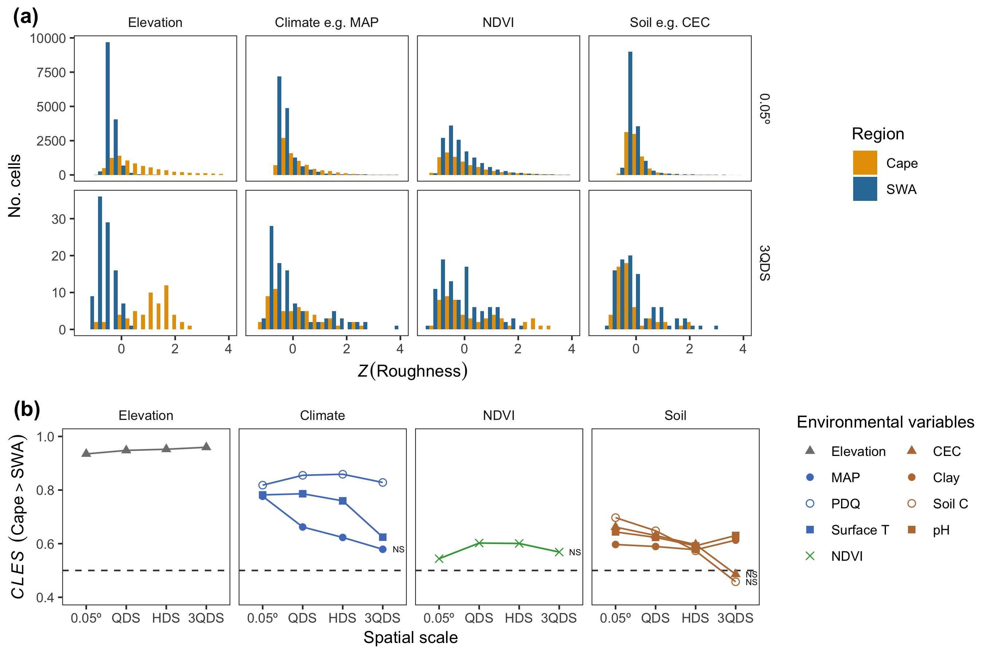

Image Caption

# References

Bibliography