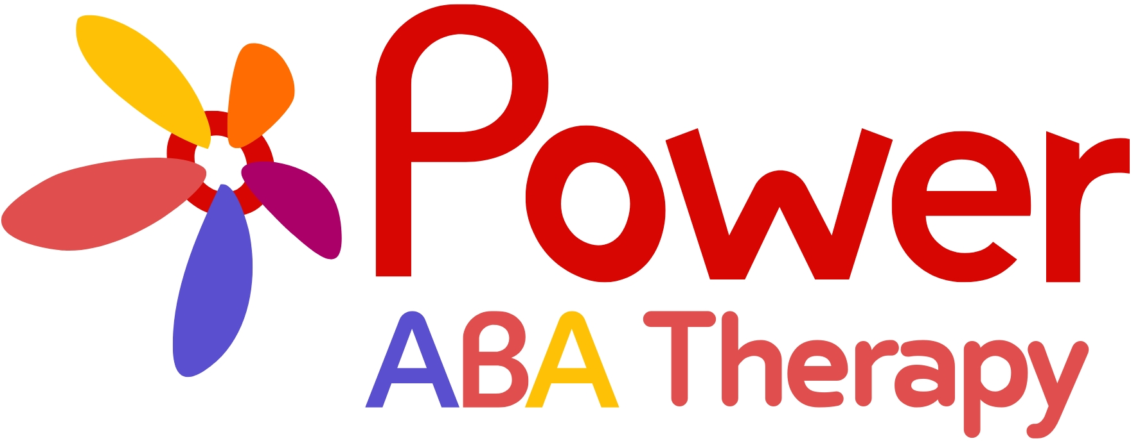
Website Design Brief
Visual identity, voice, and character rules for the site build
Excerpted from the Poppy & Parker Brand Bible • v1.3 • August 2026
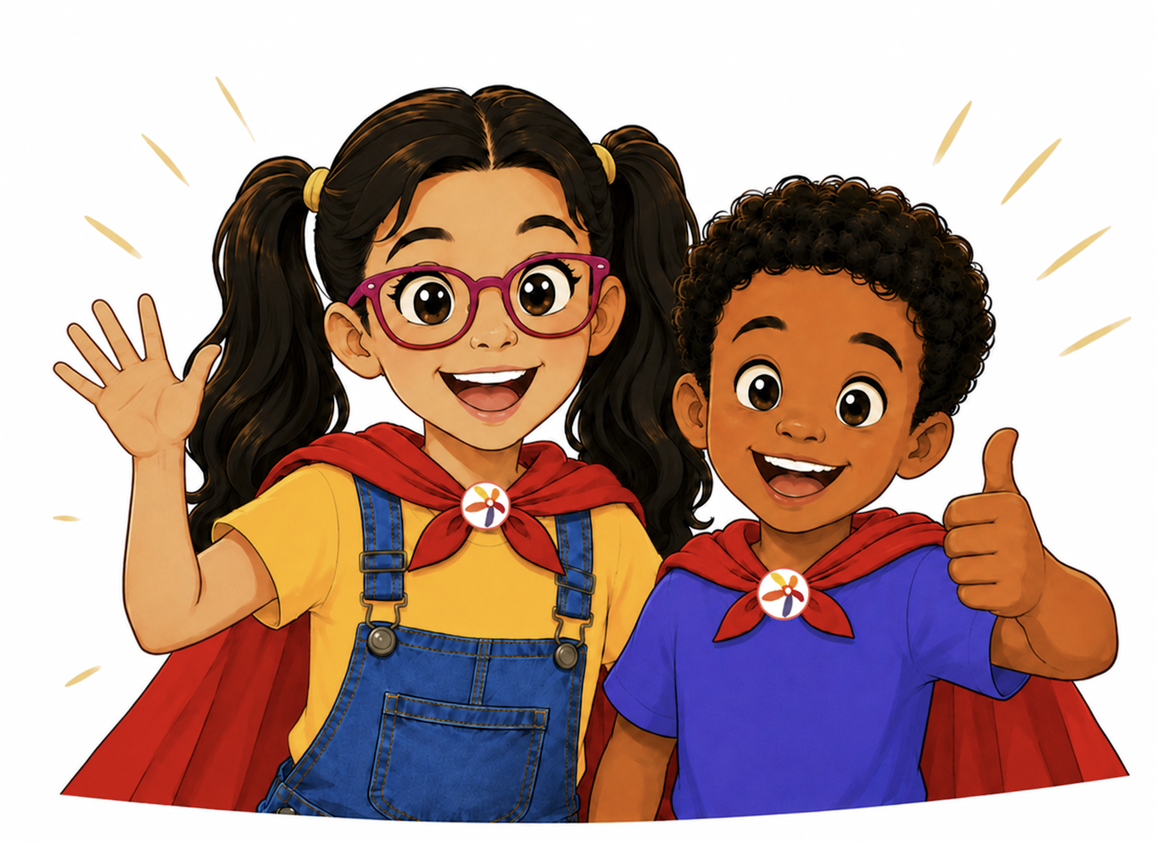
Growing stronger every day.

About This Brief
This brief pulls together everything the website build needs from Power ABA’s brand system — colors, type, logo usage, character rules, voice, and accessibility standards — sized to read start to finish rather than mined out of a longer internal document.
It’s excerpted from the full Poppy & Parker Brand Bible (v1.3, Internal: Marketing & Design). If a question comes up that isn’t covered here, ask and we’ll pull the relevant page.
Everything in this brief is launch scope for the website: navigation, a resource center, service explanations, FAQs, and character guideposts built on the visual and voice rules below. One thing it is not: the “Power Pals Adventures” story hub referenced elsewhere in the brand system is a longer-term growth vision, paired with a future YouTube Kids channel — not part of this build. If anything here reads like a request for story-hub content, flag it and we’ll confirm scope together.
What’s launch vs. future

01 | Brand at a Glance  Who this is for, and the promise every page should carry.

Brand role  Make Power ABA feel welcoming, understandable, hopeful, and memorable — supporting, not replacing, the expertise of clinicians and caregivers. | Primary audience  Parents and caregivers seeking practical, respectful guidance. The site should read as written to them first.

Tagline  Power ABA (organization)  Together we unlock the potential in every child.  Poppy & Parker (The Power Pals)  Growing stronger every day. | Purpose  Help children and families recognize strengths, use practical tools, and celebrate meaningful progress — one step at a time.

Positioning Statement
For families navigating learning, communication, and everyday routines, Poppy and Parker are friendly Power ABA guides who turn practical support into hopeful, memorable stories—because growth happens one meaningful step at a time.
Positioning

02 | Visual Identity  Colors, type, and logo rules — canonical for production.

Brand Colors (Client-Approved, August 2026)
 | Color | Hex | Primary use
 | Red | #D80602 | Primary brand color
 | Coral | #E04F4D | Primary brand color
 | Indigo | #5A4FCF | Primary brand color
 | Magenta | #AB0068 | Primary brand color
 | Orange | #FF6C02 | Primary brand color
 | Yellow | #FEC106 | Primary brand color
 | Teal | #5FCCC2 | Accent

Typography
Use | Font
Titles & Headlines | Betm Rounded Bold
Body Text | Poppy

Logo Usage
Digital Materials
Use for the website, social media, email, and other digital touchpoints.
Print & Apparel Materials
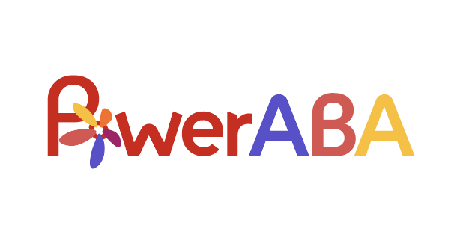
Not typically needed on-site, included here for completeness.
Illustration Style
- Polished 2D animation with clean linework, expressive faces, vivid but controlled color, and soft dimensional shading.
- Friendly proportions and movement without exaggerated babyish styling.
- Simple, uncluttered backgrounds — let the message carry the page, not the scene.
- The colorful flower badge is integrated into the red shield as part of the costume, never pasted over it.
- Consistent facial structure, hair, glasses, clothing, badge orientation, and relative height across every asset used on-site.
Composition & Asset Use
Do | Avoid
Give the characters breathing room and a clear focal point. | Crowding characters, text, icons, and props into one frame.
Use clean crops that preserve faces, hands, badges, and gestures. | Cropping through eyes, hands, badges, or important communication tools.
Place characters beside the message rather than filling the frame. | Making every page look like a children’s cartoon scene.
Use simple backgrounds so the message stays legible. | Busy patterns or sensory-heavy backgrounds that compete with the message.
Maintain consistent lighting, linework, proportions, and color. | Mixing unrelated illustration styles on the same page.

03 | Character Visual Rules  Poppy and Parker, kept consistent everywhere they appear on-site.

Poppy  Curious, creative, expressive, optimistic. Verbal.  Signature phrase: “Let’s find another way!” | Parker  Thoughtful, patient, determined. Non-verbal, communicates through an AAC device.  Signature line (AAC device): “One step at a time!”

Visual Character Anchors
Character | Non-negotiable visual cues | Flexible elements
Poppy | Dark pigtails, purple glasses, warm smile, yellow top, denim overalls, red cape, white sneakers with magenta accents, Power ABA Flower Logo Icon badge. | Pose, setting, facial expression, seasonal accessories, activity props.
Parker | Short curly hair, warm smile, indigo shirt, denim jeans, red cape, AAC communication device (worn cross-body), white sneakers with red accents, Power ABA Flower Logo Icon badge. | Pose, setting, facial expression, seasonal accessories, activity props.

Character Color Specifications
Poppy
 | Feature | Hex
 | Skin tone | #FAC49C
 | Dark pigtails | #1E1207
 | Purple glasses | #AB0068
 | Yellow top | #FEC106
 | Denim overalls | #35459D
 | Red cape | #D80602
 | Sneakers (white + accent) | #AB0068

Parker
 | Feature | Hex
 | Skin tone | #C87439
 | Curly hair | #1E1207
 | Shirt | #5A4FCF
 | Denim jeans | #263271
 | Red cape | #D80602
 | AAC device casing | #5FCCC2
 | Sneakers (white + accent) | #D80602

The Power Bloom
The flower badge both characters wear. If it appears on-site — as an icon, a loading animation, a section marker — the petal order is locked and should never be redrawn or rearranged: clockwise from the top point, Yellow, Orange, Coral, Blue, Purple.
 | Petal color | Meaning
 | Yellow | Courage
 | Orange | Curiosity
 | Coral red | Kindness
 | Blue | Calm and confidence
 | Purple | Self-expression

The Power Bloom is a brand symbol. It should remain recognizable at small sizes and never be redrawn differently from one place to the next — same rule applies whether it shows up in a social post or a website favicon.
Production note

04 | Voice & Messaging  How the site should sound, and what it should say.

Brand Voice
Always sound  Warm, encouraging, plainspoken, patient, respectful, practical, hopeful, and strengths-based. | Never sound  Shaming, patronizing, overly cute, clinical without explanation, alarmist, absolute, or focused on “fixing” a child.

Message Hierarchy
Level | Message
Power ABA tagline (organization) | Together we unlock the potential in every child.
Power Pals tagline (Poppy & Parker) | Growing stronger every day.
Core belief | Every step matters.
Team close | We’re growing stronger every day!
Caregiver reassurance | You do not have to solve everything today.

Tone by Audience
Audience | Tone adjustment | Example opening
Caregivers (primary site audience) | Supportive, specific, practical, never blaming. | “A schedule change can feel easier when a child knows what will stay the same.”
Community partners | Accessible, confident, mission-centered. | “Power ABA helps families build meaningful skills through individualized support.”

For the Website Specifically
Best use of the characters  Welcome, navigation, resource center, service explanations, and family onboarding — as guideposts, not decoration on every page. | Recommended formats  Character guideposts, resource center, story hub (see note below), FAQs.

Tone  Trustworthy and accessible. | Note  The “story hub” above is future scope — see What's Launch vs. Future at the front of this brief. Everything else in this row is launch-ready.

05 | Accessibility Standards  Not optional, and not brand flavor — build to this spec.

Area | Standard
Captions | Caption all spoken audio; edit auto-captions for accuracy.
Contrast | Use high-contrast text and do not rely on color alone to communicate meaning.
Motion | Avoid rapid flashing, unnecessary motion, and overstimulating transitions.
Text | Use readable type sizes, short paragraphs, descriptive headings, and plain language.
Images | Write meaningful alt text that describes the purpose of the image.
Audio | Keep music below speech and avoid sudden loud effects.
Downloads | Create accessible PDFs and printables with logical reading order and labels.

Before publishing anything that collects information from children or links to child-directed video, review current platform rules and applicable legal requirements with qualified counsel and compliance leadership.
Review reminder

Quick Reference
Brand | Poppy & Parker — The Power Pals, for Power ABA Therapy
Tagline | Power ABA: “Together we unlock the potential in every child.” | Poppy & Parker: “Growing stronger every day.”
Primary color | Red #D80602 — full palette in Visual Identity, above
Team close | “We’re growing stronger every day!”
Launch scope | Navigation, resource center, service explanations, FAQs, character guideposts. Not the story hub.

Questions on anything not covered here? Ask and we’ll pull the relevant page from the full Brand Bible.

