POWER ABA THERAPY

Poppy & Parker
THE POWER PALS
Brand Bible • Version 1.3 • Internal: Marketing & Design
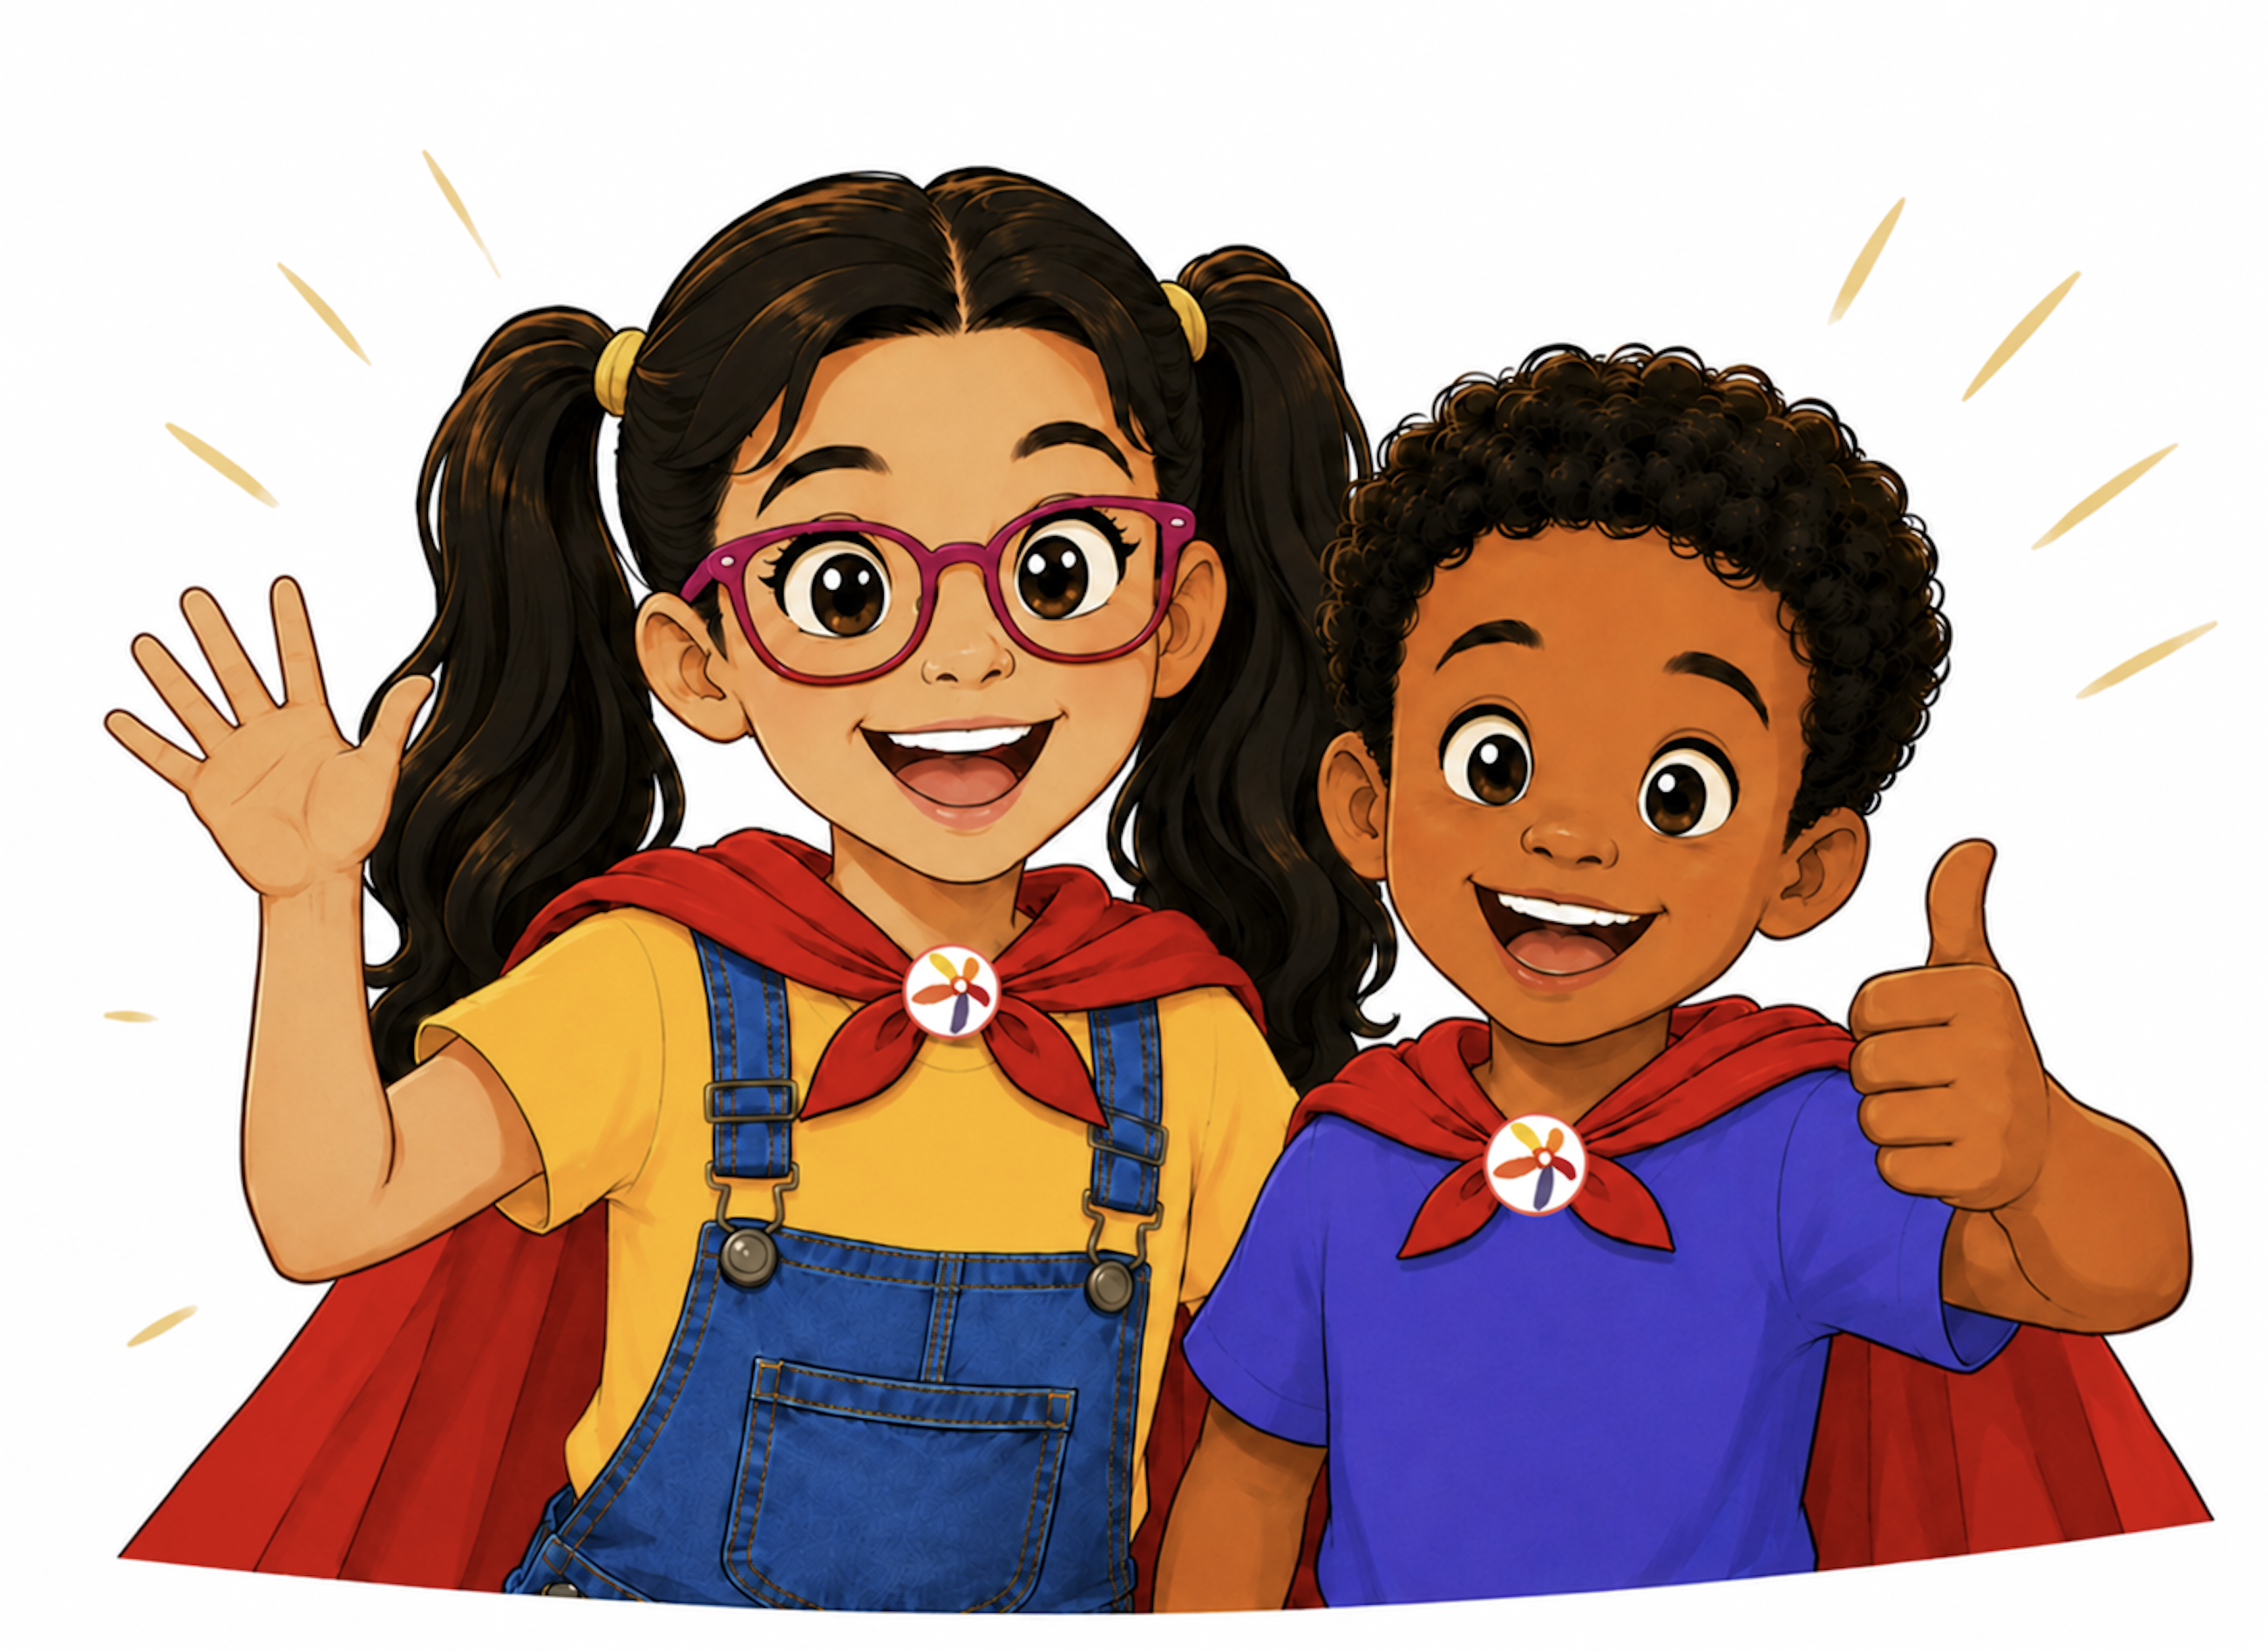
Growing stronger every day.
A story, character, messaging, and social media system for Power ABA Therapy
August 2026

01 | Brand at a Glance  The essential decisions that keep every Power Pals expression consistent.

“Every try, every step, and every success helps us grow stronger.”
Core Power Pals belief

The Brand in One Sentence
Poppy and Parker are encouraging companions who help children and families recognize strengths, practice useful skills, navigate everyday challenges, and celebrate meaningful progress—one step at a time.
Brand role  Make Power ABA feel welcoming, understandable, hopeful, and memorable while supporting—not replacing—the expertise and humanity of clinicians and caregivers. | Primary audience  Parents and caregivers seeking practical, respectful guidance. Secondary audiences include children, staff, referral partners, educators, and community members.

Mascot name  Poppy & Parker — The Power Pals | Tagline  Power ABA (organization)  Together we unlock the potential in every child.  Poppy & Parker (The Power Pals)  Growing stronger every day.

Core Brand Principles
- Strengths before deficits: begin with what a child can do, enjoys, communicates, and values.
- Progress over perfection: celebrate participation, communication, practice, and self-advocacy.
- Support without pressure: acknowledge feelings and offer practical, individualized next steps.
- Different paths are valid: growth can be nonlinear and does not need to look the same for everyone.
- Families are partners: speak with caregivers, not at them.
- The characters guide and encourage; they do not “fix,” rescue, diagnose, or promise outcomes.

Contents
02 | Brand Foundation
03 | Audience & Positioning
04 | Character Profiles
05 | Visual Identity
06 | Voice & Messaging
07 | Social Media Strategy
08 | In-Clinic Culture
09 | Content Series & Concepts
10 | Channel Playbook
11 | Sample Content Calendar
12 | Production & Consistency
13 | Story World & Narrative System
14 | Safeguards & Accessibility
15 | Launch Roadmap & Measures
16 | Quick Reference

02 | Brand Foundation  Why the Power Pals exist and what they promise families.

Purpose
To give Power ABA Therapy a warm, recognizable story system that turns encouragement, learning, communication, and everyday progress into an approachable brand experience.

Brand Promise
Power ABA promise
Power ABA Therapy helps children recognize their strengths, build meaningful skills, and grow with confidence—one step at a time.

Mission of the Mascots
- Make clinical and caregiver education easier to understand and remember.
- Model practical strategies in relatable, everyday situations.
- Help children feel welcomed without making the entire brand feel child-only.
- Give families a consistent language for effort, communication, breaks, choices, practice, and celebration.
- Create an expandable story world for social posts, videos, printables, onboarding, events, and community outreach.

Emotional Territory
We want families to feel… | How the brand creates that feeling
Welcomed | Warm expressions, plain language, familiar everyday situations, and inclusive visuals.
Hopeful | Messages centered on possibility, support, and meaningful progress without guarantees.
Capable | Practical next steps that caregivers and children can use in real life.
Understood | Acknowledgment that challenges and feelings are real; no minimizing or shame.
Celebrated | Recognition of effort, communication, self-advocacy, and individual strengths.

Brand Mantra
“Keep growing. Keep going. Every step matters.”
Internal creative mantra

03 | Audience & Positioning  A family-centered mascot system with an adult-first communication strategy.

Primary Audience: Parents and Caregivers
Most public-facing content should speak directly to adults. Poppy and Parker make information friendlier, while clinicians, caregivers, and clear educational copy carry the substance.

Secondary Audiences
Audience | What they need from the Power Pals
Children | Encouragement, predictability, simple stories, relatable choices, and positive modeling.
Clinical staff | A consistent, respectful way to explain strategies and celebrate progress.
Educators and partners | A memorable introduction to Power ABA’s family-centered values.
Referral sources | A distinctive brand asset that communicates warmth and professionalism.
Community | Accessible education that reduces confusion and builds trust.

Positioning Statement
Positioning
For families navigating learning, communication, and everyday routines, Poppy and Parker are friendly Power ABA guides who turn practical support into hopeful, memorable stories—because growth happens one meaningful step at a time.

Two-Lane Content Model
Lane A: Family Guidance  The primary lane. Parent-focused headlines, clinician-backed tips, downloadable resources, caregiver encouragement, service education, and community updates. | Lane B: Power Pals Adventures  A clearly labeled child-friendly series. Short stories, routines, preparation videos, simple coping tools, songs, and interactive prompts.

What the Power Pals Are Not
- They are not diagnostic tools, clinical authorities, or substitutes for individualized care.
- They are not “autism superheroes” who overcome, cure, defeat, or erase autism.
- They are not a promise that effort always produces a specific outcome.
- They are not used to compare one child’s pace or progress with another child’s.

04 | Character Profiles  Distinct personalities that work best as a supportive team.

Poppy  Curious, creative, expressive, optimistic, and full of ideas. Poppy loves exploring possibilities. When her first plan does not work, she practices flexibility and looks for another path.  Signature phrase: “Let’s find another way!” | Parker  Thoughtful, observant, caring, patient, and determined. Parker notices details and reminds others that courage can mean taking one manageable step or asking for support.  Signature phrase: “One step at a time!”

Poppy’s Story Function
- Introduces curiosity, creativity, communication, flexibility, and trying a new approach.
- Asks open questions and offers choices rather than rushing to a solution.
- Sometimes moves too quickly or becomes frustrated, giving her room to practice pausing and adapting.

Parker’s Story Function
- Introduces persistence, patience, self-advocacy, calm strategies, and step-by-step planning.
- Notices feelings, details, and environmental needs that others may miss.
- Sometimes feels uncertain in new situations, giving him room to model preparation and supported courage.

Their Friendship
Poppy and Parker do not complete each other because either one is missing something. They complement each other because different strengths create more possibilities. Sometimes Poppy helps Parker try; sometimes Parker helps Poppy pause. They ask, listen, practice, and celebrate together.
Relationship rule
Neither character is always the teacher, the brave one, the calm one, or the person who needs help. Their roles should change naturally from story to story.

Visual Character Anchors
Character | Non-negotiable visual cues | Flexible elements
Poppy | Dark pigtails (#1E1207), black-framed purple glasses (#AB0068), warm smile, skin tone (#FAC49C), yellow top (#FEC106), denim overalls (#35459D), red cape (#D80602), white sneakers with #AB0068 accents, Power ABA Flower Logo Icon badge. | Pose, setting, facial expression, seasonal accessories, activity props.
Parker | Short curly hair (#1E1207), warm smile, skin tone (#C87439), shirt (#5A4FCF), denim jeans (#263271), red cape (#D80602), white sneakers with #D80602 accents, Power ABA Flower Logo Icon badge. | Pose, setting, facial expression, seasonal accessories, activity props.

Character Color Specifications
Exact production hex values for each character’s non-negotiable visual cues. The flower badge on both characters is the Power ABA Flower Logo Icon badge (see Logo Usage).
Poppy
 | Feature | Hex
 | Skin tone | #FAC49C
 | Dark pigtails | #1E1207
 | Purple glasses | #AB0068
 | Yellow top | #FEC106
 | Denim overalls | #35459D
 | Red cape | #D80602
 | Sneakers (white + accent) | #AB0068

Parker
 | Feature | Hex
 | Skin tone | #C87439
 | Curly hair | #1E1207
 | Shirt | #5A4FCF
 | Denim jeans | #263271
 | Red cape | #D80602
 | Sneakers (white + accent) | #D80602

05 | Visual Identity  A colorful, optimistic system that can mature for adult audiences or simplify for children.

Brand Colors (Client-Approved, August 2026)
This palette was reviewed and approved with the client and is canonical for production.
 | Color | Hex | Primary use
 | Red | #D80602 | Primary brand color
 | Coral | #E04F4D | Primary brand color
 | Indigo | #5A4FCF | Primary brand color
 | Magenta | #AB0068 | Primary brand color
 | Orange | #FF6C02 | Primary brand color
 | Yellow | #FEC106 | Primary brand color
 | Teal | #5FCCC2 | Accent

Typography
Titles and headlines use Betm Rounded Bold. Body text uses Poppy.
Use | Font
Titles & Headlines | Betm Rounded Bold
Body Text | Poppy

Logo Usage
Two finalized logo lockups are approved for production, each built for a different kind of use.

Digital Materials
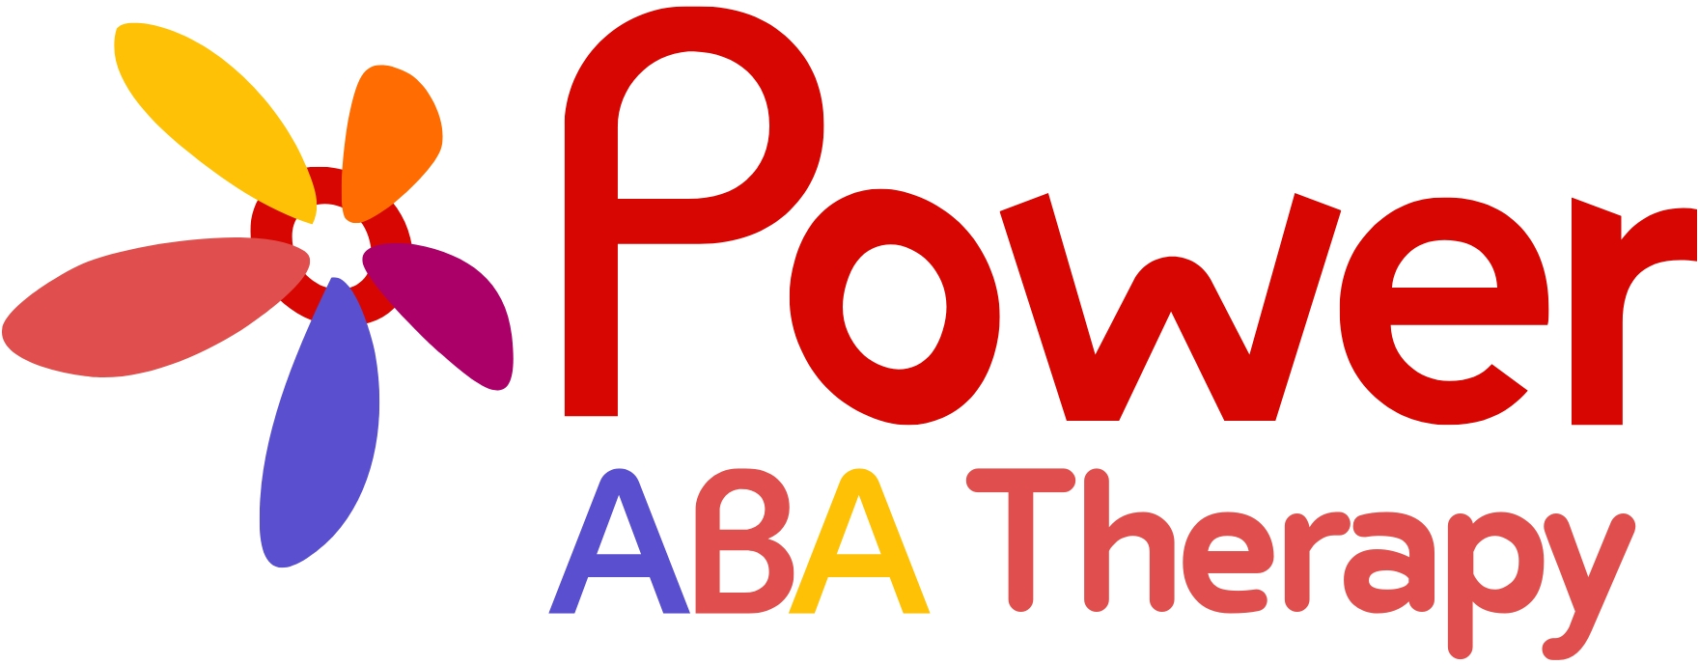
Use for the website, social media, email, and other digital touchpoints.

Print & Apparel Materials
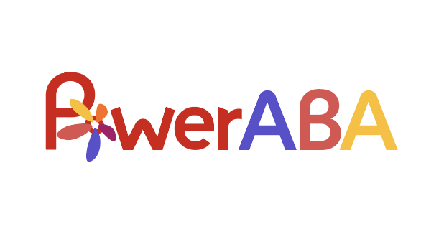
Use for printed materials and apparel — brochures, signage, shirts, and tote bags.

Illustration Style
- Polished 2D animation with clean linework, expressive faces, vivid but controlled color, and soft dimensional shading.
- Friendly proportions and movement without exaggerated babyish styling.
- Simple, uncluttered backgrounds for educational posts; richer environments for stories and video.
- The colorful flower should be integrated into the red shield badge as part of the costume—not pasted over it.
- Use consistent facial structure, hair, glasses, clothing, badge orientation, and relative height across all assets.

Adult-Facing Design
Use generous white space, restrained character placement, strong typography, calm layouts, and one clear educational message. Characters may appear as corner guides, speech-bubble hosts, or scene openers rather than filling every frame.

Child-Facing Design
Use larger expressions, simpler language, visual sequences, repetition, direct participation prompts, and predictable story patterns. Keep sensory load manageable and avoid crowded motion or rapid visual changes.

Logo and Badge Rule
Production note
The Power Bloom is a brand symbol. It should remain recognizable at small sizes, use the approved petal order and colors, and never be redrawn differently from post to post.

Composition & Asset Use
Do | Avoid
Give the characters breathing room and a clear focal point. | Crowding characters, text, icons, and props into one frame.
Use clean crops that preserve faces, hands, badges, and gestures. | Cropping through eyes, hands, badges, or important communication tools.
Place characters beside the message in adult-facing graphics. | Making every educational post look like a children’s cartoon scene.
Use simple backgrounds for tips and richer settings for stories. | Busy patterns or sensory-heavy backgrounds that compete with the message.
Maintain consistent lighting, linework, proportions, and color. | Mixing unrelated illustration styles within the same campaign.

06 | Voice & Messaging  Encouraging, respectful language that is simple without being simplistic.

Brand Voice
Always sound  Warm, encouraging, plainspoken, patient, respectful, practical, hopeful, and strengths-based. | Never sound  Shaming, patronizing, overly cute, clinical without explanation, alarmist, absolute, or focused on “fixing” a child.

Message Hierarchy
Level | Message
Power ABA tagline (organization) | Together we unlock the potential in every child.
Power Pals tagline (Poppy & Parker) | Growing stronger every day.
Core belief | Every step matters.
Poppy line | Let’s find another way!
Parker line | One step at a time!
Team close | We’re growing stronger every day!
Caregiver reassurance | You do not have to solve everything today.

Language Reframes
Avoid | Prefer
“Behave properly” | “Find a way to communicate what is needed.”
“Overcome difficult behavior” | “Practice a strategy that supports participation or regulation.”
“Normal behavior” | “Useful, meaningful, or safe skills for this child and family.”
“Refused to cooperate” | “Communicated discomfort, uncertainty, or a need for support.”
“Success means finishing everything” | “Success may be asking for help, trying one step, or returning when ready.”
“ABA will…” | “Power ABA may support…; goals and progress are individualized.”

Core Copy Bank
- Small steps can open big possibilities.
- A break can be part of the plan.
- There is more than one way to communicate, learn, and grow.
- Courage can look like asking for help.
- Progress does not need to look like anyone else’s progress.
- Celebrate the try.
- Different strengths make a stronger team.

Audience Tone Shifts
Audience | Tone adjustment | Example opening
Caregivers | Supportive, specific, practical, never blaming. | “A schedule change can feel easier when a child knows what will stay the same.”
Children | Simple, direct, predictable, encouraging. | “Parker’s plan changed. First, he noticed how he felt.”
Clinicians | Clear, collaborative, professional, strengths-based. | “Use the characters to reinforce—not replace—individualized clinical guidance.”
Community partners | Accessible, confident, mission-centered. | “Power ABA helps families build meaningful skills through individualized support.”

Simple Caption Framework
1. Name the everyday situation or caregiver question.
2. Offer one respectful insight or practical strategy.
3. Give one clear example of what the strategy can look like.
4. Close with a useful action: save, download, discuss, prepare, or celebrate.

07 | Social Media Strategy  Use the characters as trusted guides for adults and encouraging friends for children.

Strategic Role
Poppy and Parker should make Power ABA’s social content easier to recognize, understand, save, and share. They are not decorative mascots placed on every graphic. Each appearance should serve a communication purpose: introduce a topic, model a strategy, frame a story, celebrate a strength, or guide a next step.

How Often to Feature Poppy & Parker
Aim for the illustrated characters appearing in roughly two out of every three posts — not every post, and not a fixed rotation. The Power Bloom mark, color palette, and “Growing stronger every day” can carry brand identity on any post, including the ones where Poppy and Parker sit out.
- Monday (Parker’s One-Step Plan): Parker, solo. The series name already ties this to his strength.
- Wednesday (Power Pal Tip or Mini-Adventure): the swing day. For a tip, let the message pick the character — Poppy for flexibility/trying a new approach, Parker for patience/step-by-step planning. For a Mini-Adventure, use both together, since the story is about their friendship.
- Friday (Power Bloom Friday): often neither. Real staff photos, caregiver quotes, or behind-the-scenes moments work well here, carried by the Power Bloom mark and color system rather than the characters.
Default to solo appearances over showing both together. Solo appearances let which character appears signal what the post is about — pairing them on every post erases that shorthand. Reserve “both together” for Mini-Adventures, content specifically about their friendship, or brand-anchor materials (cover art, Quick Reference) meant to represent the whole brand rather than one specific tip. The one rule to hold firm: never default to showing both simply out of habit.

Recommended Audience Mix
Content lane | Approximate share | Primary purpose
Family guidance | 80% | Caregiver tips, education, service understanding, resources, and encouragement.
Community and culture | 20% | Staff, partnerships, events, values, recruiting, and behind-the-scenes trust building.

Content Objectives
- Build recognition and emotional trust around Power ABA.
- Give caregivers practical content worth saving and sharing.
- Explain services and strategies in clear, respectful language.
- Create a repeatable storytelling engine rather than relying on one-off posts.
- Support recruitment, referral relationships, and community visibility without losing the family-centered voice.

How to Keep Animation Adult-Friendly
- Write headlines directly to caregivers: “Three ways to prepare for a schedule change.”
- Pair character visuals with real clinicians, staff insight, and useful downloads.
- Use clean editorial layouts rather than preschool classroom graphics.
- Keep character dialogue short; place the full explanation in professional, accessible copy.
- Use adult calls to action: save, download, ask, prepare, share with a caregiver, or speak with the care team.

Child-Directed Content
Use a clearly labeled Power Pals Adventures series or playlist for content intentionally designed for children. Maintain separate visual packaging, simpler language, predictable episode patterns, and current platform-compliance review before publishing.
Recommended positioning line
Poppy and Parker help families learn, practice, and celebrate growth together.

08 | In-Clinic Culture  Ways the Power Bloom can grow beyond content, into everyday culture at Power ABA.

The Power Bloom doesn’t have to live only in social posts and stories — it can become something children, families, and staff experience in the clinic itself.

The Power Wall Garden
Each child works toward their own Power Bloom — a blank flower with five petal outlines for Courage, Curiosity, Kindness, Calm & Confidence, and Self-Expression. Petals are filled in whenever staff notice one of those qualities show up, individualized to what matters for that child rather than a fixed checklist. Once all five petals are earned, the flower moves to a shared Power Wall — a growing display in the clinic that becomes more alive with every child who completes one.
Petals are never removed once earned, and the wall shows no pace or ranking — it’s a garden the whole practice grows together, not a leaderboard.

The Seed Ritual
Every new client receives their first blank Power Bloom during their very first session, presented as a gift from Poppy and Parker. It’s a small moment that makes the framework part of the relationship from day one, rather than something introduced later.

The Petal Log
A simple take-home card or magnet lets caregivers note petal moments they notice at home — trying a new food, using a communication device unprompted, asking for a break independently. Those moments feed into the same flower as the ones earned in clinic, giving caregivers a tangible way to take part in their child’s progress.

Power Bloom Friday (In-Clinic)
Distinct from the Power Bloom Friday social content series: a short weekly ritual — a closing circle at the end of the week where children and staff each share one bloom moment. It costs nothing to run and keeps the Power Bloom language alive in daily practice, not just on social media.

Shared Clinical Language
Staff begin using the five petal words — courage, curiosity, kindness, calm and confidence, self-expression — in session notes and caregiver updates in place of clinical jargon. It keeps the brand’s voice consistent everywhere a family encounters Power ABA, not just in marketing materials.

09 | Content Series & Concepts  Repeatable formats that make planning easier and build audience familiarity.

Series | Purpose | Best formats
Power Pal Tips | Short, practical caregiver strategies. | Carousel, Reel, downloadable card
Poppy’s Find Another Way | Communication, flexibility, choices, and alternative approaches. | Carousel, illustrated example, clinician voiceover
Parker’s One-Step Plan | Break routines or new experiences into manageable steps. | 3-step graphic, Reel, printable checklist
Power Bloom Friday | Celebrate courage, curiosity, kindness, self-expression, or calm. | Quote card, staff post, community prompt
Power Pals Mini-Adventures | 15–60 second everyday stories using the six-beat formula. | Animated Reel, Short, story sequence
Ask the Power Pals | A mascot introduces a caregiver question; a professional answers. | Video Q&A, carousel, live-series teaser
Myth & Power Pal Perspective | Compassionate clarification of common misconceptions. | Two-panel graphic, short video
Caregiver Encouragement | Shareable reassurance that validates effort and support needs. | Quote graphic, Story, email insert
Power Tools | Teach visuals, break requests, choices, preparation, and routines. | How-to carousel, printable, demonstration
Meet the Team with the Pals | Humanize staff and connect clinical expertise to the brand story. | Portrait, interview clip, onboarding post

Mini-Adventure Episode Concepts
Title | Challenge | Power Tool | Progress moment
Parker’s Change of Plans | Rain cancels the playground. | Choice board and a new plan. | Parker shares disappointment and chooses an indoor activity.
Poppy Takes a Break | A craft becomes frustrating. | Break request and timer. | Poppy returns and tries one smaller step.
The Too-Loud Party | A celebration feels overwhelming. | Headphones, quiet space, and communication. | Parker joins for a comfortable amount of time.
A Brave Dentist Visit | An unfamiliar appointment. | Preview, visual sequence, and choice. | Poppy completes the first planned step.
The Waiting Game | A favorite activity is delayed. | First-then plan and countdown. | The friends use the plan and ask for updates.

Hook and Ending Bank
Use | Examples
Caregiver hook | “Does this routine become difficult when plans change?” • “Try this before the next appointment.”
Story hook | “Parker had a plan—then the rain started.” • “Poppy wanted to keep trying, but her body needed a pause.”
Teaching close | “The goal was not perfection. The goal was one useful next step.”
Power Pals close | “Celebrate the try.” • “We’re growing stronger every day!”

10 | Channel Playbook  Adapt the same brand idea to the expectations of each platform.

Channel | Best use of Poppy & Parker | Recommended formats | Tone
Instagram | Primary visual storytelling and caregiver education. | Carousels, Reels, Stories, quote cards, printable previews. | Warm, polished, practical.
Facebook | Family resources, local community, events, and longer explanations. | Video, link posts, carousels, event graphics, testimonials only when compliant. | Supportive and community-oriented.
TikTok | Fast tips, relatable moments, and short animated scenarios. | 15–45 second vertical video, voiceover, character reactions. | Direct, energetic, never trivializing.
YouTube | Searchable education plus a distinct Power Pals Adventures library. | Shorts, 2–4 minute stories, caregiver explainers, playlists. | Clear, steady, story-led.
LinkedIn | Employer brand, partnerships, professional education, and values. | Clinician posts, event recaps, recruiting, thought leadership with light mascot use. | Professional, human, restrained.
Email | Ongoing family education and downloadable tools. | Character-led section headers, monthly tips, story links, printables. | Personal, useful, calm.
Website | Welcome, navigation, resources, service explanations, and family onboarding. | Character guideposts, resource center, story hub, FAQs. | Trustworthy and accessible.

Suggested Weekly Rhythm
Day | Series | Role
Monday | Parker’s One-Step Plan | Practical caregiver strategy.
Wednesday | Power Pal Tip or Mini-Adventure | Education or story-based engagement.
Friday | Power Bloom Friday | Strength celebration and community participation.

Format Rules
- Design for vertical first when video is planned; crop deliberately for square and landscape uses.
- Use captions on every video and provide clear on-screen text with strong contrast.
- Open with the audience problem, not with a long mascot introduction.
- Keep one primary takeaway per post.
- Use a human professional for clinical explanations; use characters to frame, demonstrate, or remember the message.

One-Idea Repurposing Workflow
1. Start with one caregiver question and one approved answer.
2. Turn it into a five-slide Instagram/Facebook carousel.
3. Record a 20–30 second clinician voiceover using the same key points.
4. Use one quote or step as a Story card and one as a LinkedIn post.
5. Package the visual or checklist as a downloadable resource or email insert.

Call-to-Action Bank
- Save this for the next time plans change.
- Download the visual and practice it before the appointment.
- Share this with a caregiver, teacher, or support person.
- Ask your care team how this strategy can be individualized.
- Tell us which Power Tool you would like to see next.

11 | Sample Four-Week Content Calendar  A launch-ready mix of education, story, community, and encouragement.

Timing | Series | Topic | Format | Call to action
W1 Mon | Parker’s One-Step Plan | Preparing for a schedule change | Carousel | Save this plan for the next unexpected change.
W1 Wed | Meet the Power Pals | Character introduction and brand story | Reel | Which Power Pal strength speaks to your family?
W1 Fri | Power Bloom Friday | Courage can look like asking for help | Quote card | Share a small courageous moment.
W2 Mon | Poppy’s Find Another Way | Offer two meaningful choices | Carousel | Try this during one routine this week.
W2 Wed | Power Pal Tip | A break can be part of the plan | Clinician Reel | Save the three-step break framework.
W2 Fri | Power Bloom Friday | Self-expression has many forms | Graphic | Celebrate a communication win.
W3 Mon | Parker’s One-Step Plan | Preparing for a dentist visit | Printable preview | Download the visual sequence.
W3 Wed | Mini-Adventure | Parker’s Change of Plans | Animated Short | What helped Parker choose a new plan?
W3 Fri | Community | Staff shares a favorite Power Tool | Portrait + caption | Meet the people behind the support.
W4 Mon | Poppy’s Find Another Way | Communication beyond spoken words | Carousel | Notice and honor every meaningful message.
W4 Wed | Ask the Power Pals | What is a visual schedule? | Q&A video | Submit next month’s caregiver question.
W4 Fri | Power Bloom Friday | Kindness and repair | Story graphic | Celebrate a moment of reconnection.

Sample Adult-Facing Post
Parker’s One-Step Plan: Preparing for Change
A change in routine can feel easier when a child knows what is changing, what will stay the same, and what choices are available. Preview the change, show one clear next step, and leave room for questions or a break. Small preparation can make a meaningful difference.
Call to action: Save this for your next schedule change.

Sample Child-Facing Prompt
Power Pals Adventures
Parker had a plan—but the rain changed everything. First he noticed: “I feel disappointed.” Then he looked at two new choices. Which plan should he try next?

12 | Production & Character Consistency  A practical system for illustrators, animators, designers, writers, and social teams.

Master Asset Library
Asset group | Minimum set
Character turnarounds | Front, three-quarter, profile, back, and height comparison.
Expressions | Joy, curiosity, uncertainty, frustration, calm, pride, concern, and relief.
Poses | Hands on hips, pointing, listening, sitting, using a visual, asking for a break, celebrating.
Badge files | Approved Power Bloom in vector, print, embroidery, and small-size versions.
Social templates | Square carousel, vertical Reel cover, Story, landscape video, LinkedIn, and email header.
Story backgrounds | Home, clinic, classroom, playground, store, dentist, party, and quiet space.
Audio | Approved voices, pronunciation guide, music approach, and sound-effect library.

Character Continuity Checklist
- Poppy remains taller than Parker unless a story explicitly uses perspective.
- Poppy’s glasses, pigtails, yellow shirt, denim overalls, cape, and flower badge remain consistent.
- Parker’s curls, blue shirt, jeans, cape, and flower badge remain consistent.
- The flower uses the approved petal order, center, proportions, and badge integration.
- Skin tones, facial features, and hair texture are not altered between assets.
- Expressions support the story and never ridicule fear, frustration, communication, or sensory needs.
- Characters interact with children as peers or guides—not as clinical authorities.

Writing Workflow
1. Define the audience: caregiver, child, staff, partner, or community.
2. Choose one learning or emotional objective.
3. Select the character whose natural strength best introduces the topic.
4. Write the practical message before adding mascot dialogue.
5. Check the language for respect, clarity, privacy, and outcome claims.
6. Design the asset using the approved templates and character references.
7. Complete clinical, brand, accessibility, and compliance review before publishing.

Do / Do Not
Do | Do not
Use Poppy and Parker to model strategies and choices. | Use them to shame, command, or reward compliance for its own sake.
Show a range of emotions and support needs. | Make every story end with effortless happiness or full task completion.
Keep the adult audience clear in parent content. | Assume animation automatically makes a post appropriate for children.
Pair clinical topics with qualified human review. | Put unsupported clinical claims in character dialogue.
Use the Power Bloom as a consistent brand memory device. | Change the badge design, petal order, or colors casually.

File & Approval Discipline
Area | Recommended practice
File names | Use character_topic_format_version_date, such as Parker_change-plan_reel_v03_2026-08-05.
Source files | Store editable masters, fonts, linked assets, and exports in a controlled shared library.
Version control | Keep one current approved folder and archive superseded files; never overwrite the master character sheets.
Approvals | Record brand, clinical, compliance, and accessibility approval before publication.
Corrections | Document what changed and update every reused version of the affected asset.

13 | Story World & Narrative System  Everyday challenges become opportunities for communication, support, and growth.

A lane to build into, not a launch requirement
The full narrative system below — the six-beat formula, Origin Story, Mini-Adventure concepts, and Power Tools Library — supports Power Pals Adventures (Lane B), which this Brand Bible already treats as a future content lane rather than a launch-day deliverable. Treat this section as a reference to build into over time as that lane develops, not as content to produce immediately.

The World: Power Place
Poppy and Parker live in a bright, welcoming community called Power Place. It includes familiar environments such as home, school, the playground, the store, the dentist, birthday parties, therapy sessions, and community events. The world feels imaginative, but the situations stay grounded in real family life.

The Power Bloom
The colorful flower on their badges is called the Power Bloom. It does not glow because someone was perfect. It brightens when a character communicates, practices, asks for help, shows kindness, tries a strategy, or celebrates meaningful progress. Per the approved reference artwork, the five petals are arranged clockwise from the top point in this fixed order: Yellow, Orange, Coral, Blue, Purple. This order is locked and should never be redrawn or rearranged.
Petal color | Meaning | Story examples
Yellow | Courage | Entering a new room, trying one step, returning after a break.
Orange | Curiosity | Asking a question, exploring a tool, trying a different approach.
Coral red | Kindness | Helping, listening, waiting, repairing a mistake.
Blue | Calm and confidence | Using a break, breathing, preparing, following a visual plan.
Purple | Self-expression | Sharing a preference, saying no, using a device, gesture, picture, or words.

Six-Beat Story Formula
1. A familiar challenge appears: something is new, frustrating, confusing, loud, delayed, or different than expected.
2. A character notices and names the experience without judgment: “This feels hard right now.”
3. They choose a Power Tool: a visual, a choice, a break, a question, a first-then plan, practice, or trusted support.
4. They try. The first attempt does not need to be perfect or complete.
5. They identify meaningful progress: communicating, participating, asking for help, trying one step, or returning when ready.
6. The Power Bloom responds and the story closes with: “We’re growing stronger every day!”

Origin Story
Poppy once believed superheroes had to be fearless. Parker believed superheroes always knew exactly what to do. When they faced a challenge neither could solve alone, Poppy became frustrated and Parker felt overwhelmed. They paused, explained what they needed, asked for help, and broke the challenge into smaller steps. Their flower badges began to shine—not because they were perfect, but because they communicated, learned, supported each other, and tried again. That day, they became the Power Pals.

Starter Story Titles
- Parker’s Change of Plans
- Poppy Takes a Break
- The Playground Power Plan
- A Brave Trip to the Dentist
- The Too-Loud Party
- The Small-Step Celebration
- Poppy and Parker Try Something New
- The Power of Asking for Help

Power Tools Library
Power Tool | What it models | Possible visual
Visual plan | Shows what is happening now and what comes next. | Simple picture sequence or first-then card.
Meaningful choice | Offers two real, available options. | Poppy or Parker pointing to two choices.
Break request | Communicates a need to pause without shame. | Break card, quiet space, timer, or headphones.
Practice and preview | Builds familiarity before a new experience. | Short rehearsal, photo preview, or social story.
Ask for help | Models self-advocacy and trusted support. | Character approaching a caregiver, teacher, or clinician.
Calm body support | Uses individualized regulation tools. | Breathing, movement, sensory item, or reduced stimulation.

14 | Safeguards & Accessibility  Protect families, preserve dignity, and make every asset easier to use.

Privacy and Story Use
- Use fictional, composite, or generalized scenarios unless documented permission and compliance approval are in place.
- Never recreate a recognizable client story, routine, location, or outcome without appropriate authorization.
- Do not reveal protected or sensitive information through captions, background details, screenshots, or metadata.
- Keep testimonials and client images within approved legal, clinical, and organizational processes.

Clinical and Ethical Guardrails
- Avoid guaranteed results, universal timelines, and one-size-fits-all recommendations.
- Use respectful, individualized language and recognize multiple forms of communication.
- Do not frame autism, disability, emotion, or sensory needs as villains to defeat.
- Do not use fear, guilt, or urgency to drive inquiries.
- Make clear when content is general education rather than individualized clinical guidance.
- Have qualified professionals review clinical explanations before publication.

Accessibility Standards
Area | Standard
Captions | Caption all spoken audio; edit auto-captions for accuracy.
Contrast | Use high-contrast text and do not rely on color alone to communicate meaning.
Motion | Avoid rapid flashing, unnecessary motion, and overstimulating transitions.
Text | Use readable type sizes, short paragraphs, descriptive headings, and plain language.
Images | Write meaningful alt text that describes the purpose of the image.
Audio | Keep music below speech and avoid sudden loud effects.
Downloads | Create accessible PDFs and printables with logical reading order and labels.

Review reminder
Before launching child-directed video or collecting information from children, review current platform rules and applicable legal requirements with qualified counsel and compliance leadership.

15 | Launch Roadmap & Measures  Build the system in phases, test it with families, and improve it deliberately.

Phase 1: Foundation
- Finalize character sheets, flower badge, color files, and social templates.
- Clear mascot names, tagline, artwork ownership, and relevant trademark usage.
- Create a review workflow involving brand, clinical, compliance, and accessibility owners.
- Produce a core library of 20–30 static poses and expressions.

Phase 2: Soft Launch
- Introduce Poppy and Parker through one pinned post, one short video, and a website section.
- Launch three recurring series: Power Pal Tips, Parker’s One-Step Plan, and Power Bloom Friday.
- Test adult-facing content first and gather feedback from caregivers and staff.

Phase 3: Story Expansion
- Release the first Power Pals Mini-Adventure.
- Create printables tied to stories and social posts.
- Develop a searchable video playlist and email content stream.
- Add seasonal and community story environments without changing the core character designs.

What to Measure
Goal | Useful indicators
Recognition | Mascot recall, profile visits, direct mentions of Poppy/Parker, branded search.
Usefulness | Saves, shares, downloads, link clicks, resource completion.
Trust | Positive comments, caregiver questions, referral feedback, message sentiment.
Engagement quality | Meaningful replies and repeat viewers—not just total views.
Service understanding | FAQ reduction, inquiry quality, appointment preparedness.
Internal adoption | Staff use of approved language, templates, and Power Tools.
Accessibility | Caption accuracy, alt-text completion, contrast and review compliance.

Decision Rule
“If a character appearance does not improve clarity, connection, memory, or encouragement, the post may not need a mascot.”
Power Pals creative filter

16 | Quick Reference  A one-page creative brief for daily use.

Brand | Poppy & Parker — The Power Pals
Tagline | Power ABA: “Together we unlock the potential in every child.” | Poppy & Parker: “Growing stronger every day.”
Purpose | Help children and families recognize strengths, use practical tools, and celebrate meaningful progress.
Poppy | Curiosity, creativity, communication, flexibility. “Let’s find another way!”
Parker | Patience, courage, self-advocacy, step-by-step progress. “One step at a time!”
Team close | “We’re growing stronger every day!”

Creative Checklist
- Is the intended audience immediately clear?
- Does the content have one useful takeaway?
- Is the character serving a real role rather than decorating the post?
- Does the language respect the child’s communication, feelings, and individuality?
- Are the characters and flower badge visually consistent?
- Are clinical claims reviewed and appropriately qualified?
- Are privacy, captions, contrast, alt text, and motion considered?
- Does the final message support the belief that every meaningful step matters?
Official introduction copy
Meet Poppy and Parker, the Power Pals! Whether they are learning a new skill, facing an unexpected change, or finding the courage to try again, these two friends know that real power comes from patience, practice, communication, and believing in what is possible. With every adventure, they remind children and families that every step deserves to be celebrated—because we are growing stronger every day.

Final Brand Line
“Poppy and Parker help families learn, practice, and celebrate growth together.”
Power ABA Therapy

