Richard Vargas

005859278

CSE 516 Machine Learning

Dr. Zhang

**Problem 1**

Part 1 – Min-max normalization

Although Weka could be used to preprocess data, I decided to perform this in excel in order to understand the Min-max normalization a little bit better. I used the following equation on both vectors,

$$x_{i}=\frac{x_{i}-min⁡(x)}{\max\left(x\right)-min⁡(x)}$$

This resulted in the following dataset,

|  |  |  |
| --- | --- | --- |
| ID | A1_Norm | A2_Norm |
| 1 | 0.08 | 0.533333 |
| 2 | 0.28 | 0.8 |
| 3 | 0.04 | 0.466667 |
| 4 | 0.2 | 0.833333 |
| 5 | 0.12 | 0.733333 |
| 6 | 0.4 | 0.4 |
| 7 | 0.24 | 0.433333 |
| 8 | 0.16 | 0.166667 |
| 9 | 0.32 | 0.266667 |
| 10 | 0.36 | 0.233333 |
| 11 | 0 | 0 |
| 12 | 0.48 | 0.066667 |
| 13 | 1 | 0.866667 |
| 14 | 0.6 | 0.9 |
| 15 | 0.44 | 0.566667 |
| 16 | 0.56 | 0.633333 |
| 17 | 0.52 | 1 |
| 18 | 0.8 | 0.3 |
| 19 | 0.88 | 0.8 |
| 20 | 0.84 | 0.5 |

Part 2 – Iterating K-means algorithm

First Iteration

First, we must assign each point to its closest centroid, since we picked instance 1 (“x”) and 20(“o”) as our centroids, we must calculate the distance of each point to the centroid, square our result, and whichever distance is smaller we will assign to that cluster. We will calculate distance using the following equation,

$$d\left(c_{i},z_{j}\right)=√({\left(c_{i1}-z_{j1}\right)}^{2}+{\left(c_{i2}-z_{j2}\right)}^{2})$$

Such that,

$$c_{i}∈C, z_{j}∈D$$

Where c is a centroid in our set of K centroids, and z is an instance in our dataset D

Calculate relative to both centroids, and choose minimum value to classify to a cluster,

|  |  |  |  |
| --- | --- | --- | --- |
| ID | C1_Dist | C2_Dist | Min_Val |
| 1 | 0 | 0.760731 | 0 |
| 2 | 0.333333 | 0.635295 | 0.333333 |
| 3 | 0.077746 | 0.800694 | 0.077746 |
| 4 | 0.32311 | 0.721603 | 0.32311 |
| 5 | 0.203961 | 0.756865 | 0.203961 |
| 6 | 0.346667 | 0.451221 | 0.346667 |
| 7 | 0.18868 | 0.603692 | 0.18868 |
| 8 | 0.375292 | 0.757305 | 0.375292 |
| 9 | 0.358763 | 0.569951 | 0.358763 |
| 10 | 0.410366 | 0.5491 | 0.410366 |
| 11 | 0.5393 | 0.977548 | 0.5393 |
| 12 | 0.614636 | 0.563363 | 0.563363 |
| 13 | 0.978525 | 0.400056 | 0.400056 |
| 14 | 0.636274 | 0.466476 | 0.466476 |
| 15 | 0.36154 | 0.405518 | 0.36154 |
| 16 | 0.490306 | 0.310125 | 0.310125 |
| 17 | 0.641387 | 0.593633 | 0.593633 |
| 18 | 0.756865 | 0.203961 | 0.203961 |
| 19 | 0.843274 | 0.302655 | 0.302655 |
| 20 | 0.760731 | 0 | 0 |

We will now have two clusters,

|  |  |  |
| --- | --- | --- |
| C1 | | |
| ID | A1_Norm | A2_Norm |
| 1 | 0.08 | 0.533333 |
| 2 | 0.28 | 0.8 |
| 3 | 0.04 | 0.466667 |
| 4 | 0.2 | 0.833333 |
| 5 | 0.12 | 0.733333 |
| 6 | 0.4 | 0.4 |
| 7 | 0.24 | 0.433333 |
| 8 | 0.16 | 0.166667 |
| 9 | 0.32 | 0.266667 |
| 10 | 0.36 | 0.233333 |
| 11 | 0 | 0 |
| 15 | 0.44 | 0.566667 |

|  |  |  |
| --- | --- | --- |
| C2 | | |
| ID | A1_Norm | A2_Norm |
| 12 | 0.48 | 0.066667 |
| 13 | 1 | 0.866667 |
| 14 | 0.6 | 0.9 |
| 16 | 0.56 | 0.633333 |
| 17 | 0.52 | 1 |
| 18 | 0.8 | 0.3 |
| 19 | 0.88 | 0.8 |
| 20 | 0.84 | 0.5 |

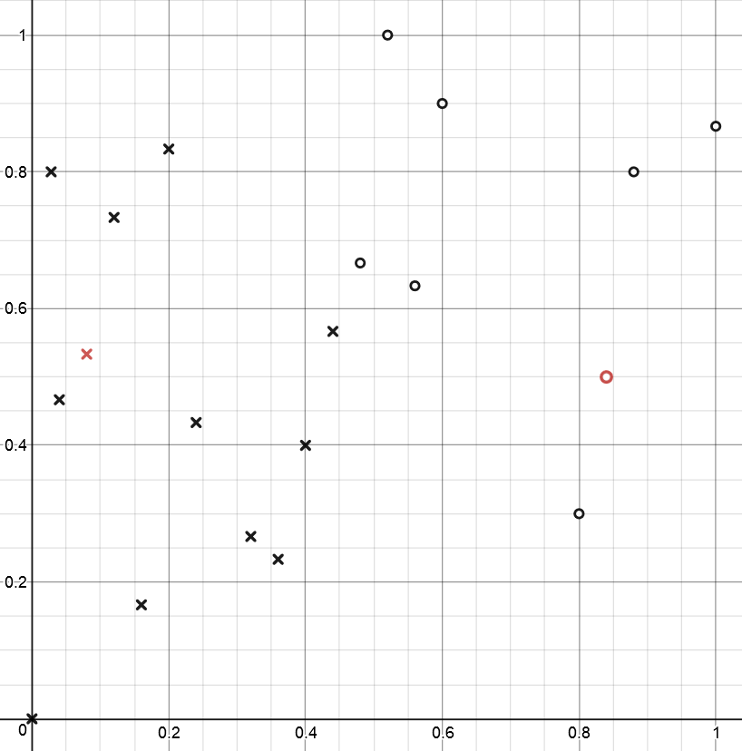

For each of these clusters we must find the average and set that to be the new Centroids for the second iteration,

$$c_{1}=(0.22,0.4528)$$

$$c_{2}=(0.71,0.6333)$$

Second Iteration

Calculate the distance of each instance from the new centroids using the same formulas as above,

|  |  |  |  |
| --- | --- | --- | --- |
| ID | C1_Dist | C2_Dist | Min_Val |
| 1 | 0.161522 | 0.637887 | 0.161522 |
| 2 | 0.352368 | 0.46117 | 0.352368 |
| 3 | 0.180535 | 0.690419 | 0.180535 |
| 4 | 0.381081 | 0.547814 | 0.381081 |
| 5 | 0.297845 | 0.598415 | 0.297845 |
| 6 | 0.187578 | 0.388001 | 0.187578 |
| 7 | 0.027894 | 0.510784 | 0.027894 |
| 8 | 0.292335 | 0.721303 | 0.292335 |
| 9 | 0.211276 | 0.535298 | 0.211276 |
| 10 | 0.2603 | 0.531507 | 0.2603 |
| 11 | 0.503396 | 0.951426 | 0.503396 |
| 12 | 0.465491 | 0.611564 | 0.465491 |
| 13 | 0.883009 | 0.372216 | 0.372216 |
| 14 | 0.586863 | 0.288463 | 0.288463 |
| 15 | 0.247731 | 0.278109 | 0.247731 |
| 16 | 0.384968 | 0.15 | 0.15 |
| 17 | 0.624061 | 0.41297 | 0.41297 |
| 18 | 0.599784 | 0.34527 | 0.34527 |
| 19 | 0.745764 | 0.238071 | 0.238071 |
| 20 | 0.621796 | 0.18622 | 0.18622 |

Gives us our new clusters

|  |  |  |
| --- | --- | --- |
| C1 | | |
| ID | A1_Norm | A2_Norm |
| 1 | 0.08 | 0.533333 |
| 2 | 0.28 | 0.8 |
| 3 | 0.04 | 0.466667 |
| 4 | 0.2 | 0.833333 |
| 5 | 0.12 | 0.733333 |
| 6 | 0.4 | 0.4 |
| 7 | 0.24 | 0.433333 |
| 8 | 0.16 | 0.166667 |
| 9 | 0.32 | 0.266667 |
| 10 | 0.36 | 0.233333 |
| 11 | 0 | 0 |
| 12 | 0.48 | 0.066667 |
| 15 | 0.44 | 0.566667 |

|  |  |  |
| --- | --- | --- |
| C2 | | |
| ID | A1_Norm | A2_Norm |
| 13 | 1 | 0.866667 |
| 14 | 0.6 | 0.9 |
| 16 | 0.56 | 0.633333 |
| 17 | 0.52 | 1 |
| 18 | 0.8 | 0.3 |
| 19 | 0.88 | 0.8 |
| 20 | 0.84 | 0.5 |

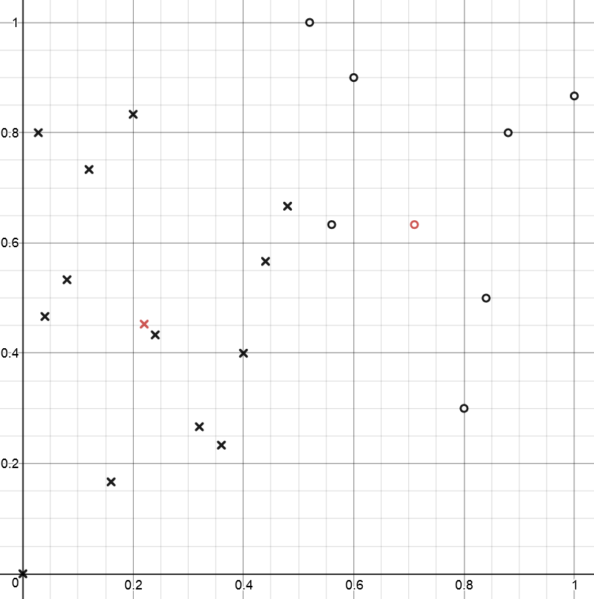

New centroids based on these averaged instances

$$c_{1}=(0.24,0.4231)$$

$$c_{2}=(0.7429,0.7143)$$

Third Iteration -

Second Iteration

Calculate the distance of each instance from the new centroids using the same formulas as above,

|  |  |  |  |
| --- | --- | --- | --- |
| ID | C1_Dist | C2_Dist | Min_Val |
| 1 | 0.19431 | 0.687112 | 0.19431 |
| 2 | 0.37904 | 0.470727 | 0.37904 |
| 3 | 0.204695 | 0.7452 | 0.204695 |
| 4 | 0.412202 | 0.555757 | 0.412202 |
| 5 | 0.332655 | 0.623148 | 0.332655 |
| 6 | 0.161656 | 0.465109 | 0.161656 |
| 7 | 0.010256 | 0.57602 | 0.010256 |
| 8 | 0.2686 | 0.799756 | 0.2686 |
| 9 | 0.175682 | 0.615769 | 0.175682 |
| 10 | 0.224505 | 0.614731 | 0.224505 |
| 11 | 0.486409 | 1.030554 | 0.486409 |
| 12 | 0.429684 | 0.698931 | 0.429684 |
| 13 | 0.879984 | 0.298902 | 0.298902 |
| 14 | 0.597541 | 0.234303 | 0.234303 |
| 15 | 0.246207 | 0.336918 | 0.246207 |
| 16 | 0.382894 | 0.199975 | 0.199975 |
| 17 | 0.64128 | 0.362351 | 0.362351 |
| 18 | 0.573365 | 0.418208 | 0.418208 |
| 19 | 0.742746 | 0.161725 | 0.161725 |
| 20 | 0.604911 | 0.235277 | 0.235277 |

Which gives us the following clusters,

|  |  |  |
| --- | --- | --- |
| C1 | | |
| ID | A1_Norm | A2_Norm |
| 1 | 0.08 | 0.533333 |
| 2 | 0.28 | 0.8 |
| 3 | 0.04 | 0.466667 |
| 4 | 0.2 | 0.833333 |
| 5 | 0.12 | 0.733333 |
| 6 | 0.4 | 0.4 |
| 7 | 0.24 | 0.433333 |
| 8 | 0.16 | 0.166667 |
| 9 | 0.32 | 0.266667 |
| 10 | 0.36 | 0.233333 |
| 11 | 0 | 0 |
| 12 | 0.48 | 0.066667 |
| 15 | 0.44 | 0.566667 |

|  |  |  |
| --- | --- | --- |
| C2 | | |
| ID | A1_Norm | A2_Norm |
| 13 | 1 | 0.866667 |
| 14 | 0.6 | 0.9 |
| 16 | 0.56 | 0.633333 |
| 17 | 0.52 | 1 |
| 18 | 0.8 | 0.3 |
| 19 | 0.88 | 0.8 |
| 20 | 0.84 | 0.5 |

­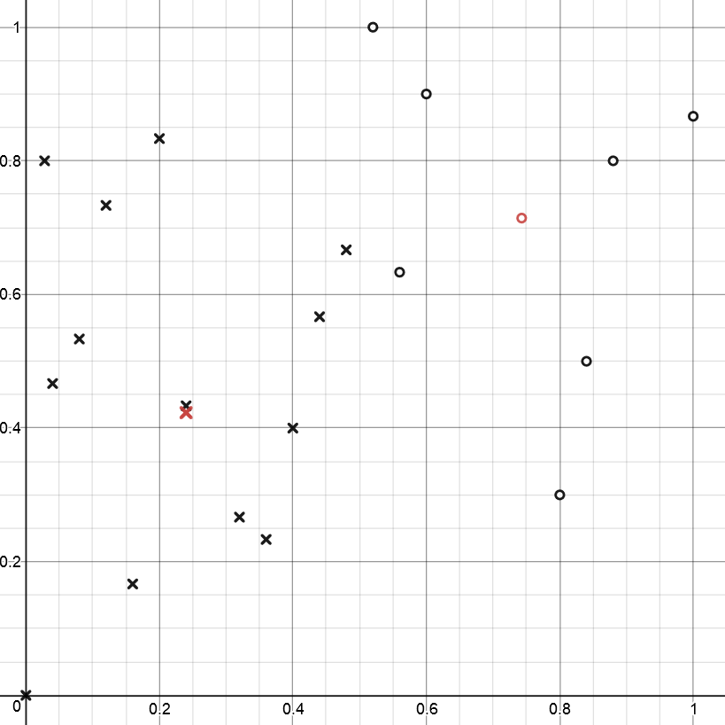

Since our clusters stayed the same, our algorithm would exit here for the fitting portion. We would end up with the same centroids as the previous iteration if we attempted to update them again.

**Problem 2**

Agglomerative Hierarchical Clustering starts by having each point as its own cluster. In this example we have the following cluster sets C1={X1}, C2={X2}, C3={X3}, C4={X4}, and C5={X5}.

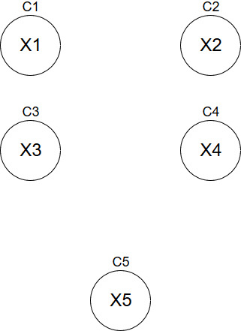

From there it starts to create new clusters, based on instances being closest together. The new cluster sets will be C1={X1,X3}, C2={X2,X4}, and C3={X5}

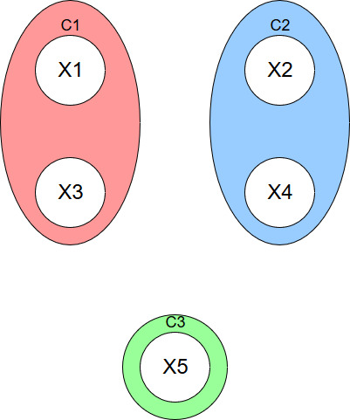

This process can continue until a desired K-clusters are met.

**Problem 3**

Density Based Clustering starts by setting a value $ε$, which the radial distance from some point x is the $ε$-neighborhood. If a point has a certain neighbor threshold (For example, 3 within its $ε$-neighborhood) then it becomes part of the cluster. In this algorithm there are three main kinds of points (or instances). First there are those which are core points, implying they are in the cluster and have the minimum number of points required and are directly reachable from our starting point. Then there are border points, which are still part of the cluster by being directly-reachable, however do not have the minimum number of points to be core points. Finally, there are noise points which are not a core point and are not directly reachable. These points are thought of similarly to outliers.

To start the algorithm, an arbitrary point is picked, and nearby instances are checked for. If a minimum number of instances exist in the $ε$-neighborhood then a cluster is started. By example, we check X1 first, since the minimum number of instances in the $ε$-neighborhood is 3, we have a core point which starts a cluster, and add all instances in the $ε$-neighborhood to the cluster set. C1={X1,X2,X3}

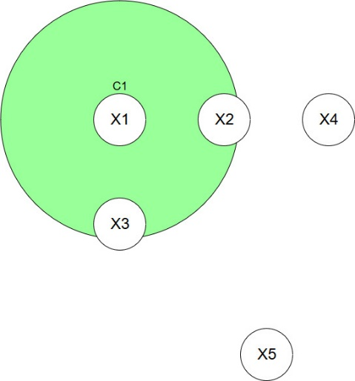

Now that we have other instances in our C1 set, we want to check the other unvisited elements X2 and X3, adding them to their $ε$-neighborhoods to the cluster we have started (if they have enough minimum instances in their respective $ε$-neighborhoods).

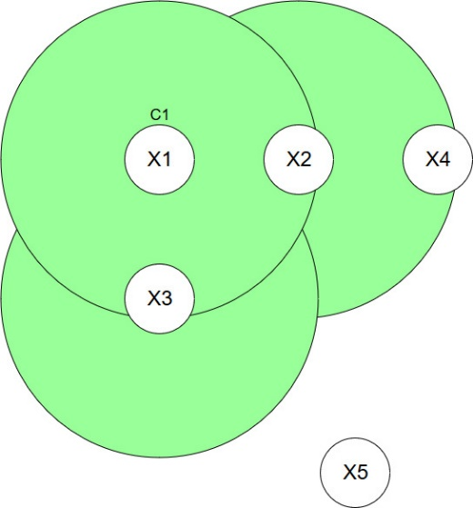

Since X2 is a core point, any instances in its $ε$-neighborhood are considered part of the cluster, and thus added to the C1 Set. Therefore C1 = {X1,X2,X3,X4}. Since instance X4 is an unvisited element we must inspect it with our algorithm. Since X4 only has 2 instances in its $ε$-neighborhood we cannot consider it a core point, thus it is a border point and still part our cluster.

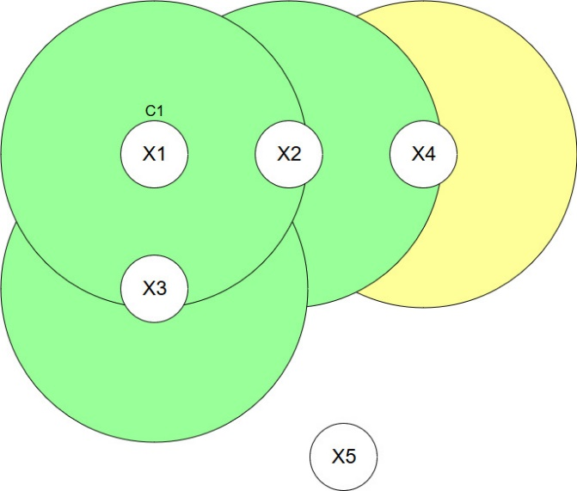

Our final instance in our data is X5, which is not reachable by any of the core points for our C1 cluster and does not have a minimum number of instances in the $ε$-neighborhood to start its own cluster, so it is considered a noise point.

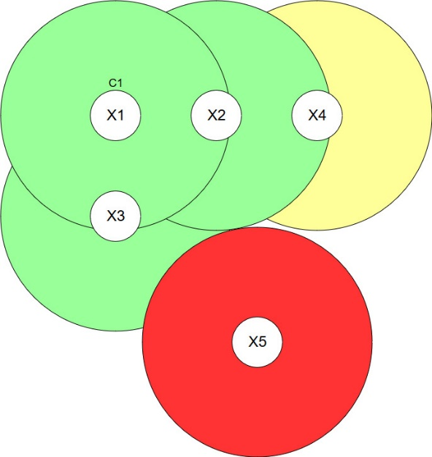

If another point were to be added within the $ε$-neighborhood of X4, then we could then change the status of X4 from a border point to a core point. On the same note, if we add 2 points to the $ε$-neighborhood of X5, then X5 would become a cluster and no longer a noise point.