GURU99 DEMO SITE
FIGMA DESIGN SPECIFICATION
UI Design Reference, Layout Measurements, Design Tokens and Components
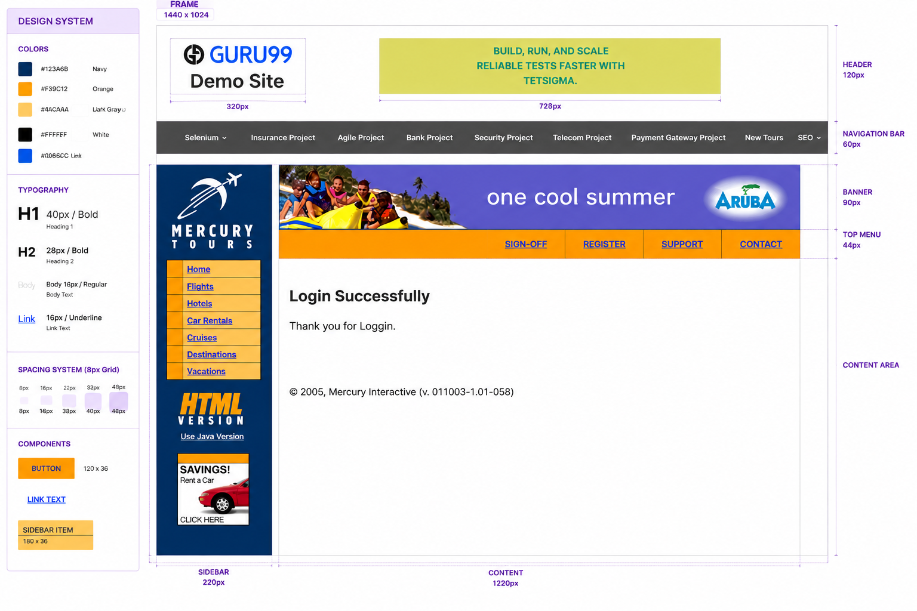

1. Design Overview
This document captures the visual and structural specifications shown in the supplied Figma-style design reference for the Guru99 Demo Site. It is intended to serve as a reference for UI development, visual validation, and Application UI versus design review.

2. Frame and Page Structure
Element | Specification | Notes
Design Frame | 1440 × 1024 px | Primary desktop design frame
Header | 120 px height | Logo area and promotional banner
Navigation Bar | 60 px height | Dark navigation strip
Banner | 90 px height | Mercury Tours / Aruba promotional banner
Top Menu | 44 px height | Orange action navigation
Sidebar | 220 px width | Left navigation and promotional content
Content Area | 1220 px width | Main application content area

3. Color Design System
Token | Hex Value | Usage
Navy | #123A6B | Sidebar / dark brand areas
Orange | #F39C12 | Top menu and button elements
Light Gray | #ACAAAA | Supporting / neutral UI
White | #FFFFFF | Main content background
Blue | #0066CC | Links and selected blue UI elements

4. Typography
Style | Size | Weight | Usage
H1 | 40 px | Bold | Primary page heading
H2 | 28 px | Bold | Secondary heading
Body | 16 px | Regular | Body content
Link | 16 px | Underline | Navigation and hyperlink text

5. Spacing System
The design follows an 8 px spacing grid. Reference spacing values shown are: 8 px, 16 px, 22 px, 32 px, and 48 px. These values should be applied consistently to margins, padding, gaps and component placement.

6. Component Specifications
Component | Size | Design Notes
Button | 120 × 36 px | Orange primary action styling
Sidebar Item | 180 × 36 px | Navigation item within sidebar
Link Text | 16 px | Underlined blue link
Navigation Item | Within 60 px navigation bar | White text on dark background

7. Page Layout
The page is organized into a full-width header, a dark horizontal navigation bar, and a two-column content section. The left sidebar is 220 px wide and contains the Mercury Tours branding, navigation links, HTML version section and promotional content. The main content area occupies approximately 1220 px and contains the promotional banner, orange action menu and login-success content.

8. Header and Navigation
- Header contains the Guru99 logo and Demo Site title on the left.
- A promotional banner is positioned toward the center/right of the header.
- Navigation bar uses a dark gray background and contains Selenium, Insurance Project, Agile Project, Bank Project, Security Project, Telecom Project, Payment Gateway Project, New Tours and SEO.
- The navigation labels are horizontally aligned and visually consistent.

9. Sidebar
- Sidebar width: 220 px.
- Primary background uses Navy (#123A6B).
- Mercury Tours logo appears at the top.
- Navigation links include Home, Flights, Hotels, Car Rentals, Cruises, Destinations and Vacations.
- HTML Version / Use Java Version section is included below navigation.
- A Savings / Rent A Car promotional block appears near the bottom.

10. Main Content
- Promotional banner appears below the main navigation.
- Orange top menu contains SIGN-OFF, REGISTER, SUPPORT and CONTACT.
- Main heading is 'Login Successfully'.
- Supporting message is 'Thank you for Loggin.' as shown in the supplied reference.
- Footer text displays the Mercury Interactive copyright/version information.

11. UI Validation Checklist
- Frame dimensions match 1440 × 1024 px.
- Header height matches 120 px.
- Navigation bar height matches 60 px.
- Sidebar width matches 220 px.
- Content width matches the specified layout.
- Primary colors match the defined hex values.
- Typography sizes and weights match the design tokens.
- 8 px spacing-grid principles are maintained.
- Buttons and sidebar items use the specified dimensions.
- Navigation, banner and content elements maintain consistent alignment.

12. Purpose of This Document
This specification can be used as a design reference for developers and QA engineers. For UI validation, the Application UI should be evaluated against these measurable design attributes including dimensions, spacing, typography, colors, component sizes, alignment and overall visual structure.

