AI Agent Open Protocols
A beginner-to-developer guide to the protocols shaping interoperable agentic AI
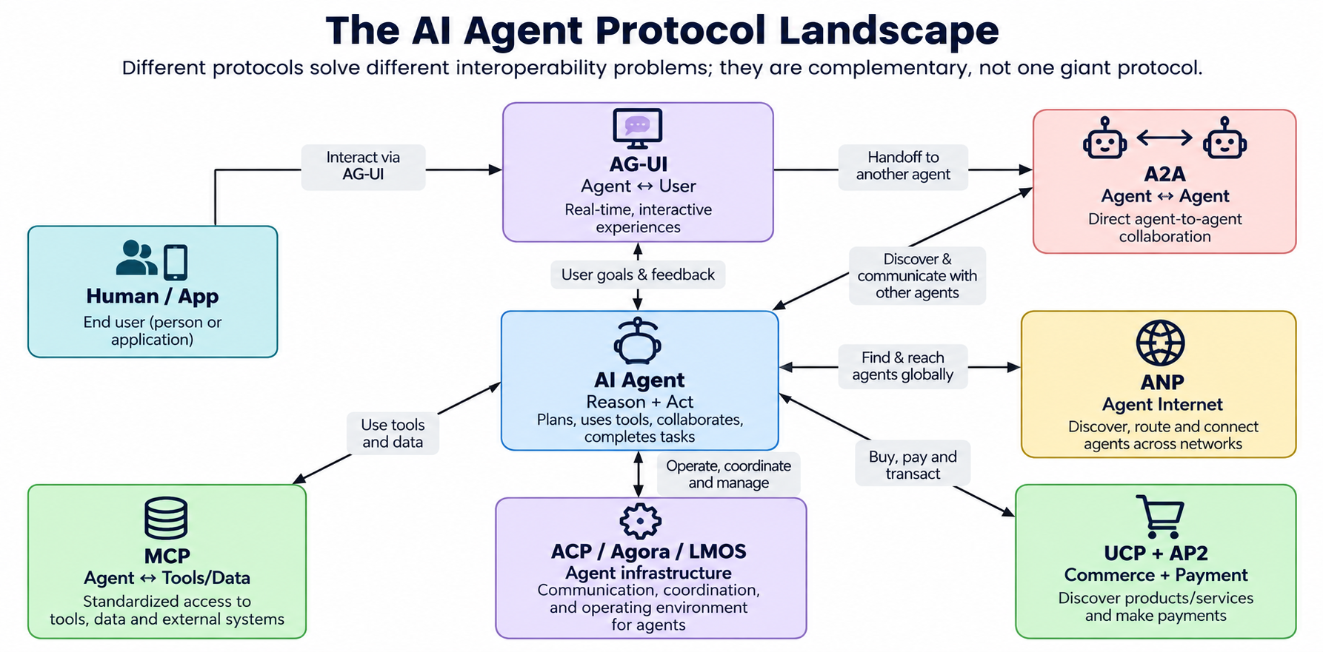

How to read this series
AI agents are moving from isolated chat experiences toward systems that can use tools, delegate work to other agents, interact with users in real time, and complete transactions. That shift creates a practical engineering problem: every agent, tool, application and business cannot afford a custom integration with every other participant.
Open protocols solve that interoperability problem by defining common ways to describe capabilities, discover participants, exchange messages, stream events, access tools and data, and execute commerce safely.
The key idea
Think of protocols as shared rules of conversation. An AI model supplies intelligence; protocols supply the contracts that let that intelligence operate across system boundaries.

One important distinction: these protocols are complementary. MCP is primarily about connecting an agent to tools and context. A2A is about agent-to-agent collaboration. AG-UI is about the live connection between an agent and a user-facing application. UCP and AP2 address commerce and payment. ANP, LMOS and Agora explore broader agent-network and protocol-negotiation models. ACP is especially important historically because its work has been incorporated into the A2A project.

The mental model
- Agent ↔ User: AG-UI
- Agent ↔ Tools & Data: MCP
- Agent ↔ Agent: A2A
- Agent ↔ Open Agent Network: ANP / LMOS / Agora
- Agent ↔ Commerce: UCP
- Agent ↔ Payments & Authorization: AP2
- ACP: an important HTTP-native agent interoperability effort that is now part of A2A

Episode 1 — Why AI Agents Need Open Protocols
A conventional application usually has predictable request and response boundaries. An agentic application is different. An agent may reason for several steps, call a database, ask another specialist agent, wait for human approval, stream progress to a browser, and finally execute a business transaction.

Without protocols: integration spaghetti
Imagine a procurement agent that needs inventory data, supplier quotes, a browser UI, checkout and payment. Without standards, the team writes a custom adapter for each supplier, a custom UI event format, a custom agent-to-agent API and a custom payment authorization mechanism. Every new partner increases the integration surface.

With protocols: composable building blocks
- MCP gives the agent a standard way to discover and call external tools and data sources.
- A2A gives agents a standard way to discover and collaborate with specialist agents.
- AG-UI gives the frontend a standard event stream for agent activity and human interaction.
- UCP gives commerce participants common capabilities and schemas.
- AP2 adds authorization, mandates and an audit trail for agent-initiated payments.
- ANP, LMOS and Agora explore larger-scale discovery, identity and protocol negotiation.
Architecture principle
Use the smallest protocol that solves the boundary you actually have. Do not add A2A when you only need a database tool, and do not build a custom UI event protocol when AG-UI already fits the interaction.

Episode 2 — MCP: Giving Agents Access to the Real World

Model Context Protocol (MCP)
MCP standardizes how AI applications connect models and agents to external tools, data and resources.

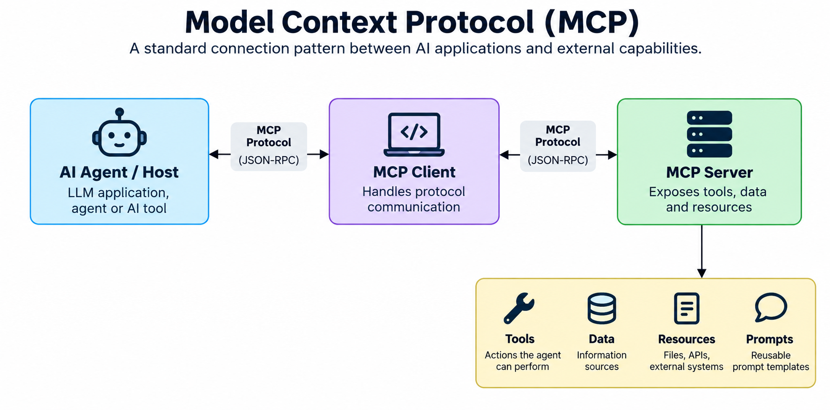

The problem it solves
An LLM can generate a plan, but it cannot inherently read your PostgreSQL database, inspect a file system, search a knowledge base or call a business API. Developers traditionally write one-off tool adapters for each integration.

How MCP works
- The host application contains the agent or model orchestration.
- An MCP client maintains the connection and session with an MCP server.
- The MCP server exposes capabilities such as tools, resources and prompts.
- The model can discover available capabilities and request tool execution through the standardized interface.

Why developers care
MCP separates agent logic from integration plumbing. A team can build an MCP server around an existing system and allow compatible clients to reuse that integration without learning the application's proprietary API shape.

For a developer
- Treat MCP servers as security boundaries, not trusted extensions. Apply authentication, authorization, least privilege and auditing.
- Design tools around meaningful business operations rather than exposing raw database primitives.
- Return structured results so the model does not have to infer schemas from prose.
- Version tools deliberately; changing a tool's arguments can break downstream agents.
- Keep secrets in the server-side environment rather than exposing credentials to the model.

Simple example
A restaurant agent receives: “Check salmon inventory.” The model discovers a check_inventory tool through an MCP server, calls it with the ingredient ID, receives structured stock information, and continues its reasoning.
Developer takeaway: MCP is the protocol to reach outward from the agent into tools and context. It is not primarily the protocol for asking another autonomous agent to do work.

Episode 3 — A2A and ACP: When Agents Need Other Agents

Agent2Agent (A2A) Protocol
A2A standardizes discovery and communication between agents built by different teams, vendors or frameworks.

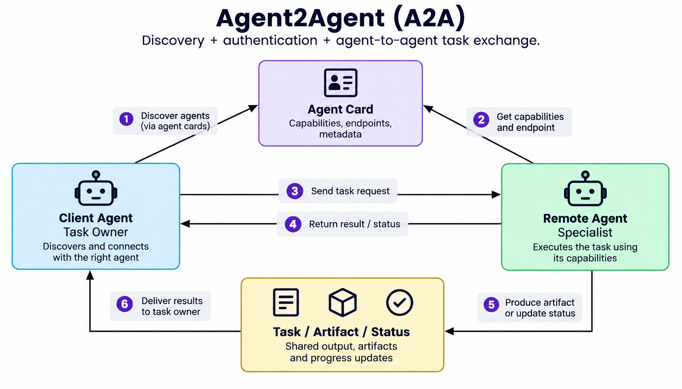

The problem it solves
A specialist agent may own expertise that is not exposed as a conventional API. A pricing agent, travel agent, fraud agent or scheduling agent can encapsulate reasoning and access to private systems. A2A lets another agent discover and collaborate with that capability without knowing its internal implementation.

Core flow
- Discovery: the remote agent publishes an Agent Card describing its identity, endpoint and capabilities.
- Authentication and authorization establish whether the caller can interact with the remote agent.
- Task exchange lets the client send work and receive messages, task status and artifacts.
- The communication model supports long-running or asynchronous work rather than assuming every task is a single HTTP response.

Why this matters
The boundary becomes capability-oriented. Instead of asking, “Which REST endpoint returns supplier quality?”, the caller can ask a specialist agent that owns the quality domain to perform the task.

For a developer
- Expose stable capabilities in the Agent Card and keep internal implementation details behind the agent boundary.
- Design tasks so that status and partial progress can be represented cleanly.
- Use strong authentication and authorization; agent-to-agent access can cross organizational trust boundaries.
- Log task IDs, agent identity, authorization decisions and artifacts for observability.
- A2A and MCP often coexist: A2A delegates work to another agent, while that remote agent may use MCP internally.

Simple example
A procurement agent needs today's seafood price. It discovers a pricing agent from its Agent Card, sends a price-check task, receives the result, and uses that result to decide whether to place an order.

Agent Communication Protocol (ACP)
ACP was designed as a lightweight, HTTP-native way for agents to communicate across frameworks and runtimes; its work is now part of A2A under the Linux Foundation.

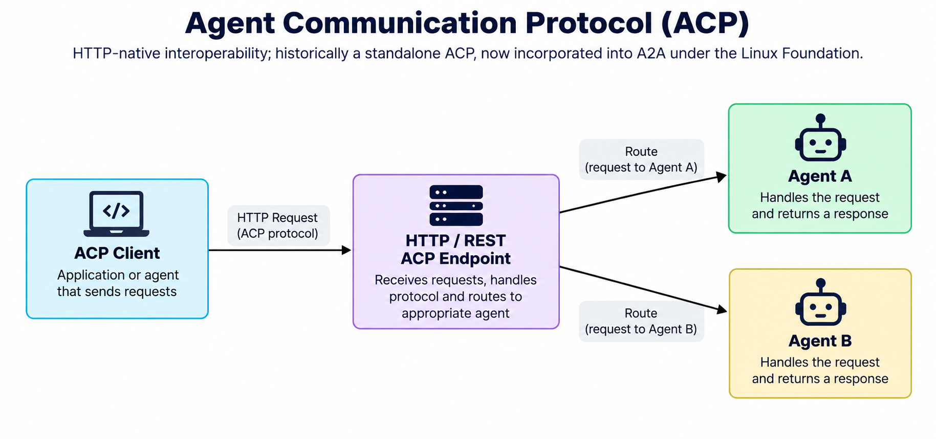

Why ACP mattered
ACP addressed the same fragmentation problem that motivates A2A: agents built in different frameworks should be reachable through a consistent interface rather than a custom connector for every framework.

How it was structured
- An ACP client sends requests to an ACP server over HTTP/REST.
- An ACP server can host or route to one or more agents.
- The design supported synchronous and asynchronous interactions, streaming and multiple content modalities.
- Discovery could be performed through online endpoints or metadata/registries.

Where it stands today
The ACP project documentation states that ACP is now part of A2A under the Linux Foundation. For a new greenfield implementation, developers should generally evaluate the current A2A specification rather than treating ACP as a separate competing standard.

For a developer
- If you inherit an ACP-based system, understand its migration path into A2A.
- Keep the transport boundary separate from business-agent logic so migration is less disruptive.
- Prefer current A2A libraries and specifications for new interoperable agent-to-agent systems.

Simple example
Think of ACP as an important chapter in the evolution toward standardized agent-to-agent communication: it helped prove that HTTP-native agent interoperability could be practical, and its work is now incorporated into the broader A2A effort.

Episode 4 — Building an Internet of Agents: ANP, Agora and LMOS
A2A focuses on practical agent-to-agent collaboration. A broader question is what happens when the number of agents becomes enormous and agents need to discover, authenticate, negotiate and communicate across organizational boundaries on the open internet.

Agent Network Protocol (ANP)
ANP aims to provide an open agent-web protocol suite covering identity, naming, discovery, negotiation, secure messaging and application collaboration.

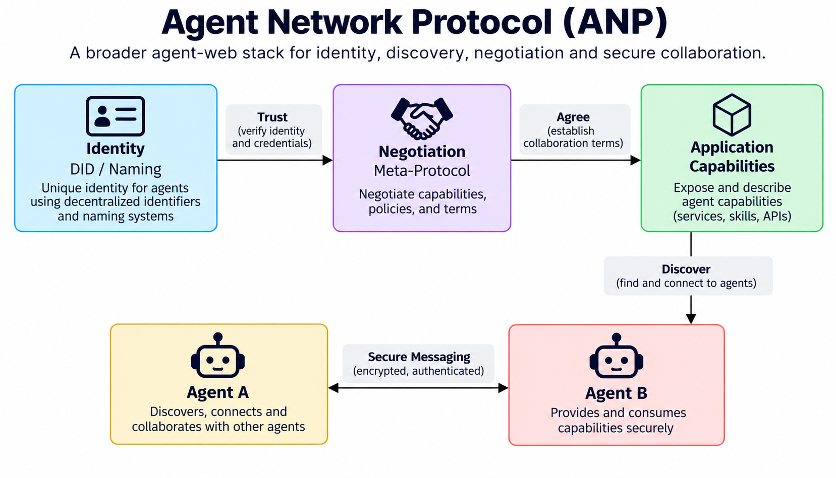

The big idea
ANP treats agents as network participants rather than merely services behind a private API gateway. The goal is an agentic web where an agent can find another agent, establish trust, understand capabilities and collaborate securely.

Layered architecture
- Identity and naming establish who an agent is and how it can be addressed.
- Discovery and description make capabilities machine-readable.
- A communication/meta-protocol layer can support negotiation of interaction methods.
- Application protocols define concrete collaboration patterns, including payment-related flows.

Why developers should care
ANP becomes relevant when the architecture extends beyond a controlled enterprise environment and needs decentralized identity, cross-domain discovery and secure messaging.

For a developer
- Separate identity from capability description: an agent's identity should remain stable even as capabilities evolve.
- Validate signatures and authorization before trusting agent metadata.
- Expect specifications to evolve; use explicit protocol/version identifiers in production.
- Do not confuse network discovery with authorization. Finding an agent does not mean you should trust or invoke it.

Simple example
A personal assistant wants to find a hotel-booking specialist on the open agent web. ANP-style discovery can help locate an agent, establish its identity and discover what collaboration protocols it supports before a business interaction begins.

Agora
Agora explores a different idea: agents can negotiate the protocol they will use for a task, with protocols described as documents that agents can understand and execute.

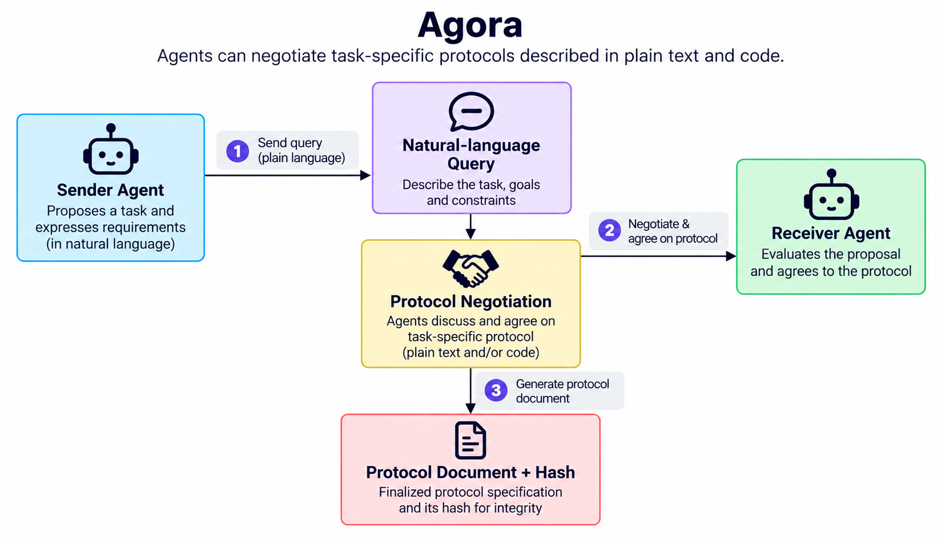

The problem it solves
Hard-coding every possible interaction protocol can become restrictive. Agora lets agents negotiate a task-specific protocol using their language understanding and programming capabilities.

How it works
- A sender agent describes or asks about the task.
- Agents negotiate which protocol is appropriate.
- A protocol document describes the rules for the interaction in natural language and code.
- A hash identifies the protocol document so both parties can agree on the same protocol definition.
- Communication can use HTTPS and JSON while the higher-level interaction rules are negotiated.

The interesting engineering trade-off
Agora is powerful because it makes protocols more dynamic. But dynamic negotiation also increases the importance of validation, sandboxing, resource limits and trust decisions. An agent should never blindly execute arbitrary code or instructions received from an unknown peer.

For a developer
- Treat negotiated protocol documents as untrusted input until verified.
- Sandbox generated or selected code and restrict filesystem/network access.
- Use protocol hashes or immutable identifiers to prevent ambiguity about which rules were agreed.
- Record negotiation transcripts for debugging and audit.

Simple example
A weather agent can ask another agent how it should request weather data. The two agents agree on a protocol document, identify that protocol by its hash, and then exchange messages according to the negotiated rules.

LMOS Protocol
LMOS, from the Eclipse ecosystem, targets an Internet of Agents where agents and tools can be published, discovered and interconnected across technologies.

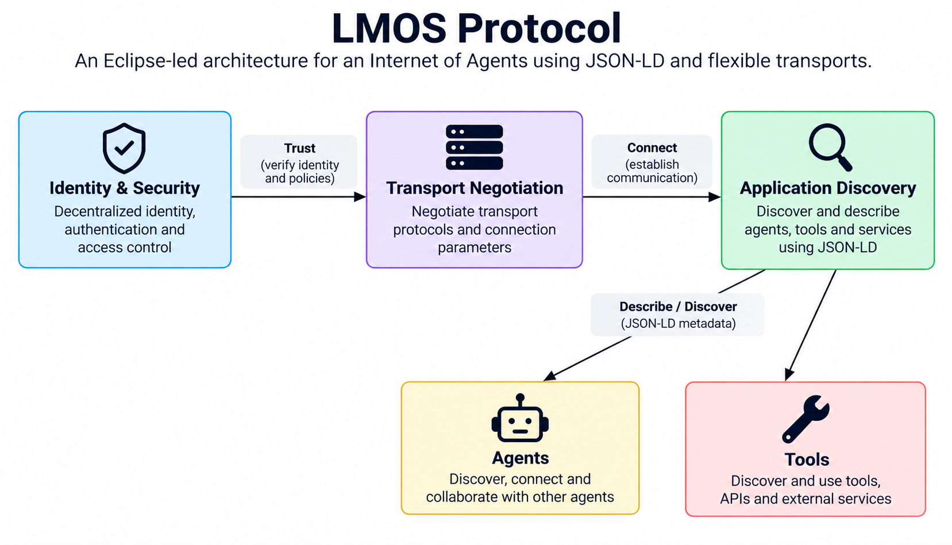

The problem it solves
A large agent ecosystem needs more than message exchange. Participants need standard descriptions, discovery, identity, security and transport flexibility.

Three layers
- Identity and security: authentication and encrypted communication, with support for approaches such as W3C DID and OAuth 2.0.
- Transport: agents can negotiate or use different transport mechanisms depending on the interaction.
- Application: standardized agent/tool descriptions, discovery, semantic data and real-time communication patterns.

A useful comparison
LMOS is closer to an ecosystem architecture than a single API call. It borrows ideas from web, semantic-web and IoT architectures to make agent capabilities discoverable and transport-agnostic.

For a developer
- Use JSON-LD when you need machine-readable semantic descriptions and interoperability across domains.
- Keep transport choices behind an abstraction so the application layer does not depend on HTTP-only assumptions.
- Use signed descriptions and strong identity checks before consuming discovered metadata.
- Treat the LMOS specification as evolving and validate the version and implementation maturity before production adoption.

Simple example
Think of LMOS as a blueprint for an agent internet: describe agents and tools, discover them, establish trust, negotiate transport, and then interact using standardized application semantics.

Episode 5 — AG-UI: Making Agent Experiences Feel Live

Agent–User Interaction (AG-UI) Protocol
AG-UI is an event-based protocol for connecting agent backends with user-facing applications through streaming, state updates, tool events and human interaction.

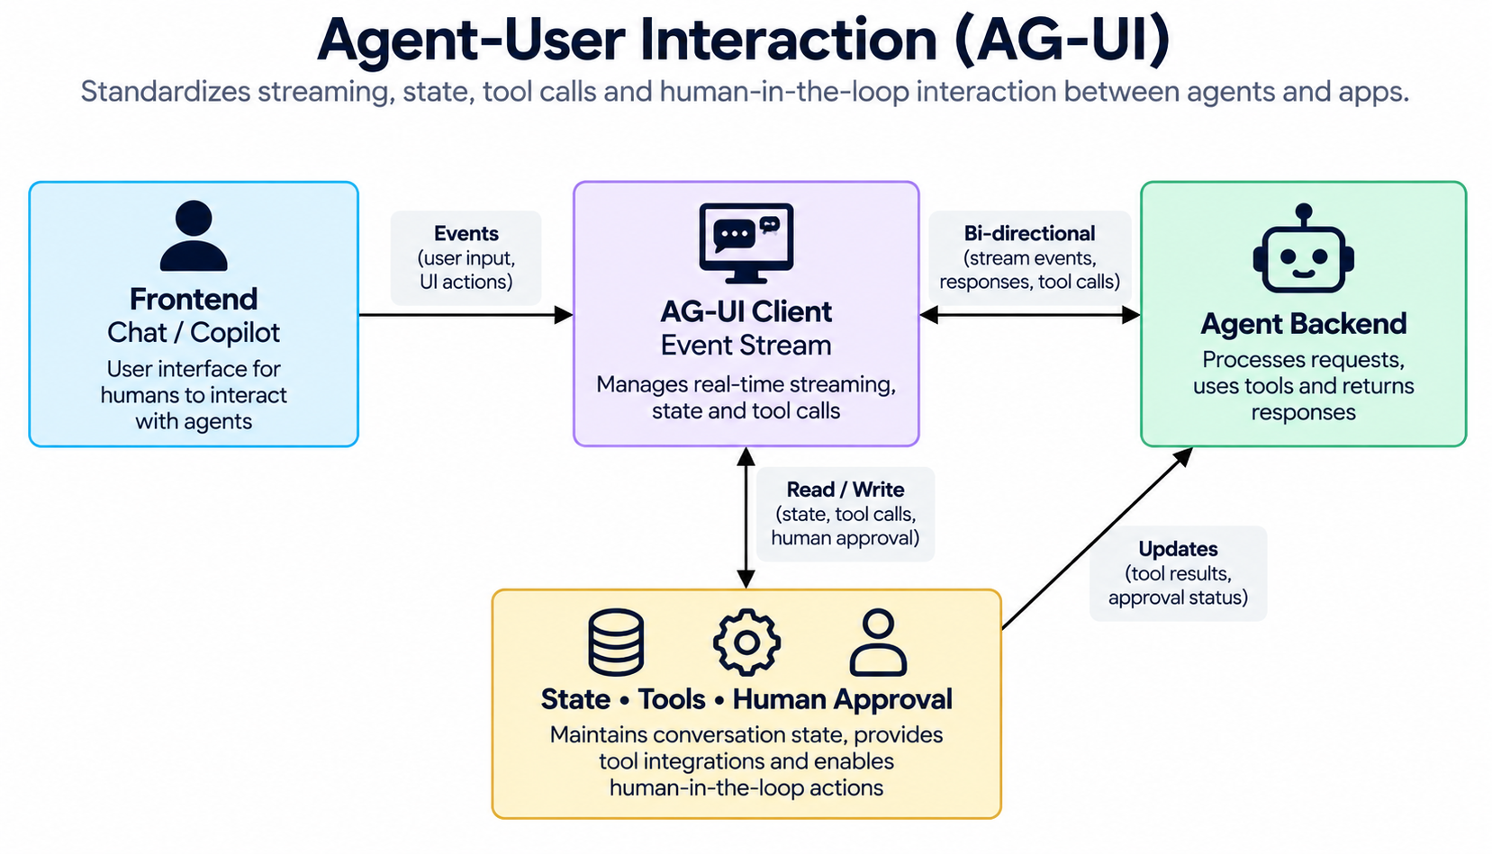

Why REST alone is not enough
A normal API call can return a JSON response and finish. An agent may instead stream text, call a tool, update state, ask the user for approval, handoff to another agent and continue. The frontend needs to understand those intermediate events.

What AG-UI standardizes
- Lifecycle events such as run started and run finished.
- Streaming text message events.
- Tool-call events and results.
- State snapshots and incremental state updates.
- Human-in-the-loop interruptions and application-side actions.
- Transport options such as SSE and WebSockets.

AG-UI versus generative UI
AG-UI is the interaction channel between an agent and an application. It is not itself a generative-UI widget specification. Generative UI standards can sit on top of the interaction channel to describe components that a client can render.

For a developer
- Model the frontend as an event consumer rather than a simple request/response client.
- Make events idempotent or recoverable where practical so reconnects do not corrupt UI state.
- Keep raw chain-of-thought out of user-facing event streams; expose safe status and activity information instead.
- Use typed event names for lifecycle, text, tools and state so frontend logic remains predictable.
- For long-running agents, support cancellation, retry and reconnection.

Simple example
When a user asks an agent to reorder stock, the browser can immediately show “Checking inventory…”, then “Calling supplier…”, then a confirmation request, and finally the completed order—all as events rather than one delayed response.

Episode 6 — UCP and AP2: When Agents Buy Things
Agentic commerce introduces a new risk: an agent can move from recommending an item to actually purchasing it. Commerce and payment protocols therefore need to separate the business transaction from authorization to spend.

Universal Commerce Protocol (UCP)
UCP defines common capabilities and schemas so platforms, AI agents and businesses can interoperate across commerce workflows.

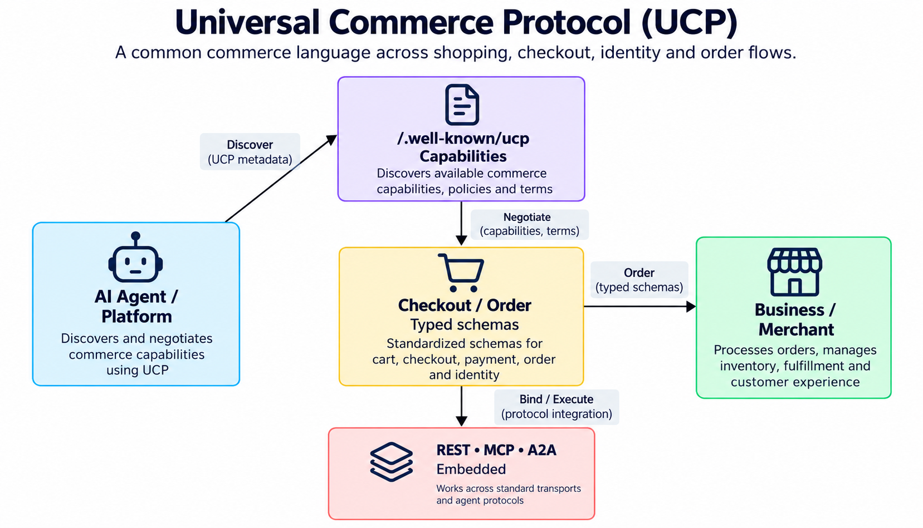

The problem it solves
Every merchant can expose a different catalog, checkout and order API. If an AI agent must integrate with thousands of merchants, custom integrations become the bottleneck.

How UCP works
- A business publishes a machine-readable profile describing supported capabilities and transports.
- The platform and business negotiate compatible versions and capabilities.
- Standard capabilities include areas such as cart, checkout, identity linking and order lifecycle.
- UCP can bind those capabilities to transports including REST, MCP, A2A and embedded flows.
- Typed schemas give the agent and merchant a shared vocabulary for commerce operations.

Why it matters
UCP turns commerce from a collection of proprietary APIs into a capability-based contract. The agent can reason about the shopping task while the protocol handles standardized interaction with the business.

For a developer
- Treat checkout as a state machine; do not model a purchase as one opaque API call.
- Use idempotency keys for operations that can be retried.
- Validate schemas at every boundary and preserve currency/amount semantics precisely.
- Keep business authorization and payment authorization distinct.
- Use AP2 when the workflow requires cryptographic proof and policy-driven authorization for agentic payments.

Simple example
A shopping agent discovers a merchant's UCP profile, learns that checkout and order capabilities are supported, creates a typed checkout request, and completes the purchase through the negotiated transport.

Agent Payments Protocol (AP2)
AP2 adds policy, authorization and auditability to payments initiated or mediated by AI agents.

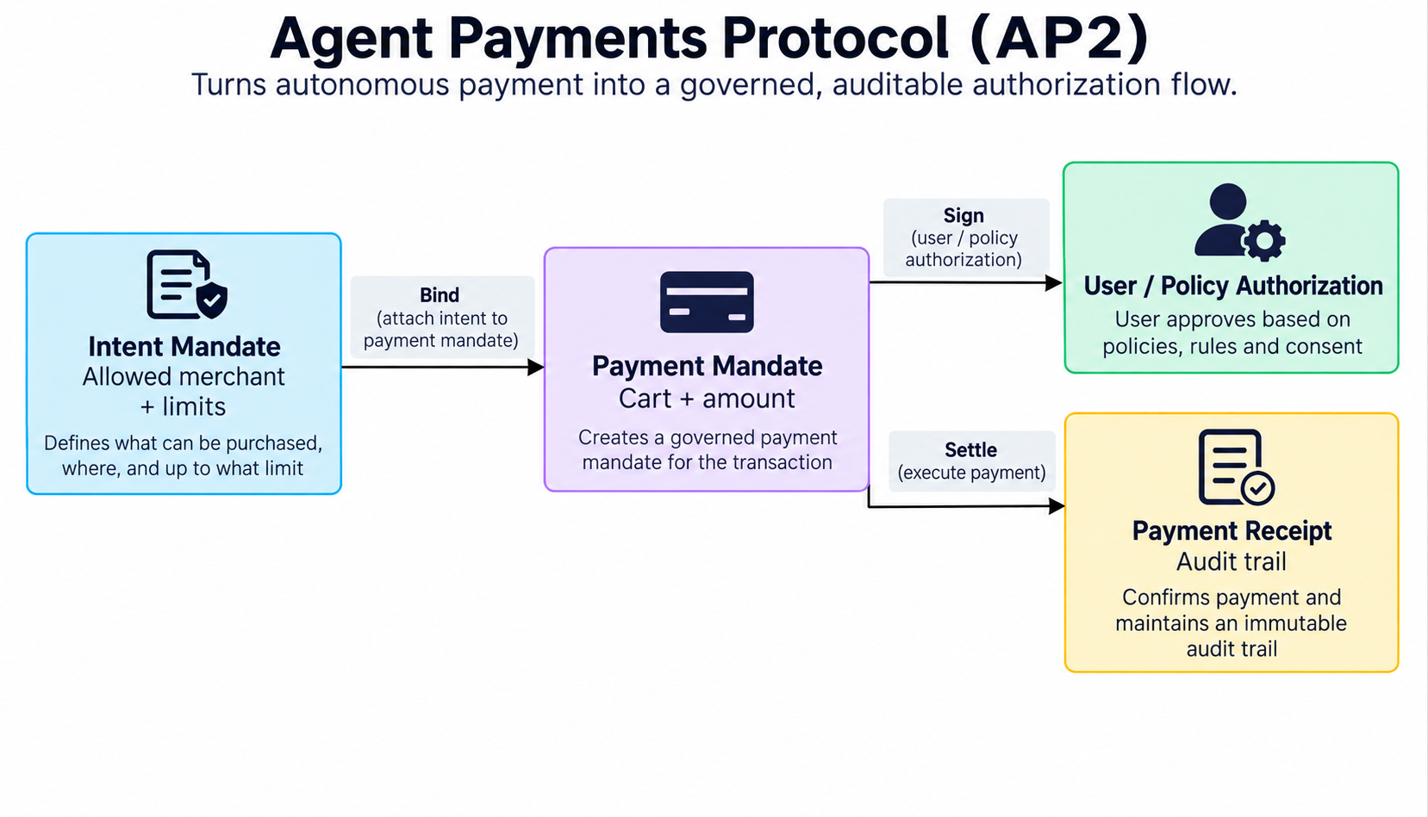

The problem it solves
If an agent can buy something, the system must answer: What did the user intend? Which merchants were allowed? What spending limit applied? Who approved the exact payment? Can the transaction be audited later?

The mandate model
- Intent Mandate captures the user's or organization's allowed intent, merchant constraints and guardrails.
- Payment Mandate binds the authorized intent to a concrete cart, amount and payment operation.
- Authorization provides the cryptographic or policy-backed proof required for the transaction.
- Payment Receipt closes the loop with a record of the resulting payment.

UCP + AP2
A simple mental model is: UCP answers “what are we buying and how do we complete the commerce flow?” AP2 answers “who authorized this payment and under what constraints?” They are complementary rather than competing protocols.

For a developer
- Never give an agent unrestricted payment credentials when a scoped token, mandate or wallet capability can be used.
- Define merchant allowlists, spend limits, expiration and human-approval thresholds.
- Persist the intent, authorization and receipt identifiers for audit.
- Use idempotency and replay protection around payment operations.
- Design failure handling explicitly: authorization failure must not accidentally trigger a duplicate purchase.

Simple example
A company lets a procurement agent auto-approve purchases from approved suppliers up to ₹10,000. The agent can complete smaller purchases automatically, but a larger purchase requires explicit approval. AP2 provides the authorization and audit structure around that decision.

Episode 7 — Putting the Protocols Together
The most useful way to understand these protocols is to see them as layers in one end-to-end workflow. Consider a restaurant kitchen manager agent with one request:
Example request
“Check our salmon inventory, compare today's wholesale price and quality, and if stock is low, order 10 kg from an approved supplier and authorize payment.”

Step-by-step protocol choreography

1. User interaction — AG-UI
The browser sends the user's request and receives a live event stream showing progress.

2. Tools and data — MCP
The agent calls the inventory system through an MCP server and discovers that salmon stock is below the reorder threshold.

3. Specialist collaboration — A2A
The agent discovers a pricing/quality specialist and sends a task to obtain current supplier information.

4. Commerce — UCP
The agent discovers the supplier's supported commerce capabilities and creates a typed checkout/order flow.

5. Payment authorization — AP2
The purchase is checked against configured merchant and spending policies; a mandate records the authorization.

6. User-facing result — AG-UI
The frontend receives tool results, status updates and the final outcome as standardized events.

Where ANP, LMOS and Agora fit
In a larger ecosystem, ANP or LMOS-style mechanisms can help with cross-domain identity, discovery and network interoperability. Agora demonstrates how agents might dynamically negotiate the rules for a specific interaction. These approaches become more interesting as agent ecosystems become more open and less centrally controlled.

A developer's protocol-selection cheat sheet
Question | Protocol | Primary boundary | Typical use
How does my agent access tools/data? | MCP | Agent ↔ Tools/Data | Database, files, SaaS APIs, search
How does one agent delegate to another? | A2A | Agent ↔ Agent | Specialist agents, enterprise multi-agent workflows
How does a frontend stream agent activity? | AG-UI | Agent ↔ User/App | Chat, copilots, approvals, state updates
How do I standardize commerce? | UCP | Agent/App ↔ Business | Cart, checkout, identity, order
How do I authorize agent payments? | AP2 | Agent ↔ Payment Authorization | Mandates, guardrails, audit trail
How do agents participate in an open agent web? | ANP | Agent ↔ Agent Network | Identity, discovery, messaging, negotiation
How do I build an Internet-of-Agents architecture? | LMOS | Ecosystem | Description, discovery, identity, transport
How can agents negotiate task protocols? | Agora | Agent ↔ Agent | Dynamic protocol selection
What about HTTP-native agent interoperability before/alongside A2A? | ACP | Agent ↔ Agent | Legacy/transition context; ACP work is now part of A2A

Protocol selection: practical rules
- Start with the boundary, not the brand. Identify whether you are connecting an agent to data, another agent, a user interface, commerce or payment.
- Prefer a mature standard when one clearly fits the boundary.
- Do not force every protocol into every architecture. A small agent may only need MCP and AG-UI.
- Keep business logic independent of protocol adapters so protocols can evolve without rewriting domain code.
- Treat discovered agent metadata, tool definitions and protocol documents as untrusted input until verified.
- Build observability from day one: trace agent identity, task IDs, tool calls, approvals, protocol versions and outcomes.
- Design for failure. Network calls, remote agents and models are all nondeterministic or fallible.
- For autonomous transactions, add explicit policy controls, authorization boundaries and audit trails.

Episode 8 — A Developer's Starting Architecture
A practical implementation does not need all nine protocols on day one. Start with a small agent and add protocol boundaries as the system grows.

Phase 1: One agent + tools
- Use MCP for external tools and data.
- Keep the model orchestration layer separate from MCP adapters.
- Add authentication and least-privilege permissions.

Phase 2: Add a real frontend
- Use AG-UI when the frontend needs streaming events, tool progress, state synchronization or human approval.
- Design UI state around events and recoverable transitions rather than a single response payload.

Phase 3: Add specialist agents
- Use A2A for remote specialist agents.
- Publish accurate capabilities and endpoints.
- Give each task a traceable ID and explicit authorization context.

Phase 4: Add commerce
- Use UCP to standardize business capabilities and checkout flows.
- Use AP2 to introduce payment intent, authorization guardrails and receipts.
- Keep purchase authorization separate from the agent's reasoning.

Phase 5: Open the ecosystem
- Evaluate ANP or LMOS when cross-domain discovery, identity and network-scale interoperability become requirements.
- Evaluate Agora-style negotiation when dynamically selected task protocols provide clear value and can be safely sandboxed.

Security checklist
- Identity: Can you prove which agent or application is calling?
- Authorization: What exactly is this agent allowed to do?
- Capability trust: Can a discovered tool or remote agent be trusted?
- Data minimization: Does the agent receive more context than it needs?
- Tool safety: Can tool calls cause destructive side effects?
- Prompt injection: Can external content manipulate tool selection or permissions?
- Replay protection: Can a payment or business action accidentally execute twice?
- Auditability: Can you reconstruct what the agent intended, did and was authorized to do?
- Human control: Where should approval be mandatory?

The most important architectural lesson
Protocols are contracts, not intelligence.
The LLM decides what it believes should happen. The protocol defines what can be requested, how it is represented, who can receive it, and how the system can prove what happened.

Conclusion — From AI Assistants to an Agentic Internet
The next stage of AI is not simply a better chatbot. It is a network of agents that can use tools, collaborate with specialists, interact with people, transact with businesses and operate across organizational boundaries.
Open protocols make that vision practical by turning proprietary integration points into shared contracts. MCP helps agents reach tools and context. A2A connects agents. AG-UI connects agents with applications and people. UCP standardizes commerce. AP2 governs agent payments. ANP and LMOS explore the foundations of an Internet of Agents. Agora explores dynamic protocol negotiation. ACP represents an important interoperability lineage that has been folded into A2A.
For developers, the goal is not to memorize acronyms. The goal is to recognize the boundary in front of you and choose the protocol that makes that boundary interoperable.
One-line summary
MCP connects the agent to capabilities. A2A connects the agent to other agents. AG-UI connects the agent to the user experience. UCP connects the agent to commerce. AP2 connects autonomous action to authorization. ANP, LMOS and Agora push the architecture toward an open, negotiable agent network.

End of series

