Data Analysis Tools for Informing Policy Decision – Embeddings

Opioids are substantially overprescribed, frequently with harmful consequences. Studies show that prolonged opioid prescriptions can increase the frequency of an opioid overdose-related emergency by 60% (Kuo 2016). This epidemic is most prevalent in poor, uninsured, urban residents of generally Caucasian or African-American origin (McDonald 2012).

While some policies have reduced the severity of the opioid crisis, new policies will be need to be enacted to continue this progress. In order to determine the best policies for the State of Minnesota, the various factors driving this crisis need to be drawn out. Fortunately there are many freely-available data analysis tools at the disposal of researchers in this field.

One such tool is matrix factoring, frequently used in automated movie recommendation algorithms. A researcher using this technique to investigate future opioid policy can provide a matrix containing historic opioid use (or prescriptions), sorted by two or more data attributes, such as year, location, distance to physician, age, ethnicity, gender, or other metrics. In Table 1, below, the overall opioid use is sorted by year and county in Minnesota.

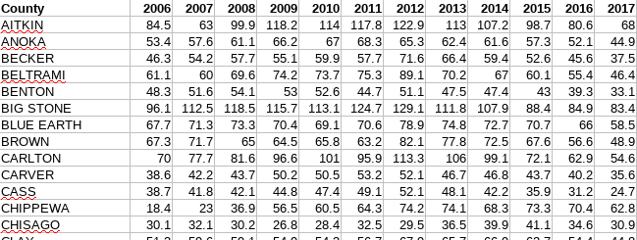
Table 1: Overall opioid prescriptions by county and year

Once the data is in matrix form, the user can factor the matrix into vectors for each data attribute. The size of the vectors is user-defined before the matrix factoring. Matrix factoring takes place by a steepest gradient optimization. Once the matrix is factored into these vectors, often called latent factors, the researcher can determine the similarity between two different data attributes. In the example from Table 1 the researcher can take the set of vectors corresponding to the counties in Minnesota and use cosine similarity to identify counties that are facing similar problems. The process described above can be found at the link below, which contains code used to produce the analysis here.

https://github.com/rvatassery/MinnesotaOpioid/

The similarities can be obvious, and the obvious similarities allow for the researcher to validate the result. For example, as expected Hennepin and Ramsey counties are the most similar to each other in terms of their latent vectors, whereas Hennepin and Pine counties are very dissimilar. Anoka, Carver, and Dakota counties are also very similar in this analysis.

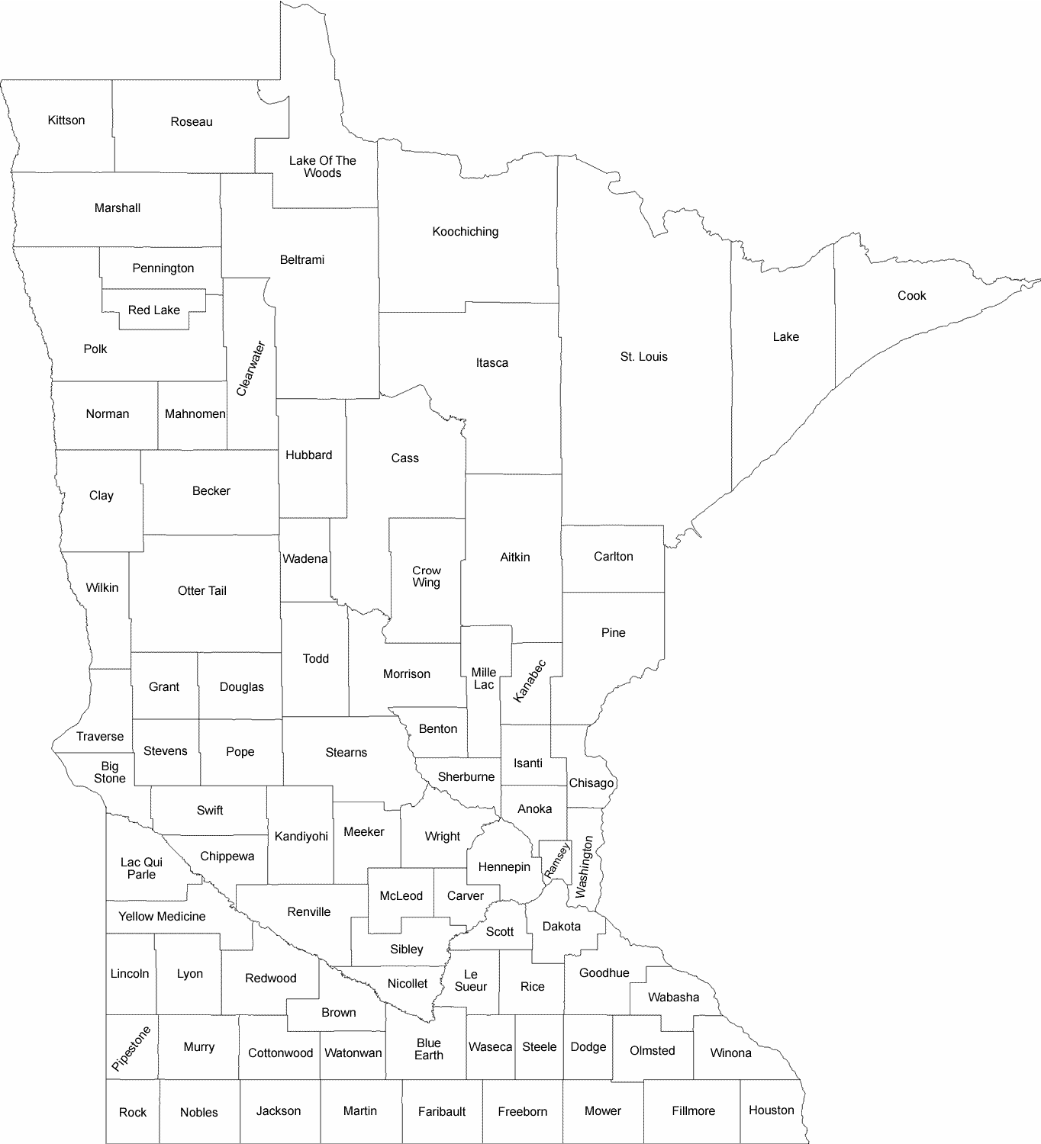

An added benefit of latent factor extraction is that the latent factor vectors themselves can tell us something useful about the counties. Since this is a
Because the algorithm doesn’t use the data labels (county or year in this case) at all, other than to present back to us what the result is, the algorithm will only find correlations that are relevant to the opioid data set.

