Architecture Diagram
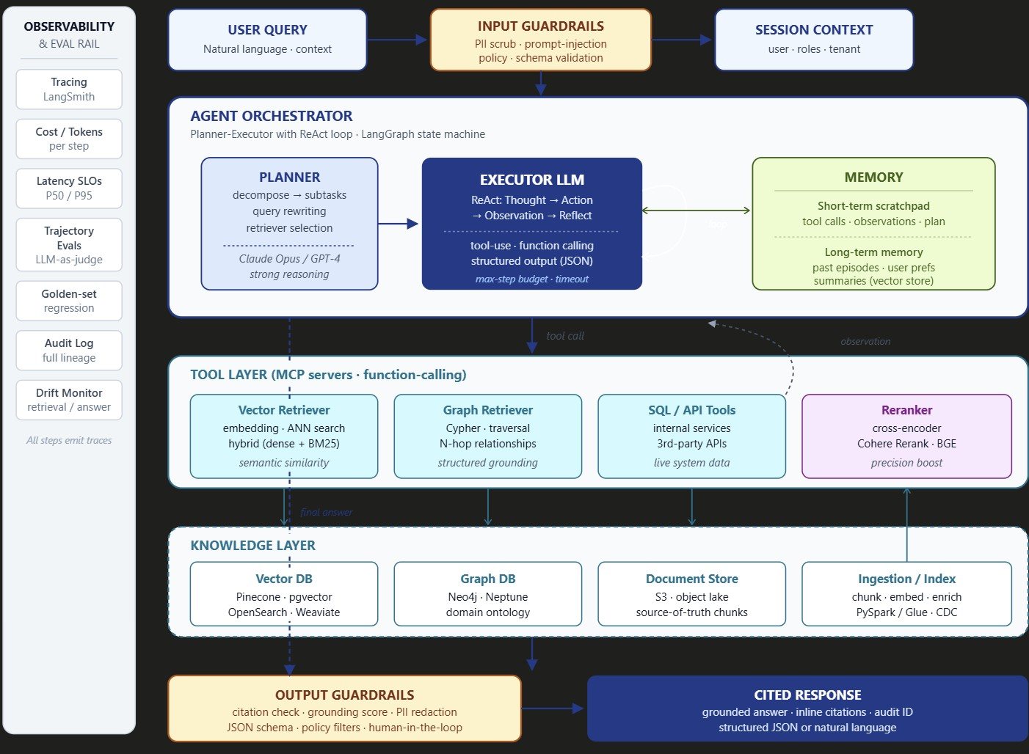
The path of a single query
1. User Query → Input Guardrails → Session Context. The query never reaches the LLM unsanitized. The guardrails layer does PII scrubbing, prompt-injection detection, length limits, and policy checks. In parallel, you attach session context — user identity, role, tenant — because retrieval and tool calls need it for authorization. This is where multi-tenant data isolation starts.
2. The Agent Orchestrator (the heart of the system). This is a state machine — in production I'd build it on LangGraph because the control flow is explicit and testable. It has three concrete pieces:
• Planner — usually a stronger model (Claude Opus, GPT-4) called once. Its only job is to decompose the query into subtasks, rewrite the query if needed, and pre-select which retrievers/tools the executor should consider. Output is a structured plan in JSON.
• Executor LLM — runs the ReAct loop: Thought → Action (tool call) → Observation → Reflect → next action. Often a cheaper, faster model since it runs many turns. The dashed loop arrow on the diagram is the critical part — this is what makes it agentic. It can call tools repeatedly, change strategy, and self-correct.
• Memory — short-term scratchpad holds the running plan and observations within a single run. Long-term memory is a vector store of past episodes, summaries, and user preferences. The bidirectional arrow matters: the executor reads memory ("have I solved something like this before?") and writes to it ("remember this strategy worked").
The whole orchestrator has hard guardrails: max-step budget, per-step timeout, total token budget. Without these, an agent can loop forever and bankrupt you.
3. The Tool Layer (this is where Agentic RAG separates from plain RAG). Plain RAG calls one retriever once. The agent here picks from a menu:
• Vector Retriever for semantic similarity ("find docs that mean roughly this").
• Graph Retriever for structured grounding ("walk from this customer to all related contracts and amendments"). This is huge in regulated domains where relationships matter more than text similarity.
• SQL / API Tools for live system data — the model can pull real numbers from your DB or hit a live service.
• Reranker — a cross-encoder (Cohere Rerank, BGE) that takes the top-50 from cheaper retrievers and re-orders them for precision before they go back to the LLM.
The agent often calls several of these per turn and fuses the results. Critically, each tool is exposed via MCP or function-calling with a typed schema — the agent can't invent a tool that doesn't exist. The dashed arrow back up to the executor is the observation — the tool result — which goes into the next reasoning step.
4. Knowledge Layer. The actual stores: Vector DB (Pinecone, pgvector, OpenSearch), Graph DB (Neo4j, Neptune), and a Document Store (S3) holding the original chunks so you can show source text and citations. Behind it, an ingestion pipeline (PySpark or Glue, often with CDC from operational systems) does the chunking, embedding, and metadata enrichment. This is where 70% of the engineering work actually lives — bad retrieval almost always traces back to bad chunking, missing metadata, or stale indexes.
5. Output Guardrails → Cited Response. Before the answer leaves the system: citation check (does every claim trace to a retrieved chunk?), grounding score (is the answer actually supported by the retrieved text or did the model hallucinate?), PII redaction, JSON schema validation if the response is structured, and a human-in-the-loop gate for high-risk actions (anything that writes to a system of record). The final response carries inline citations and an audit ID.
6. Observability rail (left side). Every step emits a trace — every prompt, every tool call, every token, every latency number. LangSmith / Langfuse on the tool side, plus an internal audit log for compliance. Trajectory evals score the path the agent took, not just the answer. Golden-set regression evals run on every prompt or model change. Drift monitors watch retrieval quality and answer quality in production. Without this rail you can't debug, can't improve, and can't pass audit.
What makes this agentic vs. plain RAG
Three things, and these are the lines I'd say out loud to an interviewer:
Adaptive retrieval. The agent decides whether to retrieve, which retrievers to use, and how often. If the first retrieval is weak, it rewrites the query and tries again — automatically.
Multi-source fusion with reasoning. Vector + graph + live API answers come back to the LLM, which reasons over the combination. A graph hit might tell it which entity to query the API for; the API result might tell it what to vector-search next. That dynamic chaining is impossible in single-shot RAG.
Self-correction and tool composition. If grounding score comes back low, the executor can re-plan and try again before the answer ever leaves the orchestrator. The output guardrail can also reject and force a retry.
What I'd actually argue for in design review
A few opinionated calls worth stating with confidence:
The planner is optional. For 60% of queries, you don't need a separate planner step — the executor can do simple ReAct alone. Add the planner only when you're seeing the executor get lost on complex multi-hop questions. Otherwise it's pure latency and cost.
Hybrid retrieval (dense + BM25) almost always beats pure vector. Pure semantic search misses keyword-exact queries (product codes, error codes, names). One of the cheapest wins in production.
Reranking is the highest-ROI step you can add. Going from top-20 vector → reranked top-5 typically improves answer quality more than swapping LLMs.
Long-term memory is overhyped for most use cases. Short-term scratchpad + good retrieval covers ~85% of needs. Long-term memory adds a stale-data failure mode you have to actively manage.
Build the observability rail before you build the agent. If you can't see what the agent did, you can't ship it to production. Every team I've seen skip this step has ended up retrofitting it under duress.
The interview-ready closer: "Agentic RAG is just RAG where the retrieval strategy itself becomes a decision the model gets to make. The architecture is the same boxes — but the loop, the multi-retriever fusion, and the guardrails around tool calls are what take it from a demo to something you can run in a regulated bank."

