**Survival of the Fittest: The Art of Winning in Battle Royale**

### **Abstract**

In the chaotic world of Battle Royale games, survival isn’t just about having the fastest reflexes or the best aim—it’s a delicate balance of strategy, movement, and resource management. With the rise of PlayerUnknown’s Battlegrounds (PUBG), millions of players have jumped into the battlefield, eager to claim that elusive Chicken Dinner. But what truly separates the champions from the fallen? Through a deep dive into gameplay data, we unravel the secrets behind strategic survival, aggressive playstyles, and squad-based teamwork. Spoiler alert: Running around like a headless chicken won’t get you that Chicken Dinner.

### **Introduction: The Battle Royale Boom**

From humble beginnings to a global phenomenon, PUBG revolutionized online gaming, introducing players to an arena where 100 people drop into a massive map, scavenge for supplies, and fight to be the last one standing. The game’s unique blend of realism, tension, and unpredictability has drawn millions into its unforgiving landscapes. But as the player count grows, so does the competition. So how does the best of the best manage to outlast 99 other players? Do you need God-like aim, or is it all about sneaky strategies? Let’s find out.

### **The Science of Survival: How Long Do Winners Stay Alive?**

It’s not just about who fights the hardest, but who fights the smartest. Data reveals that winners have an average survival time of over **1750 seconds** (nearly 30 minutes), whereas players finishing in 90th place barely last **200 seconds** (a little over three minutes). If you’re getting dropped within minutes, you might want to rethink your landing strategy!

Interestingly, for those placing **25th**, survival times range between **1000-1250 seconds**, while **50th place** finishers clock in around **600 seconds**. The takeaway? The longer you survive, the higher your chances of winning. Sounds simple, but it requires more than just hiding in a bush.

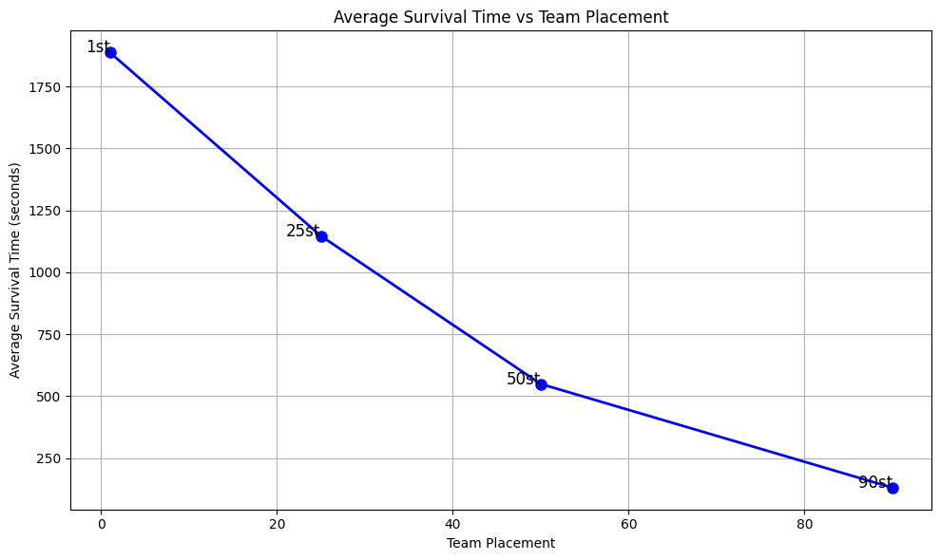

Figure 1: Trends in Survival Time

### **Walk or Ride? The Top Players' Movement Patterns**

Ever wondered how the best players move around the map? Our data shows that top 5 players walk an average of **2000 meters**, but their ride distance increases significantly compared to lower-ranked players. The winner, however, maintains a **balanced movement strategy**, walking and riding **around 2000 meters each**.

This suggests that players who rely too much on vehicles may make it to the top five, but to actually win, you need to blend aggression with stealth. Driving around might get you places faster, but it also makes you a moving target. The real pros? They know when to ride and when to walk.

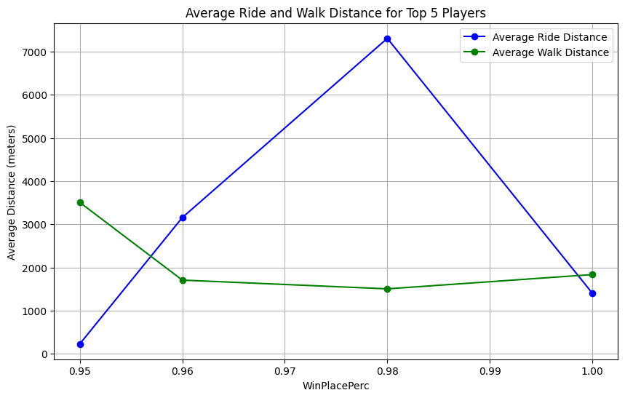

Figure 2: Trends of Walking and Riding distances

### **The Silent Stalker: Winning With Only One Kill**

Imagine this: The final circle is closing in, three players remain, and one of them has only fired a single bullet all game. And yet, they win. How? Data tells us that some players have secured victory with just **one kill**, and their movement stats are eye-opening:

The takeaway? Some winners barely fire their guns, but their **positioning and rotations** are nearly flawless. Being a silent stalker can be just as effective as being a trigger-happy warrior.

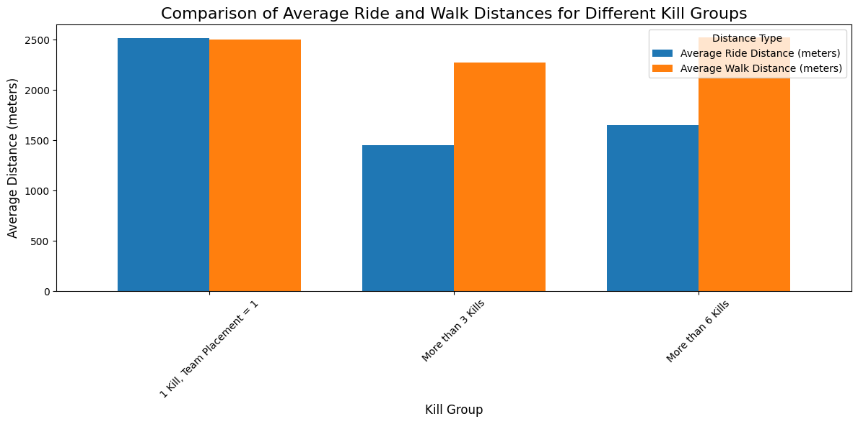

Figure 3: Analysis of Walk and Ride distances for different Kill groups

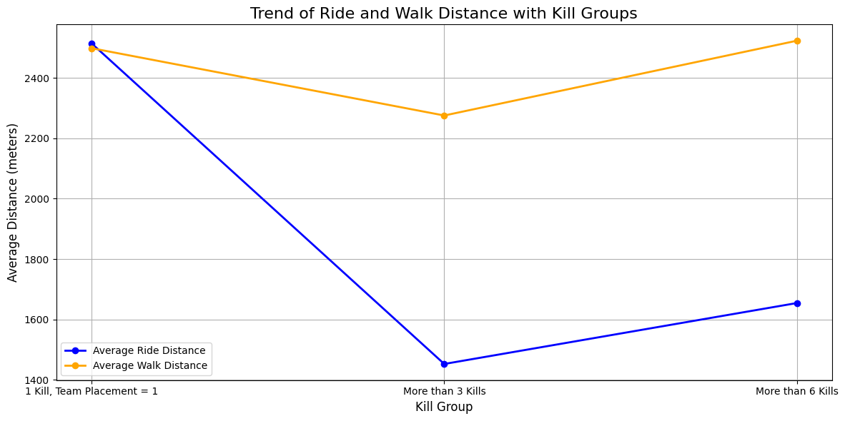

Figure 4: Trends of Walk and Ride distances for different Kill groups

### **Looting Like a Pro: The Role of Heals and Weapons**

Winning isn’t just about shooting—it’s also about looting. Our stats show that **top 10 players** have an average of more than **2.5 heals** and acquire over **5 weapons** per match. This suggests that winners prioritize landing in high-loot areas, stocking up on medical supplies, and ensuring they have a solid arsenal before engaging in fights. If you’re dropping into the middle of nowhere with nothing but a pistol and hoping for the best—think again.

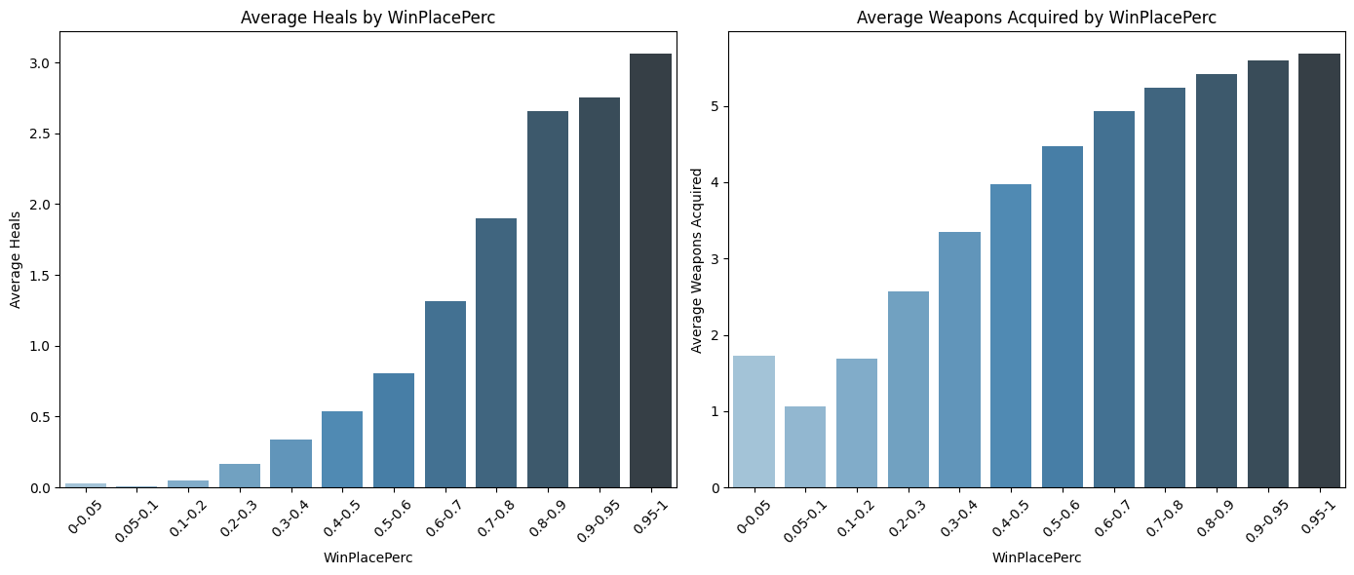

Figure 5: Analysis of heals and weapons acquired with the Win Place Percentage

### **How Many Kills Do You Need to Win?**

The age-old debate: Is PUBG a game of strategy or brute force? Our data reveals that the majority of games are won by players with **3-5 kills**. Sure, players with **10+ kills** have a higher probability of winning, but being too aggressive can backfire—those who constantly seek fights often don’t even make it to the **top 10**.

So, what’s the perfect playstyle? A mix of tactical patience and well-timed engagements. The key is **knowing when to fight and when to back off**—because every unnecessary firefight is a risk that could cost you the game.

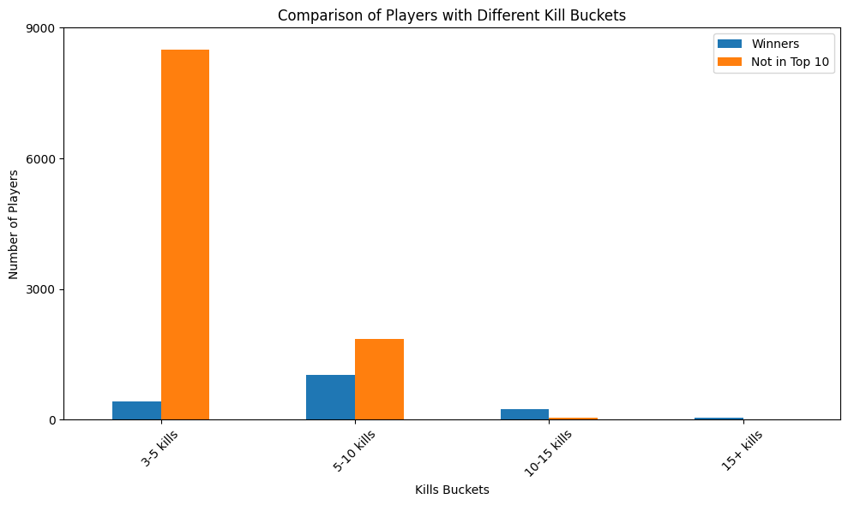

Figure 6: Comparison of Players with Different Kill Buckets

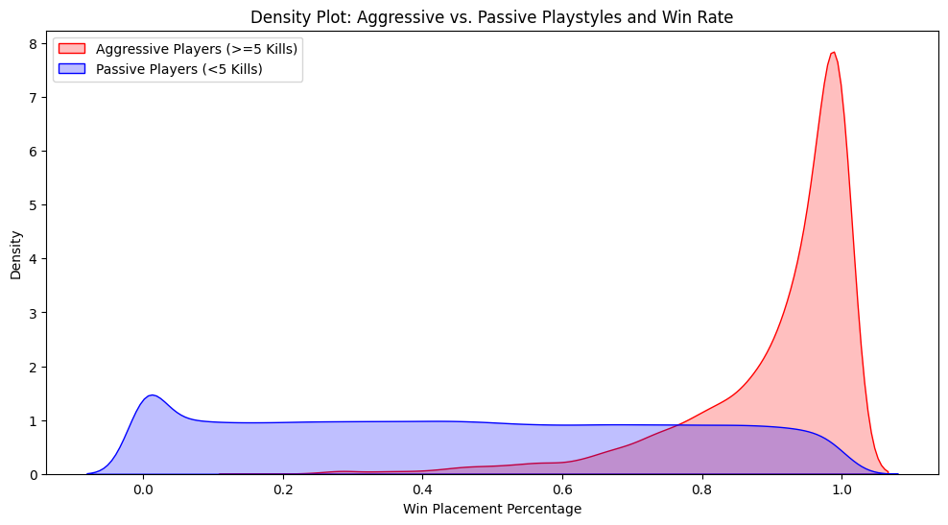

Figure 7: Aggressive vs Passive Playstyles and Win Rate

### **Squad Play: The Power of Teamwork**

While solos test individual skill, squads require **coordination, teamwork, and selflessness**. Let’s look at the difference between all teams and winning teams:

The numbers don’t lie—winning teams have nearly **4x more assists and revives** than the average squad. This proves that squads who **help each other** rather than chasing solo glory stand a far greater chance of winning. If you’re always looting while your teammate is getting shot, you might want to rethink your priorities!

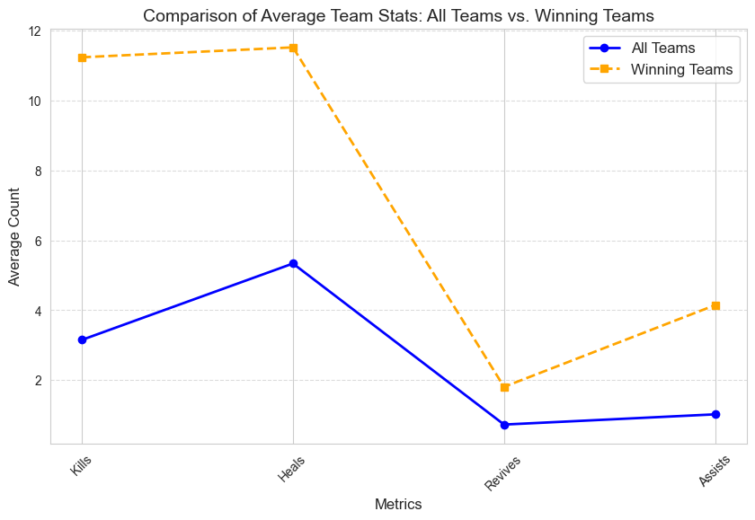

Figure 8: Squad Gameplay Analysis

### **Conclusion: The Perfect PUBG Playstyle**

Winning in PUBG is a **fine balance of strategy, survival, and calculated aggression**:

* **Survival Time Matters:** Winners last over **1750 seconds** on average.
* **Smart Movement Wins Games:** Top players balance **walking and riding**.
* **Loot Wisely:** Top 10 players prioritize **heals and weapons**.
* **Fighting Smart is Better than Fighting More:** Most winners secure **3-5 kills**, but reckless aggression often leads to defeat.
* **Squad Play Requires Teamwork:** Winning squads revive, assist, and work together more than average teams.

At the end of the day, **PUBG isn’t just a shooting game—it’s a thinking game**. So, the next time you drop into the battleground, remember: fight when necessary, move smartly, and most importantly—**stay alive.**

Now go forth and may your Chicken Dinners be plenty!