**An Independent SAGE discussion document on contact tracing and self-isolation**

On 13 February, 83 British men, women and children were allowed to leave 14 days of isolation from Arrowe Park hospital, after evacuation from Wuhan at the end of January. (1)This was an appropriate quarantine response to potential contacts of a deadly new virus. On the same day, a nurse in Brighton was placed into ‘self-isolation’ by Public Health England. (2)She was a contact of the first UK ’super-spreader’ who had returned from Singapore via a skiing trip in France (3). She had some symptoms and was astonished at the poor response. She was sent home wearing a medical mask, in a taxi with a driver without a mask. No advice was given about how to stop the spread of the virus. She had to arrange her own grocery and takeaways to be delivered to her door. Her immune system was compromised so she was fearful that the infection could be fatal. Her children were distressed when she immediately got everyone out of her house. When she called NHS111 she had to wait 15 hours to get a test. She told the BrightonArgus that self-isolation was not effective. “*I thought there would be a plan in place for something like this, but in my case, I know there wasn*’*t one.”*

Six months later, in England, little has changed. Most mild cases and contacts are told to self-isolate over the phone. We have no data on whether they follow any instructions or comply for the full 14 days. A contact may take more than a week to become infectious and longer to develop symptoms. How many of them live in multigenerational households or crowded accommodation, a possible explanation of local outbreaks as those in Leicester? How many are from the five million people working in the gig economy, where 14 days without pay means a family without income to buy food or pay the bills? Does the government collect any data on the number of isolated contacts who become cases, arguably the best indicator of isolation success, as suggested by the Royal Statistical Society? (4) Why are we not offering the financial and on-the-ground support as in South Korea, China, and Germany? We can do as many tests and trace as many contacts as we like, but without effective isolation or quarantine, the epidemic will spread.

South Korea set up a national network of community treatment centres for isolation of positives with mild or no symptoms. (Vietnam did the same.) Patients reported signs and symptoms twice daily using an app. Medical staff reviewed vital signs and provided video consultation to patients twice daily, so fewer staff were needed for tests or to respond to emergencies.

In China people were asked to wait at the clinic for the result of their test. If positive, they stayed in community medical facilities until free of the virus, indicated by two consecutive negative PCR tests. Contacts were asked to self-isolate at home for two weeks but with regular visits by community teams, and **with all rental, food and bills covered.** Daniel Falush, professor at the Institute Pasteur, Shanghai reported that "*Family members no longer infected each other... families with sick individuals stopped passing it on to other ones during inevitable provisioning trips… (later) epidemiologists went house to house looking for individuals with potential symptoms and this reduced the rate of transmission even further*.” (5)

In Germany, devolved local power, far more than in the NHS, was the key to success. Local mayors control hospitals. Testing had to be scaled rapidly so GP practices met and set up their own diagnostic centres to relieve local hospitals. The rapid, sufficient availability of testing and co-ordination by primary care meant cases were identified much earlier. (6) Meanwhile central government focused on financial support. Berlin launched a massive economic package, ten per cent of GDP, larger than any in Europe. It helped that Chancellor Merkel is a scientist and her chief of staff a doctor. Germany’s 400 local health authorities, the *Gesundheitsämter*, were made the centre of the public health response. They organised people who required isolation to be checked up for symptoms or deterioration by teams of ’scouts’.

In England we have done none of these things, except for NHS and care home cases monitored and managed successfully by over-worked health protection and district public health teams. They achieve 99% success in contact tracing and provide follow-up to cases and contacts. Testing should be organised by GPs, primary care networks or local public health clinicians to increase reliability and trust of communicating test results rapidly. This will ensure appropriate advice, monitoring, and care for positive cases and contacts; far more efficient and sustainable than car parks in remote locations.

But local authorities are disempowered and sidelined. GPs are ignored. Volunteer scouts remain largely unused. A huge contract issued to SERCO has led to thousands of contact tracers sitting at home, many doing almost nothing for weeks on end. No person asked to isolate by this centralised privatised system is followed up and workers not on PAYE are not offered financial support. Our summer lull may not last long, with signs already of increasing transmission. Without supported isolation, massive testing and tracing programmes will make little difference in a surge. The centralised contact tracing system is not working, not improving and is fundamentally the wrong design with some localities setting up their own local test, trace and isolation systems. (7)

What should be done? Independent SAGE **recommends** the following:

1. The central call centre system should be scrapped and contracts with SERCO and others cancelled. On 23rd August the government will decide whether to extend the current deal worth £108 million up to a maximum of £410 million. The Table shows that SERCO contact tracers had 91,785 contacts of newly infected people transferred from the test system over 9 weeks. They reached just 56% of them (51,524 contacts) during the same period, less than 2 contacts per tracer in more than two months. A fifth of contacts had no contact details and another fifth did not respond to contact attempts. The centralized system has no recourse to check details or find other ways of making contact (e.g. home visits). Call centre tracers also treat each individual contact separately. So with four children and two parents in a household of contacts, up to six different contact tracers might call the family, causing annoyance and confusion and charging separately for each contract. These features make it highly unlikely that the SERCO contract is cost-effective. Budgets should be shifted so contact tracers are recruited and trained by local authority public health teams.
2. The Deloitte testing contract for community tests in car parks should be ended. In the most recent week’s statistics, only 72% of home test results were received within 48 hours of the test being sent out.
3. Home testing should be ended and every person in England should have access to a test within a short distance from where they live. Local public health and primary care doctors should get real time information about test results and patient details.
4. A national framework should be agreed whereby local authorities can make their own decisions about new community restrictions, and set up community centres for quarantine and support of mild cases who cannot isolate effectively at home.
5. Central government should focus on a) strategic guidance based on evidence, b) financial support to local authorities, and c) financial support guaranteed to all cases and contacts (not just those employed on PAYE) to offset wage losses.

If we don’t take isolation seriously our economy will spiral downwards. We should have had an effective isolation policy in February, with better pandemic planning. Not to have one six months later is nothing short of public health malpractice.

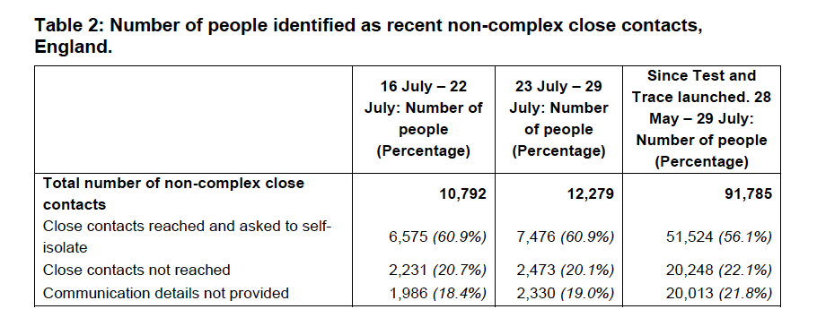

From UK government test and trace bulletin. <https://assets.publishing.service.gov.uk/government/uploads/system/uploads/attachment_data/file/907278/weekly-nhs-test-and-trace-bulletin-england-23-to-29-July-2020-accessible.pdf>

NB. Non-complex cases mean those (pillar 2) tests done in the community by the private sector, largely through the Deloittes contract and the Lighthouse labs. The contact tracing is done by Serco and Sitel, under contracts agreed with (but not tendered by) the government.

References

1. <https://www.theguardian.com/world/2020/feb/13/all-wirral-coronavirus-evacuees-set-to-leave-quarantine-after-testing-negative>.
2. <https://www.theguardian.com/world/live/2020/feb/13/coronavirus-latest-updates-deaths-in-china-pass-1300-with-jump-in-cases-live-news>
3. <https://www.theguardian.com/world/2020/feb/10/super-spreader-brought-coronavirus-from-singapore-to-sussex-via-france>
4. <https://rss.org.uk/RSS/media/File-library/Policy/RSS-COVID-19-Task-Force-Statement-on-TTI-final.pdf>
5. <https://www.telegraph.co.uk/global-health/science-and-disease/isolate-isolate-isolate-chinas-approach-covid-19-quarantine/>
6. <https://www.ft.com/content/cc1f650a-91c0-4e1f-b990-ee8ceb5339ea>
7. <https://www.theguardian.com/uk-news/2020/aug/04/local-authority-blackburn-with-darwen-sets-up-test-trace-system-english-scheme-covid>