Start of the Write-up

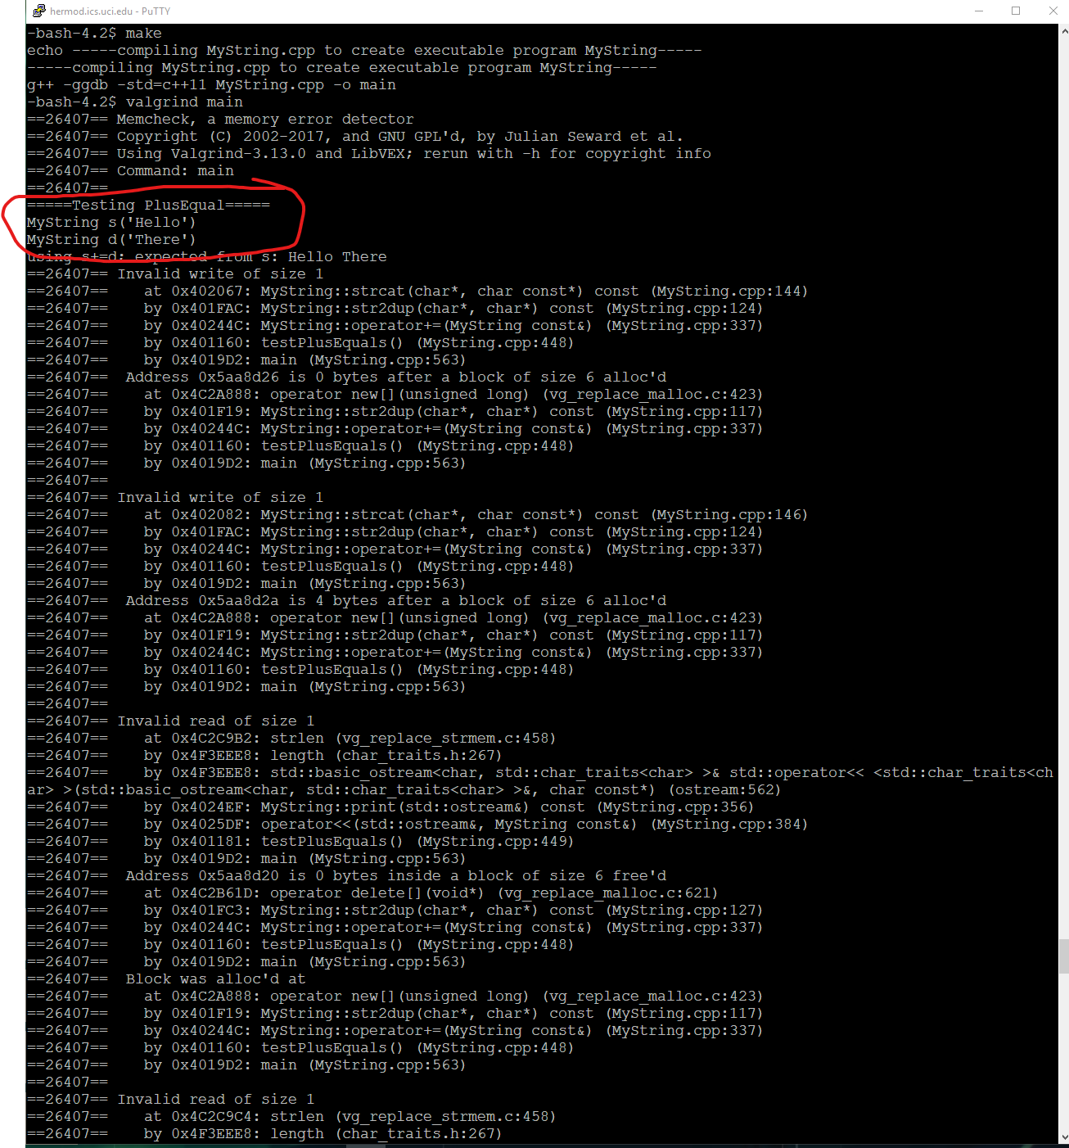

Just showing the test of plusEquals, sadly I couldn’t make it work.

It might be in my strcat function, tried different ways but couldn’t make it work.

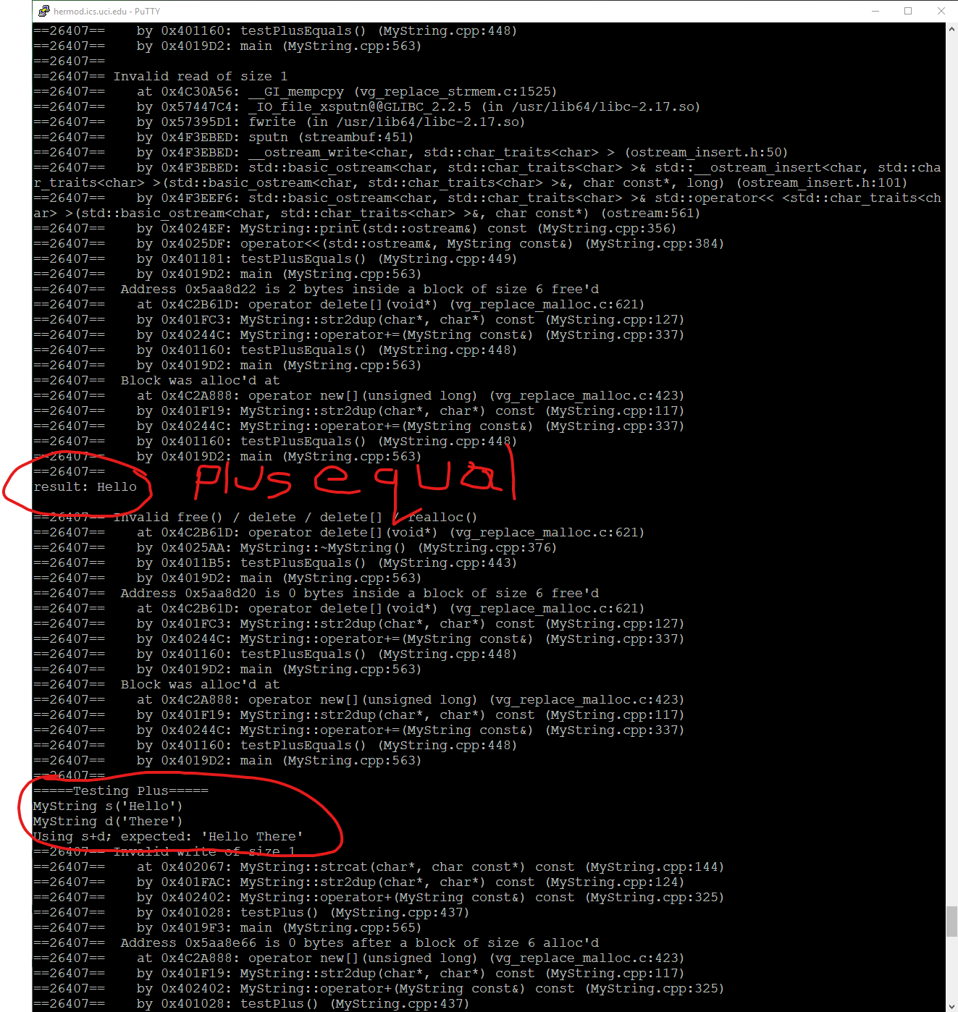

Here is the plus operator, doesn’t work as well.

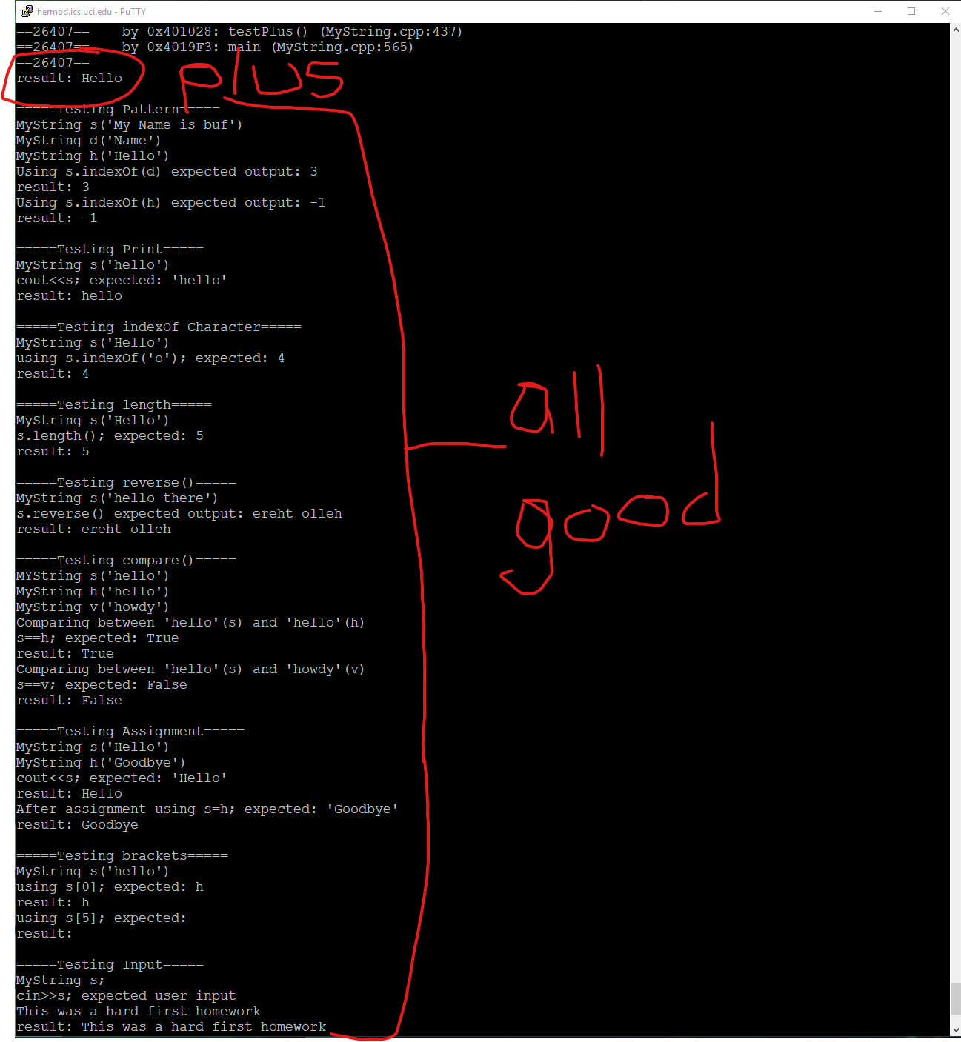

All else tested well.

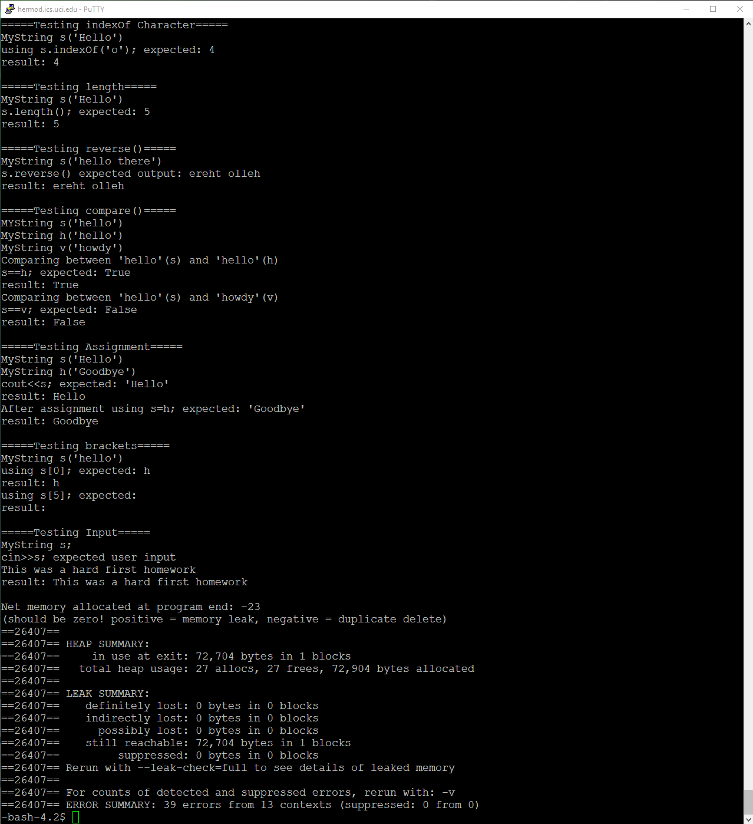

Did end up with errors but no memory leaks.

End of Write-up