Raul Cervantes

77825705

HomeWork 5

Start of Report

Above is a pic of the main function.

Above are the hash functions with their typical time complexities in Big-O.

The above 4 images is the ChainedHashTable class with their typical time complexities.

Above are the test functions with their typical time complexities.

Above is the measure and testHasher functions.

Above is the code ran with valgrind and all of its output using 3 different hash functions.

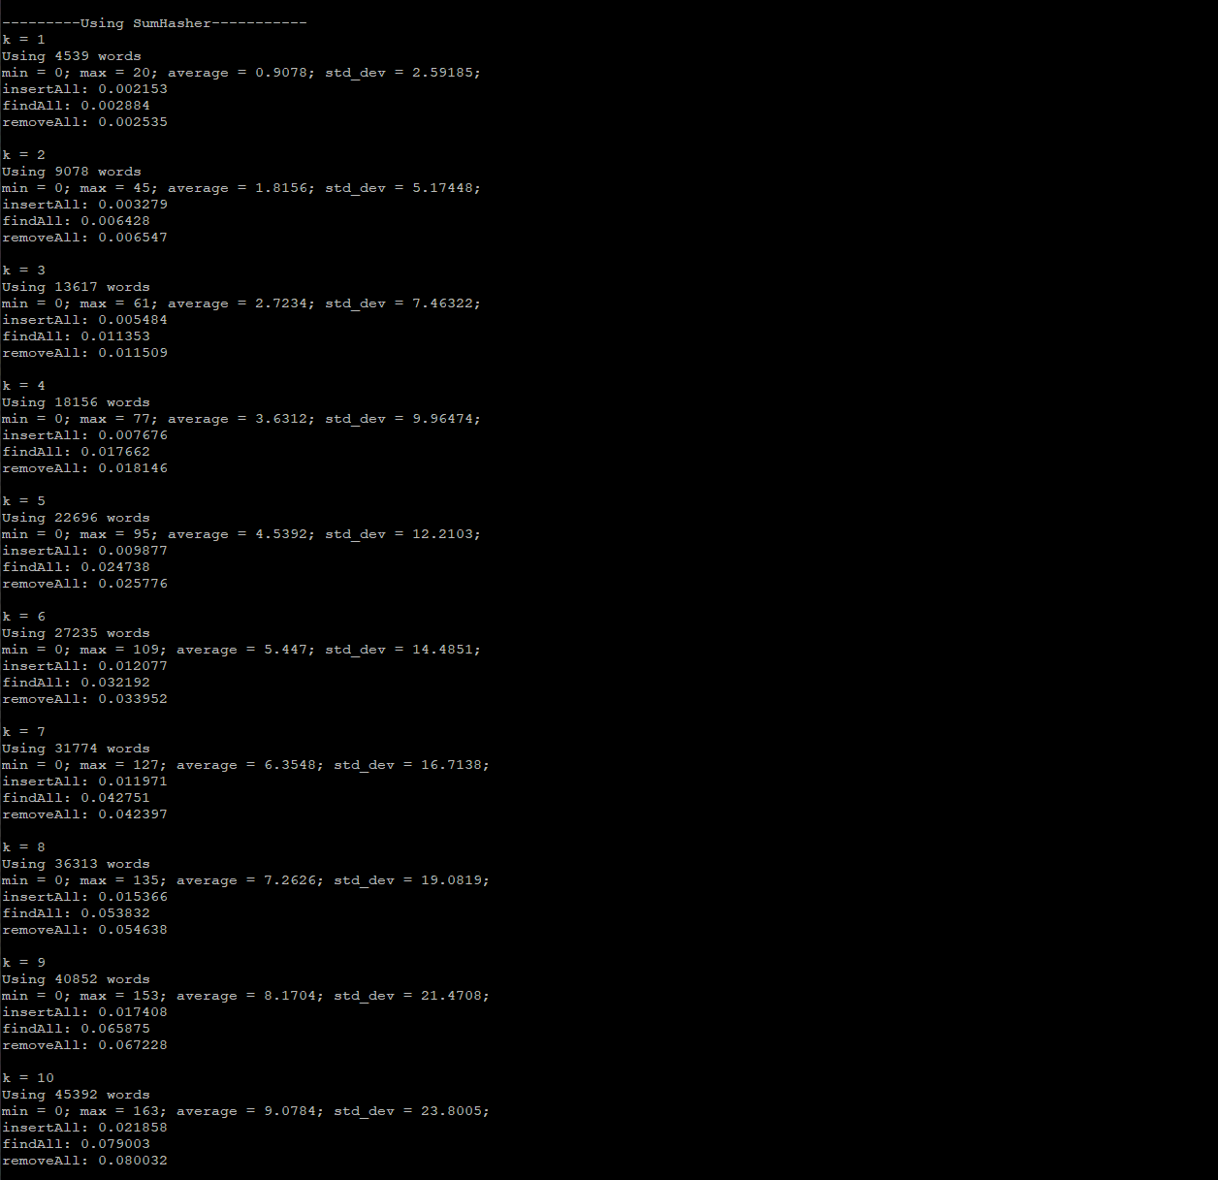

Above is the code ran with the random.txt and words.txt text files using the 3 different hash functions, no valgrind.

Here is my data of each time the functions took using different N of inputs.

End of Report