Raul Cervantes

77825705

HW8: Start of Report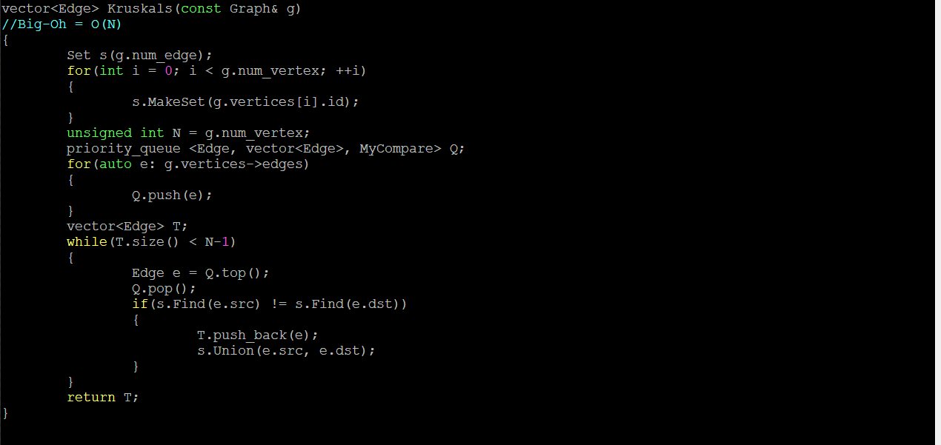

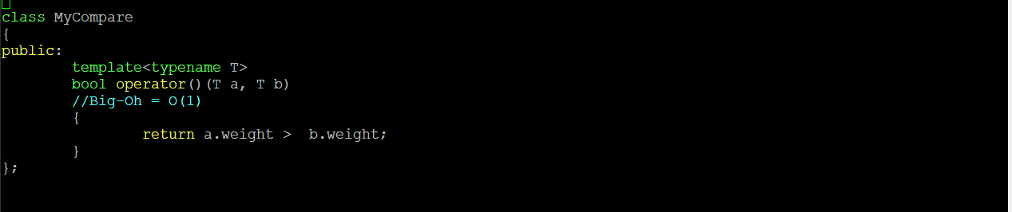

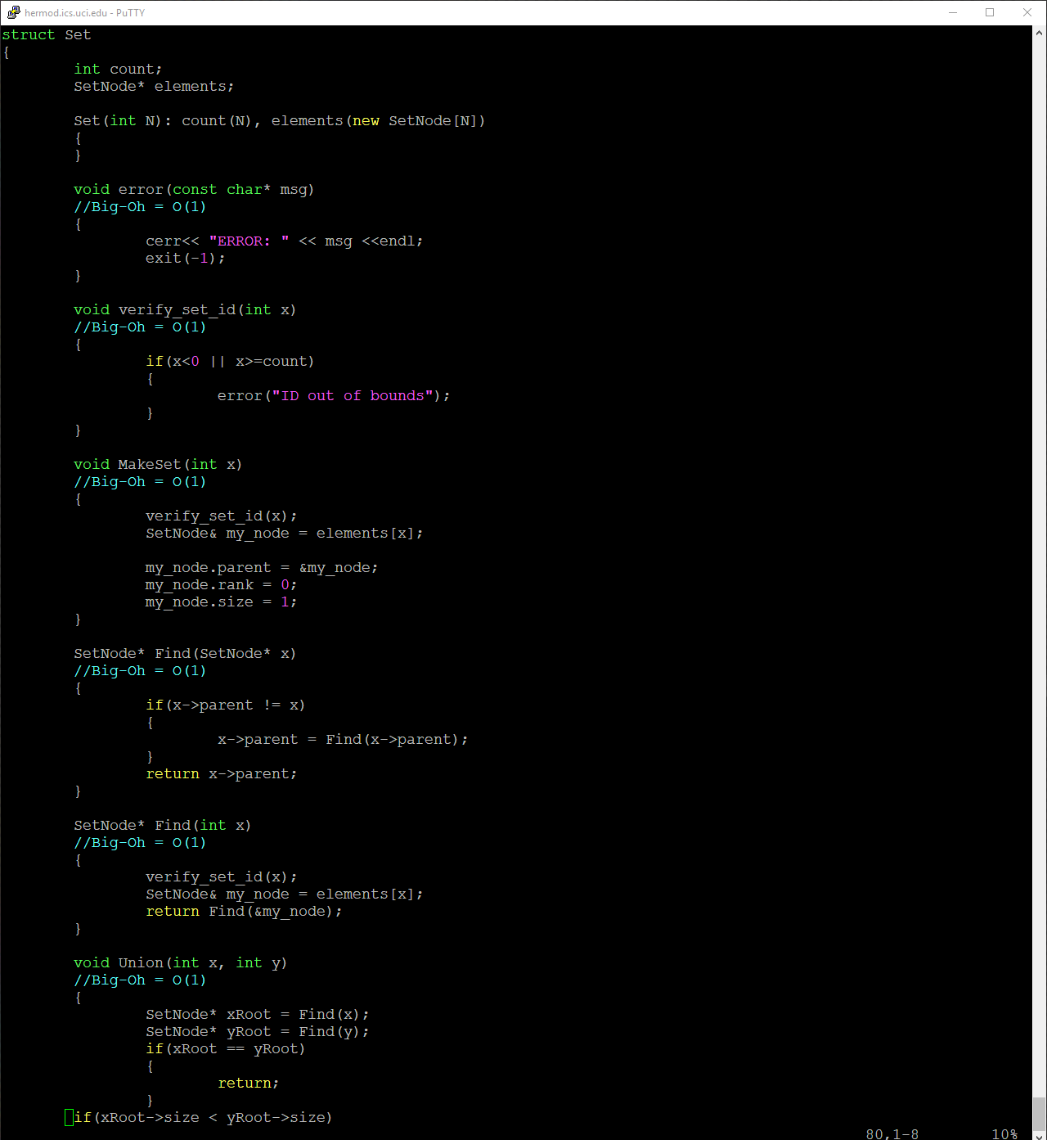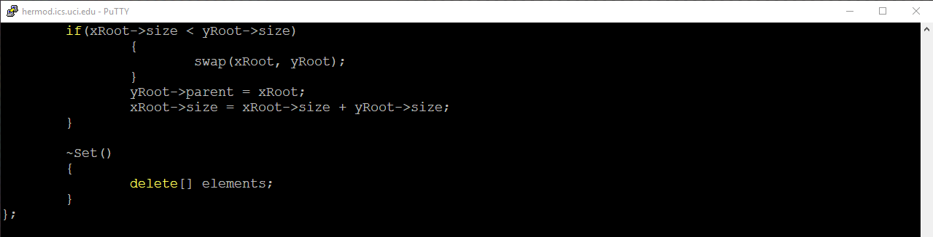

Above is my kruskals function and the set struct with its Big-Oh Notation time complexities.

Above is my valgrind for my large.graph and rdm.graph along with the execution and making of the rdm.graph.

End of Report.