Assignment 2 : Evolutionary dynamics in a spatial context
PART I
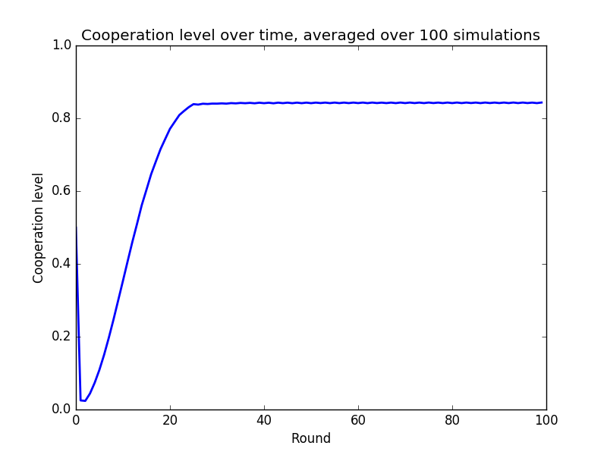
In this first part we are doing the analysis of the evolution dynamics in a context where players are in a lattice that has periodic boundary conditions. The first case is where players have a Moore neighborhood (8 players). Different lattice sizes will be discussed and furthermore the Von Neumann neighborhood (4neighbours) will also be discussed.
First asked plot :

Observations/Discussions :
At round 0 we observe that the average cooperation level is around 50% which is normal given that the intial state is probability 50% for each player to be a cooperator or a defector.

At round 1 we observe a massive drop of cooperators, a little over 0%. This is explained because of the initial state. Given a defector, he gains a +10 payoff value for each cooperator in his neighbourhood. Given a cooperator, he gains a +7 payoff for each cooperator in his neighbourhood. A defector neighbour doesn't yield any payoff for both cases. Thus any defector has a high probability of having a higher score than any cooperator given the random distribution. It implies that a large majority of cooperators will become a defector and same for defectors that will remain defectors.

For rounds from round 1 to round ~25 (until stabilisation) we observe that the level of cooperation is increasing until a value of around 80% where the level remains stable. This is because at round 1 some clusters of cooperators will remain and the rest would be defectors. Given the payoff value stated before, we can observe that cooperators at the edges of the cluster would have a higher payoff value than the surrounding defector's payoff value. Those defectors would thus become cooperator and enlarge the cluster. This operation is repeated each round until only some “lines” of defectors remain. The term lines is quoted because defectors that remain are grouped by small clusters that are often stretched and sometimes in small rectangle clusters. Of course cooperators inside the cluster remain cooperator because all their neighbours are cooperators.
So why is there a stability? When we have reached the state where only “lines” of defectors remain, if this line has a “width” of 1 defector, thir payoff would be 60 or 70 and the cooperators surrounding this line would be a little less (35, 49 or 56). So the next round, this line of defectors will enlarge. But then we come back to the - cluster of cooperators surrounded by big amount of defectors – state and then at next round this line will reduce again and never grow. Depending on the configuration this process can be bigger than a 2-rounds process but will certainly loop. On some other configuration, when the stability is reached we can observe no more variation on the cooperation level.

Second asked plot :
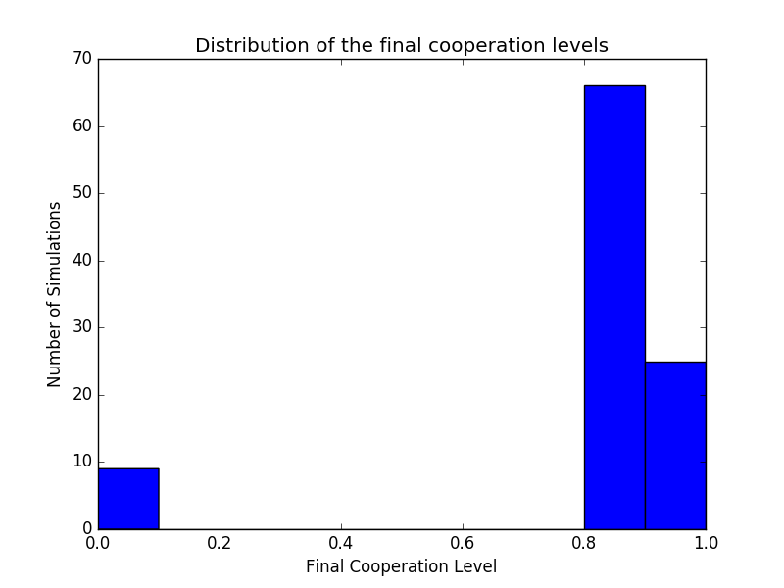
Observations/Discussions :
Here we have the final cooperation of every simulation (until stability is reached). One can observe that in a small amount of time (less than 10) the final cooperation level is 0. For the majority of time this level is above 80% and approximately the same. We can then conclude that the cooperation level is approximately the same in every run.
This level (80%) has been explained just before. This is due to the “lines” of defectors that remains and that won't always disappear.
Sometimes we see that the final cooperation level is 0%. This is due to the random distribution of cooperators and defectors at round 0 that is not propitious for cooperators. This means that at round 1 there were no clusters of cooperators large enough to spread (at least 2x2). Thus the remaining cooperators would go extinct and give that final cooperation level of 0%.
Visualisation of one run for t=0, t=1, t=5, t=10, t=20, t=50 :
t0 – Matrix of cooperation :
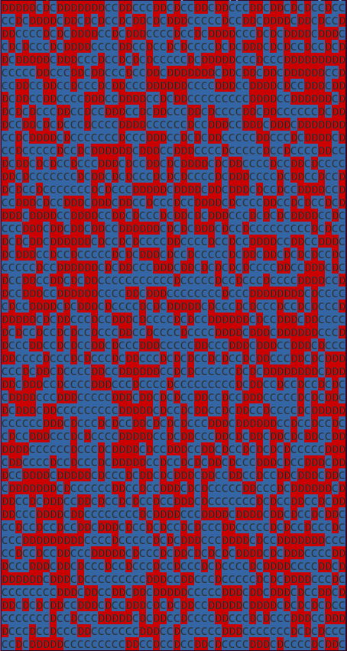
Observations/Discussions :
Random distribution of cooperators and defectors.
t1 – Matrix of cooperation :
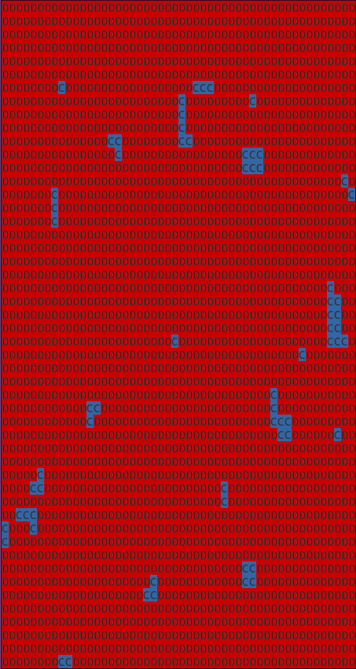
Observations/Discussions :
Defectors largely dominant in a random distribution situation. Only some little clusters of cooperators remain. The smallest ones won't (< 2x2) won't “survive”.

t5 – Matrix of cooperation :
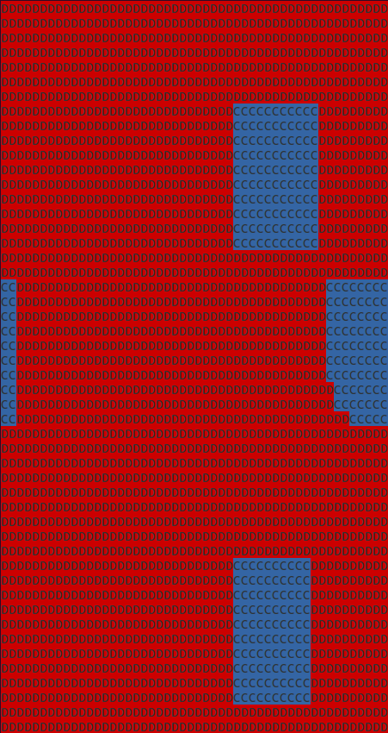
Observations/Discussions :
Remaining clusters of cooperators are expanding...

t10 – Matrix of cooperation :
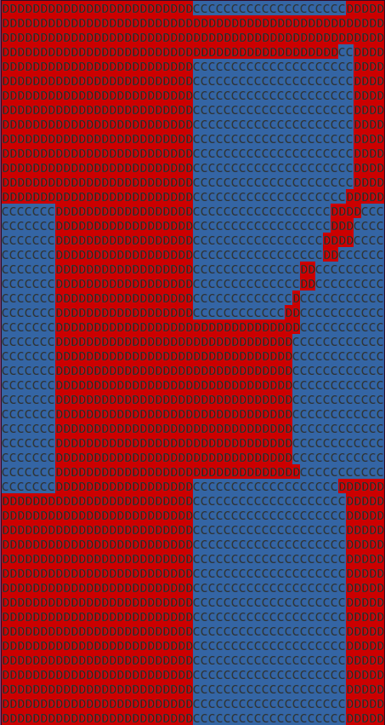
Observations/Discussions :
… and expanding ...

t20 – Matrix of cooperation :
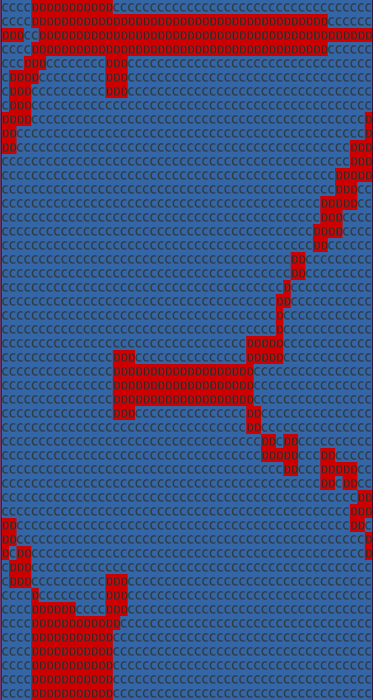
Observations/Discussions :
… and expanding. At this point, the stability is almost reached.

T50 – Matrix of cooperation :
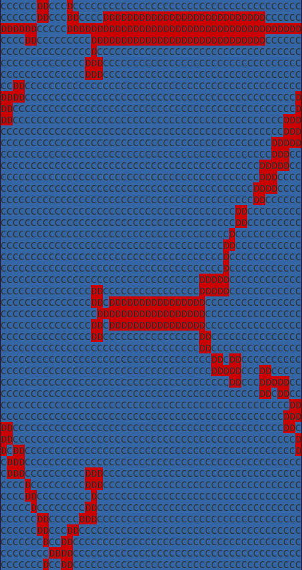
Observations/Discussions :
Stability point is reached. Cooperation level ~80%.

What happens when the size of the lattice is changed ?

- Lattice size 4x4 :

For all cases (except when the latice is initialized with only cooperators) the result will be a stable cooperation level of 0%. Let's take a look at the best case scenario for cooperators, except full cooperators : 1 defector and all the rest cooperators. This will result, in the next round, with all neighbours of the defectors becoming also defectors because the defector would have a payoff of 8*10 = 80 which is the highest possible payoff thus all his neighbour would imitate him. We would then have a 3x3 cluster of defectors surrounded by cooperators for two sides (top-left, top-right, bottom-left or bottom-rigt). Finally, in this state, there is no cluster of cooperators big enough to grow and thus cooperators would go extinct.

- Lattice size 8x8 :

To see how the result change, let's just take a look at the same plots of the case 50x50:
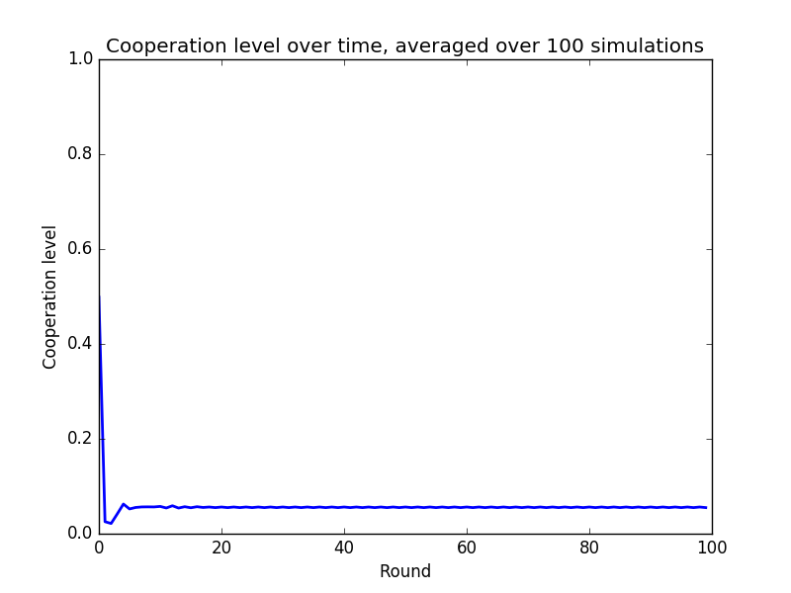
Observations/Discussions :
Compared to the case 50x50, we can see that the average cooperation level is very low. This observation will be discussed through more in the next plot.
A second major difference is the speed at which the average cooperation level stabilizes. Here the stabilisation occurs way sooner (~ round 3) than in the 50x50 case.

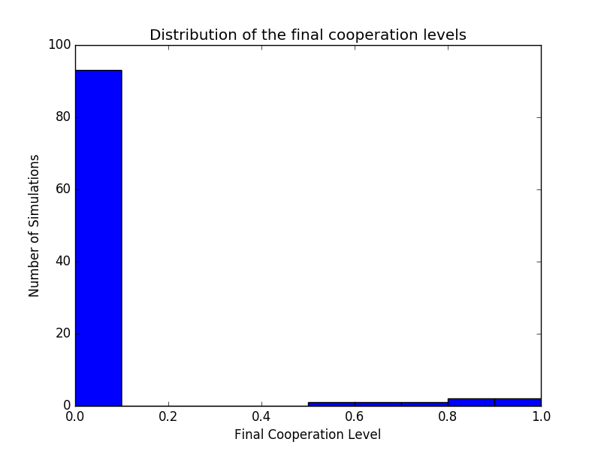
Observations/Discussions :
In a very large number of cases (more than 90 simulations over 100) the final cooperation level is 0. On the other hand, a handful of times, there's a final cooperation level that ressemble that of the 50x50 case although the variation is greater.
Although the lattice size has been doubled compared to the 4x4 case, the simulation falls plenty of time in the same scenario. The clusters of cooperators left in t1 are whether non- existant or not ig enough to grow. But in some cases there are clusters big enough to grow, this explain the few non-zero cooperation levels. For those non-zero levels, the variation is of course greater than in the 50x50 case because of the “lines” discussed previously. Because a minimum of defectors must (in most cases) exist, the ratio cooperators/defectors compared to the lattice size (8x8) implies that variation.

- Lattice size 12x12 :
Let's again look at the same plots but for a 12x12 lattice :
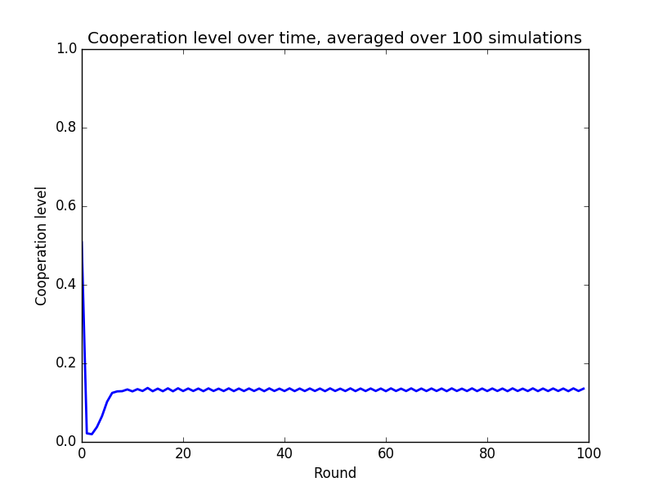
Observations/Discussions :
The results are not surprising. Observations and discussion are the same as for the case 8x8 except that the average cooperation level is a bit higher and the stabilization occurs a bit later (~ round 6).

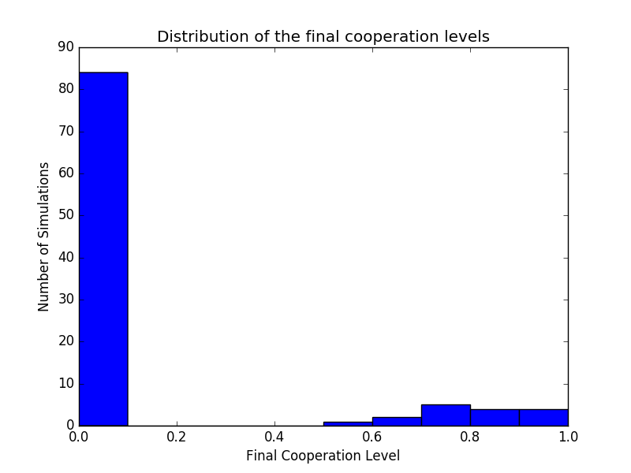
Observations/Discussions :
Again, no surprise and same as for case 8x8 except that the number of final cooperation of 0 is a little less and the number of those that ressemble the 50x50 case is a littler higher.
A higher number of players implies a higher probability of cooperators clusters to exist and thus to expand.

- Lattice size 20x20 :

As the lattice size grows, the probability of cluster of cooperators grows. The thinking way is the same as for the two previous cases (8x8 and 12x12). We will be able to observe the average cooperation be bigger, the stabilisation occuring later, the number of simulation with a final cooperation level of 0 rarer. The plots for the 20x20 case will be put in for information but will not be discussed through.
Given all those observations, one can assume that for very large lattice (bigger than 50x50), the average cooparation will tend to 99,9..% and the simulations ending with a cooperation level of 0 will tend to 0,0..1%.

Plots for case 20x20 :
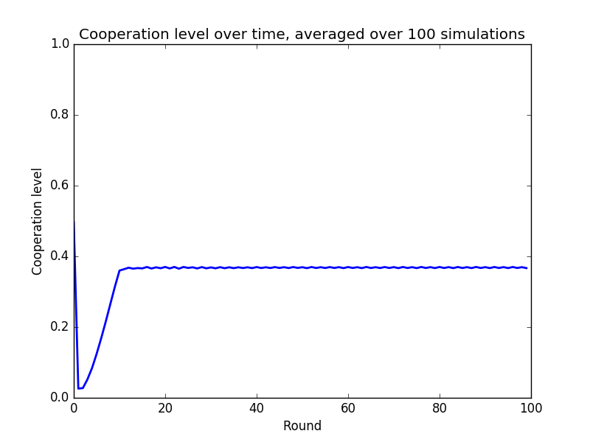
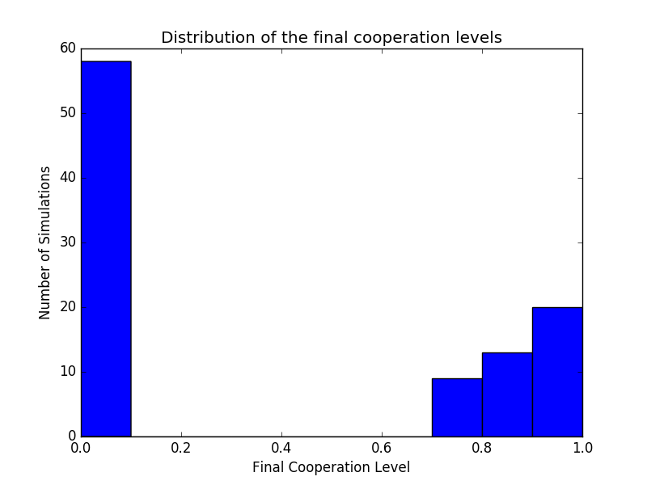

Observations and discussions for a Von Neumann neighborhood :
In order to see the differences between Moore and Von Neumann neighborhood let's take a look at the averaged coopeartion level :
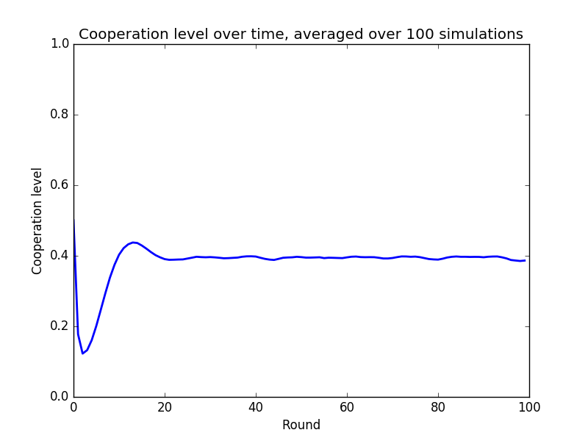
Observations/Discussions :
Compared to the Moore neighborhood, the Von Neumann neighborhood has an averaged cooperation of approximately 40% for a 50x50 lattice. The drop of cooperation at t1 is also less important. This is explained because the number of neighboors is halved. The lesser the neighboors, the lesser the temptation to cooperate. In order for the cooperators to expand, they need to have a minimum number of cooperator neighbours. So decreasing this number will just decrease the fact that the cooperators will grow.

PART II

In Part 2 we are doing the same analysis than in Part 1 but the update mechanism is different and the game itself is different. Players are now playing a snowdrift game instead of a prisoner's game. The only difference resides in the sucker's payoff that go from 0 to 3.
Here we do the replicator rule using the given formula :

Given that P,R,T and S are constant we can resume “max{P,R,T,S}-min{P,R,T,S}” to 10 - 0 = 10.
Let us assume we are in a Moore neighborhood configuration, thus the formula is simplified as follow :

Thus, this probability increase when the difference of payoff between player i and player j increases. So the higher the payoff of the chosen neighbour, the higher the chance of imitation.
The “+1” and the “/2” are there to ensure to have a probability (ie. between 0 and 1) in some cases where “(W_{j} – W_{i})/(N*10)” can be a negative number.

This kind of update mechanism makes sense in the sense that the higher number of cooperator in the neighborhood, the higher the chance to select a cooperator. In the second time, the higher the difference of payoff, the higher the chance to imitate.

Now, we do the same analysis as before and discuss the differences.
Let's begin by the 50x50 lattice, using Moore neighborhood :
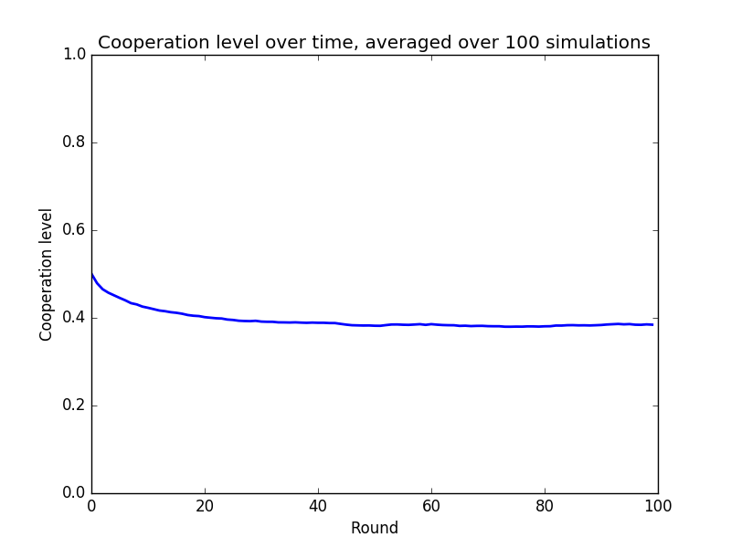
Differences :
We can observe some major differences.
There's no big drop of the cooperation at t1. This is explained because we no longer take into account the payoff value of all the neighbours but only one selected randomly. Furthermore there is no certitude that the player will imitate the selected neighbour. There is thus a huge mitigation of the cooperators/defectors, instead of the sudden drop of cooperators that we have seen in the unconditional imitation.
For the following rounds, we can see that the cooperation level, instead of growing is becoming slightly lower over time until a stabilisation level of a little less than 40%. If we were in the prisoner's dilemma situation with this update mechanism, cooperators would almost everytime go extinct because in most cases defectors would have a higher payoff than cooperators and the differences would be relatively big, increasing the chance to imitate a defecto higher. But given that we are in a snowdrift game, cooperators will have a higher payoff in average limiting the average differences between defector's payoff and cooperator's payoff. This is why cooperators remain but are not the majority.

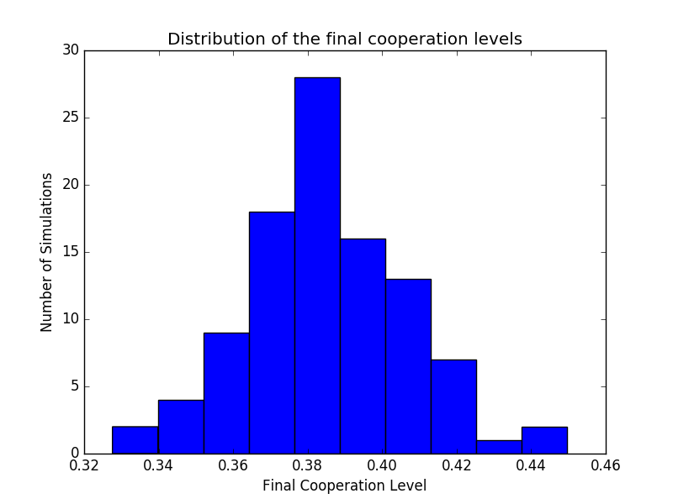
Differences:
This histogram shows that final level of cooperation of simulations is less sparse than in the unconditional imitation/prisoner's game case. We don't see any extreme value like 0% or 100% cooperation level. They are all comprises in a small range – between 33% and 45% - forming a clear normal distribution around 38%.

Visualisation of one run for t=0, t=1, t=5, t=10, t=20, t=50 :
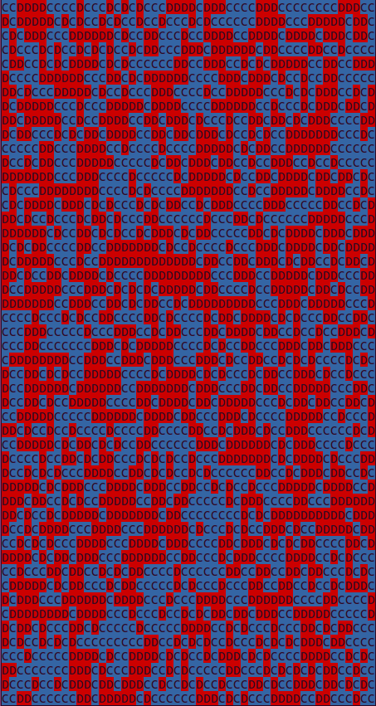
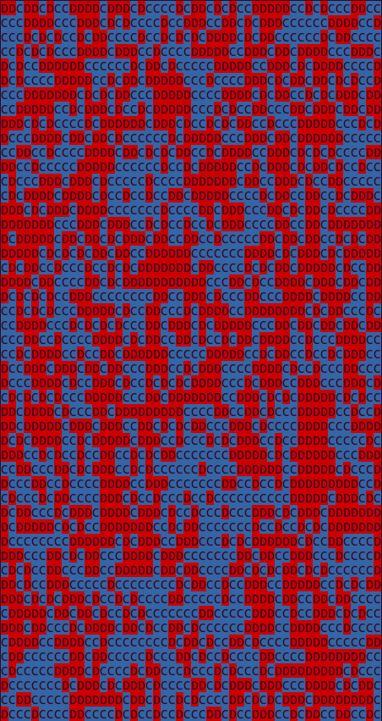
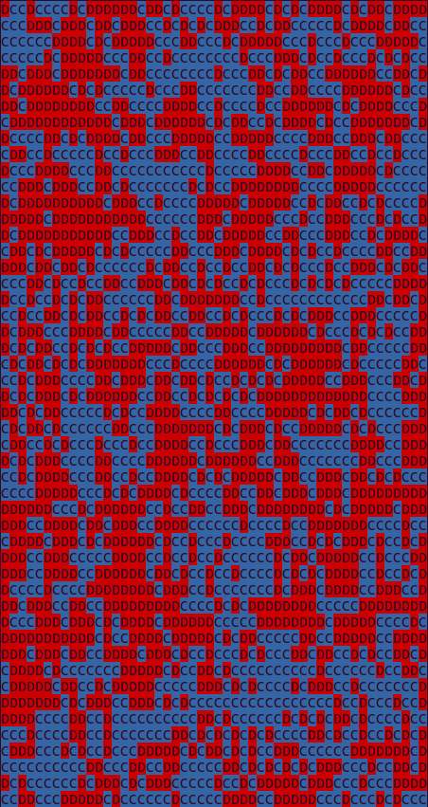
t = 0 t = 1 t = 5
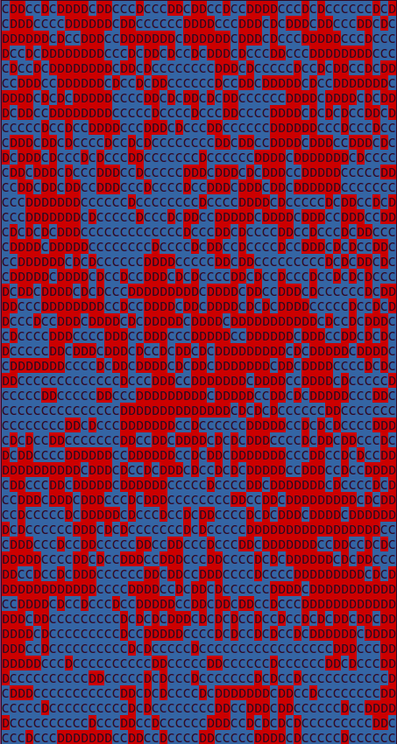
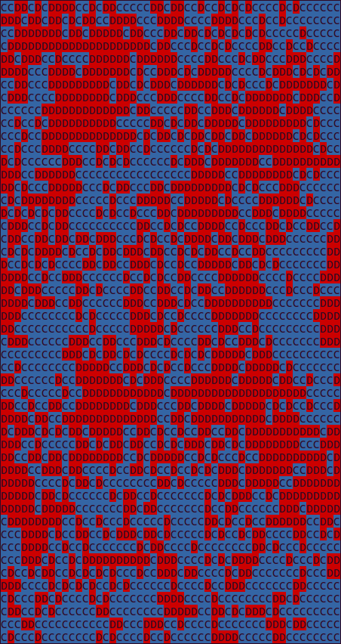
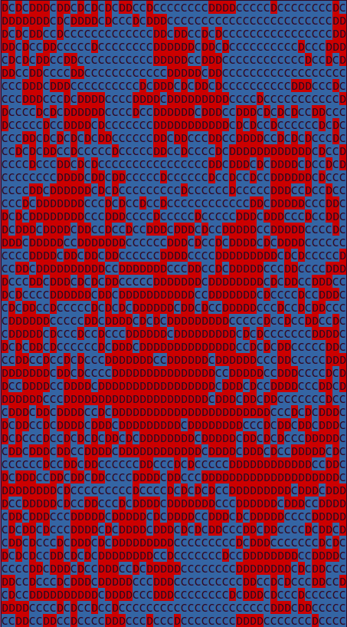
t = 10 t = 20 t = 50

As we can observe and according to the previous results, the ratio cooperator/defectors goes from around 50/50 to around 40/60. One can also observe that cooperators and defectors tend to group together due to the refractor rule.

Now let's compare with different lattice sizes :

- Lattice size 4x4 :
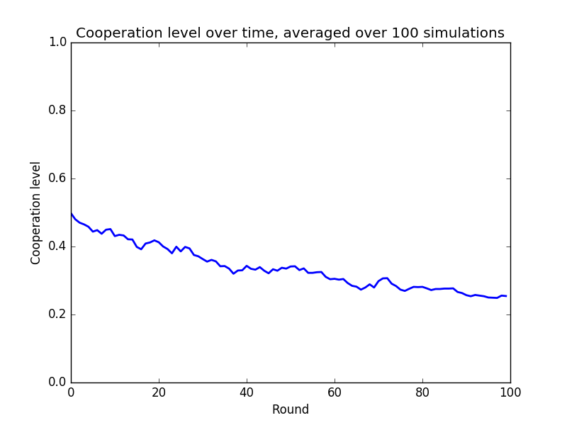
Observations/Discussions :
We see an average cooperation level that largely ressembles the one with the 50x50 lattice size. The difference between those two graphs is much less than the difference between the two same graphs but with unconditional/prisoner's game.
For this lattice size, we observe a bigger variation for every round, this is due to the replicator rule combined with the little lattice size. Any change will have a bigger impact and thus a bigger variation on the cooperation level.
We also observe that the averaged final cooperation level is lower (ie. ~25%). This is seen more clearly in the following graph.

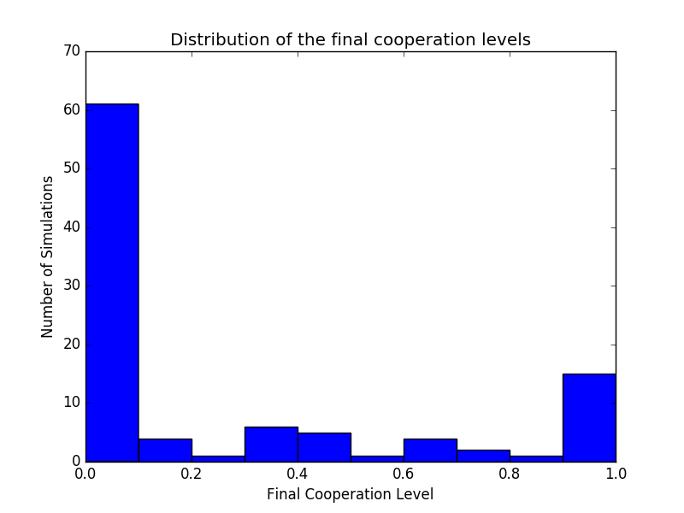
Observation/Discussion :
Here we can observe two main stability point. One at 100% cooperation and one at 0% cooperation level in a larger scale. Compared to the unconditional imitation/prisoner's game we have a distribution of final cooperation level that is more spread around all values.
Using the replicator rule there is a less strict elimination of cooperators because we select only one neighbour randomly and it is not assured that there will be an imitation.

- Lattice size 8x8 :
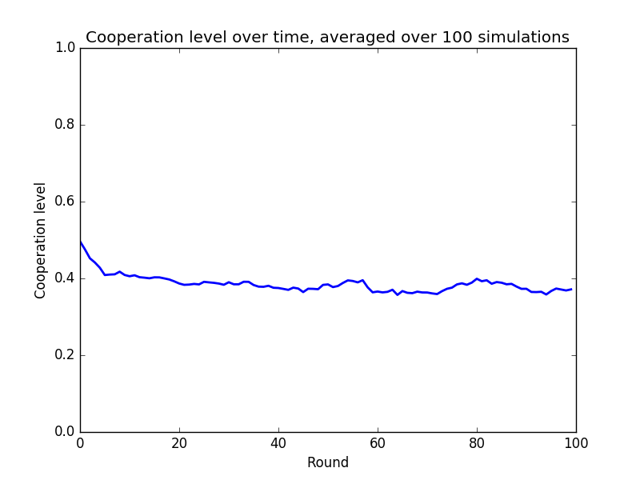
Observation/Discussion :
The graph ressembles more to the 50x50 case. We still observe the variations as in the 4x4 case but they are smaller. This is all due to the lattice size. As the lattice size is bigger, the impact of variations is smaller implying less variations on the averaged cooperation level.
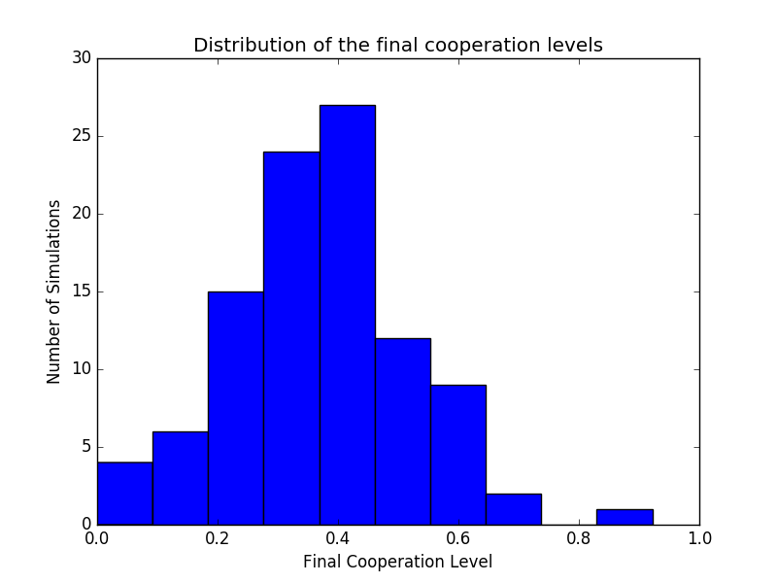
Observation/Discussion :
This histogram is completely different from the 4x4 case. There is now largely less 0% final cooperation and we see that a normal distribution begins to appear around 40%. We have a feeling that a treshold between the 4x4 case and the 8x8 case has been crossed. For new and bigger lattice sizes, final cooperation levels will tend to be more focused around this 40% value of final cooperation level.

- Lattice size 12x12 :
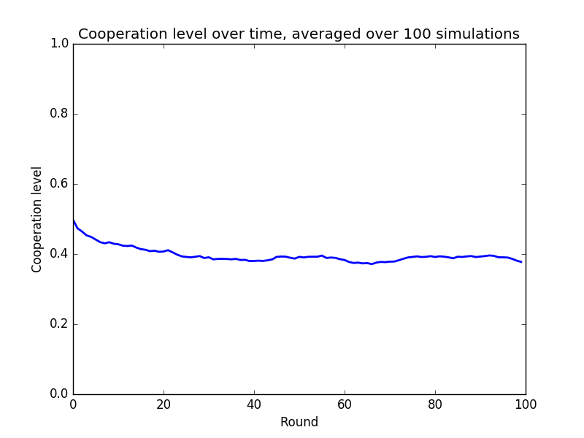
Observation/Discussion :
We have the intended plot. Less variations and values tend more to 40%. Those results come from the same deduction as before.
For the following plots and the 20x20 cases, results will just confirm what was said before so there won't be any observations/discussions as they have already been made but they will be put in this report for information and consistency.
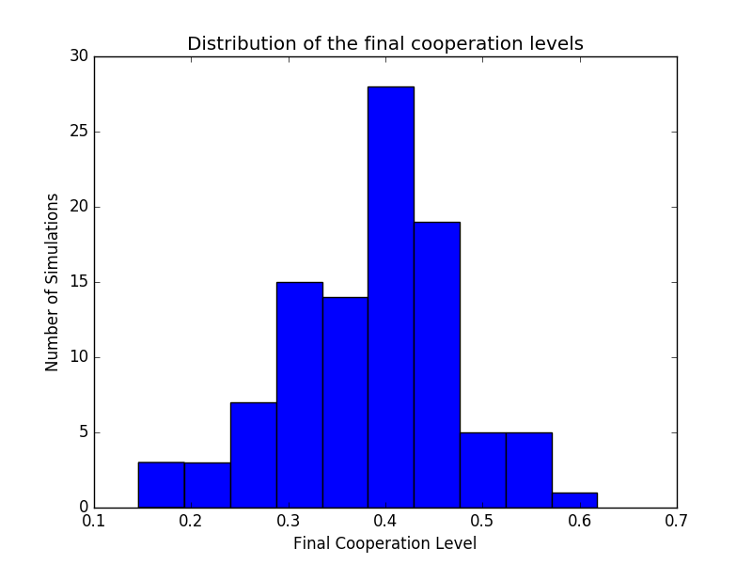
- Lattice size 20x20 :
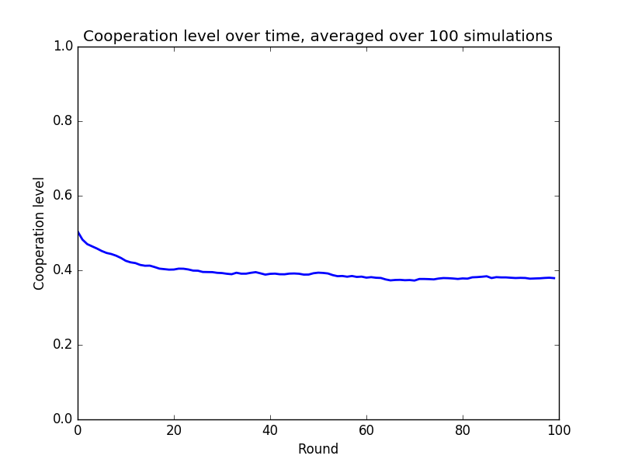
Result plots :

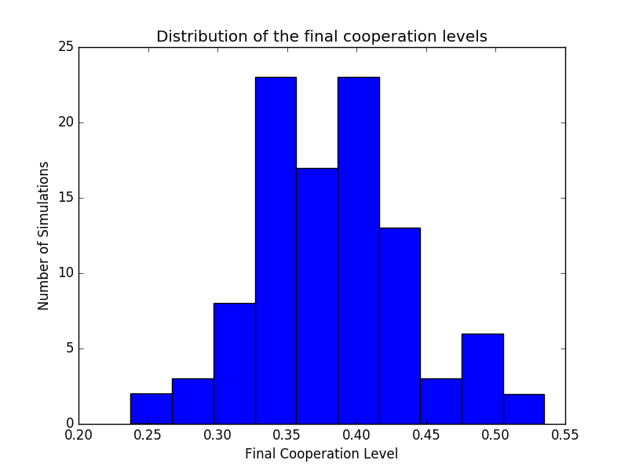

To finish with the replicator rule/snowdrift game analysis, let us compare for a 50x50 lattice size but for a Von Neumann neighborhood instead of a Moore neighborhood. Here are the resultings plots :
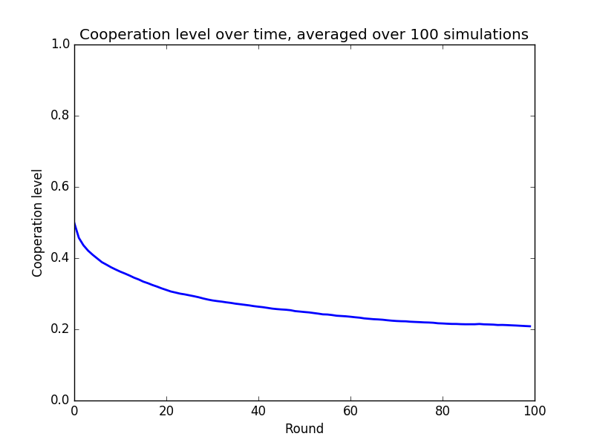
Observation/Discussions:
The result comparison/discussion for replicator rule/snowdrift game and unconditional imitation/prisoner's dilema game are slightly the same as for the 50x50 Moore neighborhood case. The comparison is more interesting between this result and the replicator rule/snowdrift game 50x50 Moore neighborhood results. The major difference resides in the final cooperation levels so it is better to take a llok at the final cooperation levels histogram :
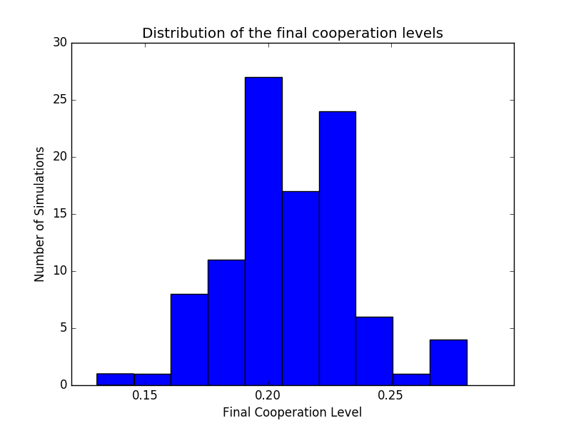
Observations/Discussions :
The final cooperations levels still forms a normal distribution but instead of it being around 38%, this time the normal distribution revolves around 22%. This is explained because this time we only consider 4 neighbours in the neighbourhood. As said before, on average defectors have a higher chance of having a higher payoff than cooperators. Because we reduce the neighborhood size, we also reduce the probability of selecting a cooperators. Nevertheless, cooperators won't go extinct because the sucker payoff is equals to 3, increasing their probability to be imitated.

