Vander Marcken Raphaël
ULB – 00320722
INFO-F-409 : Learning Dynamics
Assignment 3 : Multi-Armed Bandits

Exercise 1

Averaged reward for each algorithm over 500 simulations :
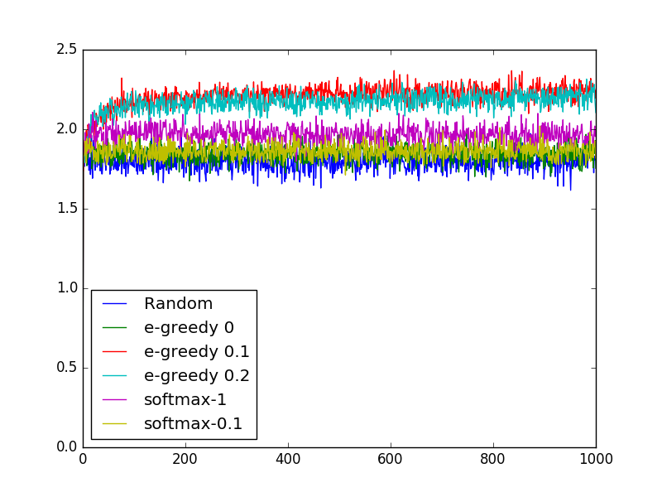
Discussion :
In the figure, we can observe that the random selection of arms yield the worst averaged reward. This is expected and is the direct consequence of constant exploration and no exploitation. Thus, no specific arm the seems to yield better reward is exploited at all.

One step above is the Є-greedy with Є=0. Such an algorithm uses constant exploitation which is the exact opposite of the previous algorithm. It means that, in the first, the algorithm will select the arm with the highest reward and stick with it for all future rounds. This algorithm will thus almost act like the random because given the Q* and standard deviation of the given arms, the algorithm will likely choose a random arm at the start. The reason because it is slightly over the random algorithm is because arm number 4 has low Q* and high standard deviation and will be thus taken less often by this algorithm which is a “good” choice regarding the reward.

By going on going higher, we have the softmax algorithm with τ = 0.1. A low temperature parameter means a high exploitation. But here we are not in a full exploitation and we take into account the Q value of the other actions. This way the algorithm yields a slightly better average reward than the previous one. On the other hand, we see that the softmax algorithm with τ = 1 is just above. A higher temperature means less exploitation and thus, more exploration. It implies that this algorithm is more likely to test other arms yielding a higher averaged reward.

Finally, we have the top 2 algorithms which are Є-greedy with Є=0.2 and Є-greedy with Є=0.1 at the very top. It means that, for Є=0.2, 20% of the time it will select a random arm and for Є=0.1, it will be 10% of the time. As we can see, this last algorithm performs the best.

Plot per arm :
Arm 1 (Q* = 2.3, σ = 0.9)
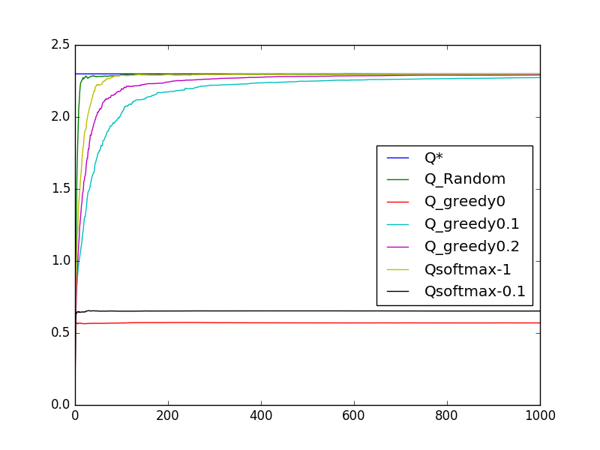
Arm 2 (Q* = 2.1, σ = 0.6)
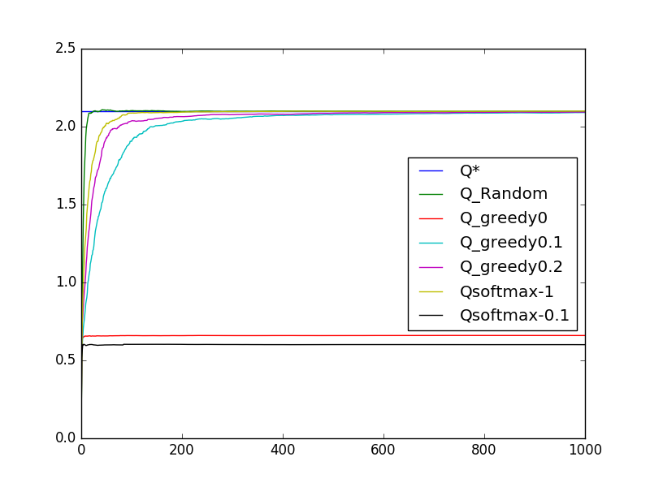

Arm 3 (Q* = 1.5, σ = 0.4)
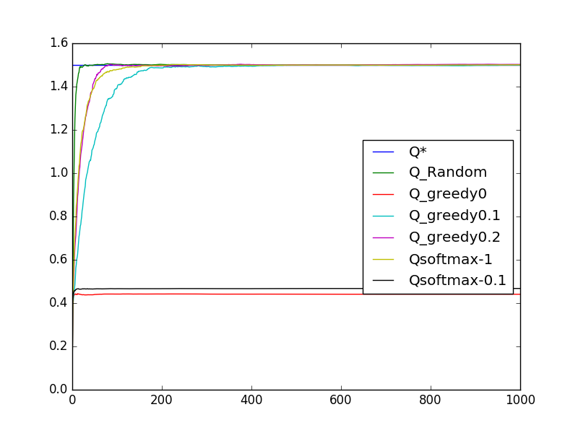
Arm 4 (Q* = 1.3, σ = 2)
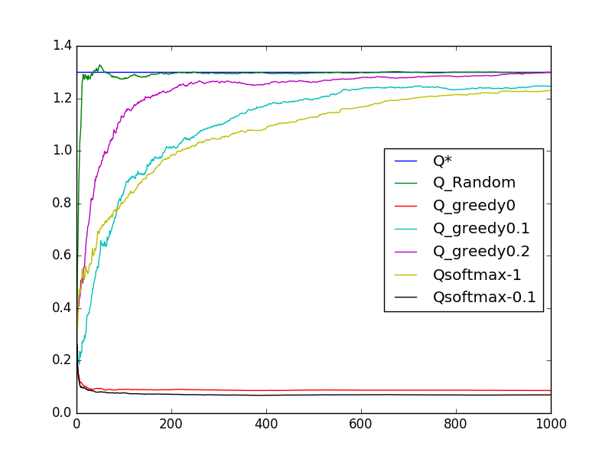

Discussion :
For all algorithms, we can observe that, as the standard deviation is bigger, the time to reach the Q* value is also bigger. This observation is quite logical because a high standard deviation means, by definition, that the values will on average far from the mean value.
As a general observation we see that the Softmax algorithm with a temperature of 0.1 and the random algorithm are close to each other but very far from the Q* value.
On average the Є-greedy algorithm with Є = 0.1 takes the longest time to reach the Q* value (apart from the two previous algorithm). We have then the Є-greedy 0.2 and the Softmax 1 algorithms that are close to each other and the random algorithm that always reaches the Q* value the first. This is all du o the exploration factor.
As an algorithm has a higher exploration factor, this algorithm will reach the Q* values faster. This also explains why the greedy-0 and softmax-0.1 that uses high exploitation are very far from Q*.

Histograms :
Random :
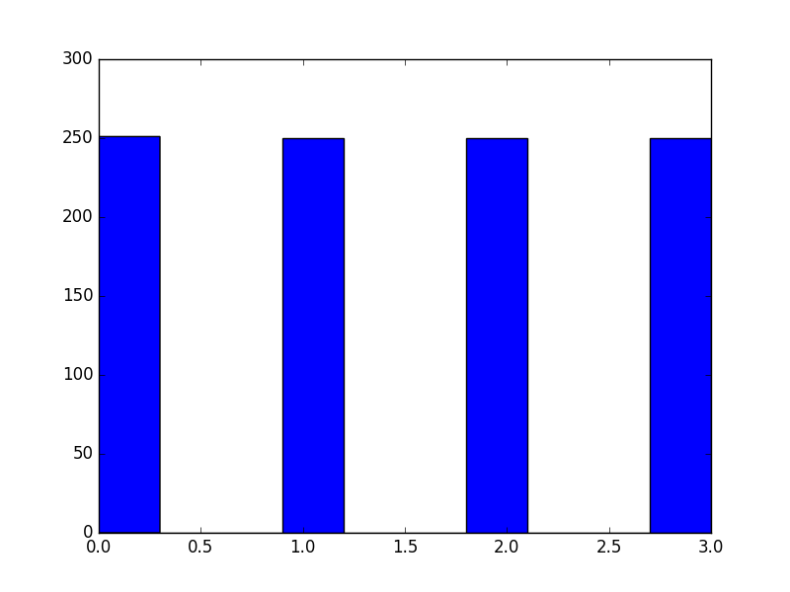
Є-Greedy with parameter Є = 0 :
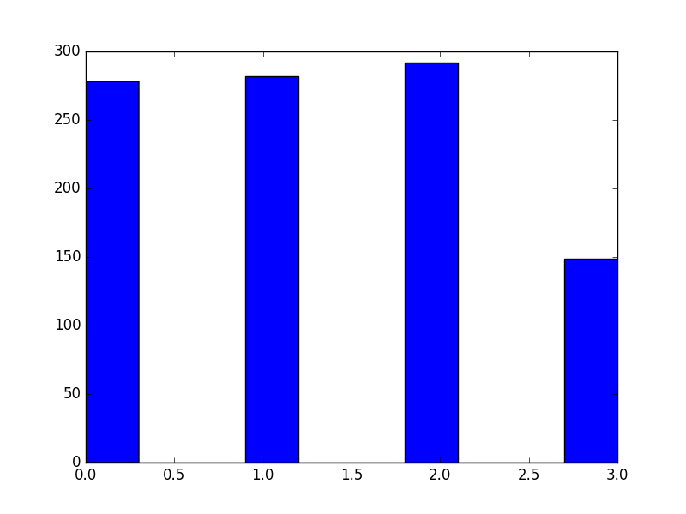

Є-Greedy with parameter Є = 0.1 :

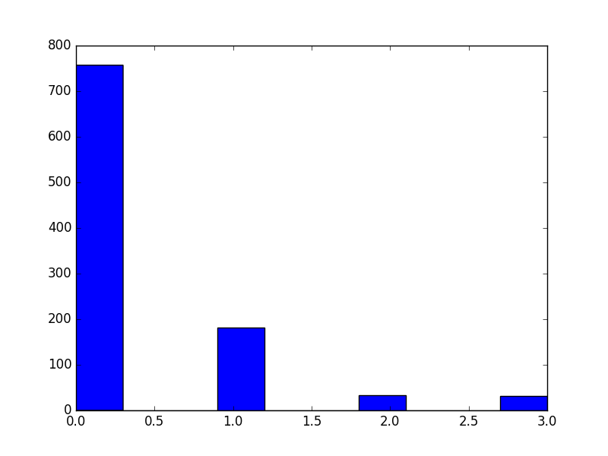
Є-Greedy with parameter Є = 0.2 :
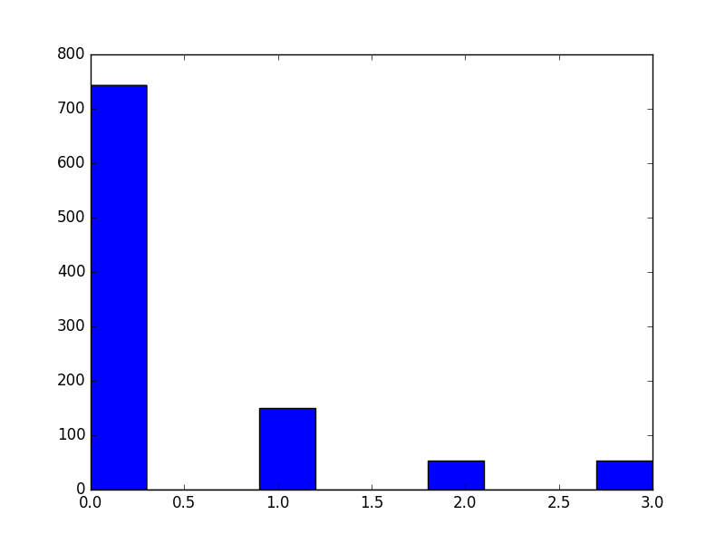

Softmax with parameter τ = 0.1 :
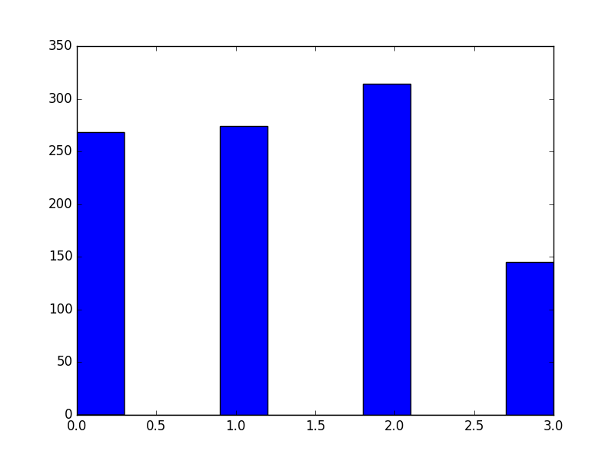
Softmax with parameter τ = 1 :
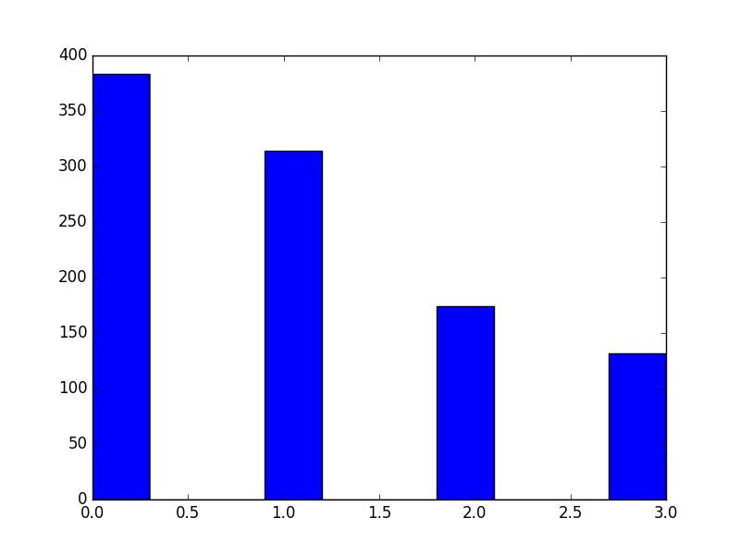

Discussion about histograms:
The repartition for the random algorithm is quite self-explained. All arms are chosen equally because the algorithm chooses one arm randomly.

The repartition for the Є-Greedy with parameter Є = 0 algorithm suits quite well what was explained before. Because of the mean and standard deviation of the arms being not too spread from each other, except for the last arm, they are each chosen almost randomly by this algorithm at first round. The algorithm, for an entire simulation will always choose the same arm. Averaged over 500 simulations, we have thus this almost equally distributed choose of arms.

The repartition for the Є-Greedy with parameter Є = 0.1 algorithm has chosen in a large majority the first arm which yield, on average, the maximum reward. We can see here that this algorithm have tested all the arms(exploration) and prefered the arm 1 the most (exploitation).

The repartition for the Є-Greedy with parameter Є = 0.2 algorithm has a very similar distribution of the previous one except that arms 3 and 4 have been chosen a little bit more often. This is explained because this algorithm, given a higher Є value, will explore more.

The repartition for the Softmax with parameter τ = 0.1 algorithm is very sparsed with the arm 4 being chosen much less often than the others. This is explained because this algorithm performs high exploitation so we have results similar to the Є-Greedy with parameter Є = 0 except that in this case we also perform a very little exploration.

On the other hand, Softmax with parameter τ = 1 algorithm has a repartition similar to Є-Greedy with non zero Є. Except that less optimal arms are chosen more (ie. arms 2, 3 and 4), meaning that this algorithm perform more exploration then Є-Greedy 0.1 and 0.2 but still performs exploitation.

Exercise 2
For exercise 2, only standard deviation has changed and is doubled for every arms.

Averaged reward for each algorithm over 500 simulations :

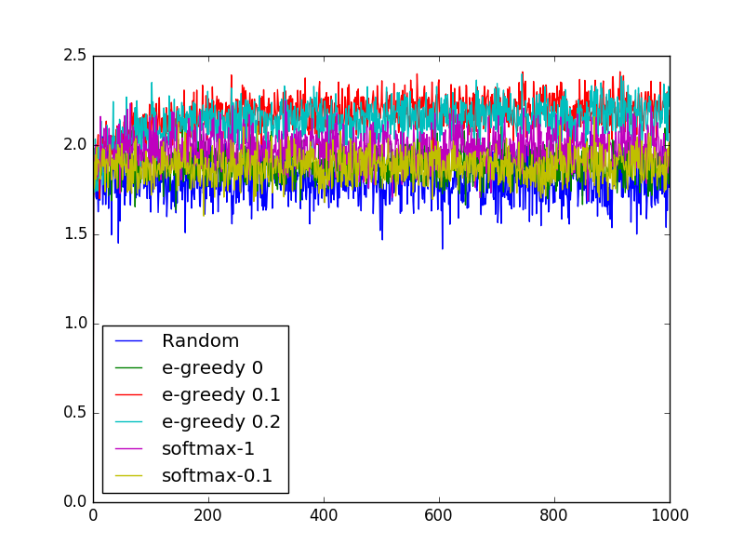
Discussion:
The order of the different algorithms have not changed. However we observe more variations of the mean reward. This is just a direct implication from doubling the standard deviation.

Plot per arm :
Arm 1 (Q* = 2.3, σ = 0.9)
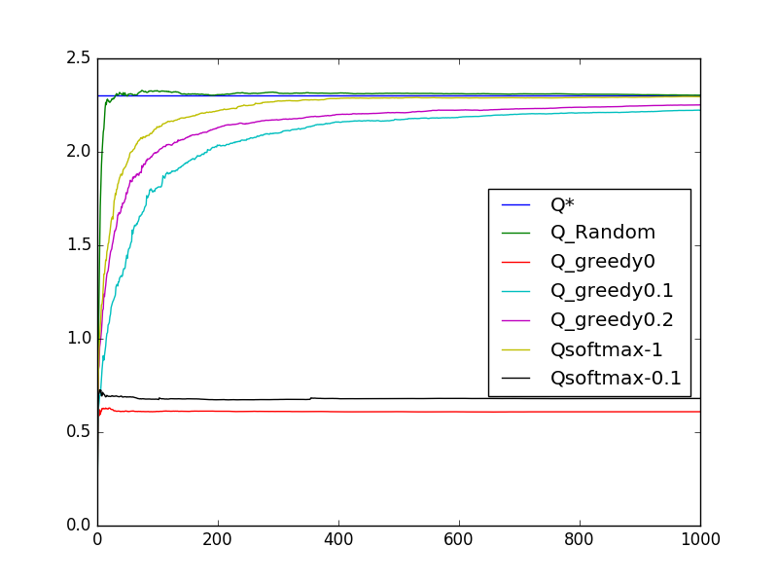
Arm 2 (Q* = 2.1, σ = 0.6)
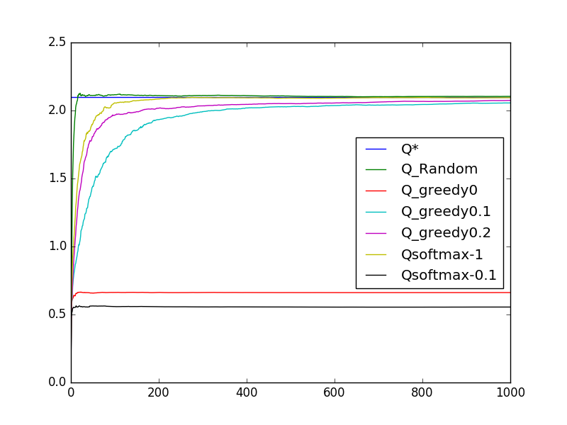

Arm 3 (Q* = 1.5, σ = 0.4)
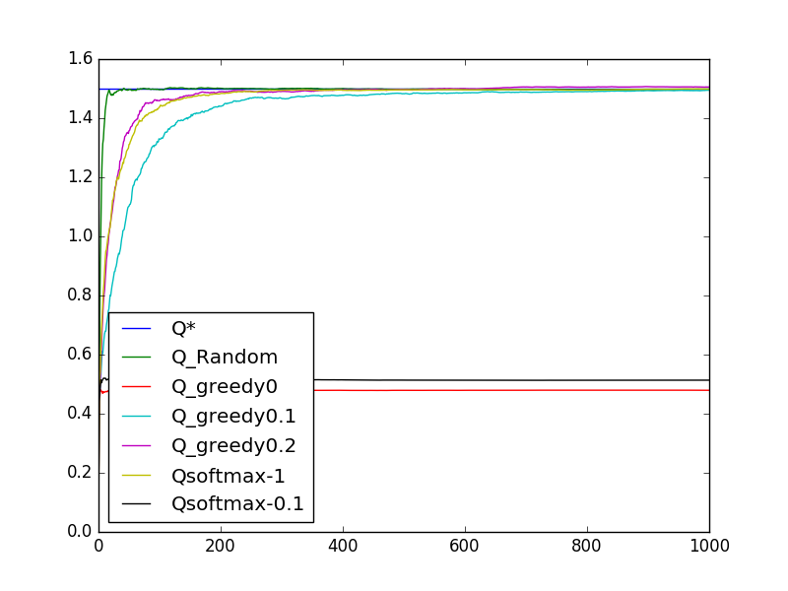
Arm 4 (Q* = 1.3, σ = 2)
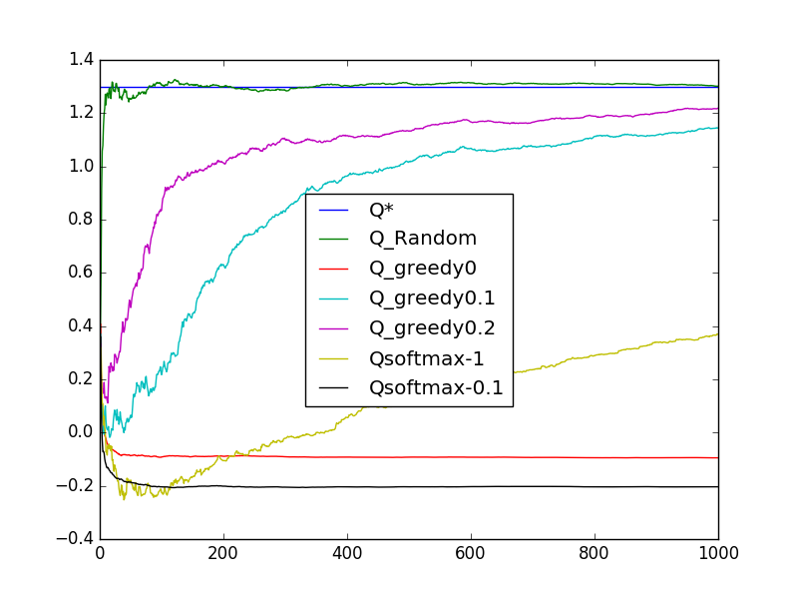

Discussion about arms:
In average, algorithms take more time to reach the Q* value. The plot for the arm 4 is rather different from others. In this case can observe that algorithms have a hard time converging to the Q* value of this arm. This is due by the original standard deviation being big (value of 2) compared to the mean (value of 1.3) and especially in this case, given that the standard deviation has been doubled (value of 4).

Histograms :
Random :
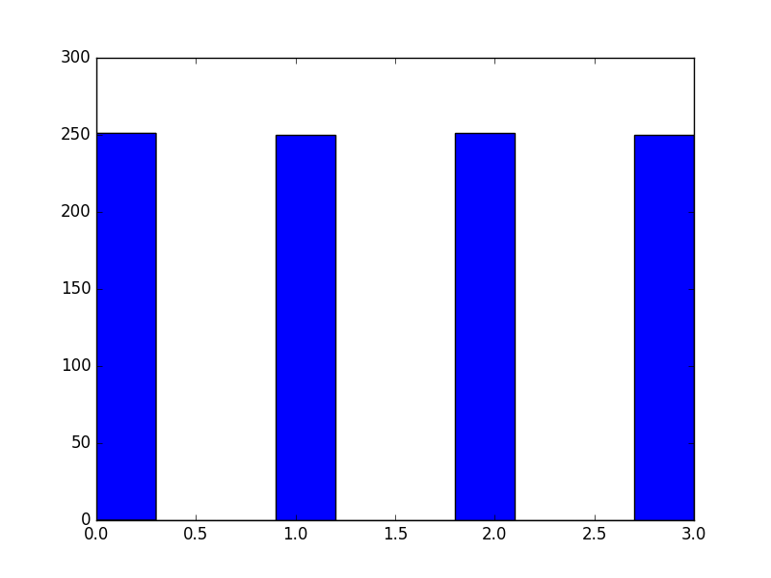
Є-Greedy with parameter Є = 0 :
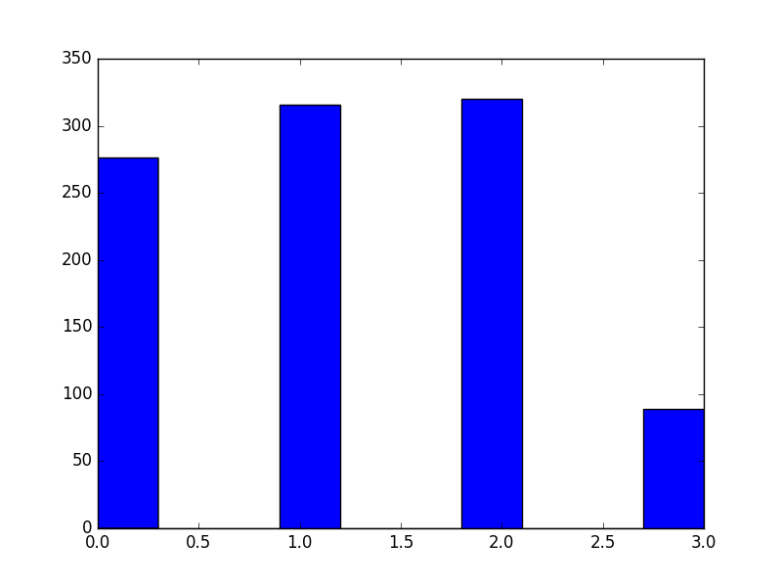
Є-Greedy with parameter Є = 0.1 :
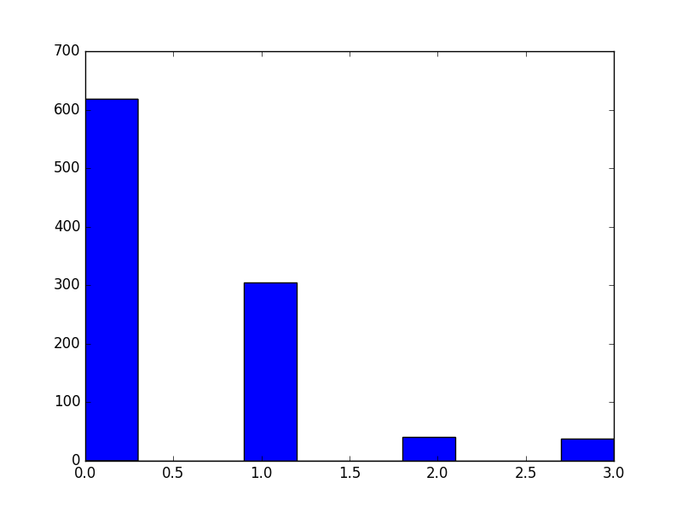
Є-Greedy with parameter Є = 0.2 :
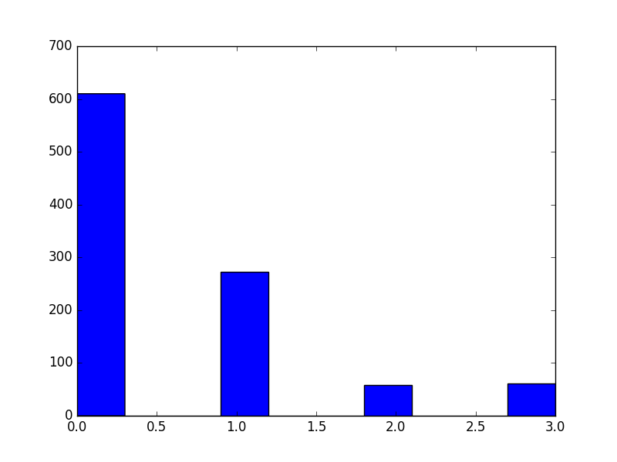

Softmax with parameter τ = 0.1 :
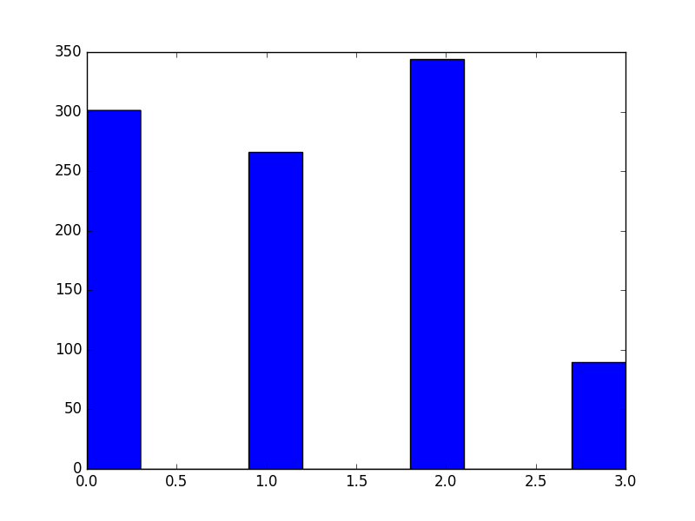
Softmax with parameter τ = 1 :
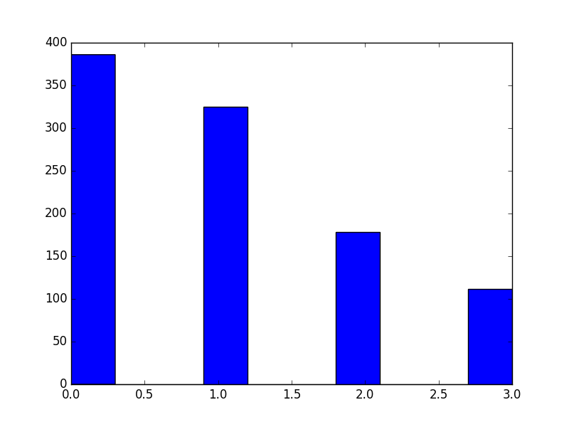
Discussion about histograms :
On average, with standard deviation doubled, the algorithms that have a “good” balance between exploitation and exploration took less often the first arm and more of the others.

We can say that now the problem is harder to learn for the algorithms and the Є-Greedy with parameter Є = 0.1 still performs the best.
Exercise 3 :
Averaged reward for each algorithm over 500 simulations :
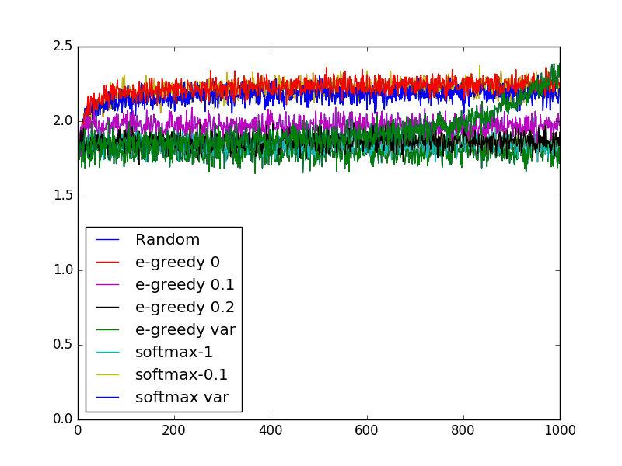
Discussion :
As we can observe, the Є-Greedy with variable parameter yields poor results for early rounds but from round ~400 this algorithm begins to perform exponentially better and becomes the best in the end.
Concerning the Softmax with variable parameter , it has results comparable to the Є-Greedy with parameter Є = 0.1 which is also very good.

Plot per arm :
Arm 1 (Q* = 2.3, σ = 0.9)
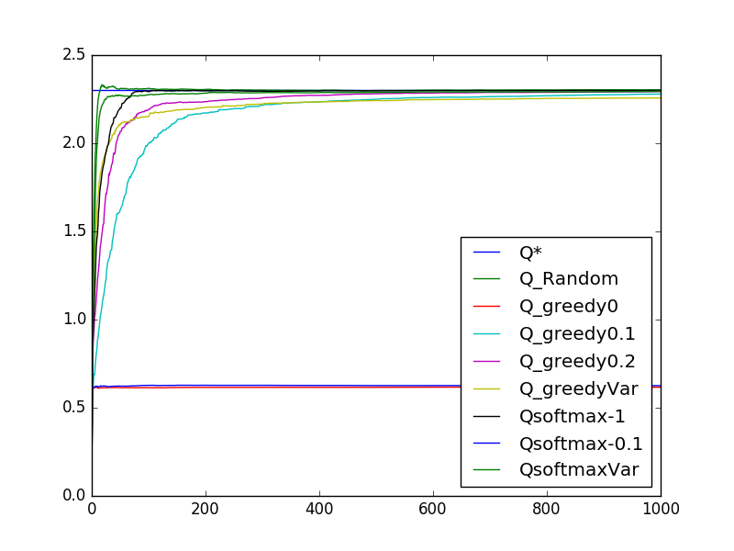

Arm 2 (Q* = 2.1, σ = 0.6)
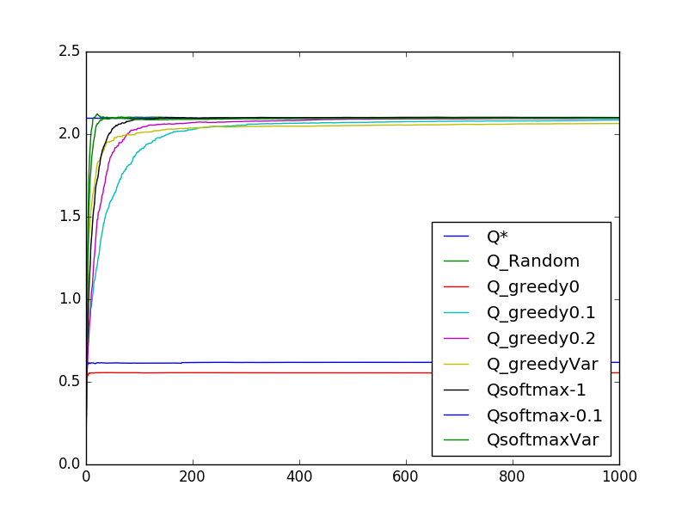

Arm 3 (Q* = 1.5, σ = 0.4)
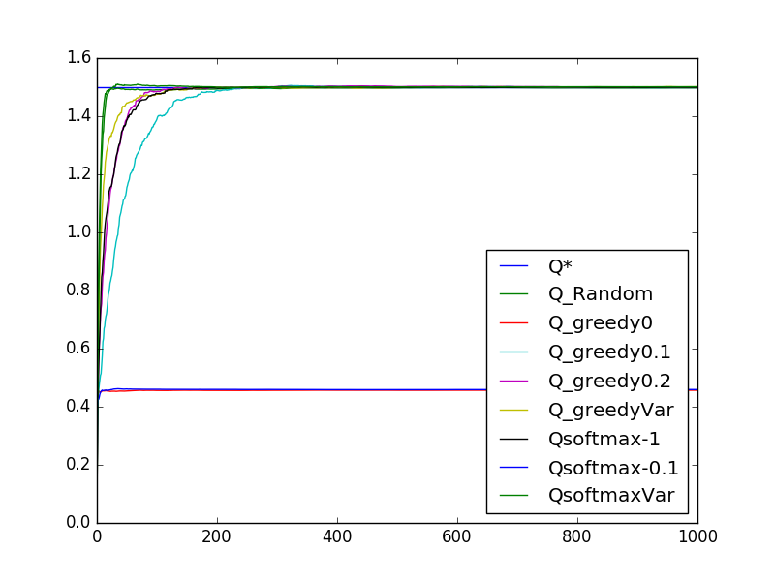
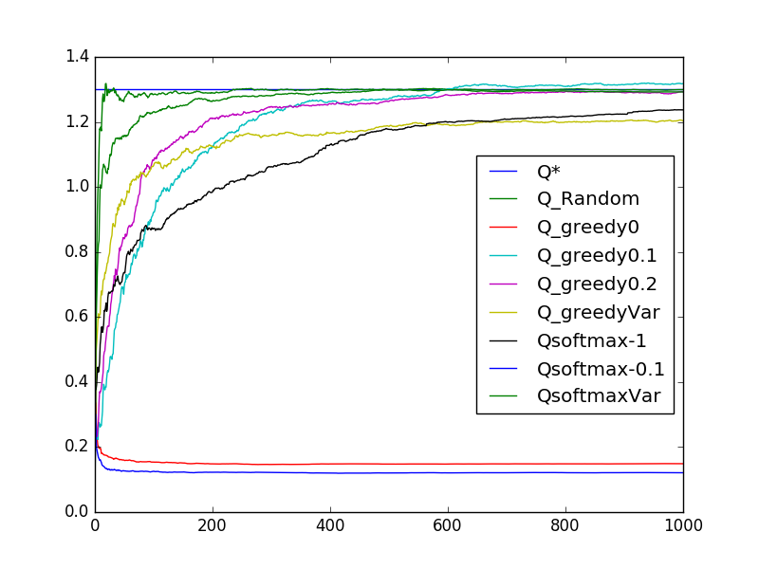
Arm 4 (Q* = 1.3, σ = 2)

Histograms :
Є-Greedy with parameter Є(t) = :
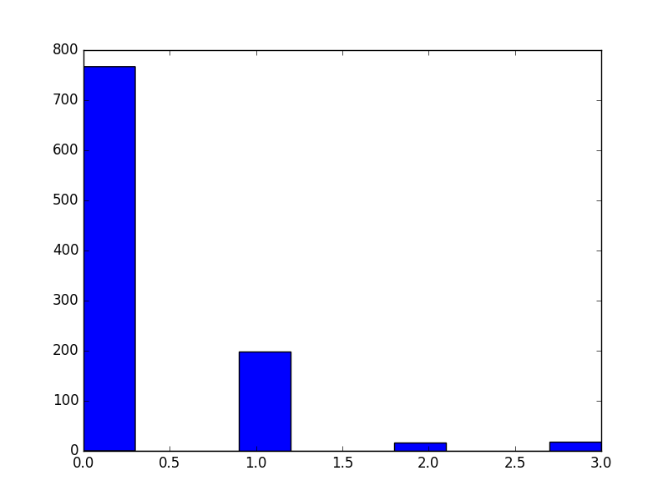

Softmax with parameter τ = :
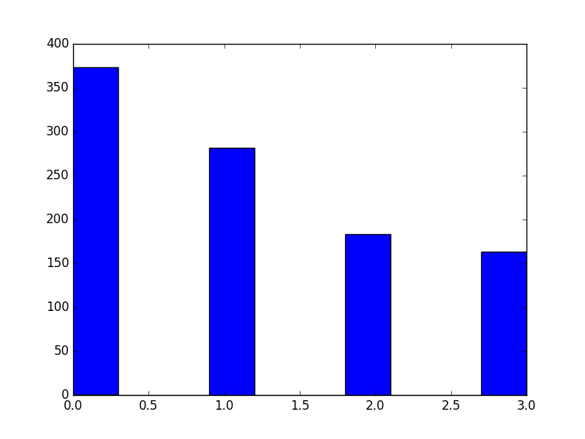
Discussions :

As the results show, those two new algorithms performs very well. Indeed, they start with low eploitation/high exploration and as time passes, the exploitation factor increases and the exploration decreases. Thus we have algorithms that begins to discover all possible rewards, having good approximation for all possible arm. This information is then well used later in a phase were they do more exploitation.

