Meeting Summary

*Summary Date: September 29, 2025*

**Timelines (Times are in Eastern time (GMT-5) unless otherwise noted):**

06/24/2025, 15:20:29 Aryan Hi, Nitish.

06/24/2025, 15:20:30 Neerav ABC Hello, Aryan. Thank you so much for initiating this bridge.

06/24/2025, 15:20:34 Aryan Can you tell me why you're trying to contact us?

06/24/2025, 15:20:42 Neerav ABC We have a global number starting with plus one and the Atos desk number used in the past.

06/24/2025, 15:20:55 Aryan You can reach us by calling the service desk.

06/24/2025, 15:21:03 Aryan If you ask them to raise a P1 and need to initiate a bridge, the service desk can contact us. Also, there is an option 7 when calling the service desk number.

06/24/2025, 15:21:17 Neerav ABC Can you share this service number 121?

06/24/2025, 15:21:21 Aryan I'll do that after the call; tell me what is the issue?

06/24/2025, 15:21:27 Neerav ABC It's a high critical site in the US. It's a factory site, and everyone is monitoring it. We received an incident and found both AB are not reachable. Praveen confirmed a power issue at the site. On-site personnel are checking the circuit breaker related to building electricity. We need to initiate a P1 and a bridge as per the process.

06/24/2025, 15:22:50 Aryan Hi, Praveen. Thanks for joining the call. Is the entire factory down right now?

06/24/2025, 15:22:58 Praveen It's down. The network is down.

06/24/2025, 15:23:00 Aryan Shared the following in the chat: MIM Bridge initiated. Critical Site is isolated with network.-INC02222

06/24/2025, 15:23:03 Praveen The whole plant lost power for 10 or 15 minutes. The telco room's power is still bad, affecting network gear. The factory has power, but the network is down.

06/24/2025, 15:23:27 Aryan What are the applications that are getting impacted?

06/24/2025, 15:23:37 Neerav ABC All the applications.

06/24/2025, 15:23:38 Praveen It's for that one site. All the applications.

06/24/2025, 15:23:39 Aryan OK.

06/24/2025, 15:23:41 Neerav ABC Obl. S.

06/24/2025, 15:23:47 Aryan Right now, as you have confirmed that the power is back and still the Internet is not up. Neerav, what are you investigating? What else are we doing now?

06/24/2025, 15:24:02 Neerav ABC We are just waiting for confirmation from the onsite users if they have checked everything is back.

06/24/2025, 15:24:10 Praveen No. Nothing's back because the entire network is down.

06/24/2025, 15:24:14 Neerav ABC Exactly. I was just referring to the network room, especially the network devices.

06/24/2025, 15:24:16 Praveen The electricians are looking into the problem. We're helpless until the electricians get the power back in that room.

06/24/2025, 15:24:50 Aryan Sorry, I missed that. Praveen, you're saying the power is up now or is the electrician still working on that?

06/24/2025, 15:24:59 Praveen Let me say it one more time; the main power in the building is up. There is one room in the building where the power has failed; it is the room where we have some of our network equipment. The electricians are trying to resolve that now. That's why the whole network is down.

06/24/2025, 15:25:18 Aryan For your information, I have elevated this ticket to a major incident and will send a notification.

06/24/2025, 15:25:29 Praveen Very good.

06/24/2025, 15:25:35 Aryan Praveen, can you confirm with the electrician how much time they will take approximately?

06/24/2025, 15:25:41 Praveen They have not given me an ETA. They've not given me a time yet; I'll try to find out.

06/24/2025, 15:25:49 Aryan Sure. Thank you.

06/24/2025, 15:30:44 Neerav ABC I can see the board devices are showing up to me. I'm logging into the devices to check. In the meantime, you can check with the site users as well.

06/24/2025, 15:31:03 Praveen I'll do some checking.

06/24/2025, 15:31:11 Aryan Thank you, Goutham, for joining the call. As a recap, this is a critical site. There is a power failure at the site, and when the power came back, there is a network room that still has some power issues. Praveen informed us that the electrician was working on that, and due to that, the network devices went down. The site got isolated completely. We have raised this up. Neerav confirmed that the devices are back up.

06/24/2025, 15:31:41 Goutham OK.

06/24/2025, 15:31:46 Aryan All is checking on that and validating.

06/24/2025, 15:31:51 Goutham Carter, thank you. Do we have the site ID?

06/24/2025, 15:31:59 Neerav ABC Yes, we have the site ID, it's XXXX.

06/24/2025, 15:32:03 Goutham XXXX, got it. Thanks.

06/24/2025, 15:32:04 Neerav ABC Devices are up from the last 7 minutes; most tunnels are up.

06/24/2025, 15:36:34 Aryan Praveen, can you confirm when the site went down?

06/24/2025, 15:36:45 Praveen Stand by. I'll put it in the chat.

06/24/2025, 15:37:13 Aryan This 2:42, that is Eastern Time, correct?

06/24/2025, 15:37:57 Praveen Yes, I just put the GMT in the chat.

06/24/2025, 15:38:00 Praveen Shared the following in the chat: Started at 2:42 PM local time 18:42 GMT. Devices started to ping at 3:29 PM (19:29 GMT).

06/24/2025, 15:38:01 Aryan I'll put this as a start time.

06/24/2025, 15:38:33 Praveen Can you check all devices on site, Neerav? Make sure they all came up.

06/24/2025, 15:38:46 Neerav ABC Yes, I'm just checking on them.

06/24/2025, 15:38:52 Praveen Thank you.

06/24/2025, 15:39:56 Aryan Praveen, you're confirming that at 3:29 PM, the devices started working. Are users able to log in or use their operations?

06/24/2025, 15:40:09 Praveen I'll check with them. I haven't talked to the end users yet.

06/24/2025, 15:42:04 Praveen Checking all services, so just stand by.

06/24/2025, 15:42:10 Goutham Is the site having just one power source? Can we check that in parallel?

06/24/2025, 15:42:34 Praveen We'll have to check that. It should be part of the problem ticket. I think it was a major issue from the substation.

06/24/2025, 15:42:43 Goutham OK.

06/24/2025, 15:42:51 Praveen We have to check on the demo. It should be part of the problem ticket.

06/24/2025, 15:42:59 Goutham Got it. Do you have the count of users impacted on the site?

06/24/2025, 15:47:23 Praveen I do not know.

06/24/2025, 15:47:26 Goutham OK.

06/24/2025, 15:48:20 Neerav ABC Multiple switches were power rebooted; now they are reachable. Some are left, and I will update soon.

06/24/2025, 15:48:36 Goutham Thanks, Neerav.

06/24/2025, 15:58:00 Praveen Shared the following in the chat: ABs not registering to the controller: AB US-01111ab-04, on switch -sw00; AB US-01111ab-45, on switch -sw09; correction, AB US-01111-12, on switch -sw07.

06/24/2025, 16:06:00 Gautham Shared the following in the chat: Current status ======================== Network devices in Floura Site went down due to Power issues.

06/24/2025, 16:34:00 Praveen Shared the following in the chat: it's ab-02, not ap-07

06/24/2025, 16:46:00 Chandhan ABC Shared the following in the chat:

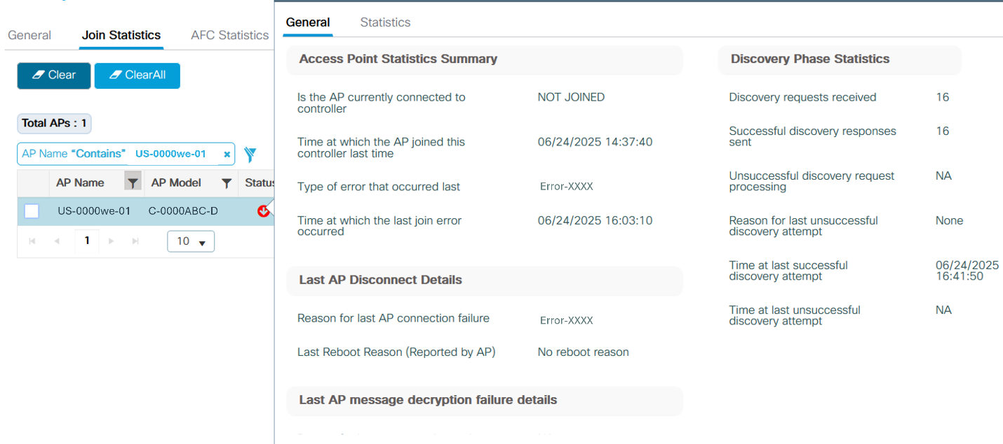

06/24/2025, 16:55:00 Neerav ABC Shared the following in the chat: obc-7111-sw01#sh crb ne X ------------------------- Device ID: UB-01111ab-45 Entry address(es): IP address: 111.XX.XXX.XX IPv6 address: AB12::7XX1:XXXXAAA:1AAA (link-local) Platform: ABCDE ABC-AB1111-A-B9, Capabilities: OOO Trans Interface: X, Port ID (outgoing port): QQQ Holdtime : 122 sec

06/24/2025, 17:10:00 Aryan Shared the following in the chat: Issue resolved; MIM Closed; Problem ticket - PRB001111

# Action Items

|  |  |
| --- | --- |
| **Action Item** | **Team** |
| Log into the board devices to check their status and check with the site users. (Status: In Progress) | ABC Team |
| Check all devices on site to ensure they all came up. (Status: In Progress) | ABC Team |

# Key Observations

* The service desk can be contacted to raise a P1 and initiate a bridge, with an option 7 available when calling.
* A high critical site in the US is experiencing a network outage due to a power issue, requiring a P1 and bridge initiation.
* The network is down due to a power failure at a critical site, and the issue has been elevated to a major incident ticket.
* Goutham raised a concern about the site having only one power source, which should be checked as part of the problem ticket.
* Praveen mentioned that the power issue might be a major issue from the substation and should be included in the problem ticket.