Transcript and chat history

June 24, 2025, 03:20PM

Aryan 0:29  
Hi, nitish.

Neerav ABC 0:30  
Hello, Aryan.  
Thank you so much for initiating this bridge.

Aryan 0:34  
I think nobody's just tell me one thing like which means you're trying to contact to us.

Neerav ABC 0:42  
Yes, that was the first thing I wanted to ask you.  
We have a global number that is starting with plus one and maybe the Atos desk number.  
That we use to contact.  
In past.

Aryan 0:55  
OK, great.  
No. You can reach to us by like calling service desk they can.

Neerav ABC 0:57  
But I.

Aryan 1:03  
If you ask them to raise a P1 and you need to initiate a bridge service desk will they can contact us. Also there is a option blind option 7. If you try try calling service desk number and just have to blindly press the.

Neerav ABC 1:17  
Can you?  
Can you share me this services number 121?

Aryan 1:21  
Yeah, I'll. I'll do that after the call.

Neerav ABC 1:23  
OK.

Aryan 1:23  
I'll do that.  
OK, OK.  
Tell me what is the issue?

Neerav ABC 1:27  
OK.  
So it's a high critical site located in us.  
It's AI.  
Think it's a factory site in the Site and everyone has eye on this site. Especially so we receive an incident and we just check that both of the AB are not reachable to us.

Aryan 1:34  
Mm hmm.

Neerav ABC 1:47  
We were just checking something and meanwhile we got a notification from Praveen as Praveen. I I think Praveen has also joined this bridge.  
So the poll is the one we initially connect.  
If, if Site has any issue, so Praveen just confirmed that there is some power issue going on on this site, that's why.  
We had got unreachable so as a part of the process we need to initiate a a P1 which we know that there is.  
Some power issue, as confirmed by Praveen. So on site persons are already checking for that because that was something related to building electricity that make the circuit breaker trip and they are checking on it.  
But we need to initiate a bridge and need to send the notification as per the process.  
So that's why I contacted you.  
To initiate that bridge.

Aryan 2:50  
OK.  
Hi. Hi, Praveen.  
Thanks for joining the call.  
Can you tell me is entire factories down right now?

Praveen 2:58  
So it's down.  
The network is down OK.

Aryan 3:00  
Shared the following in the chat:  
MIM Bridge initiated. Critical Site is isolated with network.-INC02222

Aryan 3:02  
OK.

Praveen 3:03  
The whole plant, the whole plant lost power for 10 or 15 minutes, but when it came back, the telco room where some of the network gear is, the power is still bad in that room.  
And they're trying to figure out why.  
So the factory itself is running.  
They have lights, they have power.  
It's just that one room.  
Where some of our equipment is is totally down and that means their entire network is down.

Aryan 3:27  
OK.  
So. So right now, what are the applications that you are using?  
That is, that is getting impacted with that.

Neerav ABC 3:37  
All the application.

Praveen 3:38  
I think it's for that one site all. All the applications, yeah.

Aryan 3:39  
OK.

Neerav ABC 3:41  
Obl.  
S.

Aryan 3:47  
OK.  
So right now, as you have confirmed that the power is back now and still the Internet is not up.  
So, Neerav, what what you are investigating?  
Like what else we are doing now?

Neerav ABC 4:02  
We are just waiting for the confirmation from the onsite users if they have checked everything is back.  
Now what are the?

Praveen 4:10  
No.  
Yeah, yeah, nothing's back because the entire network is down.

Neerav ABC 4:14  
Yeah, exactly.  
I I was just referring to the network room, especially in the network devices, yeah.

Praveen 4:16  
Yeah.  
So the electricians are are looking into the the problem. OK, we're we're kind of helpless until the electricians get the power back in that room, OK.

Neerav ABC 4:29  
Mm hmm.  
Yeah, exactly.

Aryan 4:50  
OK, sorry I missed that.  
So Praveen, you're saying that like the power is up now or it's still the iteration is working on that?

Praveen 4:59  
No, no, let me say. I'm gonna say it one more time.

Aryan 5:03  
Mm hmm.

Praveen 5:03  
The main power in the building is up.  
There is one room in the building that the power has failed.

Aryan 5:06  
Mm hmm.

Praveen 5:09  
It is the room where we have some of our network equipment.  
The electricians are trying to resolve that now.

Aryan 5:13  
OK.

Praveen 5:15  
That's why the whole network is down.

Aryan 5:18  
OK, OK. So for your information for all that I have elevated this ticket to a major incident and will will send a notification so.

Praveen 5:29  
OK.  
Very good.

Aryan 5:35  
Praveen, can you confirm that as per the electrician, how much time they will take any approx.

Praveen 5:41  
They have not given me an ETA.  
They've not given me a time yet.

Aryan 5:47  
OK. OK, fine.

Praveen 5:47  
I'll try to find out.

Aryan 5:49  
Sure. Thank you.

Neerav ABC 10:44  
A poll I can see the board devices are showing up to me and I'm just logging into the devices to check and by the time you can check with the site users as well, I'm just logging into the devices.

Praveen 11:03  
OK.  
Yeah.  
OK.  
I'll do some checking.

Aryan 11:11  
Thanks. Thank you, Goutham, for joining the call.  
So as a recap, I can tell you this is a critical site at us.  
Actually there is a power failure at the site and when the power came back that there is a room network room that there have still some power issues.  
And for that, Praveen informed us that the electrician was working on that due to that the network devices went down and.  
Site got isolated completely.  
So that we have raised this up Even so right now, as Neerav confirmed that the devices are back up.

Goutham 11:41  
OK.

Aryan 11:46  
So all is checking on that and validating.

Goutham 11:51  
Carter, thank you.  
So we have the site ID or.

Neerav ABC 11:59  
Yes, we have the site ID, it's XXXX.

Goutham 12:03  
XXXX, OK. Got it. Thanks.

Neerav ABC 12:04  
Yes.  
And I can see the devices are up from last 7 minutes only and both's coming up they've made the.  
Adjudicency and now I can see most of the tunnels are up.

Aryan 16:34  
Praveen, can you confirm that from when the site has site is down?  
The issue occur.

Praveen 16:45  
Yeah, stand by.  
I'll put it in the chat, OK?

Aryan 17:13  
OK.  
This 242 that is Eastern Time correct.

Praveen 17:57  
Yes, I I just put the GMT in the.

Praveen 18:00  
Shared the following in the chat:  
Started at 2:42 PM local time 18:42 GMT. Devices started to ping at 3:29 PM (19:29 GMT)

Aryan 18:01  
OK.  
OK.  
So I'll put this as a start time.

Praveen 18:33  
Can you check all of the?  
Which is on site, Neerav.  
Make sure they all came up.

Neerav ABC 18:46  
Yes, Bol, I'm just checking on them.

Praveen 18:52  
OK.  
Thank you.

Aryan 19:56  
So Praveen, you're confirming that at 3:29 PM, the devices are started working.  
So the users at the site, they're able to log in or use their operations.

Praveen 20:09  
Yeah, I'll have to let me check in with them.  
I haven't actually talked to the end users. I've been looking at the network, but let me let me try to reach out to a couple guys.

Aryan 20:17  
Yeah.

Praveen 22:04  
Are checking all their services and stuff, so just stand by.

Goutham 22:10  
OK.  
So this the if also if the part clearly that happened right is the site having just one power source or the devices can these devices that went down are connected to one power source.  
Can we just also check that in parallel?

Praveen 22:34  
We'll have to check that.  
We'll have to ask them afterwards.  
That should be part of the of the problem ticket when when the problem ticket gets brought up, we should have them check. I think it was a major. I think it was a a major issue from the substation that that caused the power to be down.

Goutham 22:43  
OK.  
OK.

Praveen 22:51  
But we, but we have to check on the demo not there.  
We'll have to ask them, but that should be part of the problem ticket. When a problem ticket gets created, OK?

Goutham 22:59  
Got it.  
Praveen, by any chance do you have the count of users impacted on the particular site? Lawrence.

Praveen 27:23  
I do not know.

Goutham 27:26  
OK.

Neerav ABC 28:20  
I have seen multiple switches and I can see all of them were power rebooted, but now they are reachable.  
Some of them are left and taking the rest of the switches and will update soon.

Goutham 28:36  
Thanks, Neerav.  
Goutham stopped transcription

Praveen 38:00  
Shared the following in the chat:  
ABs not registering to the controller: AB US-01111ab-04, on switch -sw00 AB US-01111ab-45, on switch -sw09 AB US-01111ab-11, on switch -sw07 correction, that last one is AB US-01111-12, on switch -sw07

Gautham 46:00  
Shared the following in the chat:  
Current status ======================== Network devices in Floura Site went down due to Power issues. The power seems to have been restored and ABC and GBS team are confirming Network stability. Awaiting confirmation from Local customers if network services have been restored.

Praveen 1:14:00  
Shared the following in the chat:  
it's ab-02, not ap-07

Chandhan ABC 1:26:00  
Shared the following in the chat:

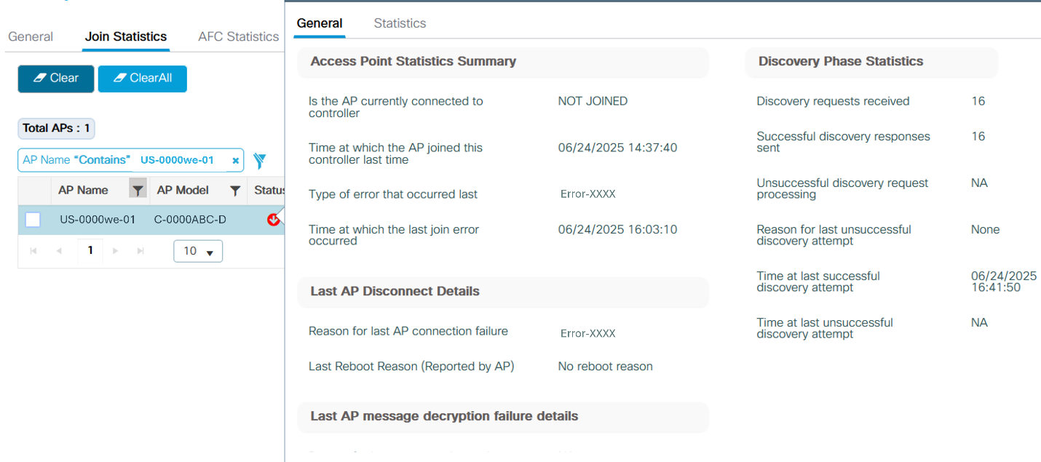

Neerav ABC 1:35:00  
Shared the following in the chat:  
obc-7111-sw01#sh crb ne X  
-------------------------  
Device ID: UB-01111ab-45  
Entry address(es):  
IP address: 111.XX.XXX.XX  
IPv6 address: AB12::7XX1:XXXXAAA:1AAA  (link-local)  
Platform: ABCDE ABC-AB1111-A-B9,  Capabilities: OOO Trans  
Interface: X,  Port ID (outgoing port): QQQ  
Holdtime : 122 sec

Aryan 1:50:00  
Shared the following in the chat:  
Issue resolved MIM Closed. Problem ticket - PRB001111