Web.xml

<servlet>

<servlet-name>resteasy-servlet</servlet-name>

<servlet-class>org.jboss.resteasy.plugins.server.servlet.HttpServletDispatcher</servlet-class>

</servlet>

<servlet-mapping>

<servlet-name>resteasy-servlet</servlet-name>

<url-pattern>/rest/*</url-pattern>

</servlet-mapping>

Or

<servlet-mapping>

<servlet-name>com.abonado.service.RestWebServicesApplication</servlet-name>

<url-pattern>/rest-app/*</url-pattern>

</servlet-mapping>

**localhost:8080/demo-app/rest/v1/restdemo/display/name**

demo-app: Application Context

rest: Servlet Mapping Path

/v1/restdemo: Path value at Service Level

/display/name: Path value at method level.

1. When no method annotation is specified, service throws 500 error.

**localhost:8080/demo-app/rest/v1/restdemo/token**

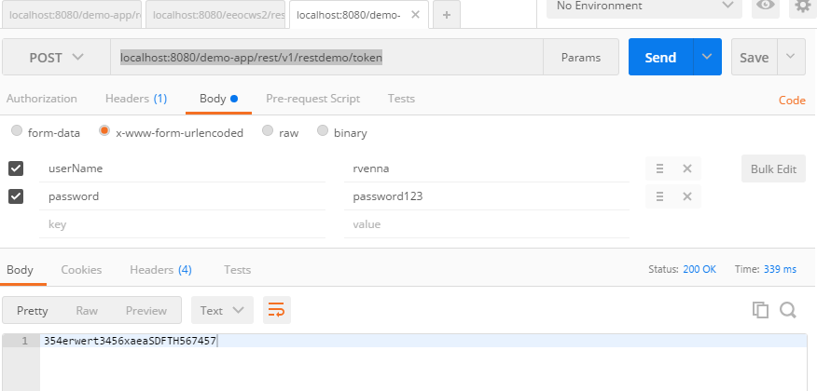

**Jasypt: Java Simplified Encryption**

Encrypt and then Encode

Decode and then Decrypt

What is *encodeBase64URLSafeString????????*

**Request body**

While constructing requests, you would be dealing with the request body editor a lot. Postman lets you send almost any kind of HTTP request (If you can't send something, let us know!). The body editor is divided into 4 areas and has different controls depending on the body type.

**form-data**

multipart/form-data is the default encoding a web form uses to transfer data. This simulates filling a form on a website, and submitting it. The form-data editor lets you set key/value pairs (using the key-value editor) for your data. **You can attach files to a key as well**. Do note that due to restrictions of the HTML5 spec, files are not stored in history or collections. You would have to select the file again at the time of sending a request.

**urlencoded**

This encoding is the same as the one used in URL parameters. You just need to enter key/value pairs and Postman will encode the keys and values properly. Note that you can not upload files through this encoding mode. There might be some confusion between form-data and urlencoded so make sure to check with your API first.

**raw**

A raw request can contain anything. Postman doesn't touch the string entered in the raw editor except replacing environment variables. Whatever you put in the text area gets sent with the request. The raw editor lets you set the formatting type along with the correct header that you should send with the raw body. You can set the Content-Type header manually as well. Normally, you would be sending XML or JSON data here.

**binary**

binary data allows you to send things which you can not enter in Postman. For example, image, audio or video files. You can send text files as well. As mentioned earlier in the form-data section, you would have to reattach a file if you are loading a request through the history or the collection.

**localhost:8080/demo-app/rest/v1/restdemo/upload/document**

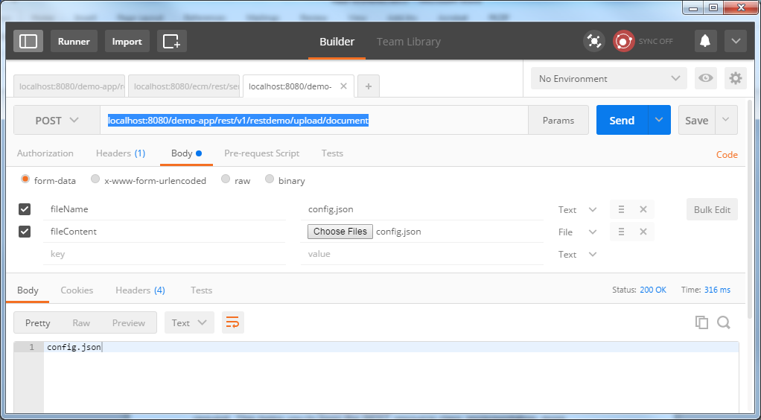

@Path("/upload/document")

@POST

**public** Response uploadDocument(@MultipartForm DocumentUploadForm documentUploadForm, @HeaderParam("security_token") String securityToken){

}

DocumentUploadForm should annotate setMethods with the @FormParam

**Regular Expression Validation for Path Parameter:**

@Path("/welcome/{name: [a-zA-Z]+}")

@GET

**public** Response getMessageByName(@PathParam("name") String name){

**return** Response.*status*(Response.Status.***OK***).entity("Welcome:"+name).build();

}

**Query Parameter Example:**

localhost:8080/demo-app/rest-app/v1/restdemo/queryparam/welcome**?name=rama**

@Path("/queryparam/welcome")

@GET

**public** Response getNameByQueryParam(@**QueryParam**("name") String name){

**return** Response.*status*(Response.Status.***OK***).entity("Welcome:"+name).build();

}

Matrix Parameter

localhost:8080/demo-app/rest-app/v1/restdemo/matrixparam/welcome;name=rama;country=usa

? is used in Query Parameters. Semi colon (;) is used in Matrix Parametersl;

**public** Response getURIInfoValues**(@Context UriInfo** ui){

MultivaluedMap<String, String> queryParameters = ui.getQueryParameters();

MultivaluedMap<String, String> pathParameters = ui.getPathParameters();

**public** Response getHeaderValues**(@Context HttpHeaders** headers){

MultivaluedMap<String, String> headersMap = headers.getRequestHeaders();

JBoss Default JSON Provider is Jackson. Rest web services provider: resteasy